1. Log in to Shopify
2. Go to ‘Apps’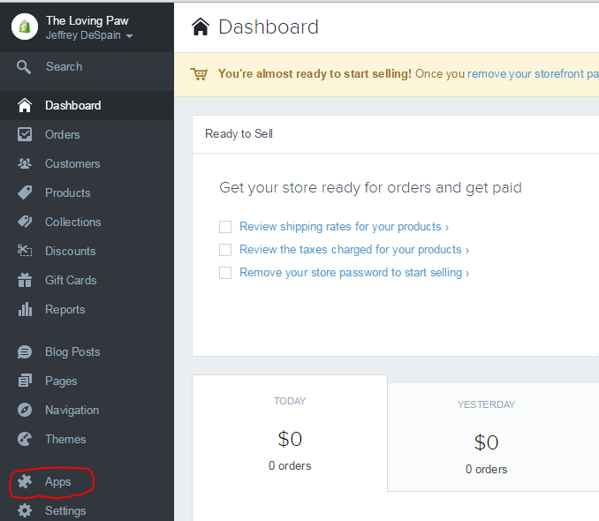
3. Select the WordPress Plug-in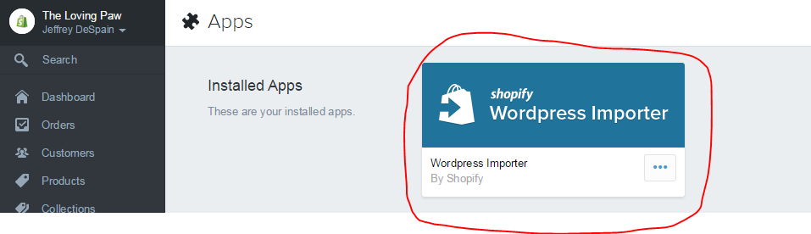
4. Enter your username and password and click ‘Authorize Wordpress Access’