1. Log in to the Shopify Admin site and go to the Pages link.
2. Click the About Us link

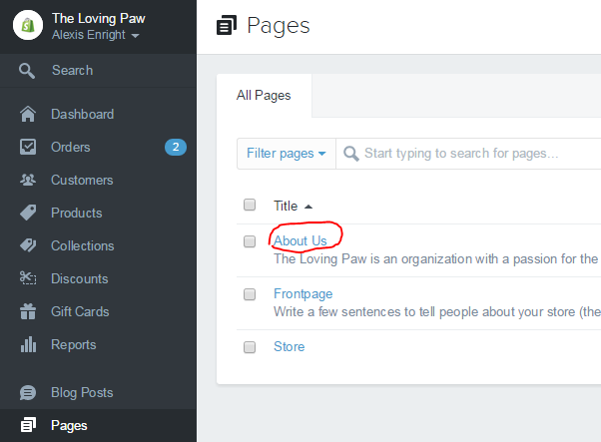

1. Enter the text that you want displayed on the page in the ‘Content’ Box.

