# ADDING A CONTACT US PAGE

1. Log in to the Shopify Admin site and go to the Pages link.
2. Click Add a Page in the upper right hand corner

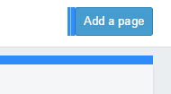

1. Enter a title for you contact page in “Title”
2. Enter anything your want your audience to read below the title in the “Content” Box

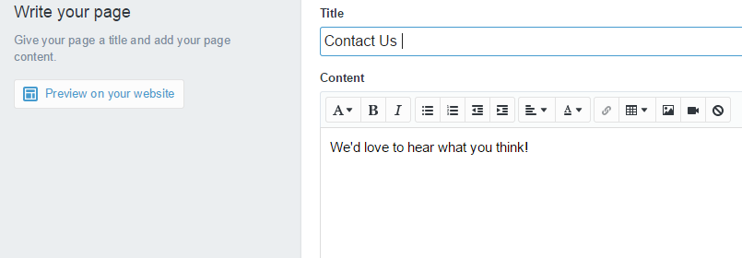

1. Click Preview on your website to see what the page will look like before you publish
2. Click Save Page in the upper right hand corner