1. Log in to the Shopify Admin
2. Select Themes

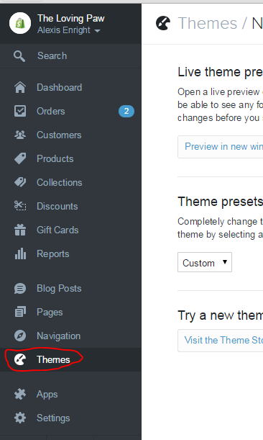

1. Scroll to bottom of page and select Footer

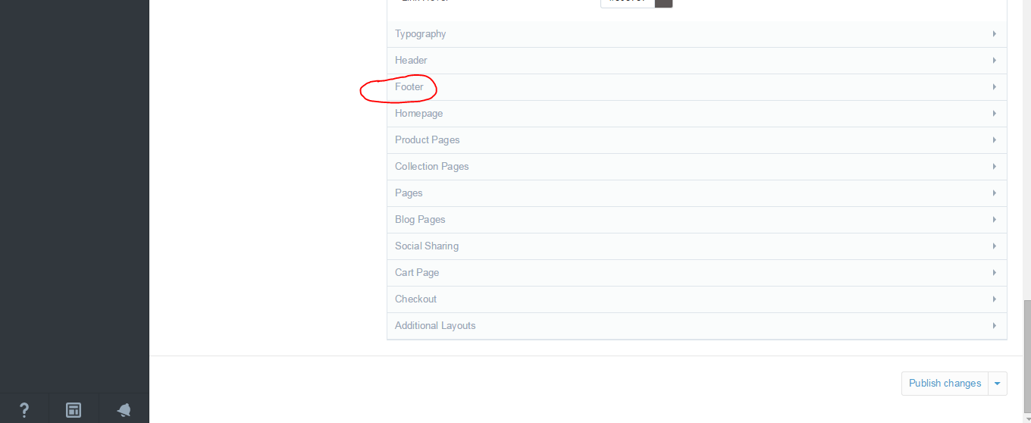

1. To change the About Module Text, type in the text that wish to be displayed on the page footer in the ‘About Module Text’ textbox.

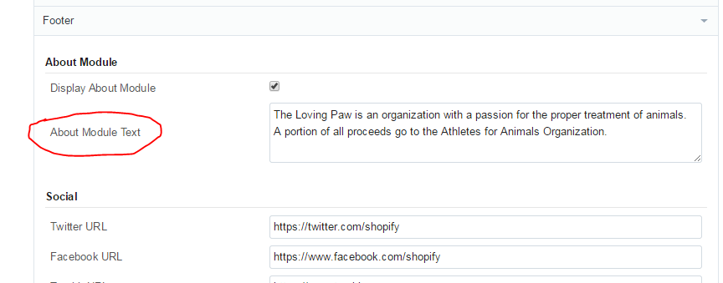

1. To change the Contact Module, scroll down to the Contact Section, then enter the appropriate address in the labeled address boxes

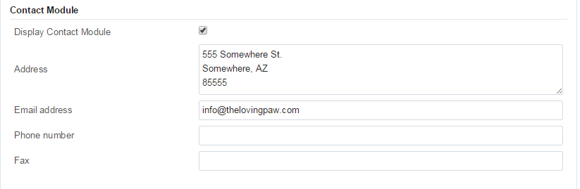

1. Scroll down and click Publish Changes

