**Add Social Media Links to Shopify “New Standard” Theme**

1. Select Themes

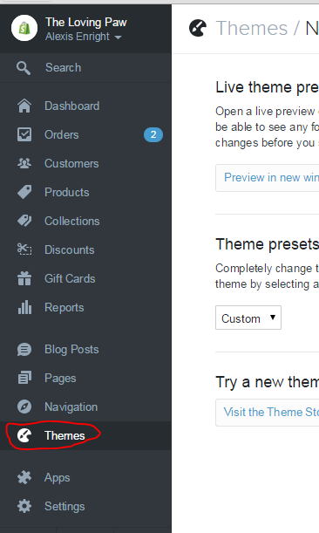

3. Click the “Customize theme” button

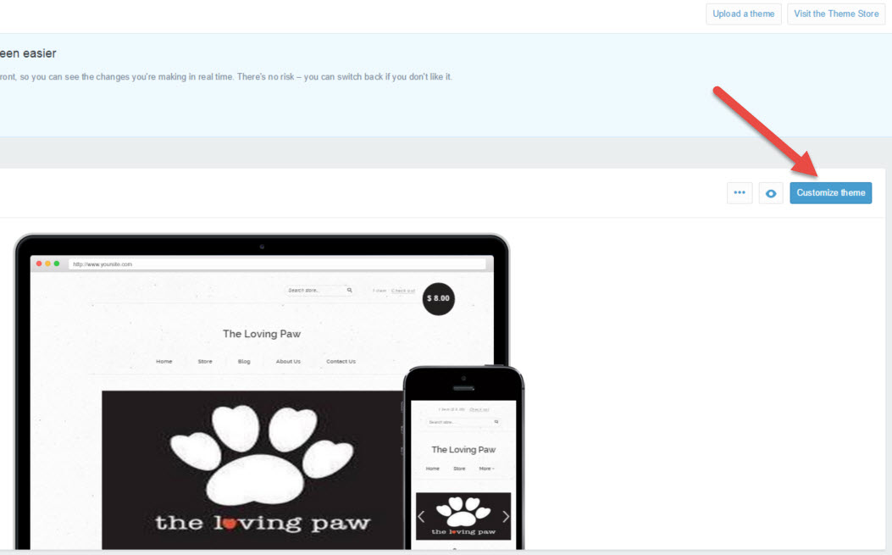

4. Scroll down the list and Click “Footer”



5. Under “Social”, insert The Loving Paw’s social media links (i.e. Twitter, Facebook, Instagram, etc…). URL boxes left blank will not show in the footer.

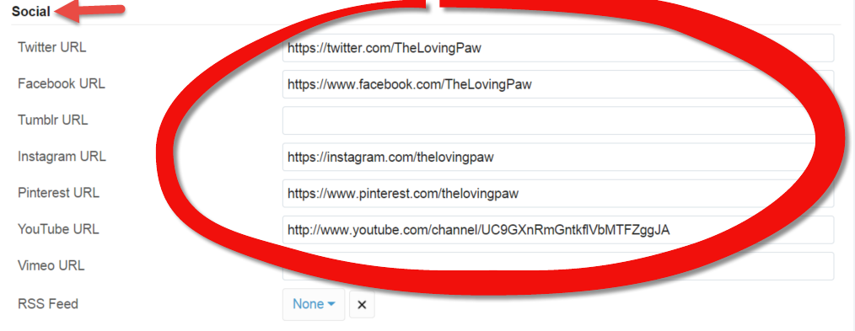

6. Click on the RSS Feed drop down list and select “None”

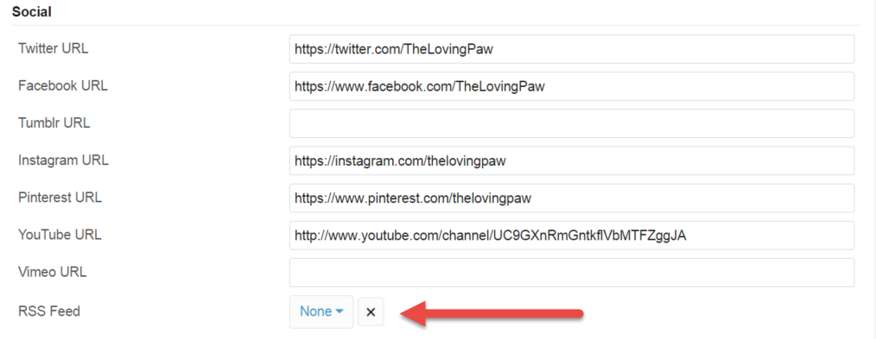

7. Click the “Publish changes” button in the top right of the menu

