1. Login to Shopify Admin Page
2. Select Themes

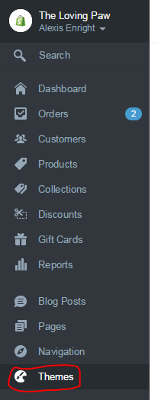

1. Select Customize Theme

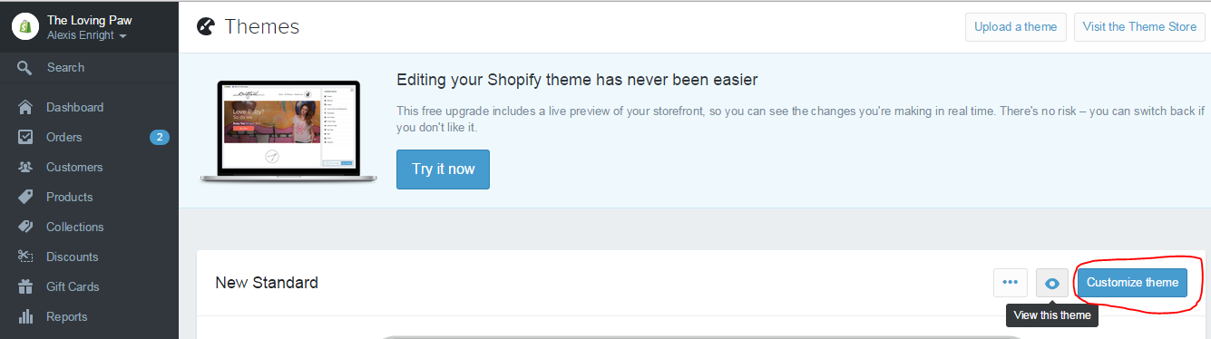

1. Scroll to the bottom of the page and select footer

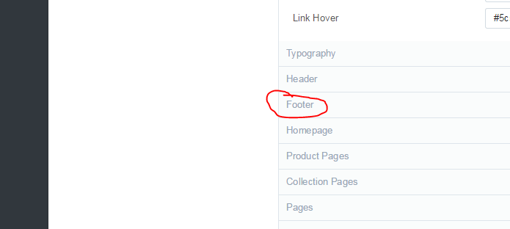

1. Scroll to the Newsletter Section and uncheck the Display Contact Module Box

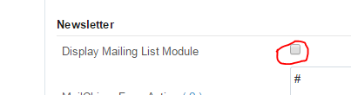

1. Scroll to the top of the page and select Publish Changes

