1. Enter required information to receive a Shopify account. Shopify offers all functionality of a paid account in their comprehensive trial account.

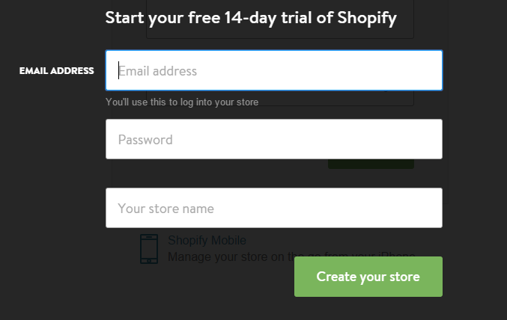

1. Once you are registered, you will be redirected to, and be logged in to your shopify admin panel. This panel will serve as your landing page or a portal for all web-building tasks until launch and any management activities post-launch.

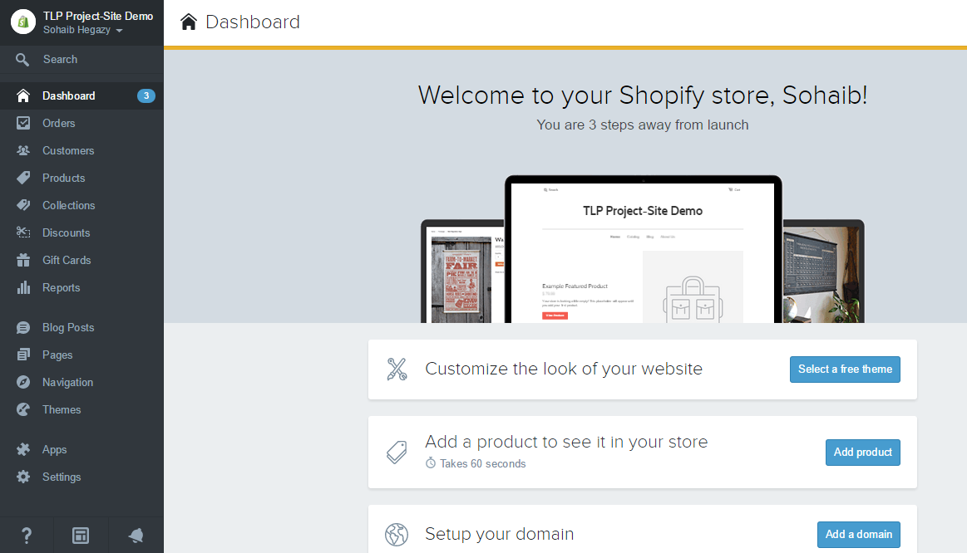

We will begin utilizing this site, and adding The Loving Paws’ products in a separate tutorial to follow.