**Creating and Developing a Shopping Cart Within Shopify**

1. The first important step to take to further develop the storefront, as the admin panel prominently displays, is to select a theme. Within Shopify, themes are easy to “test out” due largely to the ease of changing between tasks and the wide array of offerings in the theme store making a decisive pick nearly impossible the first time around.

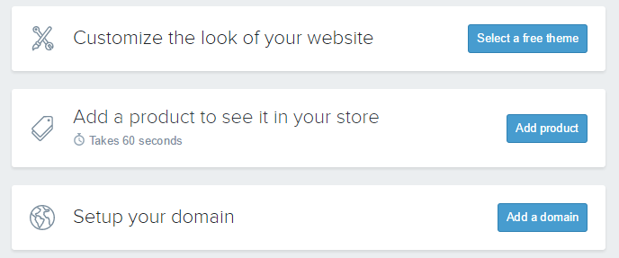

1. For the purpose of testing, our team of developers chose to implement the “New Standard Theme”, available in the “free” section of Shopify’s theme store. From preliminary client feedback, we intend to continue using this theme and through tasteful styling and CSS coding, create the theme our client is wishing for.

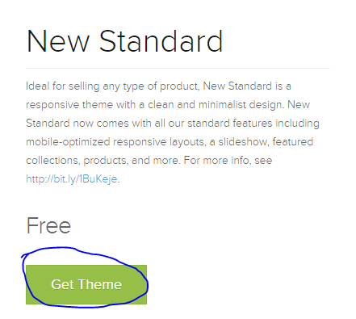

1. With the theme installed, the next prompt you will see by visiting the dashboard link, signified by a home icon, is to create a product. We took this step next, choosing a simple product from our clients’ Etsy store and replicating it in Shopify.

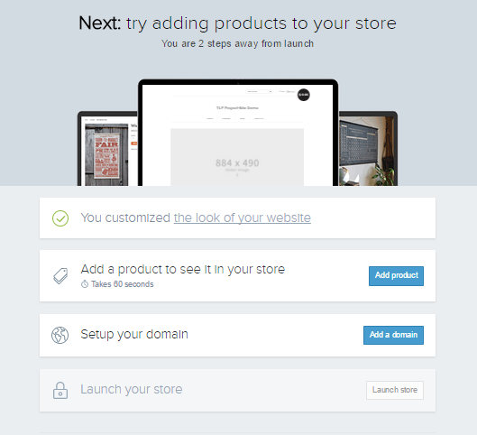

1. With a product page from the existing site to work with, we followed Shopify’s “Add product” page’s order to arrive at a completed/filled out new product page.

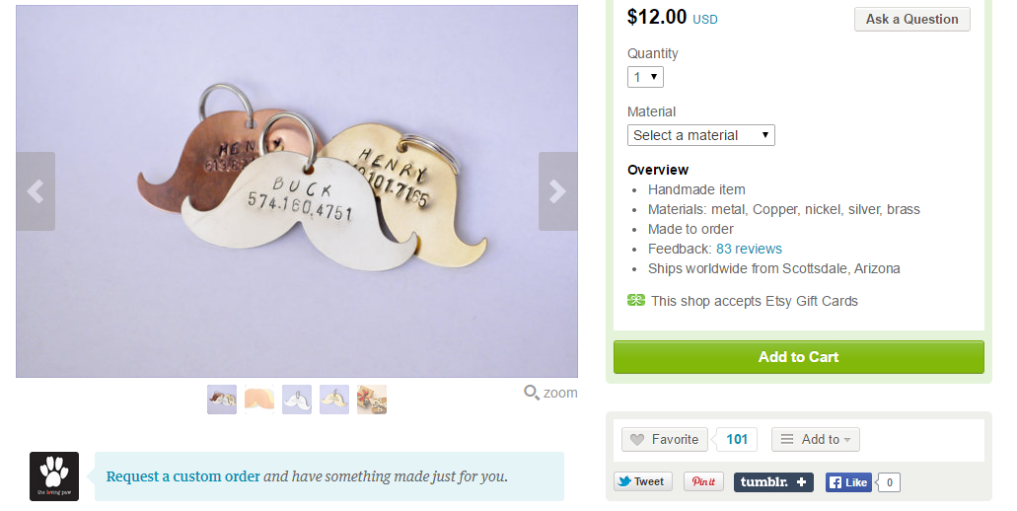

**Product to be brought from OLD Platform**

1. A completed product page for the product being brought into Shopify is shown in the following images. Shopify details criteria for each field on a new product page we therefore believe it is outside of the scope of this tutorial to discuss field-level requirements.

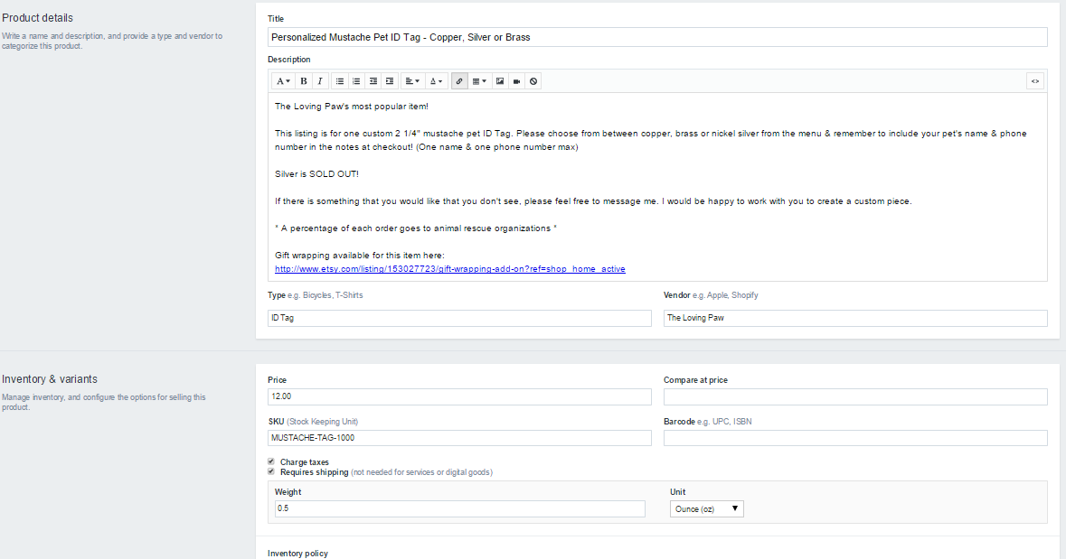

Screen 1 above (first screen of the add a product page shown)

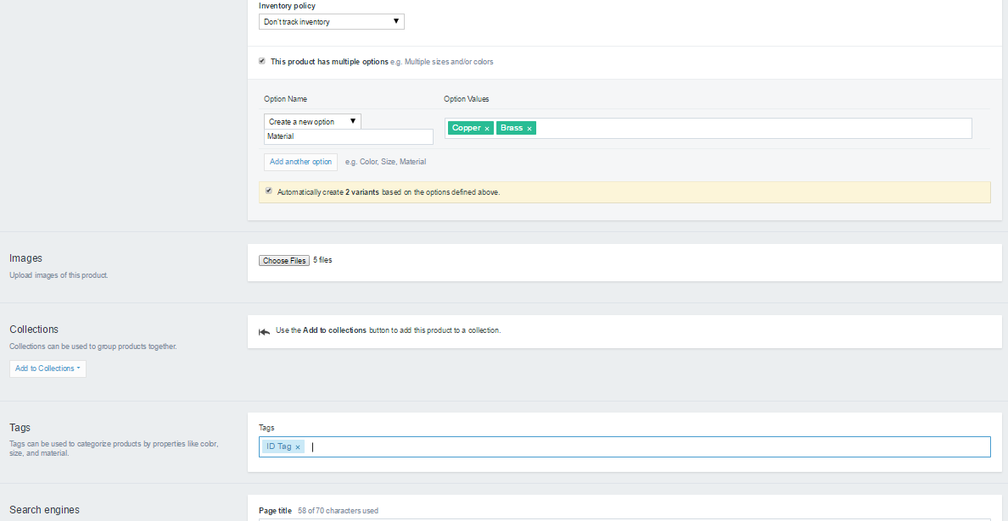

Screen 2 above (middle screen of the add a product page shown)

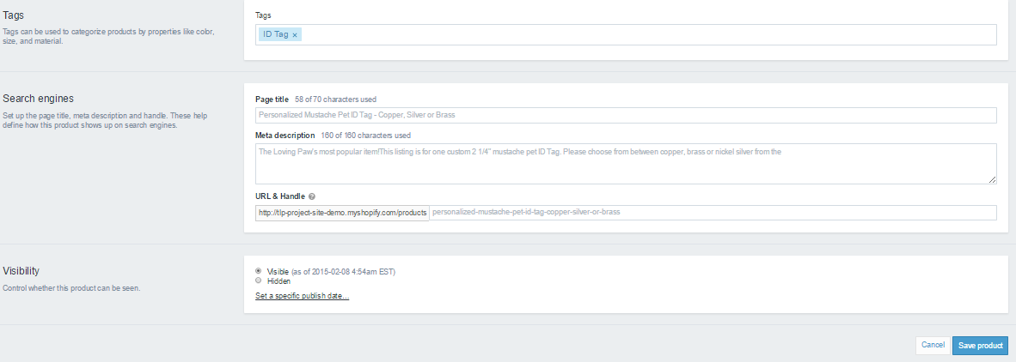

Screen 3 above (end of the add a product page shown)

1. With a new product now added, the remaining task indicated on the dashboard is to “Setup your domain” 🡪 “add a domain” which we ignore for the remainder of this tutorial. This is where we will return to when the store is completely built and ready to be put online for customer interaction.
2. Understanding that there are extensive customization offerings beyond our clients’ modest number of products, we postpone the theme customizations, or more specifically the “product page template” customizations until after all products are imported from the old platform, Etsy, to the Shopify platform.
3. To streamline importing new products, we utilize Shopify’s CSV import functionality to allow our development team to manually enter products in database format to a central file and adding them to Shopify with one seamless transaction.
4. To begin this process, we can either utilize a generic CSV template from Shopify, or we can “Export” our previously added product to a CSV and add future products to that file. From the Shopify admin panel, we export our product to a CSV file by clicking “Products” and selecting “Export”, the leftmost selection at the top right of the page. When clicked, you will be presented various export options. Select “All Products” and formatted to: “CSV for Excel, Numbers, and other spreadsheet programs”.

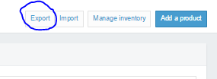

Selecting the export function from the product landing page from admin panel

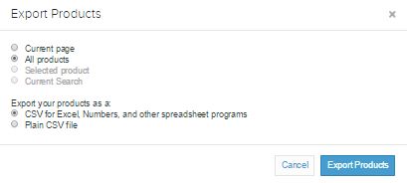

1. The CSV file containing current products will be emailed to the email Shopify has on record, and must be downloaded from there. Our CSV file containing the previously added product, opened in Excel is shown below.

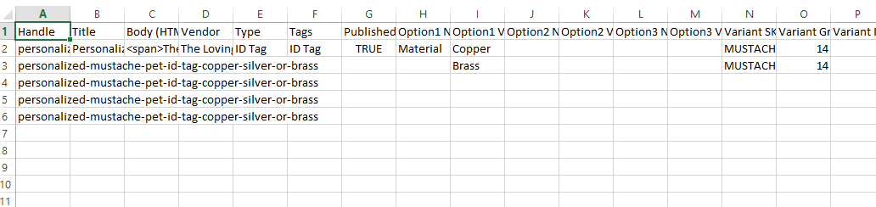

1. The basic rules to follow in Shopify is only fill-in the fields applicable to the product(s) entered. Another important rule seen in the above screenshot is the need for 5 rows of product handles, even though only 2 options exist. The reason 5 rows are needed even though variation 1 (Copper) and Variation 2 (Brass) *should* warrant 2 rows, is the existence of 5 images, which are out of scope from the screenshot but exist in column Y. Shopify necessitates as many rows as images, and any rows with images need to have the product handle copied down until covering all images.
2. Through following rules such as those stated above, and those defined and explained further on Shopify’s website (http://docs.shopify.com/manual/your-store/products/product-csv), we now had a CSV file with 274 rows, 28 products, and 100 images, including the product already in the CSV upon its export, ready to import into our site. **A very convenient feature within Shopify’s import function is the default “no overwrite” feature.** This means you can “tack on” a product to a large CSV file with many items already in your store and when you re-upload the CSV, Shopify skips those unchanged and does not duplicate them unnecessarily.
3. Our completed CSV file is available for download/viewing at: (<https://cdn.shopify.com/s/files/1/0766/0915/files/The_Loving_Paw_Backup_Inventory_CSV_With_Images.csv?1859276011081501917>).
4. With the new products imported, our site is taking shape! View/Modify individual products until satisfied with their appearance.
5. Recall from step 9, that various products offer many customizations and therefore warrant the use of custom templates. Having imported the above CSV file, we can view for example the product titled “Personalized Mustache Pet ID Tag - Copper, Silver or Brass” offers “Pet Name” and owner “Phone Number” stamping as standard. Since Shopify only natively supports drop-down-menu based selections/options, we can achieve text-box level themes through utilizing “line item properties”.
6. Utilizing a Shopify tutorial, we implemented line item properties through modifying the code for the theme’s “product template” and adding code to display a text field (note in future applications this can be scaled to fit multiple text fields), for each, a Pet’s name, and the owner’s phone number. We must remember to use HTML5’s “required” designation when declaring the text box field for each entry (name and phone no.). Naming the revised template as “Product.NameAndNumberStandard.Liquid” allows for easy locating for other products with Pet Name and Owner Number as standard. This product’s page now appears in compliance with business rules.

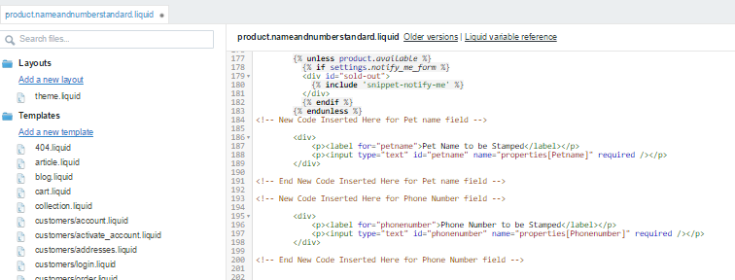

Shown above, we implemented 2 simple text fields one for Pet name, and another for Owner Phone number. Utilizing the required field, the template is now able to validate user entries.

This template becomes named “Product.NameAndNumberStandard.Liquid” for future use in similar applications. 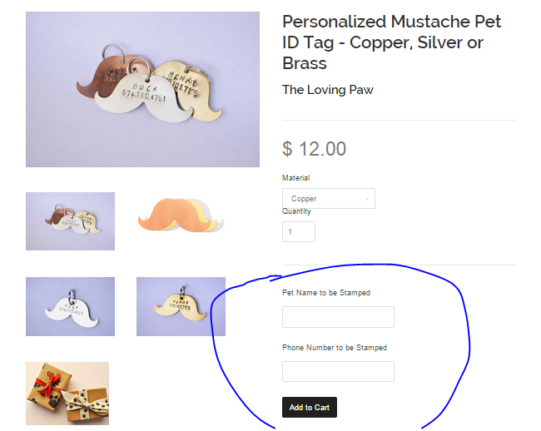

1. The Product.NameAndNumberStandard.Liquid template is available for download at