**Add Slider Images to Shopify “New Standard” Theme**

** Note: The optimal dimensions for your slider images are 884px wide by 490px high.

1. Select Themes

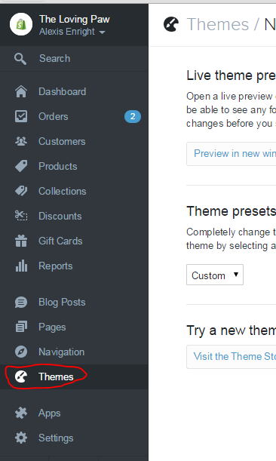

3. Click the “Customize theme” button

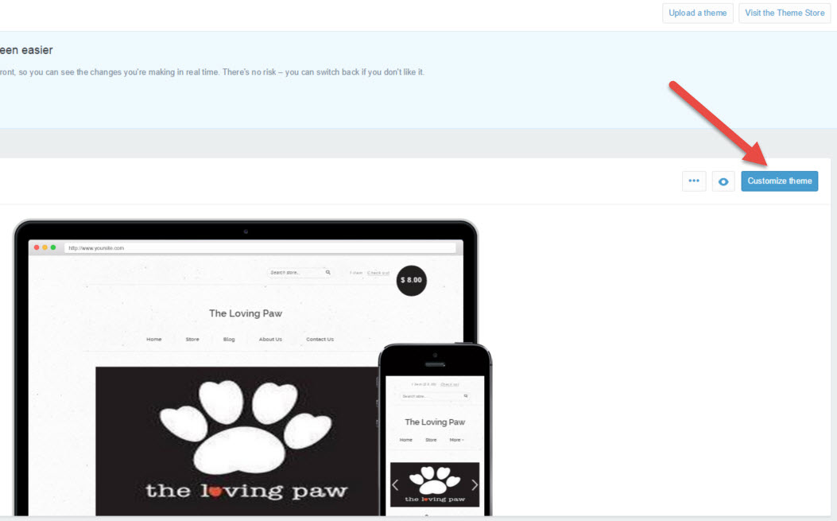

4. Scroll down the list and Click “Homepage”



5. Within the Slider/Options subsection:

* Checkmark the following boxes:
* Enable slider
* Auto-rotate slides
* Set “Rotation interval” to 6-8 seconds (seconds between image changes)



6. Enable up to 6 slides (6 images)

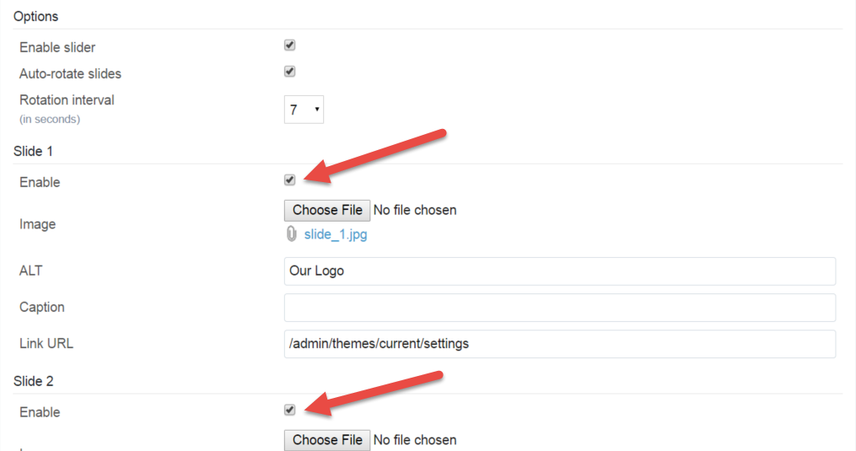

7. Click “Choose File” button, and navigate to the image you want to add

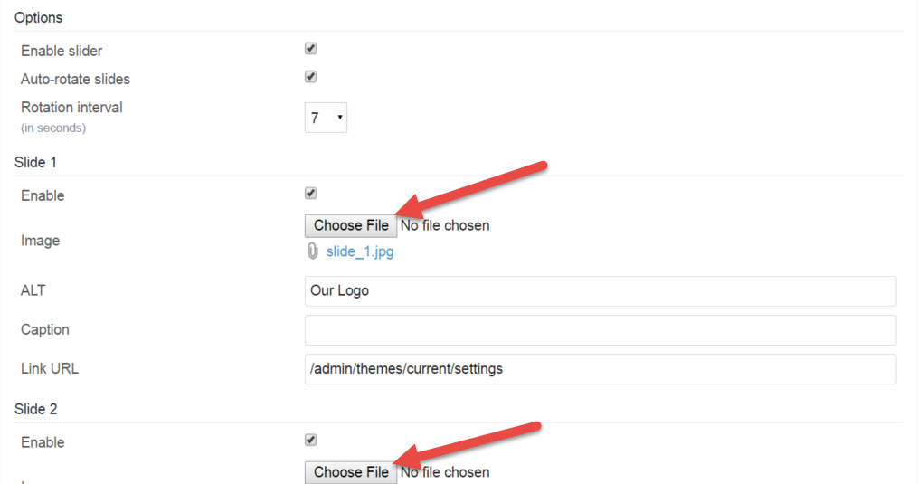

8. The “open” dialog box will appear. Navigate to your image, select the image to add, and click open

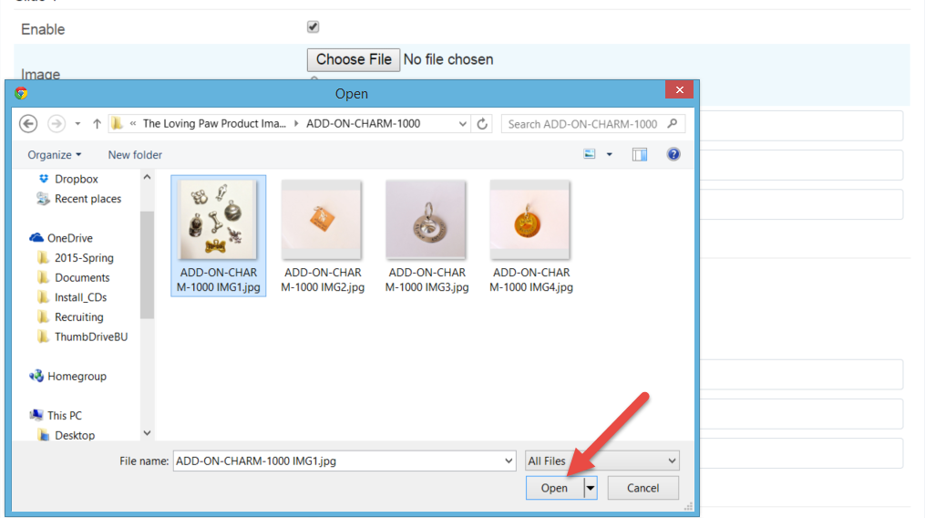

9. Fill the “ALT” box with a text description of the image. The ALT attribute provides alternative information for an image if a user for some reason cannot view it (because of slow connection, an error in the code, or if the user uses a screen reader).



10. (Optional) Add a Caption to the slider image



11. Add a Link URL to the web page that correlates to the image.

Example: Athletes For Animals image = <http://www.athletesforanimals>



12. Repeat steps 6-10 to add additional slider images