1. Open a web browser and navigate to: <http://www.nchsoftware.com/capture/index.html>
2. Click the ‘Record Your Computer Screen’ Button

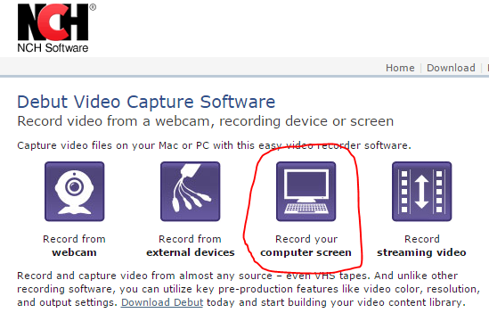

1. When the file has completed downloading, open it. (If you aren’t using Chrome, then you might have to look for this file in your Downloads folder on your computer)

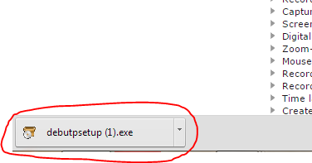

1. Click ‘Accept’ (If you’re installation steps are different, just follow those steps to complete the install)

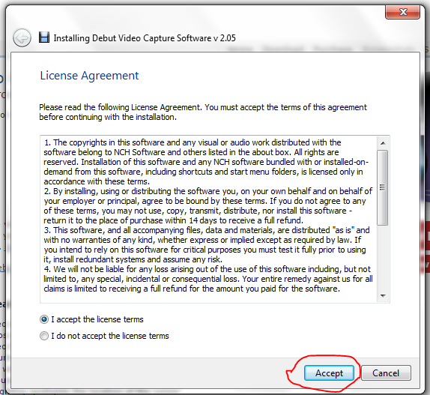

1. The video recording software is now downloaded. Navigate to: <https://the-loving-paw-project.myshopify.com/>
2. If prompted for a password, enter: plowts
3. Now you will record yourself trying to complete three tasks which will be listed below as steps.
   1. These steps are designed to be brief and non-detailed so that we can understand how easy to navigate our site is.
   2. Please talk out loud (your computer will record you) and walk us through each step that you are taking.
      1. Tell us what you like and don’t like (how the site works, how you like the functionality)
   3. If something doesn’t make sense or you’re having trouble finding out how to complete an action, say so.
   4. If you can’t proceed with one of the steps because you don’t know how, state that and move on to the next step
   5. Return to the site’s home page (: <https://the-loving-paw-project.myshopify.com/>) after you have completed each test (steps 10-12)
4. Click the record button on the screen recording software
5. Click the ‘Yes, switch to “Fast Capture” mode” button, then go back to the web browser with The Loving Paw website active and try to complete the three steps below. You are now being recorded.

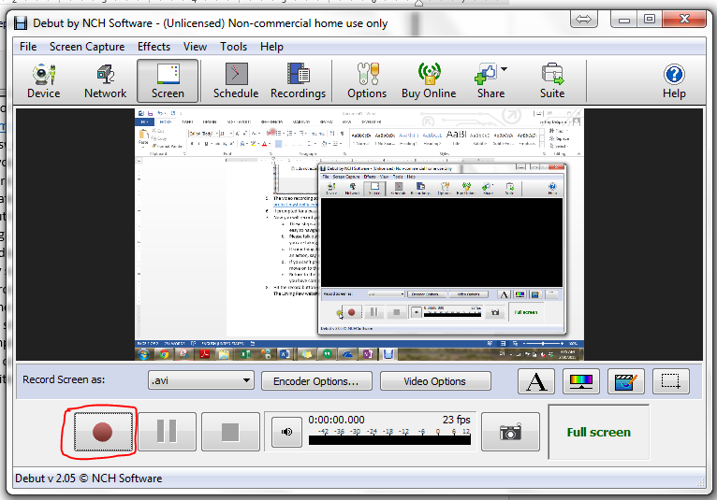

1. Start on the site home page and try to purchase an item.
   1. When you get to the page below, you have completed the test (do not hit the ‘Place Order’ button)

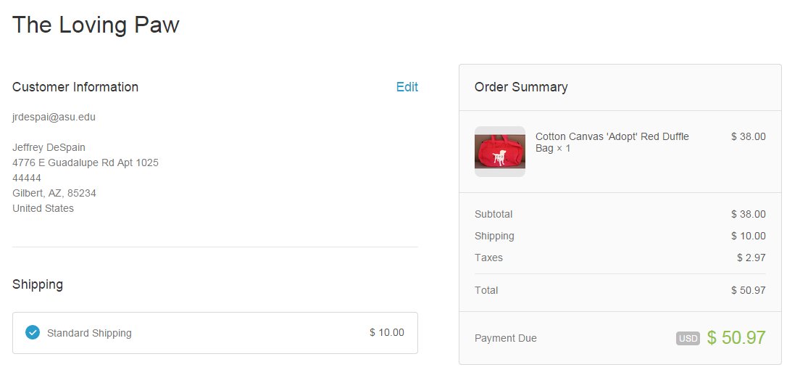

1. Start on the home page and find the ‘Contact Us’ page and send a message
2. Start on the home page and find and purchase the following item: Royal Blue Men's T-shirt - #AnimalRescue
   1. Follow step 9a. (Do not actually click the ‘Place Order’ button)
3. Click the ‘Stop’ Button on the Screen Recording software

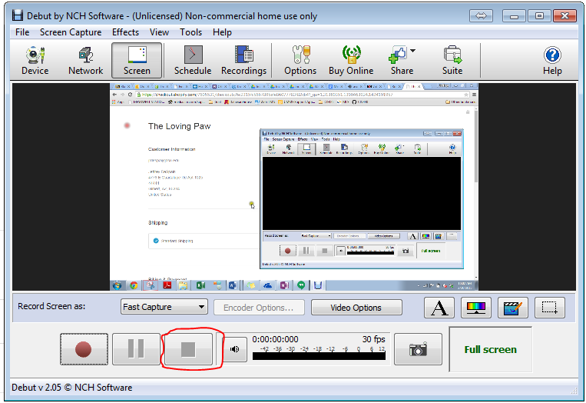

1. Click the ‘Recordings’ button

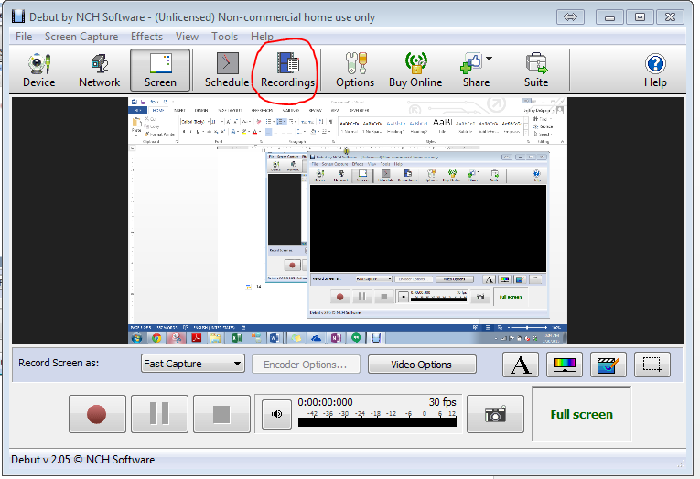

1. Find your video and select ‘Convert’ (This can take a few minutes)

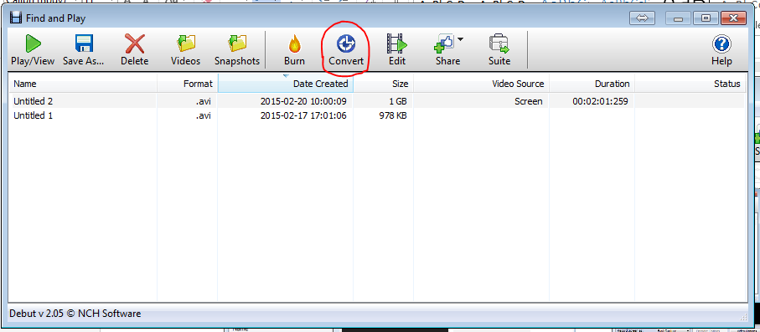

1. Click yes if needed to authorize the software download. This will download video conversion software
2. Select the video, then change the Output Format to mp4 (see image below)

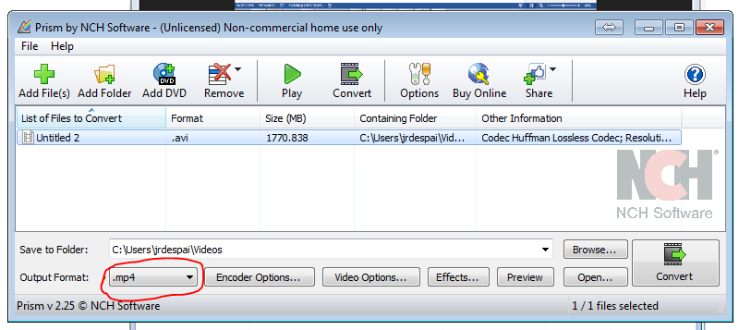

1. Click the ‘Convert’ Button

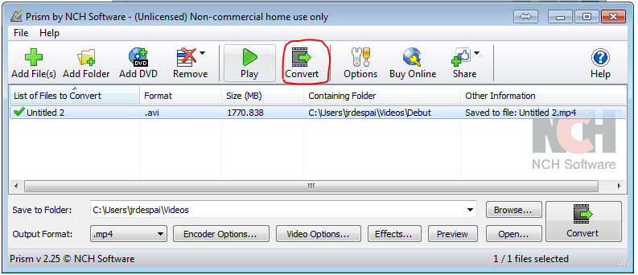

1. Once this operation has completed, your file is saved on your computer in the location listed under ‘Containing Folder’
2. If needed, email this file to the Loving Paw team member that asked you to complete the tests, otherwise, you are done!