1. Go to [www.unity3d.com/get-unity/download](http://www.unity3d.com/get-unity/download), here you will click on choose your Unity + Download.

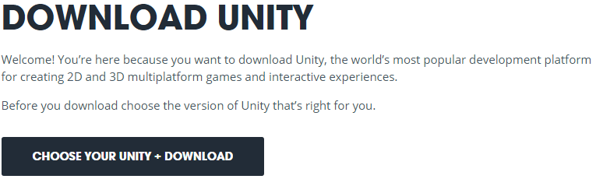

1. This will direct you to another page where you will choose personal edition free download.

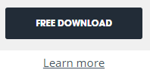

1. This will direct you to another page where you will choose Download Installer.

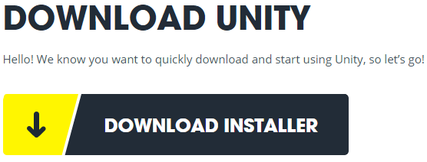

1. Double-Click the UnityDownloadAssistant.exe file from your download location.



1. This will bring up the download assistant:
   1. Allow the application to make changes on your computer.
   2. Click the next button.
   3. Accept the License Agreement and click next button.
   4. The components selected you can leave same, you can select the example Project as well. Then click the next button.
   5. Accept License Agreement for Unity and Visual Studio, then click the next button.
   6. The download will now start.
   7. Click Finish.
2. You will need to create a Unity Account and confirm the account. Use your login information in the Unity window.

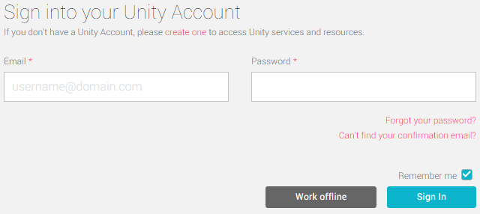

1. Next download the DevilDash.unitypkg to your computer from the location provided.
2. In the Unity main screen select New Project in the Upper right hand corner.



1. Name the project, use the default location, select 2D project and create project.

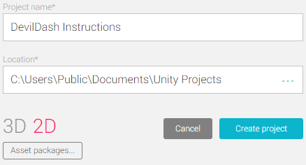

1. Under the asset tab select import package – custom package.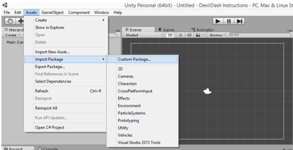
2. Locate the DevilDash.unitypkg from your computers downloader, select and then open it.
3. Importing package window will open, all items should be selected and click import.

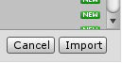

1. Once the package has finished importing, locate the DevilDash icon under the assets window and double click the package, the game will open in the scene viewer window.

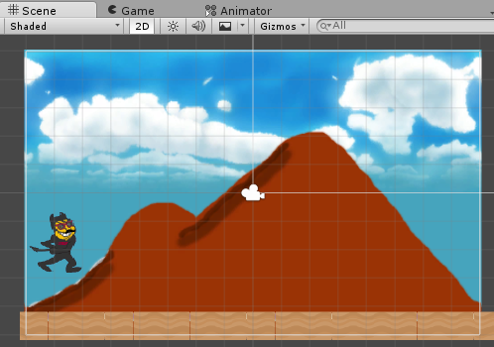

1. From here the game can be exported to the platform of your choosing by going to, File – Build & Run then clicking on whichever PC or Mobile application you would like to use.

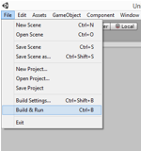

1. From the build settings menu that pops up click the run and build button and enjoy the game!

