# Information Radiator Write-Up

Olivia Sin

### Current Project Plan

Project Sogeti Skills calls for the creation of an internal application that allows the registration of two types of users: consultants and account executives. The purpose of the application would be to track consultant availability and their skills and allow account executives to see a listing of available consultants and filter by their skills.

### Proposal

A third type of user should be created for management. This would allow for a requested skills matrix of all the consultants and skills for that date as well as a view of older matrices by date. (Mockup of a matrix at end of document)

### Methodology

This would not require any re-design of the current application but as an extension of the current plan would require some additional code. The registration of a user with a managerial role would require different validation. This extra user type would require an additional table in the database with corresponding stored procedures. There would also be a different landing page for this user upon sign-in. A skills matrix would require the information that is already within the database but would require some SQL to optimize its retrieval and code to adapt the data into a matrix format for consumption. Another table would be required in the database to store historical matrices.

### Time and Resources Required

The proposed addition to this project builds upon the architecture and design already planned, resulting in less time to execution. Although the account executive view accesses the same data, it is a greatly simplified query and return listing. I believe this would increase the length of the project by 3 weeks based on the current pace of development. 1 week for the creation of a new user with different permissions and validations and landing page as well as the architecture/design of storing historical data; 2 weeks to create a functional skills matrix that makes sense visually as well as adaptable to storage.

### Benefits

This would be a good utilization of the data that is already being collected by this application and would help management to visualize the skill set of their employee pool and the ways in which it is growing or changing over time as tracked by the application. This would quickly identify gaps in skill areas within the consultant pool and aid in guiding consultant plans for training and advancement.

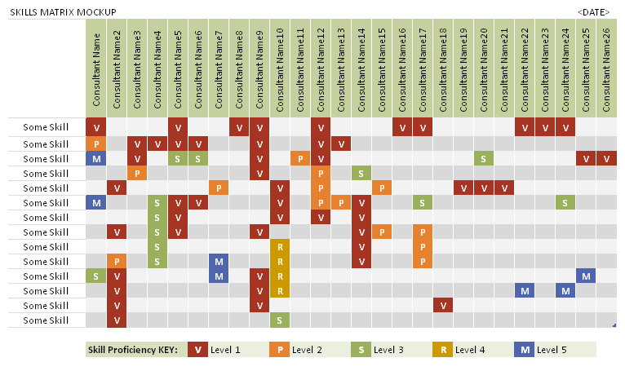(MockUp Example of Skills Matrix)