CSC240 Exam #1

Austin Spencer
04/23/2020

(1) What is printed by the following program? (Write your answer to the right of the program.)

Assume that the local variables are stored at these addresses:
value 3275
store[0] 3276
store[1] 3277
ptr 3278

#include <iostream.h>

int main()
{
int store[2];
int *ptr;
int value;

store[0] = 86;
store[1] = 99;
ptr = store;
value = 42;

cout << &ptr << endl; //3278
cout << ptr << endl; //3276
cout << *ptr << endl; //86
cout << *(ptr - 1) << endl; //42
return 0;
}

(2) What is functional programming? (List a few attributes that distinguish it from procedural programming.) What is the advantage of doing functional programming?

Functional programming expresses computation as the evaluation of mathematical functions. Functional programming also reduces the reliance on variables and change of state to express the sequence of computation. Also, mostly relies on recursion rather than iteration. One advantage of using functional programming is it eliminates “side effects”.

(3) Given the following list in Scheme notation: ( ( a ) b ( c d e ) )
(a) Draw the associated tree diagram for this list.
(b) Write the Scheme code to return this item: d
[If you refer to a variable, remember to define the variable.]
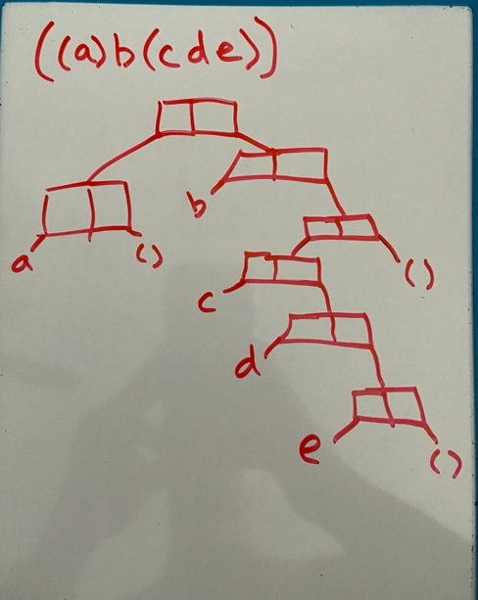

b)
(define myList’((a)b(cde))
(car(cdr(car(cdr(cdr list)))))

(4) Consider the following expression:
Write a named Scheme FUNCTION to evaluate this expression.

(define (mathProblem x y z)
(define (mathProblem x y z)
(/
(-
(-
(expt 2 14)
(* 5 x y)
)
x)
(+ x y)
)
)

(5) Write a function, skipSum, to compute and return the sum of every other positive integer up to and including a given positive integer N. (The function will do no user input or user output.)
if N is odd, skipSum(N) = 1+3+5+...+(N-2)+N
if N is even, skipSum(N) = 2+4+6+…+(N-2)+N
Another way to define it is as follows:
skipSum(N) = N+(N-2)+(N-4)+...+(K+2)+K
where K is 1 if N is odd, or 2 if N is even
(a) in C++ (using a loop, NOT recursion). [To test if a number, n, is even, use: “if ( n % 2 == 0 )” ]
(b) in Scheme (using recursion). [You should not need to determine if n is odd or even, but if it seems
like you must, assume you have an additional function “even?” that returns true if the given
integer is even]

a)
#include<iostream>
using namespace std;
//skipSum function

void skipSum()
{
int N = 3;
int sum = 0;
int count = 1;

if (N % 2 == 0)
{
count = 2;
}
while(count <= N)
{
sum = sum + count;
count = count + 2;
}
}

b)
(define (skipSum n)
(if
(> n 0)
(+ n
(skipSum(- n 2))
)
0
)
)
(6a) A German topologist has created an experimental three-dimensional figure called a "polystrudel" (nicknamed a 'poodle'). Write a subprogram in C++ that computes the diagonal and volume of a polystrudel given the arc length of one face using the following formulas:
d = PI • a/2
v = (4/3)ad
where
a = arc length of one face (inches)
d = diagonal (inches)
v = volume (cubic inches)
PI = 3.14159
Pass all information through the parameter list. Do not ask the user for any inputs or display any results.
Write the subprogram according to these specifications. Do NOT modify them. Do NOT take into account the specifications of the main program (6b); this is supposed to be a general-purpose tool for many applications, and not just the one that follows.

(6b) Mercedes Benz has decided to redesign their company logo to be a special two-stage polystrudel, where the arc length of its face is equal to the diagonal of a smaller polystrudel. Write a program to compute and display the diagonal and volume of this two-stage polystrudel.

Ask the user for the arc length of the smaller polystrudel. Repeat the question until it is a positive number. Then compute the diagonal and volume of a polystrudel of that size, and use the results to compute the diagonal and volume of the larger polystrudel. Display the diagonal and volume of the larger one.

Repeat those steps until the user chooses to stop.

Use the subprogram from (6a) to do the calculations. Do NOT repeat the code; just call the function.

6a)
void computeVolumeAndDiagonal( double arcLength, double PI_,
double &diagonal_, double &volume_)
{
diagonal_ = PI_ * (arcLength/2.0);
volume_ = (4.0/3) * arcLength * diagonal_;

}

6b)
int main()
{
const double PI = 3.14159;
double diagonal, volume;
double arc = -1;

while(arc <= 0){

cout << "Please give the arc length of smaller polystrudel: ";
cin >> arc;
if (arc <= 0){
cout << "The length needs to be positive!" << endl;
}

computeVolumeAndDiagonal(arc, PI, diagonal, volume);
computeVolumeAndDiagonal(diagonal, PI, diagonal, volume);
cout << diagonal << endl;
cout << volume << endl;

return 0;
}
}

