## Understanding the microscopic simulation mechanism using GMNS and DTALite v0.51

Data set

[DLSim/release at main · asu-trans-ai-lab/DLSim · GitHub](https://github.com/asu-trans-ai-lab/DLSim/tree/main/release)

## Learning Goal:

Levels of modeling elements:

|  |  |  |
| --- | --- | --- |
| Category | Lement | GMNS file names |
| A | Network | Node.csv, link.csv |
| b | Demand | input_path.csv |
| c | Signal | timing.csv, |
| D | Scenario | Setting |
| E1 | Link output | link_performance.csv, |
| E2 | Path output | path.csv |
| E3 | Agent output | agent.csv |
| E4 | Trajectory output | trajectory.csv |

## 1. Network Generation

Export map.osm from OpenStreetMap and use osm2gmns to generate node.csv and link.csv with GMNS format for complete network. Then, use net2cell to generate cell based microscopic network.

Here are some steps to process network information.

1. Change the unit of length (from meters to km) in link.csv.
2. Give default values of free_speed, capacity and vdf_tt in link.csv.
3. Lane change penalty in link.csv.
4. Use model cell_code to select subarea node.csv and link.csv.

## 2. Demand Generation

Use trace2route to generate cell based paths based on macro network data. Here are some detailed steps.

* Obtain input_agent.csv from the macroscopic regional network from or GPS traces
* Use trace2route to generate the map matched sequence in output_agent.csv
* Rename output_agent.csv to input_path.csv add path_id field, according to settings.csv and add fields, o_zone_id, d_zone_id as the node numbers
* Add values for zone_id for those selected origin and destination nodes in input_path.csv

## 3. Traffic Signal

We already have signal control (vol2timing) modules to read the signal timing. Here are main_node_id field and movement field in link.csv. Then, use vol2timing to read timing.csv to simulate signal timing.

## 4. Traffic assignment and simulation

Work on cell-based path. Use 0.1 sec as simulation interval and simple spatial queue (CA). in addition, we also need a simple strategy to determine reaction time tau to consider time-dependent speed reduction.

Run DTALite.exe

We could obtain some key information about traffic assignment simulation, such as assignment mode, agent types, link types, simulation time period, input file name, file format and so on in setting.csv

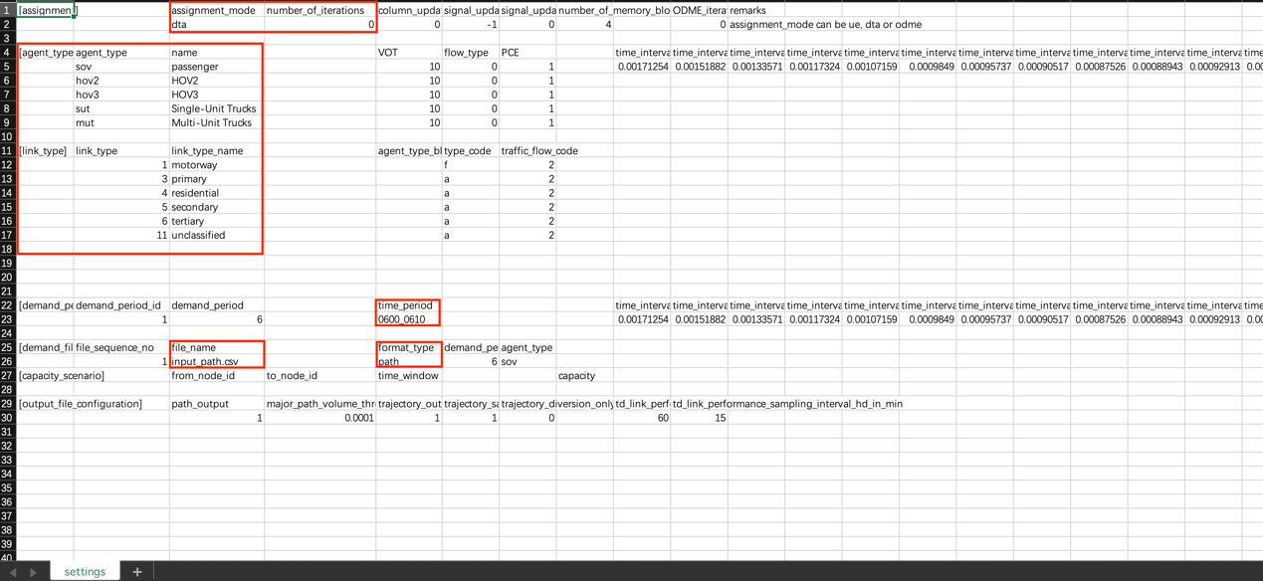

## 5. Check different levels of input and output

The following input and output files need to be checked systematically.

a. node.csv, link.csv.

b. input_path.csv, timing.csv, settings.csv

c. link_performance.csv, TD_link_performance.csv (link volume, aggregated speed and so on).

d. path.csv (assignment or given input file, both of them need to be visualized in Nexta ->agent diaglog)

e. agent.csv (with different vehicles with different departure times from simulation step (visualized in nexta ->agent dialog)

f. trajectory.csv

## 6. Load node.csv in Nexta