Understand Network Equilibrium Model: Braess’s Paradox and Simplified Sioux Falls Network

Prepared by Tie Shi and Xuesong Zhou

|  |
| --- |
| Braess's paradox, credited to the German mathematician Dietrich Braess, states that adding extra capacity to a network when the moving entities selfishly choose their route, can in some cases reduce overall performance. This is because the Nash equilibrium of such a system is not necessarily optimal.  The paradox is stated as follows:  "For each point of a road network, let there be given the number of cars starting from it, and the destination of the cars. Under these conditions one wishes to estimate the distribution of traffic flow. Whether one street is preferable to another depends not only on the quality of the road, but also on the density of the flow. If every driver takes the path that looks most favorable to him, the resultant running times need not be minimal. Furthermore, it is indicated by an example that an extension of the road network may cause a redistribution of the traffic that results in longer individual running times."  *Source: http://en.wikipedia.org/wiki/Braess%27s_paradox* |

|  |  |
| --- | --- |
| https://lh4.googleusercontent.com/k5G6i4tAaRMu-FP3V4z6fiuGIF4bQo1aMIRIgC_NAAojjiBd3T_Y7EtkFcC1vTeQhmqZSAarIZROkXzMBMnOzKP6pPute1cLSec8A2M5u5-rGvOUNpQ* | https://lh5.googleusercontent.com/eytcObaOy7YedOCRUUV_wnUNmgENflqwlftxlOl3IDuGYq-GD0uBuB1mvLDxEIQ27pb52D6wws5Dak1q-QPrQ8FFf_fngB7rU6yECYxkwe-xt8z1AF4* |

**Contents**

**Task 1. Build static traffic assignment, configure BPR parameters**

**Problem 1. Sensitivity analysis using different demand levels**

**Task 2. Build dynamic traffic assignment, configure link capacity, link length**

**Problem 2. Sensitivity analysis using different traffic flow methods**

**Learning objectives:**

1. How to create a network
2. Understand modeling principles of user equilibrium
3. Understand the impact of adding a link and analyze the performance at link, path and network levels
4. The impact of different levels of demand on Braess’s paradox
5. Understand the impact of road pricing on Braess paradox and how to resolve Braess’s Paradox

**General descriptions of traffic assignment**

Traffic assignment loads an origin-destination (OD) trip matrix onto links of a traffic network, while satisfying a certain route choice behavioral model, e.g., a deterministic static equilibrium.

Traffic assignment is used to predict/estimate how trip-makers may shift to other routes or departure time in response to a number of strategies such as road pricing, incidents, road capacity improvement and traffic signal re-timing.

For example, tolling typically lead to traffic diversion on alternative routes and/or other transportation modes, and many traffic congestion mitigation strategies should be developed to improve the capacity to which the traffic may be diverted, for example, signal optimization, traveler information provision, and transit operation.

The common time periods include morning peak, afternoon peak and off-peak, and we can use the time of day factor to calculate the trip in the peak hour (e.g., morning peak may be 11% of daily traffic) from a 24 hour demand volume.

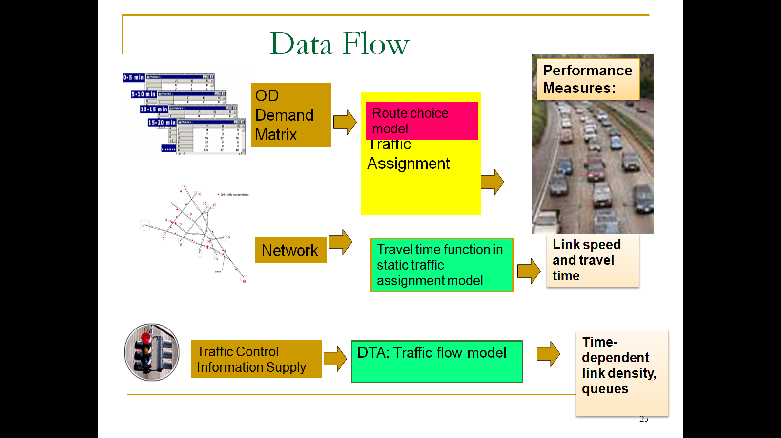

Static Traffic Assignment

There are a number of key components for static traffic assignment methods.

1. input trip table describes the flow per hour from each origin zone to each destination zone
2. a traffic network consisting of nodes, links and link volume delay functions
3. volume delay function such as BPR **(Bureau of Public Roads** **)** relationship that shows increased link travel time as an increase in link volume

*TT* = *FFTT*[1 + 0.15(v/c)4]

where:

*TT* = link travel time

*FFTT*= free-flow travel time of link

v = link flow

c = link capacity

[Remark: the link travel time function typically in only dependent on its own flow, while ignoring link volume on opposing or conflicting directions. The link capacity might not be a strict upper limit on flow, e.g. specified by highway capacity manual. ]

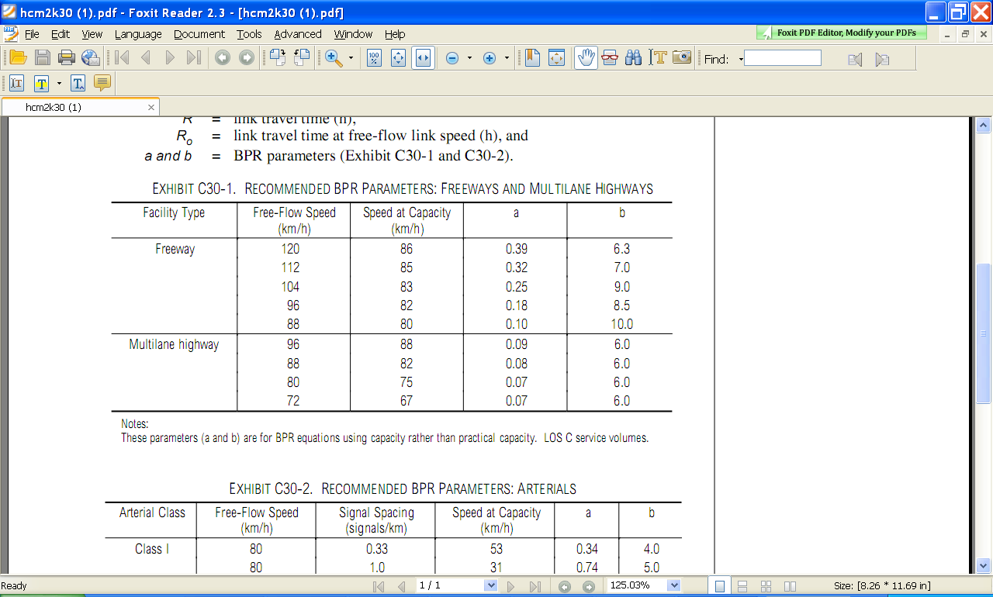

Source: HCM 2000, BPR Parameters for Freeway and Highway

As one of the ***simplest*** cases of behavior, user Equilibrium (UE) Principle assumes users are“greedy” and are familiar with the system. E*quilibrium requires iteration* to reach the following two principles:

* Principle A: No individual trip maker can reduce his path costs by switching routes.
* Principle B: All used routes between an O-D pair have equal and minimum costs

While all unused routes have greater or equal costs *(to the used path costs)*.

Wardrop (1952) proposed the user equilibrium and system optimal principles of route choice behavior in his seminal paper, and Beckman et al. (1956) formulated the static user equilibrium traffic assignment problem as an equivalent convex mathematical programming problem. Since their influential contributions, the development of the static network assignment formulations, algorithms and applications have made remarkable progress. The books by Sheffi (1985) and Patriksson (1994) provide the most comprehensive coverage on the static traffic assignment problem and its variants.

**Dynamic Traffic Assignment (DTA)**

Dynamic Traffic Assignment (DTA) problem, which seeks to distribute given time-dependent origin-destination (OD) trips over time and space in a transportation network according to specific user behavior and system assumptions. These DTA models offer more realistic and tractable tools that describe the inter-relation between OD demand flows and network flow patterns. The combination of dynamic traffic assignment models and dynamic OD demand estimation models structures an integrated traffic state estimation framework that can produce consistent and realistic assignment results for general traffic networks.

Recognizing the limitations of static traffic assignment models in describing the dynamics of network flow propagation and dynamic travel behavior in response to real-time information, dynamic traffic assignment models have attracted active research and development attention, starting from Merchant and Nemhauser’s pioneer work (1978a, b) that presented a mathematical programming formulation for a one-destination system optimal DTA problem. Peeta and Ziliaskopoulos (2001) provided a state-of-art review and detailed discussions of formulation approaches, model objectives, underlying assumptions, solution methodologies, traffic flow modeling strategies as well as operational requirements and capability.

The existing DTA methodologies are classified into two major groups: analytic approach and simulation based approach, and the former line further includes three types of formulations: mathematical programming, optimal control and variational control. The analytic approach has the potential on deriving theoretical insights. However, well-behaved mathematical formulations are currently unavailable and principal difficulties occur in how to ensure the FIFO property and how to preclude the holding of traffic in SO assignment.

In order to avoid mathematical intractability, simulation-based dynamic traffic assignment is intended to capture dynamic tripmaker decisions and complex traffic processes in the practical deployment for realistic networks. For instance, a simulation based DTA system, DYNASMART (Mahmassani et al., 1994, Mahmassani 2001), can allow (1) a richer representation of traveler behavior decisions, (2) an explicit description of traffic processes and their time-varying properties, and (3) a more complete representation of the network elements, including signalization and other operational controls.

# Task 1: Build a network for static traffic assignment, and configure BPR parameters

This task will help you familiar with basic input for traffic assignment and reproduce the famous Braess paradox.



1 “Braess_Network.tnp” file.

For convenience, we call link1->3; 4->2; 1->4; 3->2; 3->4 as a, b, c, d, e, respectively.



Step 1: Verify the BPR parameters in the below table ( The table is from the excel file (“Braess's_Paradox_Network\Task1-Braess_network_without_link34\Braess_Network\3-link” ).

|  |  |  |  |  |  |  |
| --- | --- | --- | --- | --- | --- | --- |
|  | Travel time function | FFTT | Lane capacity | # of lanes | alpha | beta |
| Links a, b | (v/100) | 0.01 | 100 | 1 | 1 | 1 |
| Links c, d | 45 min | 45 | 1900 | 3 | 0 | 0 |

Setp 2: Select a traffic flow model and Traffic Assignment Method.

Step 3: Review summary statistics.

After clicking the option “Yes”, the users can see the output_summary.csv file opened in Excel, which shows detailed information about the simulation results.

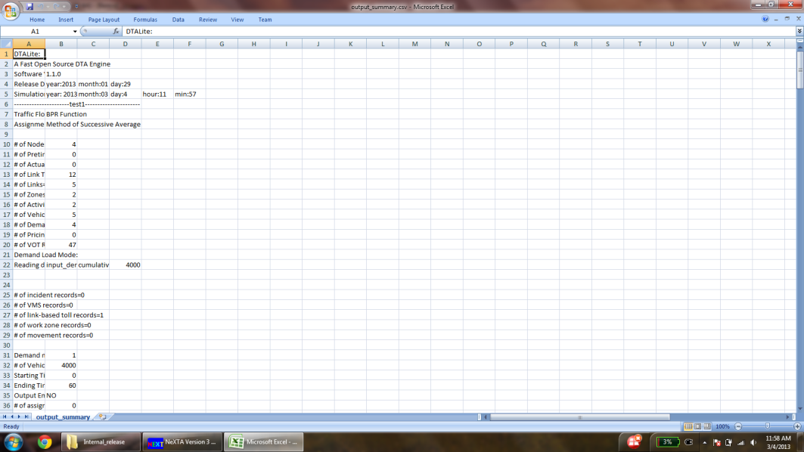

Then close the output_summary.csv file.

Step 4: Display the link volume.

This step is to visualize important link attributes and simulation results on the map. First, click  (the button to the extreme left in NEXTA), which opens up a dialog box named “Display Configuration”.

Selecting the Link Text Label to be displayed: For example, the users want “Total Link Volume” to be displayed on the map. Under the tab “Link Text Label”, choose “Total Link Volume” from the list and click “OK”.

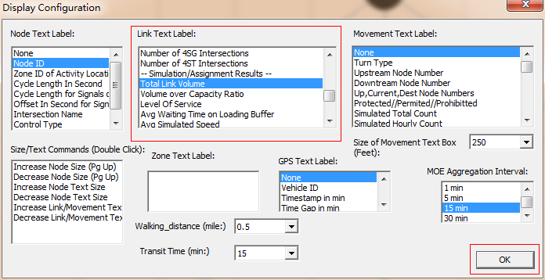

The volume values on each link are shown in the map as shown below.

|  |  |  |  |  |
| --- | --- | --- | --- | --- |
|  | a | b | c | d |
| Total Link Volume(vhc) | 2006 | 1994 | 1994 | 2006 |

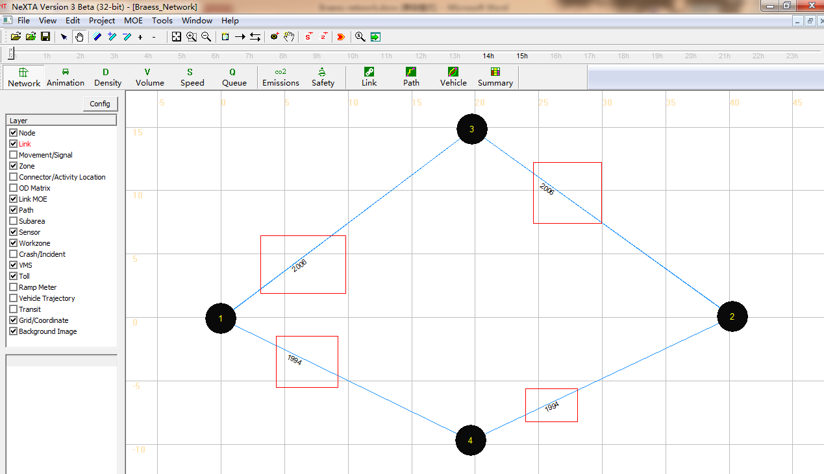

This is a modeless dialog, so users can also change the text label selected. They can select different text labels like Average travel Time(min), Link Capacity Per Hour, # of Lanes, Free Flow Travel Time and so on and see the corresponding display for the text label selected on the background map, without closing the “display configuration” dialog box.

Step 5: Prepare statistics for the base case scenario.

Use the “vehicle” button to verify the path selection information. Click the button  ,then a dialog box named “Find/Filter Vehicles” appears.

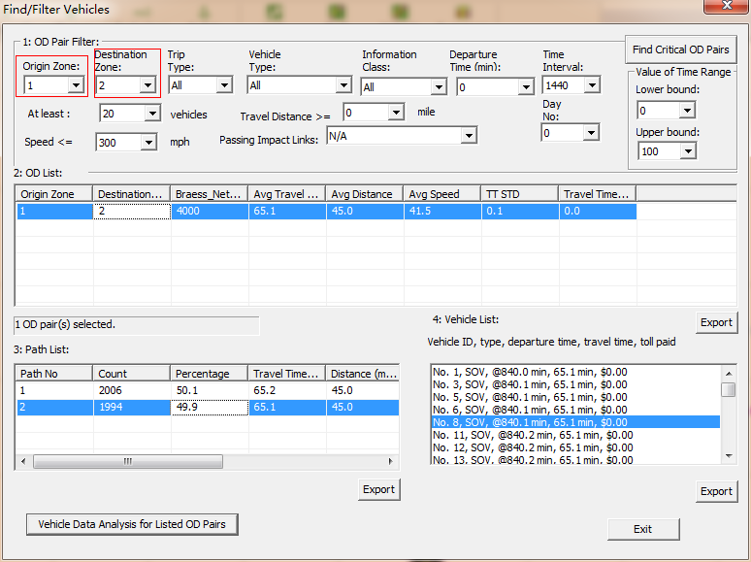

Select “1” under the tab “Origin Zone” and “2” under “Destination Zone”, which displays an OD pair from Zone 1 to Zone 2 under OD list. The Braess_Network Count, Average Travel Time, Average Distance, Average Speed, TT STD and Travel Time per Mile STD are shown in the OD list. Click on the OD list generated and we can see the path list related to the Demand, travel time at paths 1 and 2.

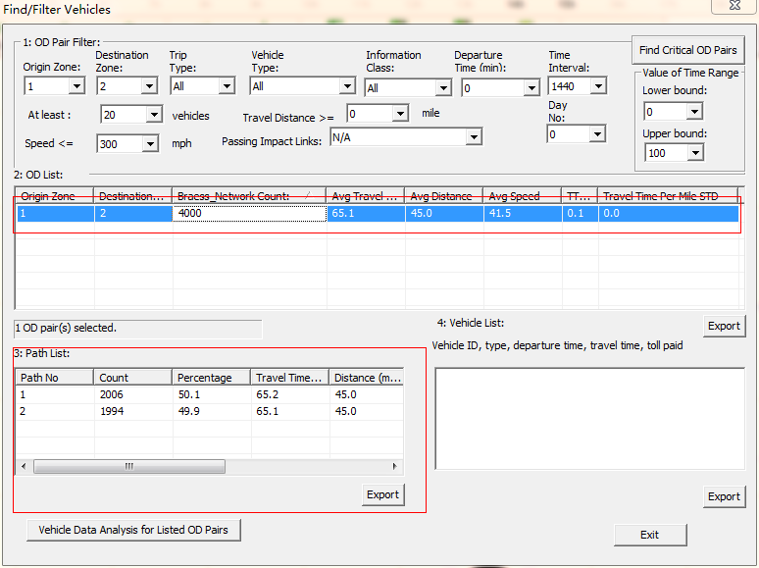

Arbitrarily, choose one path by clicking on one of the options in the “Path List” (either path 1 or path 2), and the count of the vehicles taking the selected path are shown in “Vehicle List”. At the same time, the corresponding path is also highlighted in the map.

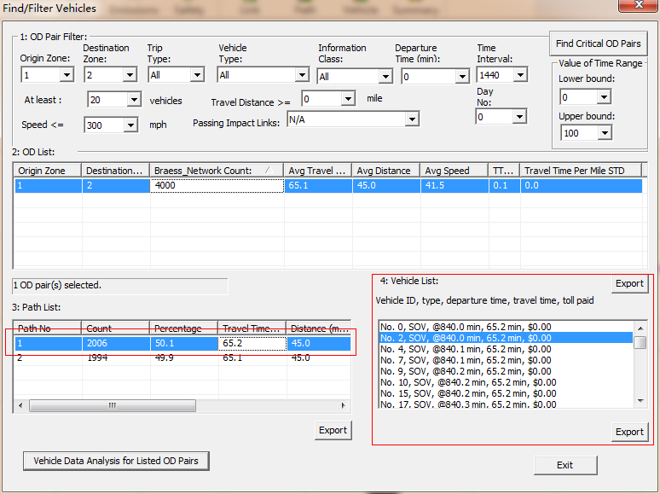

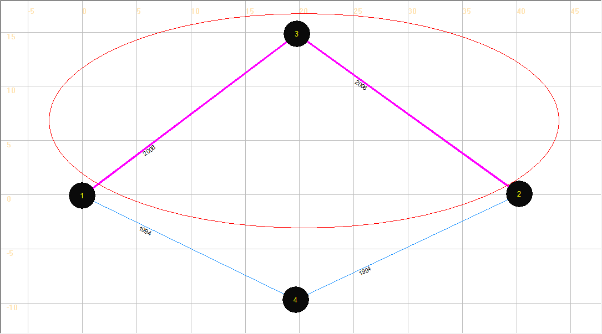

Step 6: Use the “summary” button to verify the overall network performance.

Click the button  in MOE Bar, then a dialog box named “Data Summary Dialog” appears. Select items in X Axis and Y Axis Drop-down lists (For example, select “15-min Departure Time Interval” and “Cumulative Number of Vehicles”, respectively).

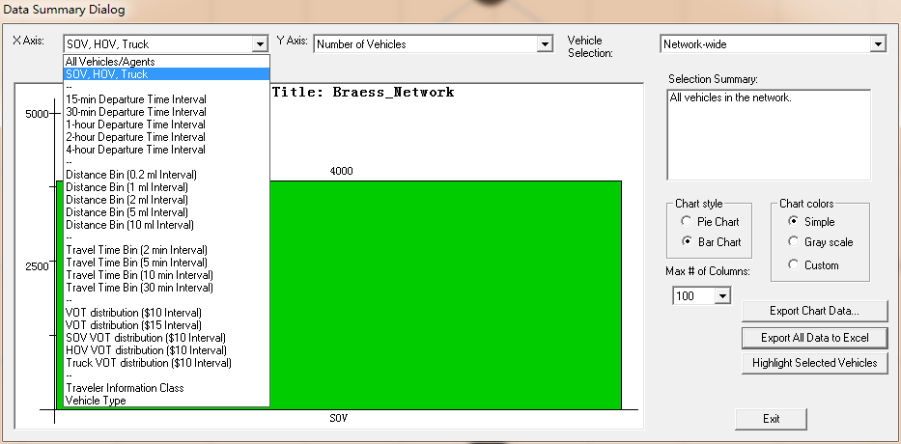

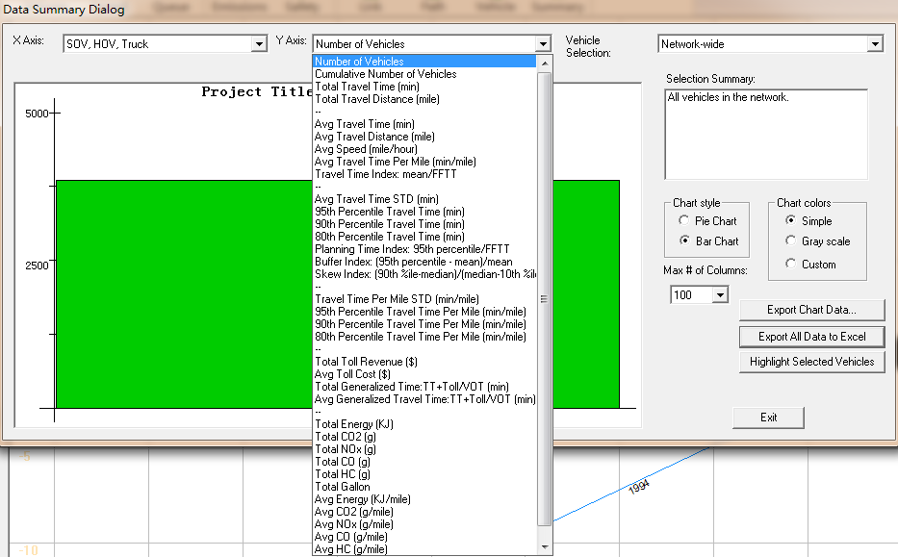

The figure showing the Cumulative Number of Vehicles is displayed as shown below.

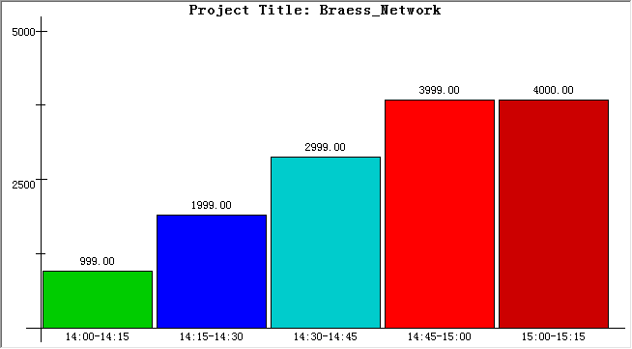

Select the item “Avg Travel Time (min)” under the Y Axis drop-down list to show the average travel time in the network.

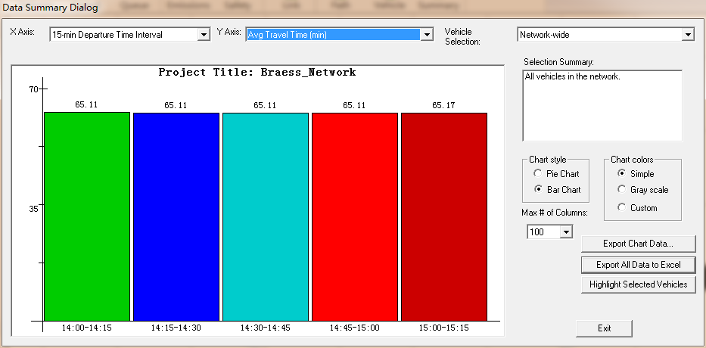

Try to change items in the drop-down lists and figure format to check other network performances.

Step 7: Close the NEXTA.

3: Add a link 3->4, or “e” into the Braess network and run the static simulation.



Step 1: Open the excel file “Braess_Network.xls” (“Braess's_Paradox_ Network \Task1-Braess_network_with_link34-static\Braess_Network.xls)” and add basic information of link 3->4 (e) into the “3-link” sheet, save and close the excel file.

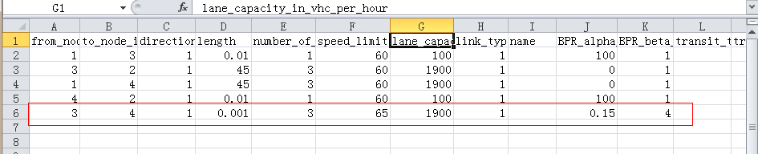

Step 2: Now, import the same excel file “Braess_Network.xls” (the one with the information added in Step 1) into NEXTA to create a new network, and then save it as “Braess_Network.tnp” in the same folder.

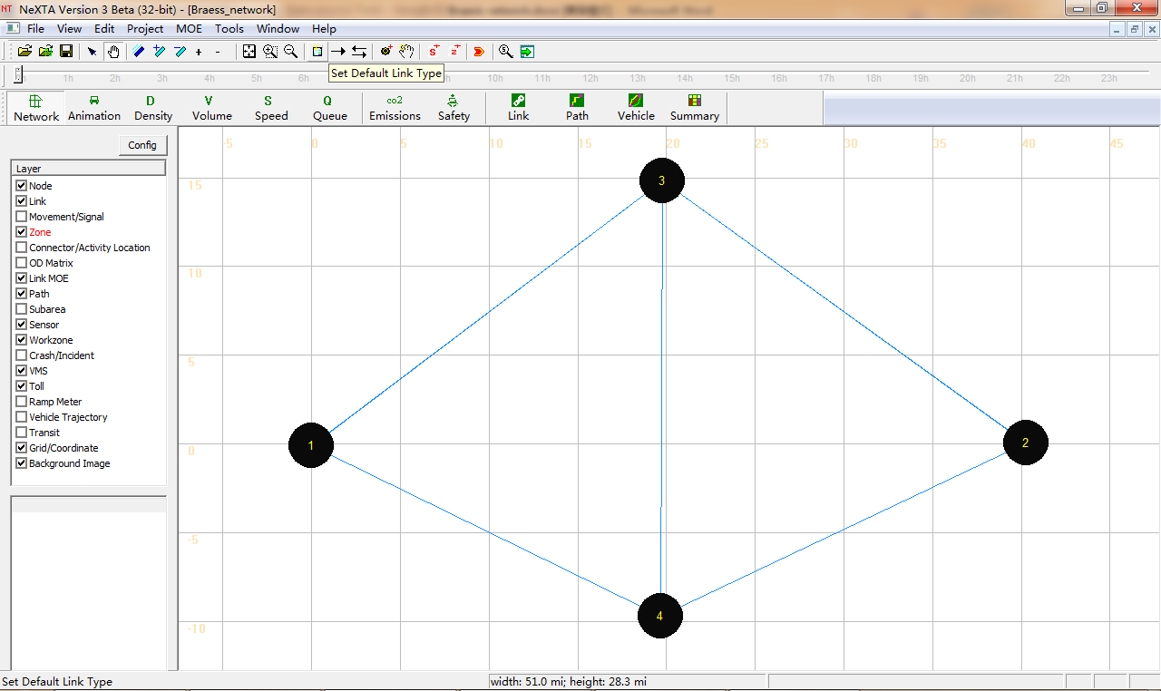

Step 3: Run the simulation for the new network by choosing “BPR Function” under the Traffic Flow Model list and “Method of Successive Average” under the “Traffic Assignment Method” list.

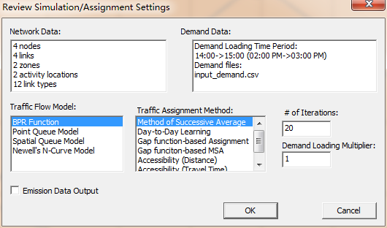

Step 4: Display the volume values on each link in the new network (Using Config).

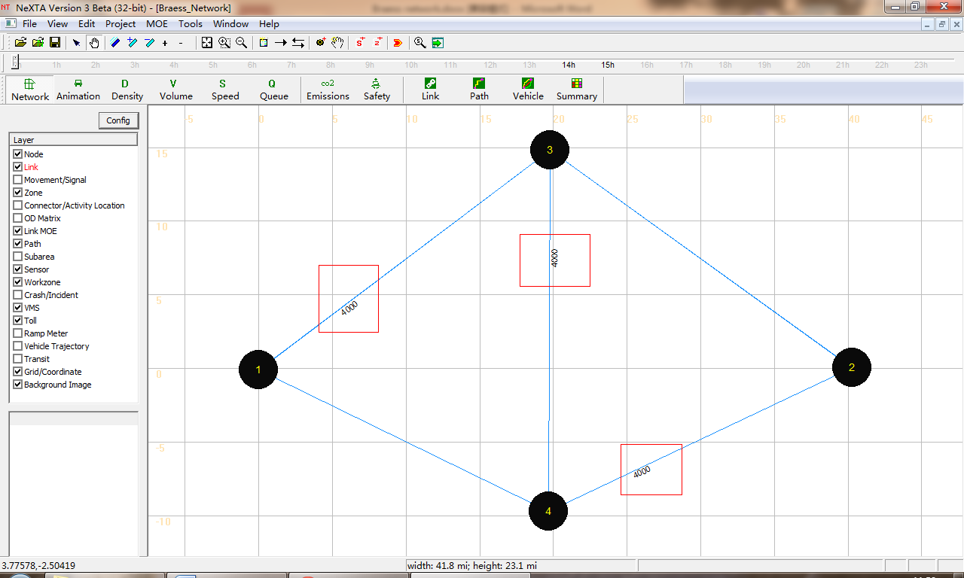

The volumes displayed on each link are shown in the table below.

|  |  |  |  |  |  |
| --- | --- | --- | --- | --- | --- |
|  | a | b | c | d | e |
| Total Link Volume(vhc) | 4000 | 4000 | 0 | 0 | 4000 |

Table: Showing the simulation result

Step 5: Vehicle path dialog.

There are 3 paths from Node 1 to Node 2 in Braess network (shown in different colors). For convenience, we mark them as path 1, path 2 and path 3 in the figure shown below.



Using NEXTA to display the shortest path in Braess network.

Click “Path” on the GIS Layer Panel. Right click on Node 1 to choose the option “Direction from here”. Node 1 becomes highlighted as the start point of the shortest path. Then right click on Node 2 to choose the option “Direction to here”.

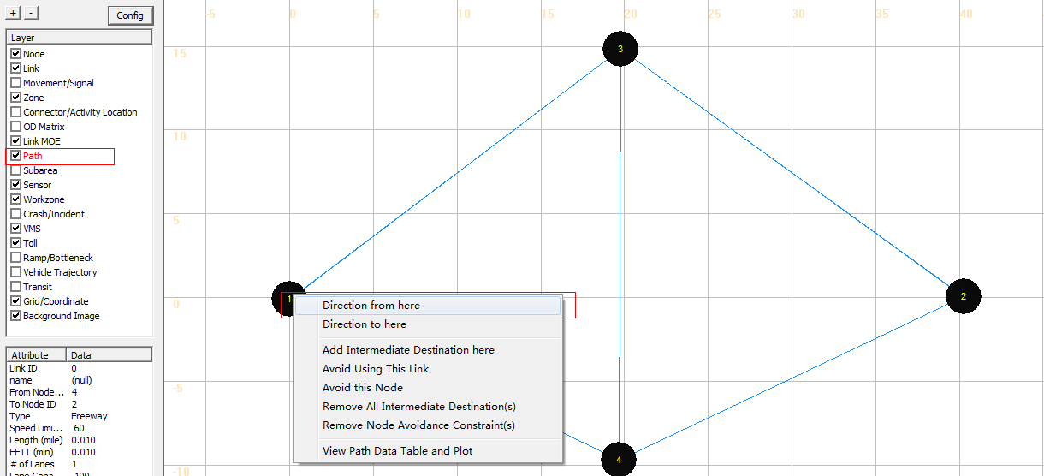

The shortest path from Node 1 to Node 2 is highlighted in the map as shown below.

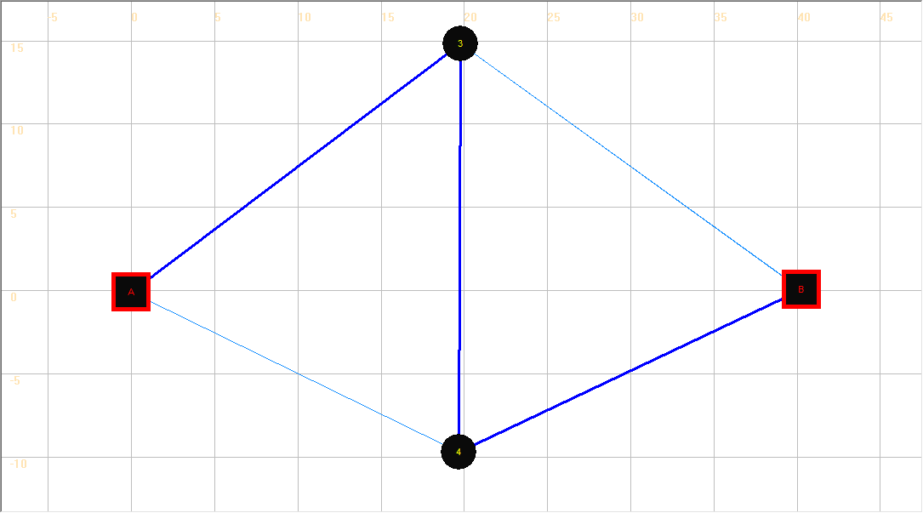

Check the shortest path in the table with the displayed path.2

|  |  |  |
| --- | --- | --- |
|  | Travel time | Flow |
| Path 1 | Link a (40.01)+Link d(45)= 85.01 min | 0 |
| Path 2 | Link c (45)+Link b(40.01)= 85.01 min | 0 |
| *Path 3* | *Link a(40.01)+Link e(0.001)+Link b(40.01)= 80.02 min* | *4000* |

Step 5: Close the NEXTA.

3: Compare system-wide performance differences between two networks.

The Braess paradox is a User Equilibrium system that is not necessarily System Optimal. Under User Equilibrium principles, the users are greedy and selfish to choose their own route for minimum costs, and users are familiar with the system. There are two principles that describe this notion of equilibrium in math formulation:

Principle A: No individual trip maker can reduce his path costs by switching routes.

Principle B: All used routes between an O-D pair have equal and minimum costs; While all unused routes have greater or equal costs (to the used path costs).

From the displayed values of the volume on two different networks mentioned above, we can complete the following table.

|  |  |  |
| --- | --- | --- |
|  | Without adding link e | Adding link e |
| Total number of vehicles | 4000 | 4000 |
| System-wide total travel time | 260040.7 | 320083.8 |
| Average travel time for each vehicles | 65.01 | 80.02 |
| Volume on link a | 2006 | 4000 |
| Volume on link c | 1994 | 0 |
| Path 1 travel time | 65.07 | 85.01 |
| Path 1 volume | 2006 | 0 |
| Path 2 travel time | 64.95 | 85.01 |
| Path 2 Volume | 1994 | 0 |
| Path 3 travel time | —— | 80.02 |
| Path 2 Volume | 0 | 4000 |

If we try to compare the travel times before and after the addition of link e, it is observed that the travel times on path 1 and 2 are shorter, before the addition of link e. After adding link e into the Braess Network, all the vehicles travel through link e, and the system-wide total travel time increases significantly. However, for one single vehicle, the driver does not have an incentive to switch his route, as the travel times for the two paths (Start-A-End and Start-B-End) are 85.01 minutes when all the other vehicles travel through link e(except for that one vehicle). Therefore, there is a paradox on Braess network under reasonable assumptions, necessary and sufficient conditions in a general transportation network.

It should be noted that the length of link e must be short enough to ensure that the travel time on path 3 is less than the travel times on both path 1 and 2.

4: Consider Link e is a Toll Link and run static simulation.

Step 1: Click  in Tool bar to open “Braess_Network.tnp” file. We can see that the Braess network with link e is displayed on the map.

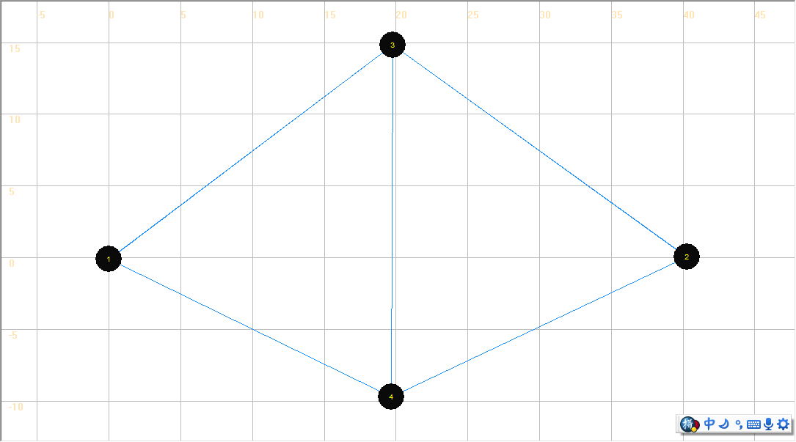

Step 2: Click “Toll” on the GIS Layer Panel, and then click  to select link e. Set link e as a Toll link by clicking “Add Link-based Toll” in the right click drop-down list.

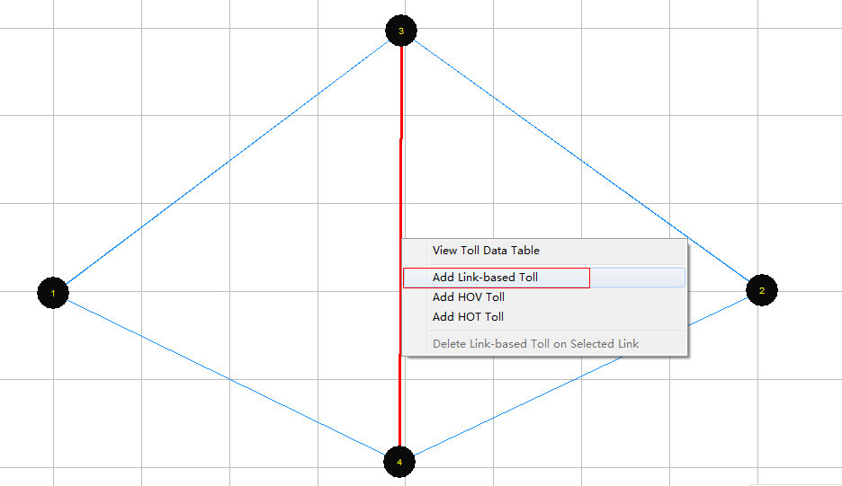

A dialog box named “View/Edit Scenario Configuration” appears. Users can modify the values of the charge of toll on the link. After the input of the desired charge of toll, click “Save Data”.

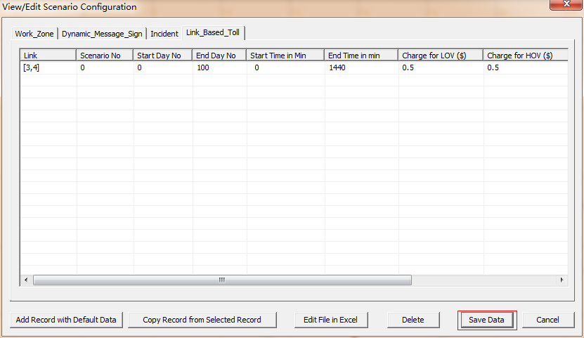

Step 3: Run simulation on the new network and display the volumes on the map.

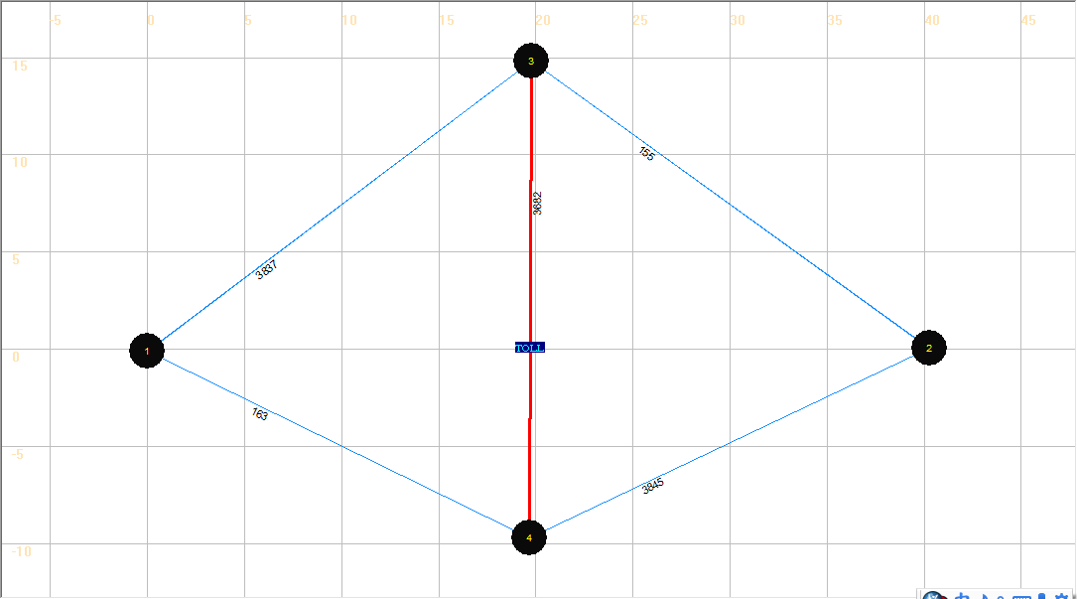

|  |  |  |  |  |  |
| --- | --- | --- | --- | --- | --- |
|  | a | b | c | d | e |
| Total Link Volume(vhc) | 3837 | 3845 | 163 | 155 | 3682 |

We can see some vehicles shifting from Path 3 to Path 1 and Path 2 because of introducing the toll on path 3.

Step 4: Close NEXTA.

# Problem 1: Sensitivity analysis using different demand levels

In this problem, we will explore the sensitivity of Braess paradox to different demand level. Try to change the demand in Braess network, and run static simulation to do sensitivity analysis.

1. Analysis on low demand on Braess Network

Step 1: Launch NEXTA, and open the file ” Braess_Network.tnp” in the folder” Task2-Braess_network_with_link34-static - low” by clicking  in Tool Bar. Braess network appears on the interface.

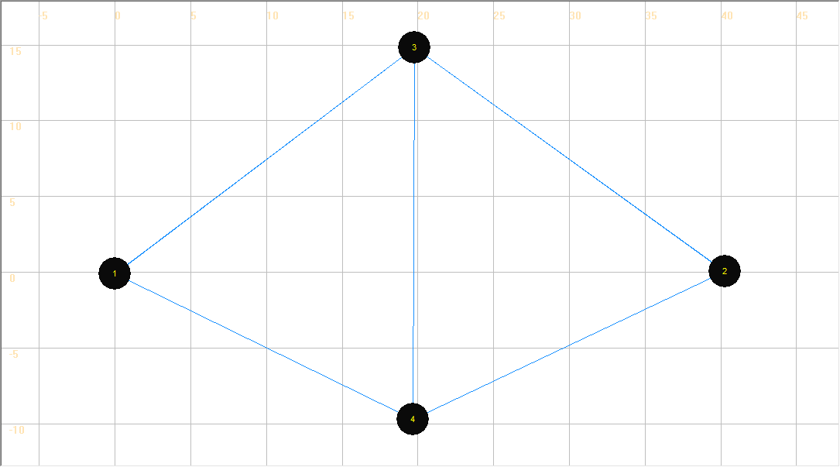

Step 2: Click the button  to modify the demand to low level.

In the dialog “Review Simulation/Assignment Setting”, we can change the value of “Demand Loading Multiplier” at 0.1. Then, the demand will change into 4000*0.1=400 (the original demand is 4000 ).

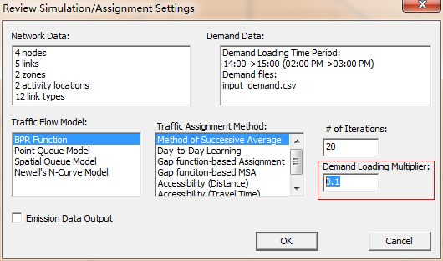

Step 3: Run simulation using “BPR Function” as “Traffic Flow Model” and “Method of Successive Average” as “Traffic Assignment Method” on Braess network, display the volume value on the network.

|  |  |  |  |  |  |
| --- | --- | --- | --- | --- | --- |
|  | a | b | c | d | e |
| Total Link Volume(vhc) | 400 | 400 | 0 | 0 | 400 |

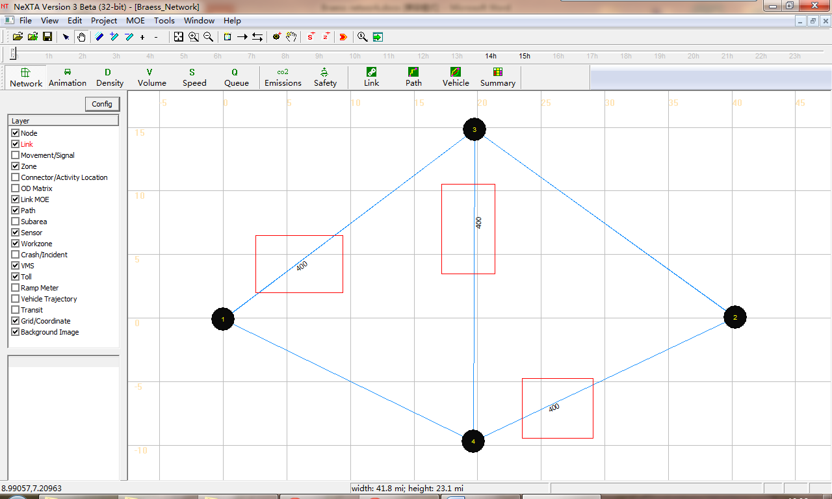

Step 4: Check the values of parameters from the output files,

Step 5: Open the imported excel file, then delete the link e from the network and save the excel file.

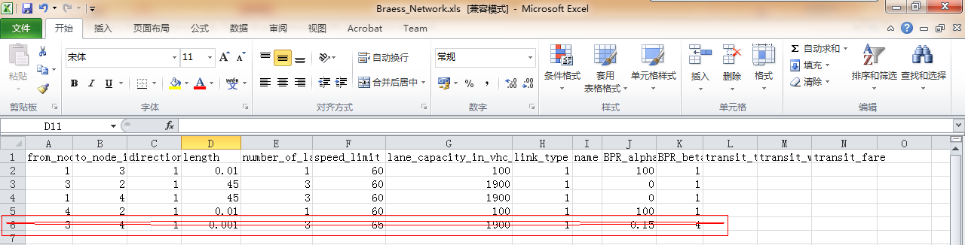

Step 6: Import the new excel file into NEXTA, and create a new network.

Step 7: Run the simulation

Keep the “Demand Loading Multiplier” at 0.1. Use BPR Function to run simulation and display the volume values on each link.

|  |  |  |  |  |
| --- | --- | --- | --- | --- |
|  | a | b | c | d |
| Total Link Volume(vhc) | 188 | 188 | 212 | 212 |

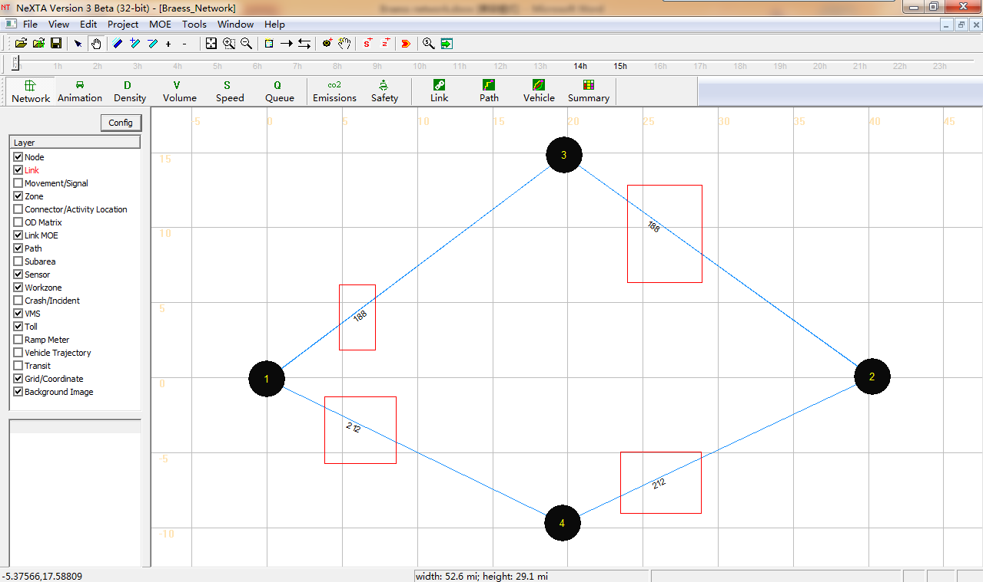

Step 8: Compare and analysis the system performance between two networks under low demand.

|  |  |  |
| --- | --- | --- |
|  | Without adding link e | Adding link e |
| System-wide travel time | 18806.88 | 3208.37 |
| Volume on link a | 188 | 400 |
| Volume on link c | 212 | 0 |
| Path 1 travel time | 46.89 | 49.01 |
| Path 1 volume | 188 | 0 |
| Path 2 travel time | 47.13 | 49.01 |
| Path 2 volume | 212 | 0 |
| Path 3 travel time | —— | 8.02 |
| Path 3 volume | 0 | 400 |

From the statistics above, the system performance of the Braess network with link e is much better than the other’s. The travel time for a single vehicle or whole system decrease because of link e. Thus, no paradox occurs.

Step 8: Close NEXTA.

2. Analysis on high demand on Braess Network

Step 1: Launch NEXTA, and open the file ” Braess_Network.tnp” in the folder” Task2-Braess_network_with_link34-static - high” by clicking  in Tool Bar. Braess network appears on the interface.



Step 2: Click the button  to modify the demand to high level.

In the dialog “Review Simulation/Assignment Setting”, we can change the value of “Demand Loading Multiplier” at 2.5. Then, the demand will change into 4000*2.5=10000 (the original demand is 4000 ).

. 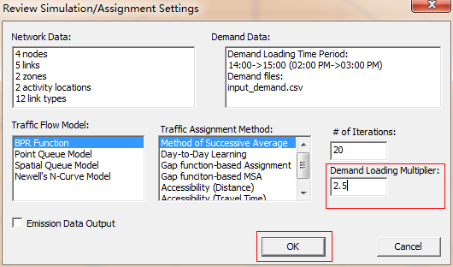

Step 3: Choose “BPR Function” in “Traffic Flow Model” list and “Method of Successive Average” in “Traffic Assignment Method” list on Braess network, then click OK to start simulation. Display the volume values on the map.

|  |  |  |  |  |  |
| --- | --- | --- | --- | --- | --- |
|  | a | b | c | d | e |
| Total Link Volume(vhc) | 5463 | 5020 | 4537 | 4980 | 483 |

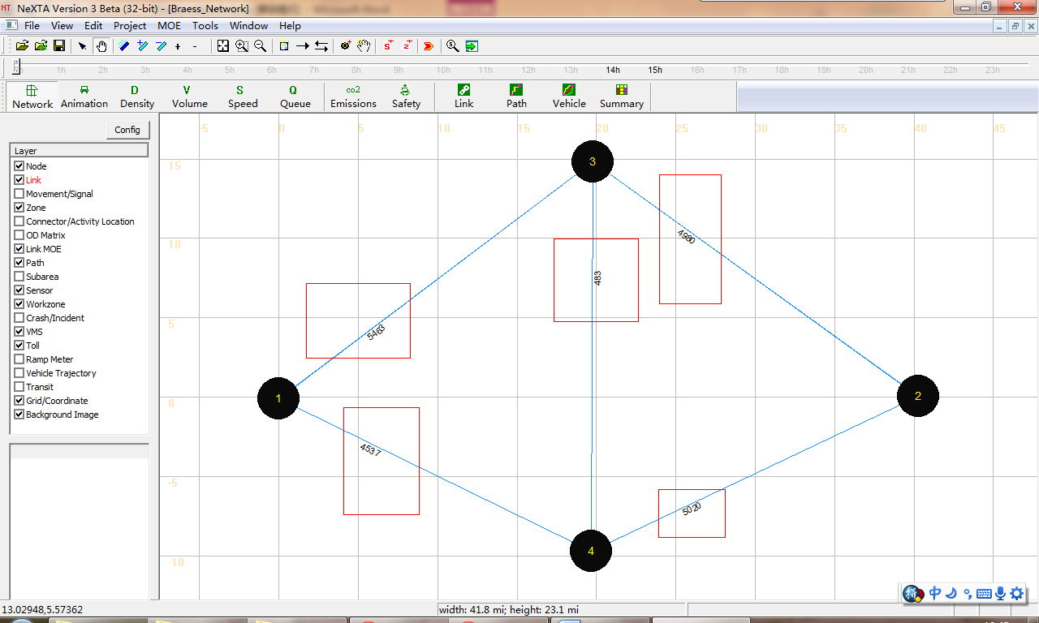

Step 4: Record the values of parameters from the output files, then close NEXTA.

Step 5: Open the imported excel file, then delete the link e from the network and save the excel file.



Step 6: Import the new excel file into NEXTA, and create a new network.

Step 7: Keep “Demand Loading Multiplier” at 2.5. Run the simulation using BPR Function to obtain the volume values on each link.

|  |  |  |  |  |
| --- | --- | --- | --- | --- |
|  | a | b | c | d |
| Total Link Volume(vhc) | 4827 | 5173 | 5173 | 4827 |

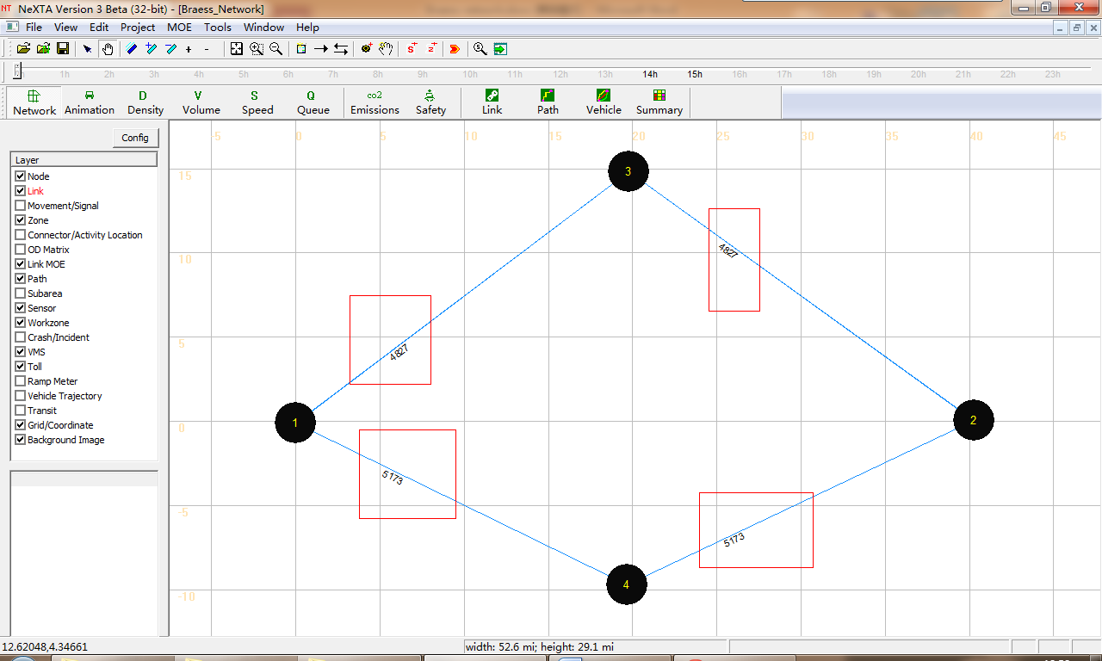

Step 7: Compare and analysis the system performance between two networks under low demand.

|  |  |  |
| --- | --- | --- |
|  | Without adding link e | Adding link e |
| System-wide travel time | 950698.6 | 978817.97 |
| Volume on link a | 4827 | 5463 |
| Volume on link c | 5173 | 4537 |
| Path 1 travel time | 93.28 | 99.64 |
| Path 1 volume | 4827 | 4980 |
| Path 2 travel time | 96.74 | 95.21 |
| Path 2 volume | 5173 | 4537 |
| Path 3 travel time | —— | 104.85 |
| Path 3 volume | 0 | 483 |

From the statistics above, not all vehicles take the path 3 because of link capacity limitation. And the travel time on path 3 is a little longer than other two paths’. Neither does paradox occur under high demand in Braess network.

Step 8: Close NEXTA.