**DTA + ABM Integrated System**

Prepared by Xuesong Zhou and Yunchao Qu

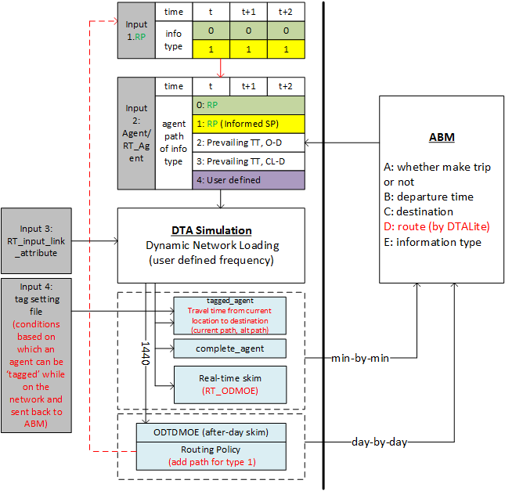

Fig. 1 Framework of DTA+ABM integrated system

Tab. 1 Description of input and output data

|  |  |  |  |  |
| --- | --- | --- | --- | --- |
| **Data** | **Identifier** | **File Name** | **Main Attributes** | **Notes** |
| **Input** | **1.IRP** | **RT_Input_Routing_Policy_xxhxxmxxs.csv.csv** | **Experienced path set (IT = 0)**  **Informed shortest path (IT = 1)** | **frequency is defined in the “DTASetting.txt”. RT_Input_Routing_Policy_Frequency_in_Seconds** |
| **2.ILA** | **RT_input_link_attribute_xxhxxmxxs.csv** | **Real time data of link capacity, link speed limit and so on** | **frequency is defined in the “DTASetting.txt”.**  **RT_Input_LinkAttribute_Frequency_in_Seconds** |
| **3.IAT** | **input_agent.csv (standard input)** | **For initializing all agents at the beginning of simulation (e.g., origin, destination, departure time, path)** | **attribute “format_type” in “input_demand_meta_data.csv” should be “agent_csv”** |
| **4. (RT_IAT)** | **RT_Input_Agent_xxhxxmxxs.csv** | **Current path, alternative path, route switch flag** | **Given by DTALite or user defined** |
| **5.IMS** | **optional_MOE_setting.csv** | **Make decisions about which agents can be tagged** | **do not use the file “input_tagged_setting.csv”** |
| **Output** | **1.OTA** | **RT_Output_Tagged_Agent_xxhxxmxxs.cs** | **Current path, alternative path, route switch flag, only output the tagged agents in “input_MOE_setting”** | **output frequency is defined in “RT_Output_Tagged_Agent_Frequency_in_Seconds”** |
| **2.OCA** | **RT_Output_Complete_Agent_xxhxxmxxs.csv** | **Path node/time sequence of this completed trip** | **output frequency is defined in “RT_Output_Complete_Agent_Frequency_in_Seconds”** |
| **3.ODR** | **RT_output_ODMOE_xxhxxmxxs.csv (skim)** | **Average travel time of each OD pair** | **output frequency is the same with ORP** |
| **4.ORP** | **RT_Output_Routing_Policy_xxhxxmxxs.csv** | **Path set information of each OD pair** | **output frequency is defined in “RT_Output_Routing_Policy_Frequency_in_Seconds”** |
| **5.OAT** | **output_agent.csv**  **(standard output)** | **Information type, departure time, path node sequence, path time sequence, complete status, current node/link/path** |  |

**Functions**

1. **Prepare input files**

* Basic link attributes are required as inputs before simulation, link attributes are stored in input_linkAttributes.csv file.
* Demand data as original agent inputs for generating input agents, and for calculating experienced shortest path. Demand data can be input through input_demand_meta_data.csv
* Input_tag_setting.csv file are required for tagging agents whose information is in “input_MOE_setting.csv”. Information types will be introduced below.
* Some attributes in “DTASetting.txt” are required for controlling files input and output frequency, e.g.,

[ABM_integration]

RT_Input_LinkAttribute_Frequency_in_Seconds=0

RT_Input_Agent_Frequency_in_Seconds=0

RT_Input_Routing_Policy_Frequency_in_Seconds=900

RT_Output_LinkMOE_Frequency_in_Seconds=60

RT_Output_Complete_Agent_Frequency_in_Seconds=60

RT_Output_Tagged_Agent_Frequency_in_Seconds=60

RT_Output_Routing_Policy_Frequency_in_Seconds=900

1. **Input and output**

**Input**

* For all agents *in input_agent.csv*, there are at most 5 categories of information types, which are listed as follow,

1. information type 0: habitual,
2. information type 1: learning from previous day,
3. information type 2: pre-trip,
4. information type 3: en-route.
5. information type 4: user defined

* For each agent with information type 0, he/she will randomly choose one path from the *input_routing_policy.csv* as its current path. The probability of choosing this path is defined by the flow ratio in the *input_routing_policy.csv*.
* For each agent with information type 1, he/she will choose the informed shortest path as its current path. The informed shortest path is calculated based on the link travel time of previous day, which is recorded in the *input_routing_policy.csv*. (Here, the node sequence and flow radio of each experienced path and informed shortest path are stored in *RT_input_routing_policy_xxhxxmxxs.csv*.)
* For each agent with information type 2, he/she will select the path from its origin to destination with shortest travel time based on the current link travel time at its departure time . (Agents with information type 2 will be tagged at their origins, and controlled by *input_MOE_setting.csv*.)
* For each agent with information type 3, he/she will dynamically select the path from its current node to destination with shortest travel time based on the time-dependent link travel time at some time interval *t* (the time frequency of en-routing is that is defined by user setting, e.g, = 5 min)*.* The calculated instantaneous shortest path will be stored as the *alternative path* for the agent.
* For each agent with information type 4, he/she will switch to the user defined alternative path (or sub path) by the “path_switch_flag”. These agents are fully controlled by users, and if users don’t provide a path for one agent, DTALite will provide a default shortest path according to the prevailing link travel time.
* Switch flag is provided in this file which stands for whether agents with all information types will switch to the new calculated shortest path or stay on previous calculated shortest path. The tagged setups are controlled by input_tag_setting.csv.

*It should be noted that*

* After generating a certain path for each agent according to its information type, DTALite will run a DNL process for one simulation time interval (i.e., = 6 s).
* If the path set is an empty set at the beginning of the simulation, each agent with information type 0 or 1 will choose the shortest path based on the current link travel time at its departure time .
* During the simulation process, *RT_input_agent_xxhxxmxxs.csv* will be provided by DTALite or ABM will keep assigning agents with new trip tasks, departure time. These updated agents can be created for their alternative paths. Agents who complete the assigned trips will be stored in *RT_output_complete_agent_xxhxxmxxs.csv file*. It output frequency set up by DTASetting.txt

**Output**

* If the output frequency does not equal to 0 (it is the min-by-min case), DTALite will output files including *RT_output_tagged_agent_xxhxxmxxs.csv, RT_output_complete_agent_xxhxxmxxs.csv, and RT_Output_ODMOE_xxhxxmxxs.csv* every min, which is defined by user setting (e.g. = 15 min).

*RT_Output_tagged_agent_xxhxxmxxs.csv* mainly utilized by agents with information types defined in “input_MOE_settings.csv”, offering alternative paths and switching decisions.

*RT_Output_complete_agent_xxhxxmxxs.csv* stores agents who have completed their assigned trips, and these agents can be candidates for further trip assignments.

*RT_Output_ODMOE_xxhxxmxxs.csv* file reflects current network OD pair trip time, can be potentially used to assign agents who want to select shortest path before trip.

* If the output frequency does not equal to 0 (it is the day-by-day case), DTALite will output files *output_ODTDMOE.csv* and *output_agent.csv* when the simulation is completed. (These two files are standard output files.)

*output_ODTDMOE.csv* file summarized the shortest path.

*output_agent.csv* file summarized the time-space trajectory of all agents.

* Convert the previous day *RT_output_routing_policy_xxhxxmxxs.csv* to *RT_input_routing_policy_xxhxxmxxs.csv* for providing experienced shortest path and informed shortest path for current day (i.e. day 2) agents who have information type 0 and 1 to select paths.

**Flow chart (data)**

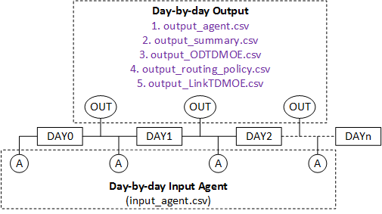

1. day-by-day

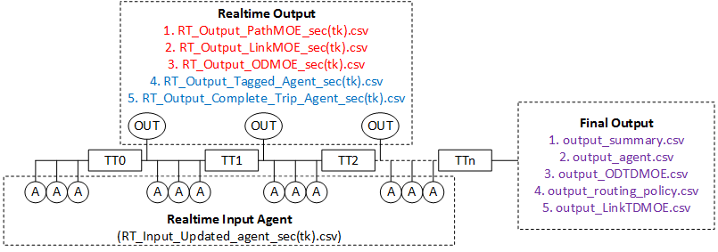

1. min-by min

Fig. 2 Flow charts of real-time DTA simulation

**Process**

1. **Initialization**

At the beginning, set

1. prepare agents: (user defined) : *IAT*
2. prepare simulation schedule: ( user required) : *ISS*
3. prepare input tag setting : (tagging agents with information type 3) : *ITS*
4. **Real-time input**

If the current time interval (is the input frequency, i.e. 1 minute), input the following data,

1. input updated agents : *IUA*
2. input Real-Time Link Attribute : *ILA*

otherwise, skip this step and go to Step 3.

1. **Simulation**

Run DTALite one iteration (dynamic network loading), and update time interval ( is the simulation frequency, i.e. 6 seconds)

1. **Real time output and ABM**

If the current time interval (output frequency, i.e. 15 minutes or 1440 minutes), output the following data for real-time ABM,

1. output tagged agents: (agents with information type 3) : *OTA*
2. output complete agents : *OCA*
3. output Real-Time ODMOE : *ODR*
4. Real-time adjusting attributes of agents by ABM, and then go to step 2 for the next time interval. If simulation time interval t = 1440 min, go to step 5.
5. **Final output (after one day simulation)**

Output summary files to ABM to adjust the attributes of agents, and prepare data for the next day simulation

1. output routing policy: *ORP* : Regard ORP as input routing policy for instructing next day path selection. *ORP→ IRP*
2. output ODTDMOE : *OOD* : Standard outputs for ABM utilizing.
3. output output agent : *OAT* : Can be used as input agents for next day after ABM adjusting. *OAT→ IAT*
4. **Adjust attributes of agents and prepare agent file for the next day simulation.**