**User Guide for Signal Simulation in DTALite**

Prepared by Danting Wu, Xuesong Zhou

This document aims to offer users to understand input settings for signal scenarios implemented in DTALite. This flexible data format allows uses to further apply multiple types of signal timing strategies for signal scenarios evaluation. Section 1 shows the data requirement and setting process for performing signal scenario in DTALite. Section 2 presents basic information about a sample case and provides the guidelines about data preparation and parameter specification in basic input files. Section 3 mainly introduces how to set up reasonable and common value of parameters in scenario setting files.

**Section 1: Key files required for signal scenario settings**

The key input setting files and output files for signal scenario are shown in Table 1.

**Table 1. Key files for signal scenario settings**

|  |  |  |
| --- | --- | --- |
| **File Group** | **Files list** | **Remark** |
| Input files | 1. input_demand.csv | Demand content for specifying distribution(observed flows of intersections) |
| 2. input_demand_file_list.csv | Demand files specification, loading multiplier, specify departure time distribution |
| 3. input_zone.csv | TAZ definition |
| 4. input_link.csv | Properties of all links in network |
| 5. input_node.csv | Properties of all nodes in network |
| 6. input_movement.csv | Definition especially for left-turn type movements |
| 7. input_signal.csv | Specify signal control rules for signal scenarios, such as plan_ no, cycle time, offset, green time, saturation flow rate |
| 8. input_scenario_settings.csv | Specify signal representation model and assignment settings |
| …… |  |
| Output files | 1. output_agent.csv | Statistics of agents such as path node/time sequence, OD, departure/arrival time |
| 2. output_summary.csv | General statistics of simulation results for each iteration |
| ...... |  |

**Section 2: Data preparation**

A fixed-time controlled signal are chosen as a simple case in this guide. The detailed information is shown in figure 1-2 and table2.

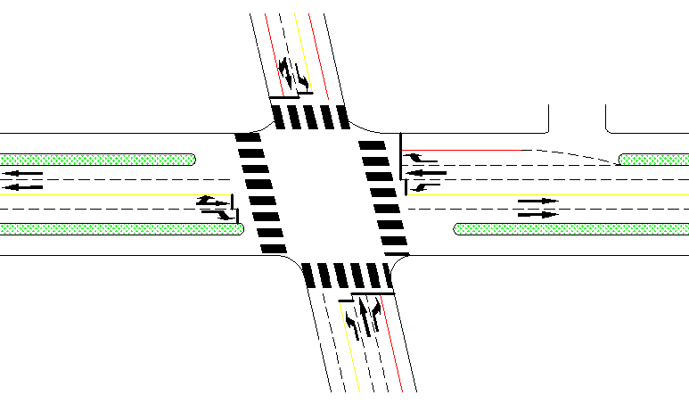

**Figure 1. Geometry construction of sample intersection**

**Table 2. Observed volume of sample intersection**

|  |  |  |  |  |
| --- | --- | --- | --- | --- |
| **direction** | **left-turn flow**  **(pch/h)** | **straight flow**  **(pch/h)** | **right-turn flow**  **(pch/h)** | **sum**  **(pch/h)** |
| eastern entrance | 229 | 659 | 190 | 1078 |
| southern entrance | 176 | 157 | 312 | 645 |
| western entrance | 121 | 677 | 182 | 980 |
| northern entrance | 117 | 160 | 219 | 496 |

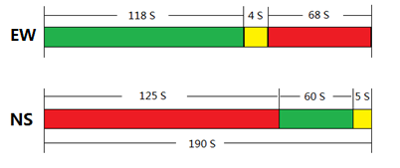

**Figure 2. Fixed-timing plan of sample intersection**

In this case, the traffic network including 5 nodes and 8 links are built in NeXTA, as shown in Figure3.

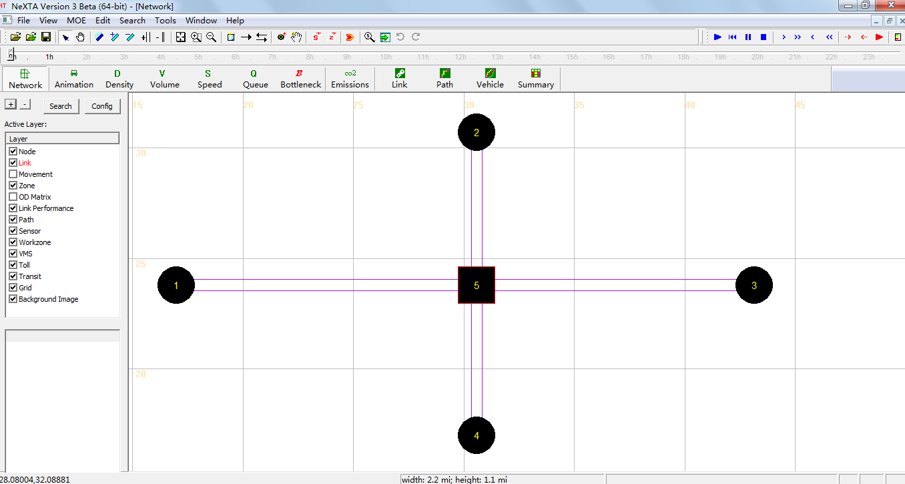

**Figure 3. Traffic network displayed in NeXTA**

As described above, the required basic input data files for signal scenario include the demand data (input_demand.csv and input_demand_file_list.csv) and the traffic network data (input_node.csv, input_link.csv, input_zone.csv). The detailed format of input files based on sample data are listed in Table 3-7.

**Table 3. Sample data in file input_demand.csv**

|  |  |  |
| --- | --- | --- |
| **from_zone_id** | **to_zone_id** | **number_of_trips_demand_type1** |
| 1 | 2 | 121 |
| 1 | 3 | 677 |
| 1 | 4 | 182 |
| 2 | 3 | 117 |
| 2 | 4 | 160 |
| 2 | 1 | 219 |
| 3 | 4 | 229 |
| 3 | 1 | 659 |
| 3 | 2 | 190 |
| 4 | 1 | 176 |
| 4 | 2 | 157 |
| 4 | 3 | 312 |

**Table 4. Sample data in file input_demand_file_list.csv**

|  |  |  |  |  |  |  |  |
| --- | --- | --- | --- | --- | --- | --- | --- |
| **scenario_no** | **file_sequence_no** | **file_name** | **Format**  **_type** | **Loading**  **_multiplier** | **start_time**  **_in_min** | **end_time**  **_in_min** | **number_of**  **_demand**  **_types** |
| 1 | 1 | input_demand.csv | column | 1 | 0 | 60 | 1 |

**Table 5. Sample data in file input_zone.csv**

|  |  |  |  |
| --- | --- | --- | --- |
| **zone_id** | **production** | **attraction** | **geometry** |
| 1 | 0 | 0 | <Polygon><outerBoundaryIs><LinearRing><coordinates></coordinates></LinearRing></outerBoundaryIs></Polygon> |
| 2 | 0 | 0 | <Polygon><outerBoundaryIs><LinearRing><coordinates></coordinates></LinearRing></outerBoundaryIs></Polygon> |
| 3 | 0 | 0 | <Polygon><outerBoundaryIs><LinearRing><coordinates></coordinates></LinearRing></outerBoundaryIs></Polygon> |
| 4 | 0 | 0 | <Polygon><outerBoundaryIs><LinearRing><coordinates></coordinates></LinearRing></outerBoundaryIs></Polygon> |

**Table 6. Sample data in file input_zone.csv**

|  |  |  |  |  |  |  |
| --- | --- | --- | --- | --- | --- | --- |
| **from_node**  **_id** | **to_node**  **_id** | **length** | **number_of**  **_lanes** | **number_of**  **_leftturn_lanes** | **speed_limit** | **jam_density** |
| 1 | 5 | 0.625 | 2 | 1 | 25 | 200 |
| 5 | 3 | 0.625 | 2 |  | 25 | 200 |
| 2 | 5 | 0.625 | 2 | 1 | 25 | 200 |
| 5 | 2 | 0.625 | 1 |  | 25 | 200 |
| 5 | 4 | 0.625 | 1 |  | 25 | 200 |
| 4 | 5 | 0.625 | 3 | 1 | 25 | 200 |
| 3 | 5 | 0.625 | 3 | 1 | 25 | 200 |
| 5 | 1 | 0.625 | 2 |  | 25 | 200 |

**Remark:**

1. Number of lanes: the number of lanes on specific links.
2. The value of “Number of left-turn lanes” should be specified when left-turn lanes exist(including separated left-turn lanes and shared left-turn lanes).

**Table 7. Sample data in file input_node.csv**

|  |  |  |  |  |  |
| --- | --- | --- | --- | --- | --- |
| **node_id** | **control_type** | **control_type**  **_name** | **x** | **y** | **geometry** |
| 1 | 0 | unknown_control | 16.97894 | 23.79017 | <Point><coordinates>16.978937,23.790170</coordinates></Point> |
| 5 | 5 | pretimed_signal | 30.58159 | 23.79017 | <Point><coordinates>30.581594,23.790170</coordinates></Point> |
| 3 | 0 | unknown_control | 43.16913 | 23.79017 | <Point><coordinates>43.169128,23.790170</coordinates></Point> |
| 2 | 0 | unknown_control | 30.58159 | 30.69301 | <Point><coordinates>30.581594,30.693011</coordinates></Point> |
| 4 | 0 | unknown_control | 30.58159 | 16.98884 | <Point><coordinates>30.581594,16.988842</coordinates></Point> |

**Remark:**

1. The control type of intersection nodes should be specified as “pretimed signal”(as shown node 5 in the table above).

**Section 3: parameter settings in key simulation configuration files**

The required parameter settings are defined in simulation configuration files such as input_movement.csv, input_signal.csv and input_scenario_settings.csv. The detail format in files are listed in the following table 8-11.

**Table 8. Parameter settings in file input_movement.csv**

|  |  |  |  |  |
| --- | --- | --- | --- | --- |
| **node_id** | **up_node_id** | **dest_node_id** | **turn_type** | **prohibited_flag** |
| 5 | 1 | 2 | Left | 0 |
| 5 | 2 | 3 | Left | 0 |
| 5 | 3 | 4 | Left | 0 |
| 5 | 4 | 1 | Left | 0 |
| 5 | 1 | 3 | Through | 0 |
| 5 | 2 | 4 | Through | 0 |
| 5 | 3 | 1 | Through | 0 |
| 5 | 4 | 2 | Through | 0 |

**Remark:**

1. The specification of left-turn type movement at signal intersections is required, while the through type movement is desired.
2. “node_id”, ” up_node_id” and ” dest_node_id” means the node ID of intersection, upstream node and downstream node respectively. For example, node_id is signal node 5 in our example.
3. prohibited_flag =1 when the movement is forbidden, or else prohibited_flag =0.

**Table 9. Parameter settings in file input_signal.csv**

|  |  |  |  |  |  |  |  |  |  |  |  |  |
| --- | --- | --- | --- | --- | --- | --- | --- | --- | --- | --- | --- | --- |
| **from**  **_node**  **_id** | **to**  **_node**  **_id** | **plan**  **_no** | **plan**  **_startime**  **_in_sec** | **plan**  **_endtime**  **_in_sec** | **to**  **_node**  **_cycle**  **_in_sec** | **to**  **_node**  **_offset**  **_in_sec** | **through**  **_saturation**  **_flow_rate**  **_per_hour**  **_per_lane** | **through**  **_green**  **_start_time**  **_in_sec** | **through**  **_green**  **_end_time**  **_in_sec** | **left**  **_saturation**  **_flow_rate_**  **per_hour**  **_per_lane** | **left**  **_green**  **_start_time**  **_in_sec** | **left**  **_green**  **_end_time**  **_in_sec** |
| 1 | 5 | 1 | 1 | 86400 | 190 | 0 | 1800 | 1 | 118 | 1800 | 1 | 118 |
| 2 | 5 | 1 | 1 | 86400 | 190 | 0 | 1800 | 126 | 186 | 1800 | 126 | 186 |
| 3 | 5 | 1 | 1 | 86400 | 190 | 0 | 1800 | 1 | 118 | 1800 | 1 | 118 |
| 4 | 5 | 1 | 1 | 86400 | 190 | 0 | 1800 | 126 | 186 | 1800 | 126 | 186 |

**Remark:**

1. For a better understanding, the important data fields for signal scenario settings and gives corresponding explanations are listed in the following table 10.
2. For the format simplicity, we list multiple link records associated one phase at one signal nodes. For example, 4 records above for the first plan at node 5. To follow this format, please repeat this phase plan number and its starting time, ending time, offset and cycle length, across all link based records associated with this plan at this signal node.

**Table 10. Related attributes for signal scenario settings in file input_signal.csv**

|  |  |
| --- | --- |
| **Data field** | **Remark** |
| plan_no | the sequence number of timing plans |
| plan_startime_in_sec | defines the execute period of timing plans (in seconds) |
| plan_edntime_in_sec |
| to_node_cycle_in_sec | the cycle length of the intersection |
| to_node_offset_in_sec | This parameter is used to denote the difference of green start time between adjacent intersections in signal cooperative control, one can use any default values in one-point controlled signal |
| through_saturation_flow_rate_per_hour_per_lane | Saturation flow rate of through traffic flow (per lane per hour) |
| through_green_start_time_in_sec | defines the start and end time (in seconds) of green phase for through traffic flow |
| through_green_end_time_in_sec |
| left_saturation_flow_rate_per_hour_per_lane | Saturation flow rate of left-turn traffic flow (per lane per hour) |
| left_green_start_time_in_sec | defines the start and end time of green phase for left-turn traffic flow |
| left_green_end_time_in_sec |

**Table 11. Parameter settings in file input_scenario_settings.csv**

|  |  |  |  |  |  |
| --- | --- | --- | --- | --- | --- |
| **scenario_no** | **scenario_name** | **number_of_iterations** | **traffic_flow_model** | **signal_representation_model** | **traffic_analysis_method** |
| 1 | test1 | 10 | 2 | 2 | 0 |

**Remark:**

1. the signal_representation_model of ”2” is required to enable signal scenario assignment.
2. “number_of_iterations” defines the total numbers of iterations for scenarios corresponding to “scenario_no”.
3. the traffic_flow_model of ”2” is dedicated to spatial queue model.