Lesson 3.2: Route Choice Behavior Modeling Considering Traveler Information Provision

**3.2.1 Data Set:**

**3.2.2 Contents:**

Introduction

Background Information

Route Choice in DTALite

Information Classes in DTALite

Variable Message Signs (VMS) in DTALite

Implementation in DTALite

Case 1: Base Network with Incident

Case 2: Incident Model with Pre-trip & En-route Information

Case 3: Incident Modeling with Traveler Information and VMS

Viewing Detailed Simulation Data without NeXTA

**3.2.3 Learning Goals:**

1. Understand how different types/sources of travel time information are used in the route choice process in DTALite

2. Understand how to change incident, VMS, and travel time information settings in DTALite

3. Understand how to evaluate the route choice effects of VMS & traveler information in NeXTA

# 3.2.4 Introduction:

This document describes how to utilize and model the impacts of traveler information provision in DTALite, with examples demonstrating its use under different modeling conditions. Specifically, an incident in a small network is modeled under three conditions: without traveler information, with traveler information, and with additional VMS (variable message sign) information for modeling detours.

# 3.2.5 Background Information:

Traveler information provision is a congestion management strategy used by many transportation management centers (TMCs) and transportation departments (DOTs) to alleviate traffic problems caused by incidents and work zones. Conceptually, a traveler information provision service presents a driver with information about potential routes to their destination (e.g., travel time, delay, incident location, etc.), and the driver can select a route based on that additional information. This information can be provided before the trip is made (pre-trip), perhaps through a 511 telephone service or a website like [Google Maps](https://maps.google.com/?layer=t) or a [DOT website](http://commuterlink.utah.gov/). Information can also be provided during travel (en-route), which can be accomplished through GPS and mobile phone applications, or variable message signs (VMS).

Dynamic traffic assignment (DTA) has often been used to assess the impacts of traveler information provision services due to its flexibility in modeling multiple route choice conditions in large transportation networks. In most traffic simulations, drivers choose routes which minimize their own travel time, and they make their decision based on information available to them. In many cases, simulations provide static (idealized or free-flow conditions) or historical travel time information to the driver when choosing a route to their destination. Adding multiple information types (pre-trip and en-route information) to the route decision-making process complicates these models by adding additional steps in the route choice process. For example, different information types provide information at different times during a driver’s trip, requiring multiple shortest path calculations. The link cost definitions in the shortest path, based on travel time, are dependent upon the type of information provided (e.g., current travel time vs. predicted travel time at departure vs. historical travel time). Additionally, drivers may have different responses to different information sources, and drivers can choose to not change their route. These components all contribute to increased simulation complexity and may affect computational performance.

DTALite’s agent-based assignment engine supports most travel information provision services in its route choice model, utilizing simple, flexible user inputs to assign information classifications (or information classes) to specific agents while maintaining computational efficiency.

# Route Choice in DTALite

In DTALite, an agent or driver chooses a route based on the generalized cost to travel between an origin and destination. This generalized user cost is based upon three components: travel time, value of time (VOT), and tolling/pricing: $Cost = Travel Time × VOT + Toll$

Each variable in the generalized cost equation is specific to the agent/driver. Every agent/driver has their own value of time, travel times through the network are estimates which are dependent upon the type of information available to that agent/driver, and the toll is dependent upon the demand or vehicle type (SOV vs. HOV). When offered multiple paths with different estimated travel costs, the agent/driver is assumed to select the path/route which minimizes their own cost (Wardrop’s 1st Principle). When making successive decisions about route choice (e.g., choosing a new path after departure, and/or choosing a path in the second simulation iteration), the new path must overcome the “willingness to switch” paths, which is a relative threshold used when comparing travel times . That is, the agent/driver may decline to change paths if the alternative path does not meet some minimum amount of travel time (i.e., 5% travel time savings). Variables controlling route choice can be adjusted by the user in the DTASetting.txt file in the project folder.

## Information Classes in DTALite

There are three different types of traveler information classes in DTALite, each of which are associated with different types of travel time information provided to agents/drivers.

Historical Information: Travel time estimates used to compare routes between an Origin and Destination in the route choice process are based on the average experienced travel time from trips with the same departure time interval in prior simulation iterations (i.e. previous day in a day-to-day learning environment). The agent/driver selects a path which minimizes their travel time based upon these travel time estimates.

Pre-trip Information: Travel time estimates used to compare routes between an Origin and Destination in the route choice process are based upon current travel time data. In this case, the current path travel time estimates are based upon link travel times experienced by other drivers at the agent/driver’s departure time. Again, the agent/driver selects a path which minimizes their travel time based upon these travel time estimates.

En-route Information: Again, travel time estimates used to compare routes between an Origin and Destination in the route choice process are based upon current travel time data. In this case, the current path travel time estimates are based upon link travel times experienced by other drivers over multiple time intervals (e.g. in the last 15 min) during the trip, with link travel times associated with the interval in which the vehicle would enter each link for different paths. The agent/driver selects a path which minimizes their travel time based upon these travel time estimates, but they also have the option to change their path each minute during the simulation. Travel time information is provided at the end of a link.

In DTALite, link travel times are updated at specific travel time aggregation time intervals (e.g., 5 minutes), and travel time estimates for different information classes incorporate randomized error (driver perception error). These model parameters can be adjusted by the user in the DTASetting.txt file in the project folder.

## Variable Message Signs (VMS) in DTALite

Variable Message Signs (or Dynamic Message Signs) are used in DTALite to cause travelers to consider changing their current route. A VMS is located on a link in the network, and vehicles passing through the link are potentially affected by the sign. Each VMS has a response rate specified by the user, representing the probabilistic percentage of travelers which are affected by the sign and decide to consider a new route to their destination. If an agent/driver considers selecting a new route, a new shortest path calculation is performed from the end of the link (on which the VMS is located) to the traveler’s destination. It is assumed that the VMS provides some travel time information (based on prevailing travel condition) to the driver to help them select a new route, which is incorporated into the shortest path calculation. In DTALite, this travel time information is updated at a specified time interval (e.g., 60 minutes), which can be adjusted by the user in the DTASettings.txt file in the project folder.

It is important to note how VMS is implemented in DTALite, and how it affects drivers in the network. VMS is only effective when placed upstream from a detour point. For example, if the VMS is designed to re-route drivers around a work zone, locating the VMS on the link with the work zone present allows the vehicles to enter that link before they consider the detour, defeating its purpose. Also, while a driver may be affected by the VMS, it is not guaranteed that their route choice will be affected. Consider the work zone example again, with the VMS upstream of the work zone. VMS placed on a link will affect all travelers on that link, not just the travelers potentially traveling through the work zone. As a result, a driver affected by the VMS may have previously selected a route around the work zone, and the updated VMS travel time information might not change that route choice.

## Implementation in DTALite

Groups of agents/drivers are randomly assigned to different information classes in DTALite based on percent distributions. For example, approximately 10% of drivers may use pre-trip information to choose a route to their destination, another 10% might use en-route information through a GPS-enabled device (and/or other service) to choose their route, and the remaining population might use historical information. Since this distribution is utilized when generating agents/drivers in the network, it is considered a demand attribute, and it is applied separately to different demand types. The user can define a demand type (e.g., SOV, HOV, Truck, etc.), and associate a specific information type distribution for each demand type. To adjust these information class distributions, the user can edit the input_demand_type.csv file in the project folder. An example is shown in Table 1 below.

**Table 1: Fields in input_demand_type.csv file considering traveler information provision**

|  |  |  |  |  |
| --- | --- | --- | --- | --- |
| demand_type | demand_type_name | avg_VOT | percentage_of_pretrip_info | percentage_of_enroute_info |
| 1 | SOV | 10 | 10 | 10 |
| 2 | HOV | 10 | 10 | 10 |
| 3 | truck | 20 | 0 | 0 |

# Case 1: Base Network with Incident

The first step in this example is to establish an initial simulation run for a simple 6-node network, shown in Figure 1 below. Drivers will travel from Zone 1 to Zone 4 (bottom-left corner to top-right corner) under very light traffic to reduce potential effects of congestion on route choice. With light traffic, all vehicles travel at free-flow speed (shown in Figure 1), resulting in everyone using the same route (the route along Nodes 1, 5, 6, to Node 4 has 4-minute travel time, while the others have 6-minute travel time). As a result, the incident must take place on a link used by the drivers – in this case, we use the link between Node 6 and Node 4. The incident will start in the middle of the simulation so that the change in travel time will not affect all drivers, allowing us to observe the effects of traveler information provision in Case 2. In Case 1, the model does not consider the effect of traveler information provision services.

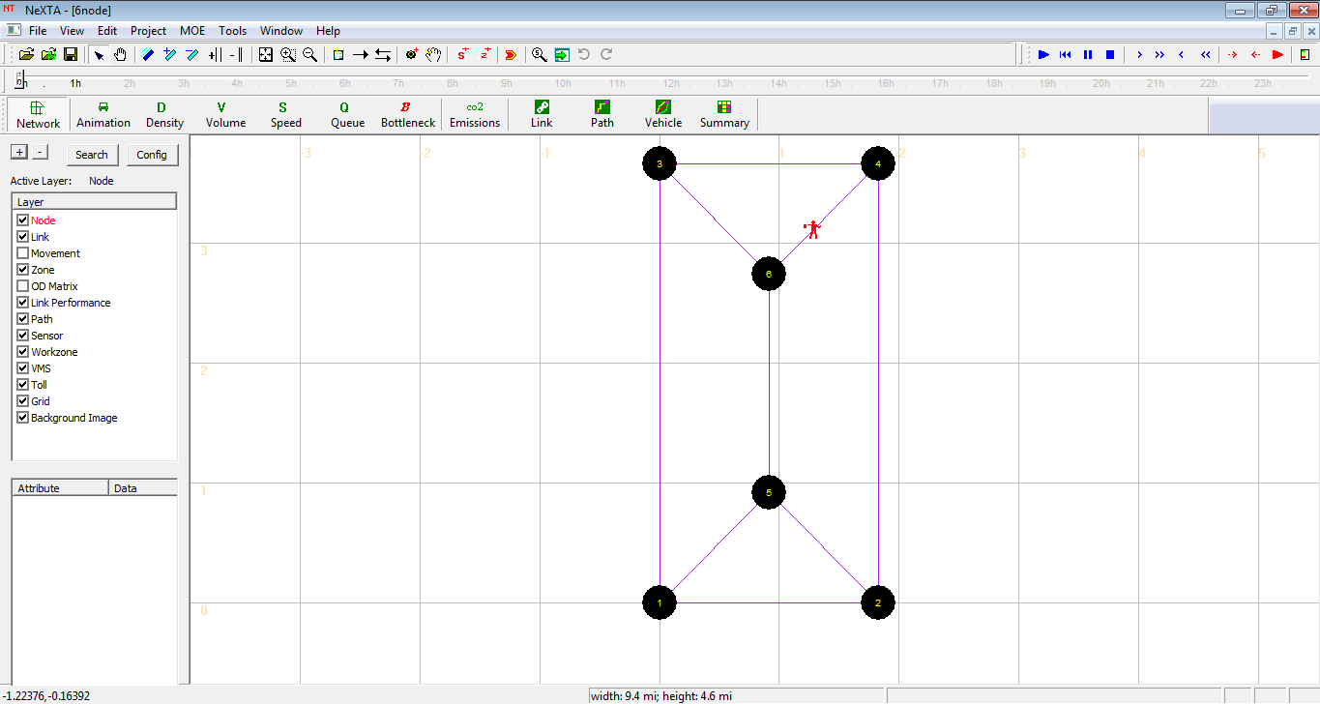

**Figure 1:** Basic6-Node Network with free-flow travel times

## Basic Simulation Setup: Incident and Demand Data

An incident occurs on the link between Node 6 and Node 4, starting 60 minutes after the simulation begins and link reducing capacity by 99% for one hour. To add the incident, select the Link Layer, and use the Select Object Tool to select the link between Node 6 and Node 4, as shown in Figure 2. Since the incident implementation is same as work zone scenario, the following will use work zone to represent the incident situation.

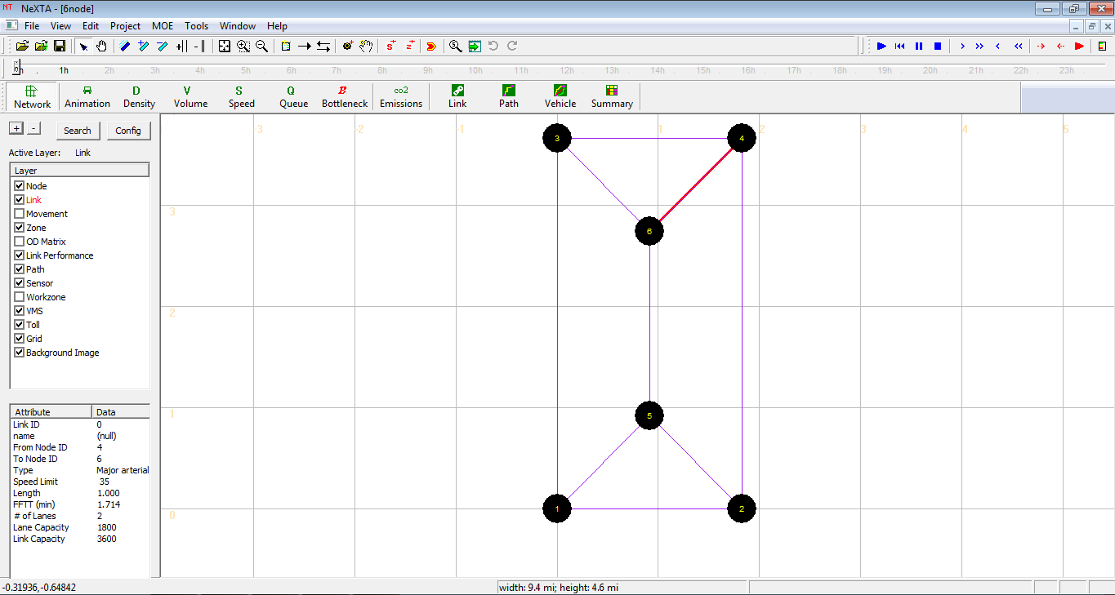

**Figure 2:** Select the link between Node 6 and Node 4 using the Select Object Tool

Next, add the incident to the link in the network. Select the Workzone Layer, right-click on the network, and select Add Workzone on Selected Link, as shown in Figure 3.

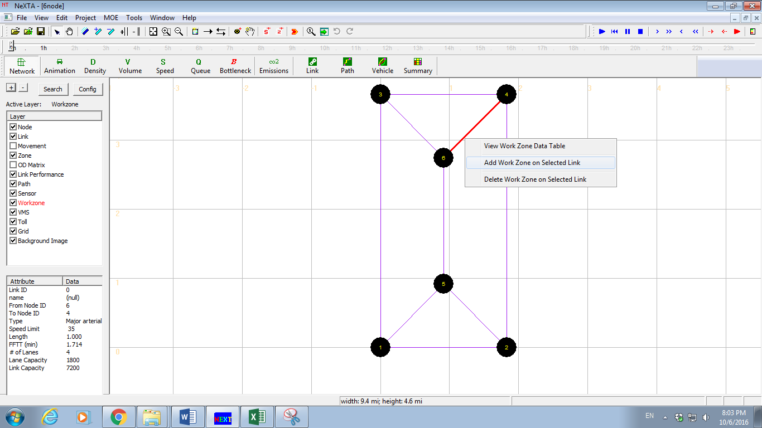

**Figure 3:** Adding incidents to links in NeXTA

A new window will open, shown in Figure 4, creating a new incident in the table and allowing the user to adjust the incident condition settings in the simulation. Each field can be edited by double-clicking on a cell, and either typing or using drop-down lists to make changes. In this case, edit the Day No. to create the incident on Day 1, change the start time and end time to 60 and 120 minutes, respectively, and change the Capacity Reduction Percentage to 99%, as shown in the figure below. If the capacity reduction percentage is set to 100%, then no vehicles could use that link.

Press the Save Data button to save any changes. Alternatively, these changes can also be made in Excel in the Scenario_Incident.csv file in the project folder, which can also be accessed using the Edit File in Excel button.

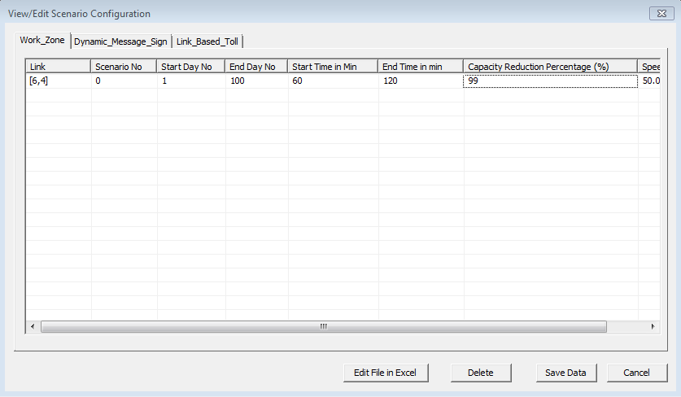

**Figure 4:** Editing incident conditions in Case 1

To return to this menu again, select the Incident Layer, right-click on the network, and select View Incident (work zone) Data Table, shown in Figure 5, or go to Project -> Traffic Management Scenario Data, and select the Incident (work zone) tab.

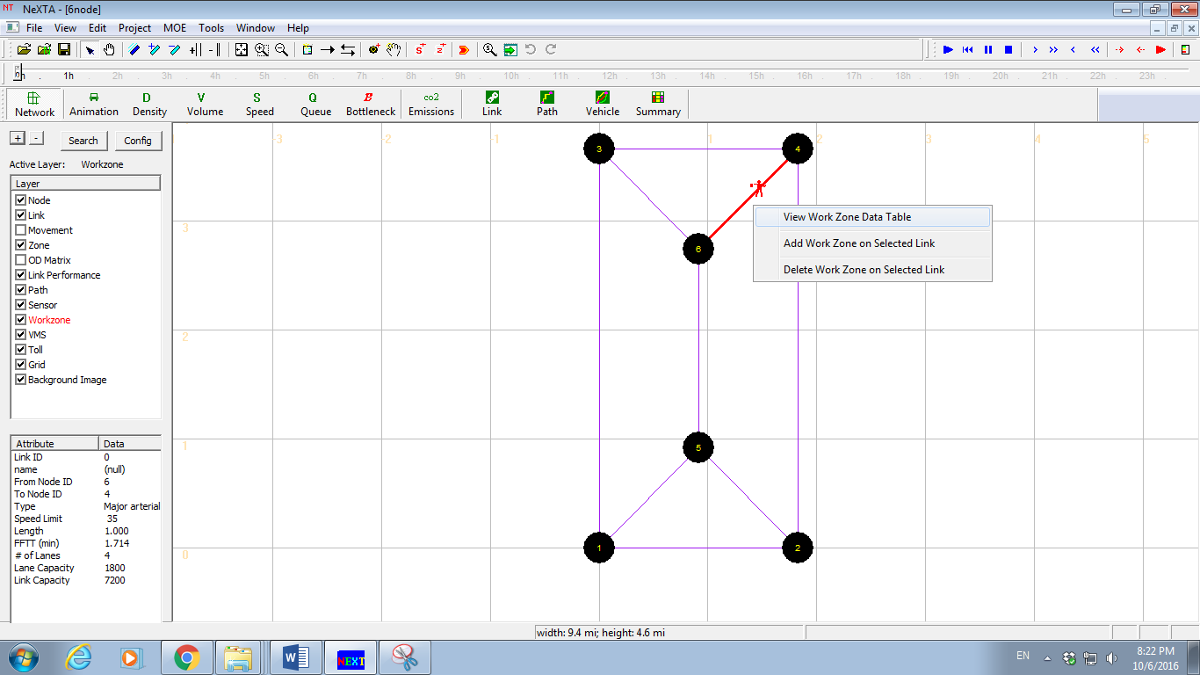

**Figure 5:** Right-click menus for accessing incident data in NeXTA

Travel demand data is specified in the input_demand.csv file in the project folder, but can also be viewed in NeXTA. To view the travel demand data for the simulation, open the OD Demand Table by going to Project -> Demand Database. A new window opens as shown in Figure 6 below. Select the 1st entry in the Demand File List to populate the OD Demand Matrix with travel demand data. The Demand File List shows that the demand is loaded over a 3-hour period, resulting in one vehicle leaving Zone 1 each minute over the time of the simulation.

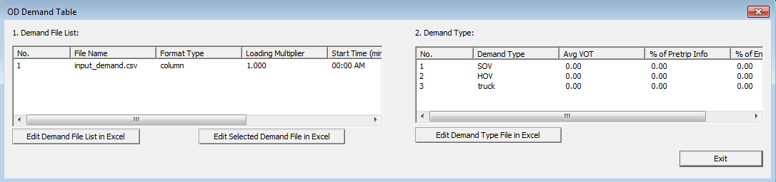

**Figure 6:** Viewing the OD Demand Table in NeXTA

Lastly, edit the input_demand_type.csv file in the project folder to make sure that no demand types use pre-trip or en-route information in the simulation. This is easily accomplished by checking the CSV file in Excel, and making sure the data in the percentage_of_pretrip_info and percentage_of_enroute_info fields with zeros, as shown in Table 2.

**Table 2: Edited input_demand_type.csv file for Case 1**

|  |  |  |  |  |
| --- | --- | --- | --- | --- |
| demand_type | demand_type_name | avg_VOT | percentage_of_pretrip_info | percentage_of_enroute_info |
| 1 | SOV | 10 | 0 | 0 |
| 2 | HOV | 10 | 0 | 0 |
| 3 | truck | 20 | 0 | 0 |

## Run the Simulation

Now that the network input data is prepared, run the traffic assignment engine. Select the Run Simulation button in NeXTA to run DTALite. First, NeXTA displays a window allowing the user to adjust the simulation settings, as shown in Figure 7. This simulation is run using a Point-Queue model with MSA, only running for one iteration (one-shot assignment). After making any necessary changes, press OK to run the simulation.

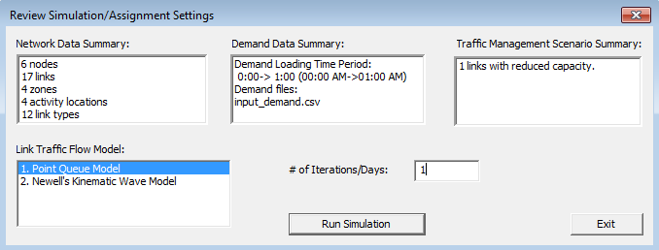

**Figure 7:** DTALite simluation settings in NeXTA

After the simulation completes, load the results into NeXTA. To observe the path choice in the network, open the Vehicle Data Analysis Tool in NeXTA by clicking the Vehicle button  on the MOE toolbar. A new window will open, shown in Figure 8, which allows the user to apply filters for analyzing route choice decisions for different OD-pairs, vehicle types, information classes, etc.

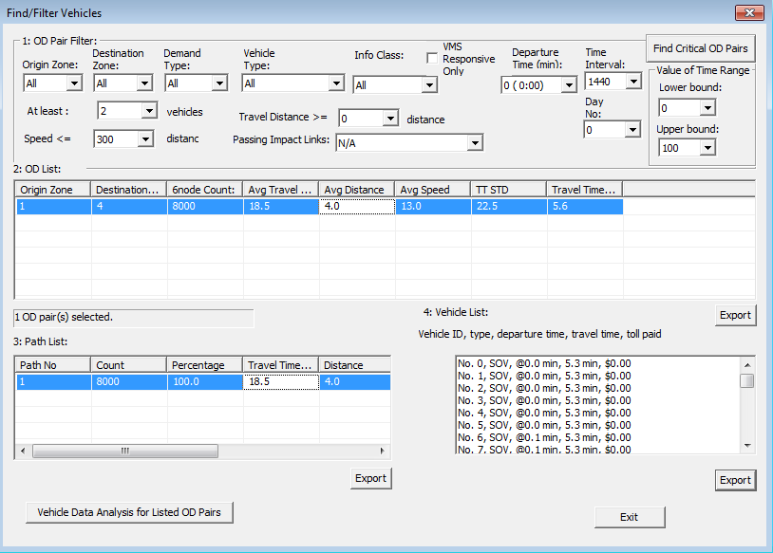

**Figure 8:** Viewing vehicle path choice in NeXTA using the Vehicle Data Analysis Tool

Select the row of data in the OD List to populate the Path List with data for vehicles traveling between Zone 1 and Zone 4. Next, select the row of data in the Path List to show that path on the network map, as shown in Figure 9.

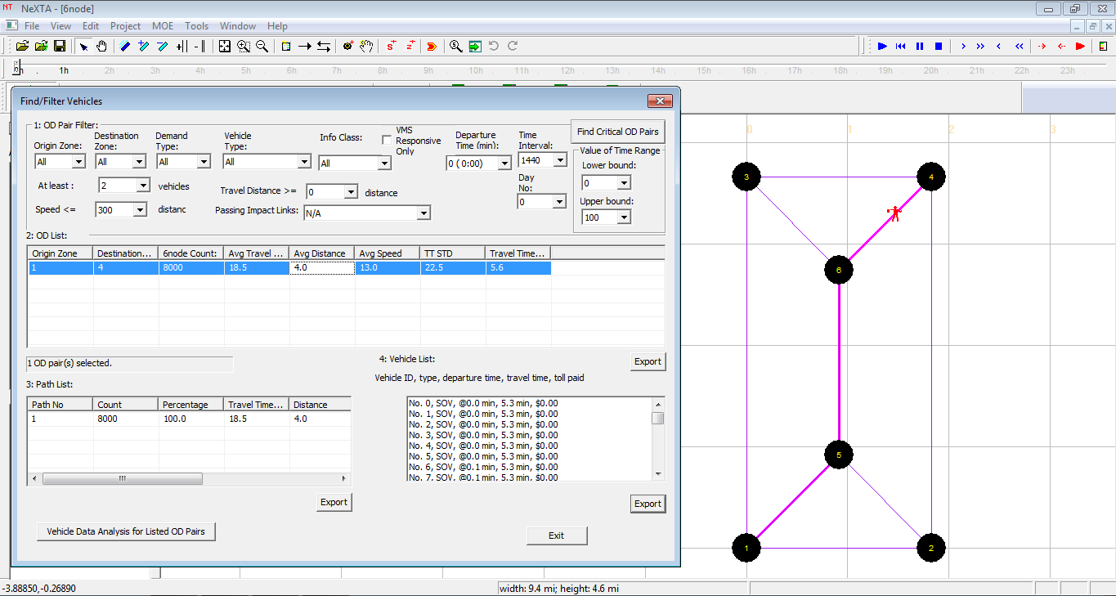

**Figure 9:** Displaying vehicle path data in NeXTA using the Vehicle Data Analysis Tool

The path utilized by these vehicles is shown using purple links. This path is the shortest path using free-flow travel times, which is the basis for the traffic assignment in the first iteration in DTALite. It is clearly shown that the travelers have no information about the incident occurring during the second hour of the simulation because they did not change their paths. Scrolling through the Vehicle List in the window, a significant travel time increase is found near the starting time of the incident, and the travel time returns to near free-flow conditions after the incident ends.

Additionally, this vehicle data can be viewed in tabular form by examining the output_agent.csv file in the project folder. The table provides a summary of departure time/location, destination arrival time/location, demand information (demand type, pricing type, information class VOT, etc.), and path data (path/node sequence, path travel time data, etc.).

# Case 2: Incident Model with Pre-trip & En-route Information

The next step in this case study is to provide additional information to travelers in the traffic assignment model, and evaluate their new route choice behavior. First, edit the input_demand_type.csv file in the project folder again, using 10% for both pre-trip and en-route information classes for SOV demand (only SOV demand is used, so changing HOV is not necessary). An example is shown in Table 3 below.

**Table 3: Edited input_demand_type.csv file for Case 2**

|  |  |  |  |  |
| --- | --- | --- | --- | --- |
| demand_type | demand_type_name | avg_VOT | percentage_of_pretrip_info | percentage_of_enroute_info |
| 1 | SOV | 10 | 10 | 10 |
| 2 | HOV | 10 | 0 | 0 |
| 3 | truck | 20 | 0 | 0 |

**Run the simulation again**, using the same settings for comparison to Case 1. Load the simulation results in NeXTA again, and use the same technique to view the route choice data: Open the Vehicle Data Analysis Tool in NeXTA by clicking the Vehicle button , and populate the Path List by selecting the 1st row in the OD List again.

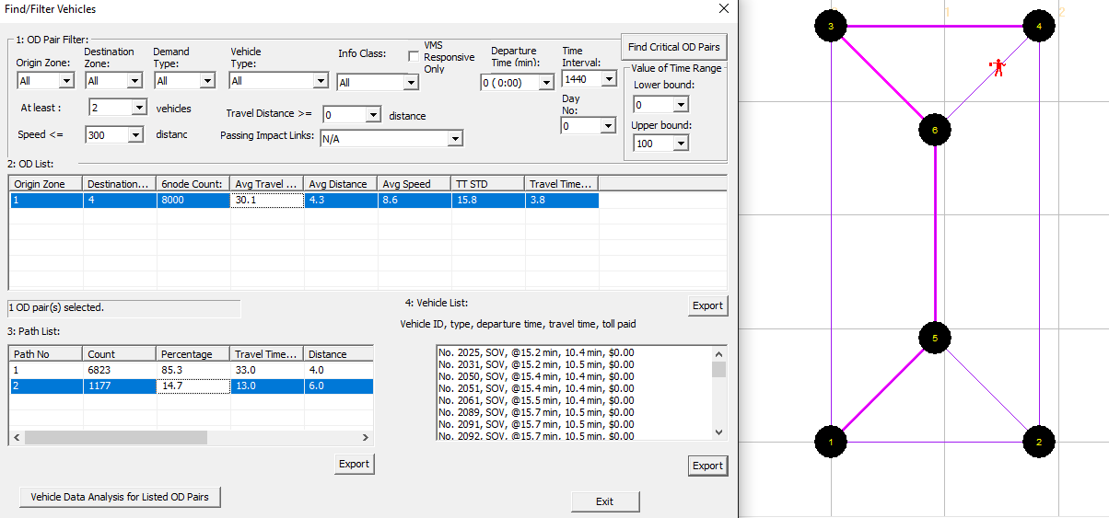

**Figure 10:** Additional paths in Case 2 due to traveler information

With the new simulation results, we first notice that the Path List has changed – there are now multiple paths in the Path List, as shown in Figure 10. The third column in the Path List shows that 85.3% of drivers used the previous route (through the incident), while 14.7% used detours. The fourth column of the Path List shows the average travel time for each path, which shows that drivers taking detours experienced shorter average travel times over the three-hour simulation.

The Vehicle Data Analysis Tool also allows the user to apply some advanced filtering. By changing the Info Class field to “Historical info”, “Pre-trip info”, or “En-route info”, the OD and Path lists will be limited to only vehicles of that specific information type. Filtering for historical information users only, Figure 11 shows that the drivers all still use the same route through the incident, with an average travel time of 34.2 minutes during the simulation. Meanwhile, filtering for travelers with pre-trip information offers two different routes and an average travel time of 13.4 minutes, as shown in Figure 12. Paying careful attention to the data in the Vehicle List, notice that there are no drivers with pre-trip information selecting the route through the incident during the second hour of the simulation (during the incident). Figure 13 shows that no drivers with pre-trip information passed through the incident while it was in effect (at left), and data for a second path (at right) shows that the incident’s congestion effects changed their route choice for several minutes after the incident was no longer in effect (the vehicle with departure time = 123.3 minutes). This was due to the queue building at the incident location.

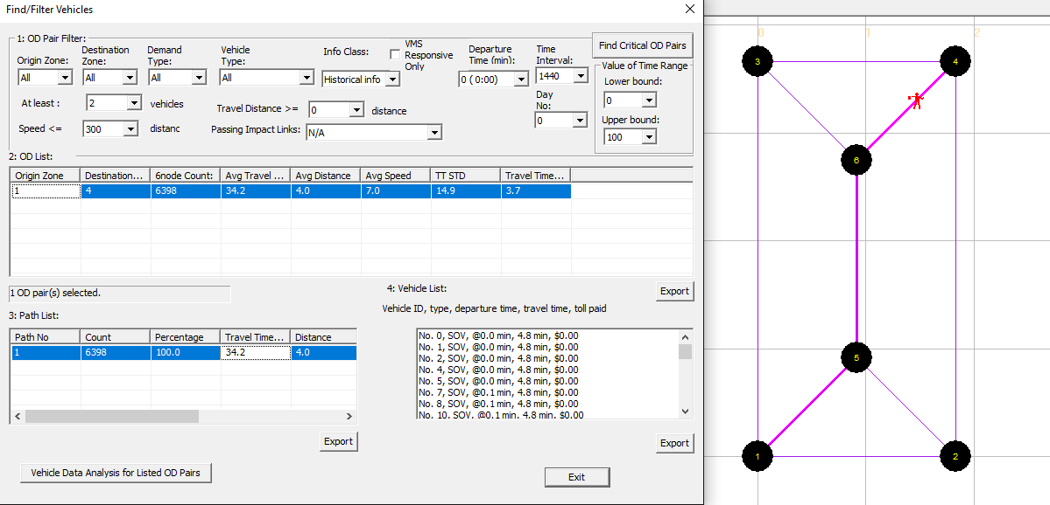

**Figure 11:** Route choice for travelers with only historical information

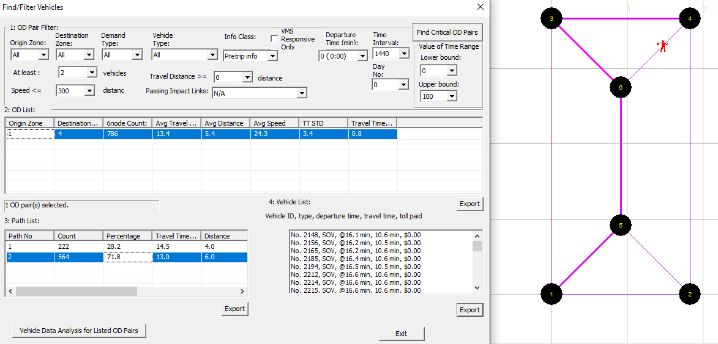

**Figure 12:** Route choice for travelers with pre-trip information

Filtering for travelers with en-route information also shows that two different routes were utilized and an average travel time of 13.2 minutes, as shown in Figure 13. Note: It may be necessary to change the value in the field labeled “At Least # Vehicles” to view data for en-route travelers in this example. The data in the Vehicle List shows that no drivers with en-route information select the route through the incident during the second hour of the simulation (during the incident), as expected.

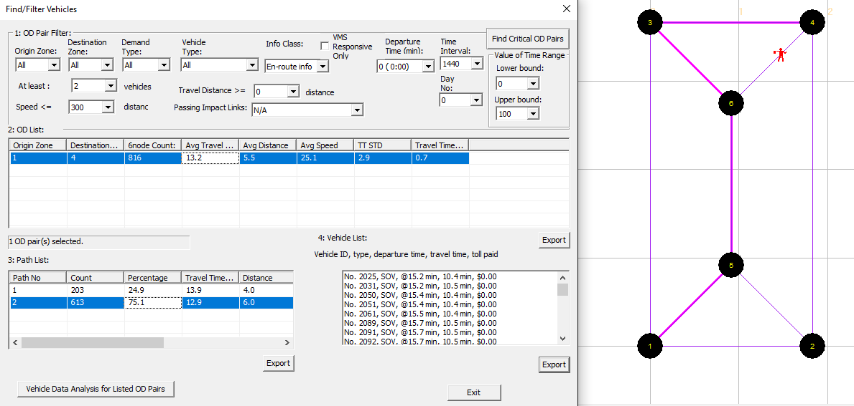

**Figure 13:** Route choice for travelers with en-route information

Comparing between information classes, the average travel time in this example is lowest for drivers with en-route information. Although, en-route information may be no better than pre-trip information in some situations when the number of vehicles are less. It is also interesting to note that the alternative paths used by drivers with en-route information are not the same as those used by drivers with pre-trip information – the en-route paths include Node 5, while the pre-trip paths do not. This is due to the fact that the drivers with en-route information adjust their routes after their departure, meaning that they must travel along the first link in their path (along Nodes 1, 5, 6, & 4) before changing their route. The drivers with pre-trip information select their routes before departure, allowing them to select routes excluding Node 5. These paths are shown in Figure 14.

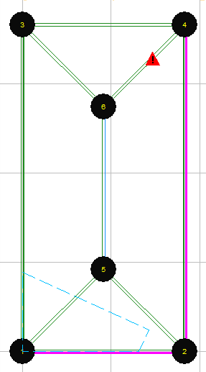 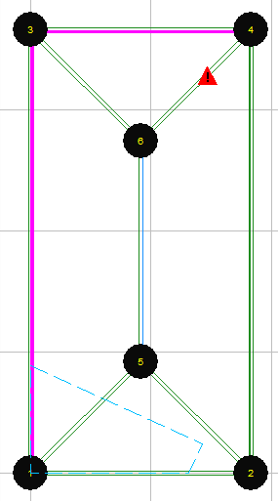 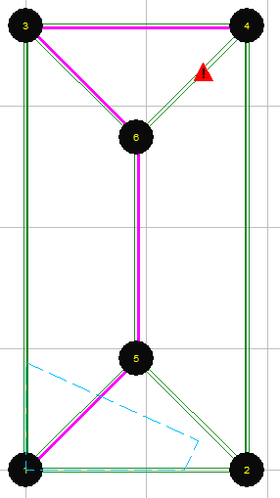 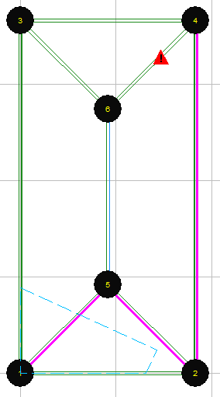

**Figure 14:** Alternative paths for pre-trip (left half) and en-route information users (right half)

Those paying careful attention may have noticed that slightly more than 10% of the travelers had pre-trip information, and slightly fewer than 10% had en-route information – both differ from values specified in the simulation settings file. As these characteristics are randomly assigned to the agents based on a uniform probability distribution, small samples will experience more variance from the specified values in the input_demand_type.csv file.

# Case 3: Incident Modeling with Traveler Information and VMS

The third step in this example is to add a VMS to the link between Node 1 and Node 5 to observe its potential route choice impacts. To add a VMS to a link, select the link by selecting the Link Layer, and use the Select Object tool to select the link (in this case, between Node 1 and Node 5). Then, select the VMS Layer, right-click, and select Add VMS on Selected Link, as shown in Figure 15. A new window will open, shown in Figure 16, creating a new variable message sign in the table and allowing the user to adjust the VMS settings in the simulation.

Just as when changing the incident conditions, each field in the VMS table can be edited by double-clicking on a cell. In this case, edit the Start Day No. and End Day No. to display messages on Day 1, change the start time and end time to 80 and 140 minutes, respectively, number of detour routes is 2. Detour route 1 is represented as “3;5;6;3;0.6”, which means that the detour route 1 has three nodes and the route is 5🡪6🡪3, and 60% percent of travelers at node 5 will choose route 1 when facing the VMS. Similarly, detour route 2 is represented as “3;5;6;4;0.4”. All details are shown in the Figure 16 below. Press the Save Data button to save any changes. Alternatively, these changes can also be made in Excel in the Scenario_Dynamic_Message_Sign.csv file in the project folder, which can also be accessed using the Edit File in Excel button.

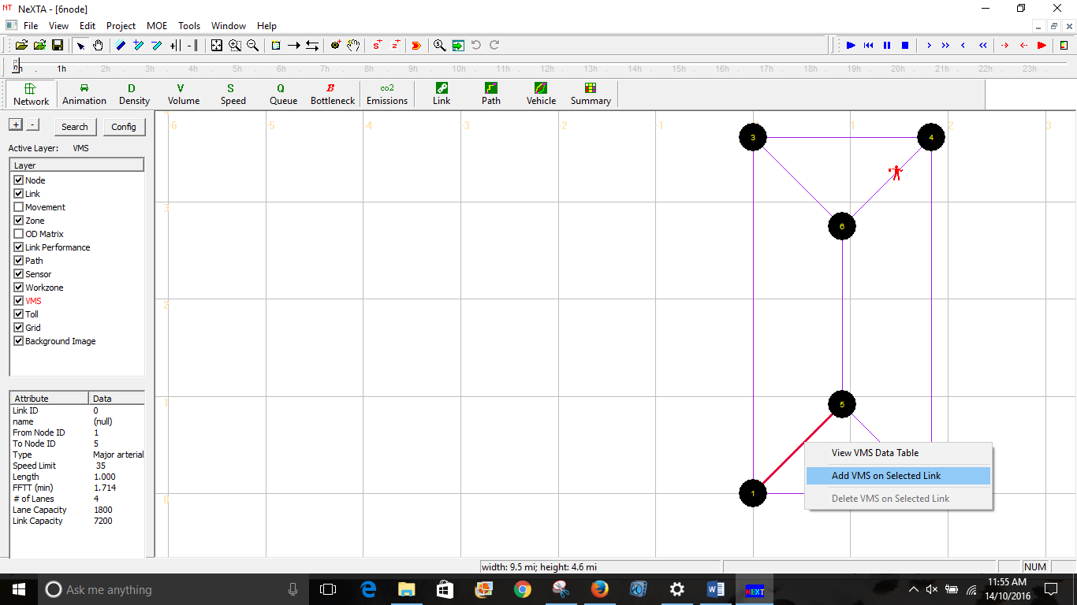

**Figure 15:** Adding VMS to links in NeXTA

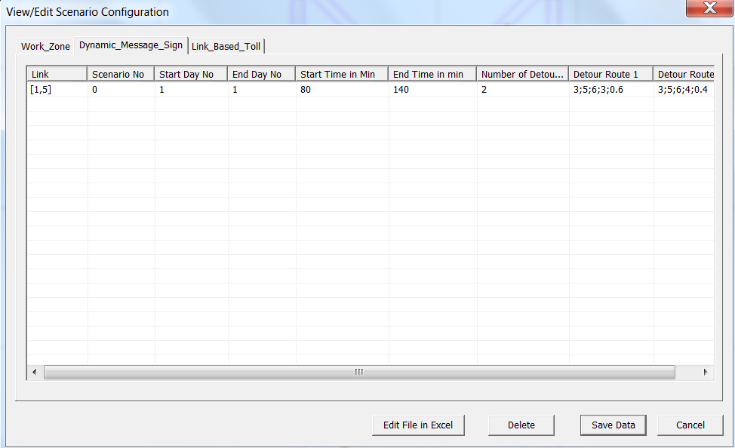

**Figure 16:** Editing VMS attributes in Case 3

**Run the simulation again**, using the same settings based on case 2 for comparison to Case 1 and Case 2. Load the simulation results in NeXTA again, and use the same technique to view the route choice data: Open the Vehicle Data Analysis Tool in NeXTA by clicking the Vehicle button , and populate the Path List by selecting the 1st row in the OD List again.

**Figure 18:** Updated path information in Case 3 due to traveler information and VMS

With the new simulation results, we first notice that the Path List has changed slightly from Case 2. There are still multiple paths in the Path List, but the percentage of drivers taking the route with the incident has decreased, as shown in Figure 18. The third column in the Path List shows that 85.3% of drivers used the previous route (through the incident), while 14.7% used detours. The fourth column in the Path List shows that the drivers taking detours experienced shorter average travel times again, but the average travel time through the incident is slightly lower than in Case 2 (11.6 minutes vs. 12 minutes).

By filtering for travelers with historical information, the Path List shows that drivers now use two additional alternative paths which were unused before by drivers within this information class. Viewing the Vehicle Data associated with these alternative paths in the Path List, the drivers using these alternative paths only have departure times within the time period in which the VMS is functioning (between 80 and 140 minutes), as shown in Figure 19. Additionally, the vehicle path data shows that the drivers affected by the VMS experience significant travel time savings. The drivers affected by VMS saved approximately 6 minutes (6 minutes vs. 12.7 minutes), based on average travel times. However, the travel time savings is much higher when comparing vehicles with similar departure times – vehicles leaving near the 85th minute in this information class were experiencing 30-40 minute travel times, compared to the 6 minute travel time experienced by Vehicle 85.

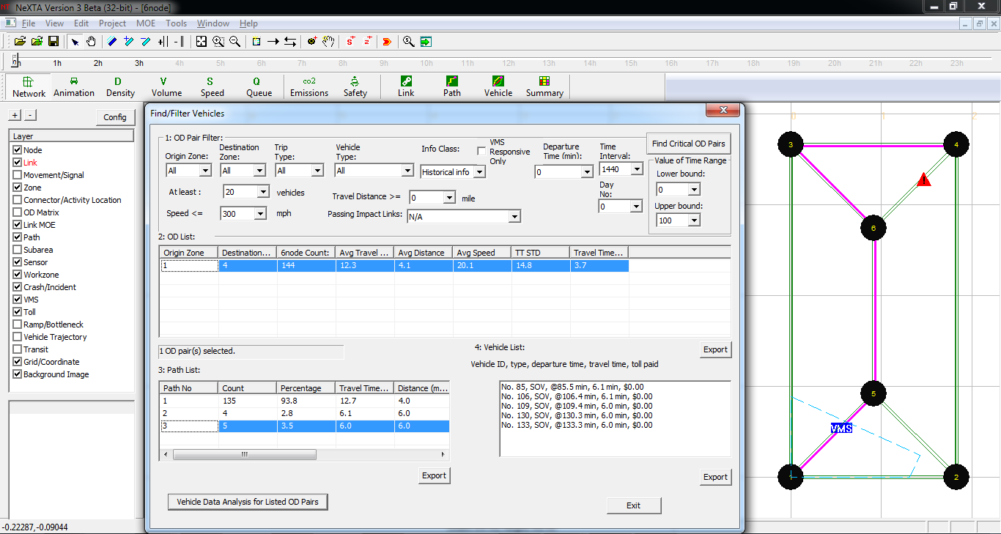

**Figure 19:** Vehicle data for alternative paths used by drivers with historical information, due to VMS

To quickly find the vehicles affected by the VMS, click on the VMS Responsive Only check box (near the Info Class filter field used previously). The results (without using the information class filter), shown in Figure 20 below, identify 10 vehicles which change their paths due to the VMS.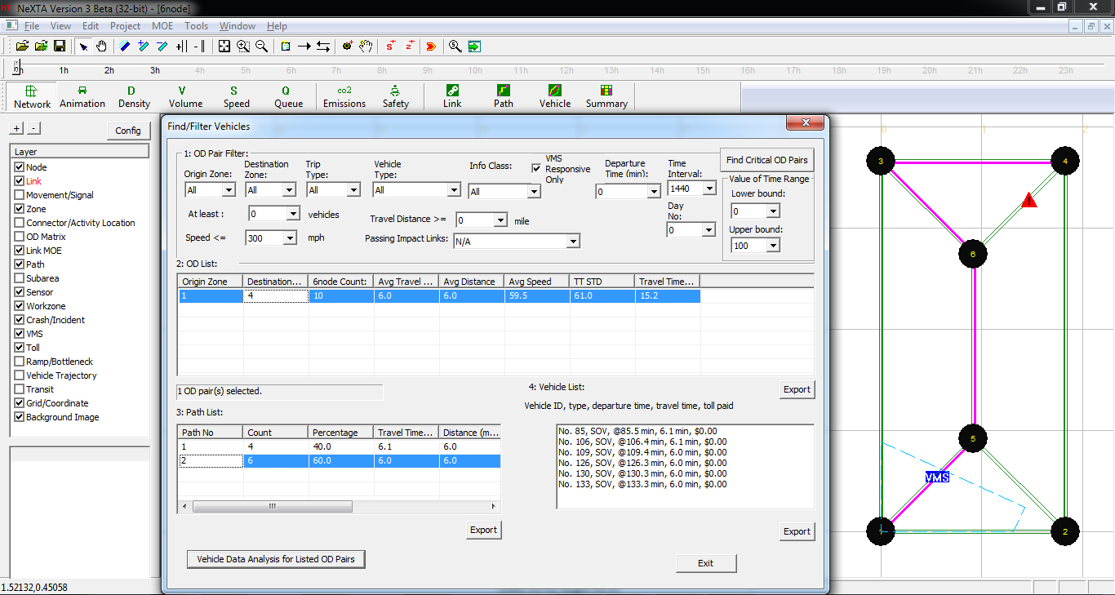

**Figure 20:** Path data for all vehicles affected by VMS in Case 3

Figure 19 shows 9 vehicles affected by VMS (choosing alternative paths) while Figure 20 shows 10 vehicles affected by VMS, indicating that a vehicle from another information class was affected by the VMS. After testing different combinations of information class and VMS response in the filters, it appears that a single driver with en-route information was affected by the VMS, as shown in Figure 21.

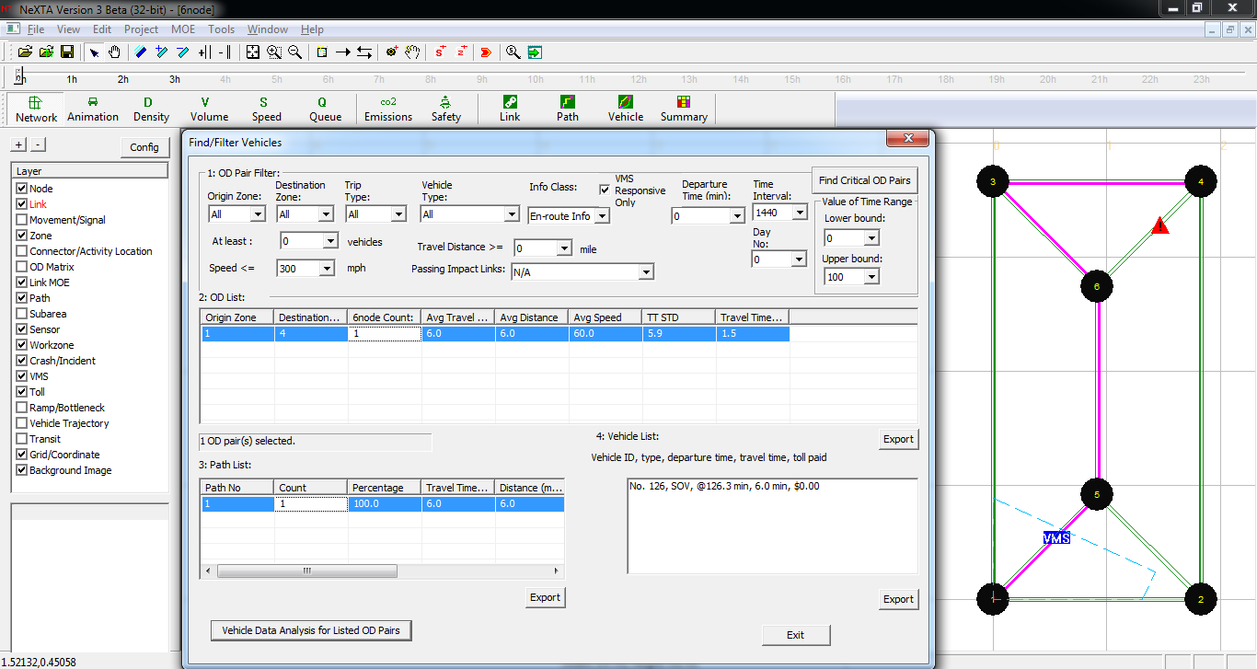

**Figure 21:** Drivers with en-route information affected by VMS in Case 3

# Viewing Detailed Simulation Data without NeXTA

As mentioned in Case 1, nearly all of the information provided within the Vehicle Data Analysis Tool can be found in a simple text format in the output_agent.csv file in the project folder. This file contains information about each vehicle in the simulation, including departure time/location, destination arrival time/location, demand information (demand type, pricing type, information class VOT, etc.), and path data (path/node sequence, path travel time data, etc.). Additionally, vehicles which responded to the VMS are identified using a code in the VMS_response_info field.

**Recommendation**

If you find that some instructions/questions are unclear or have recommendations for improvement, please add a comment to this online document (Insert → Comment, or use the Comments button at the top-right corner), and/or contact the author at xzhou99@gmail.com, so that we can improve this working document for you and other users/students. Thanks!