Chapter 2: Comprehensive Guide to the User Equilibrium Principle: A Two-Corridor Example and an Exploration of Braess’s Paradox

|  |
| --- |
| In the world of transportation and traffic engineering, the User Equilibrium Principle is a fundamental concept that helps us understand how individuals' selfish choices can impact the overall performance of a network.  Imagine a scenario where you have a road network with different routes connecting various points. Each route has a certain capacity, and cars start from different points and have specific destinations. In this situation, we want to determine how the traffic flow will be distributed throughout the network.  Traditionally, one might assume that adding more capacity to the road network would lead to improved traffic flow. However, Braess's Paradox, discovered by the German mathematician Dietrich Braess, challenges this assumption. It states that when individuals selfishly choose their routes based on what seems best for them, increasing the capacity of the network can sometimes lead to a decrease in overall performance.  Here's why this paradox occurs: The preference for a particular route not only depends on the quality of the road itself but also on the density of traffic flow. If each driver selects the path that appears most favorable to them individually, the resulting travel times may not be minimal for everyone. Surprisingly, Braess's Paradox demonstrates that expanding the road network could cause a redistribution of traffic that ultimately leads to longer travel times for individual drivers.  In this comprehensive guide, we will delve deeper into the User Equilibrium Principle and explore a specific example involving a two-corridor scenario. By understanding the principles behind Braess's Paradox and the User Equilibrium Principle, we can gain valuable insights into traffic behavior and network optimization.  So, let's embark on this journey to uncover the intricacies of the User Equilibrium Principle and explore Braess's Paradox together!  *Source: http://en.wikipedia.org/wiki/Braess%27s_paradox* |

|  |  |
| --- | --- |
| https://lh4.googleusercontent.com/k5G6i4tAaRMu-FP3V4z6fiuGIF4bQo1aMIRIgC_NAAojjiBd3T_Y7EtkFcC1vTeQhmqZSAarIZROkXzMBMnOzKP6pPute1cLSec8A2M5u5-rGvOUNpQ* | https://lh5.googleusercontent.com/eytcObaOy7YedOCRUUV_wnUNmgENflqwlftxlOl3IDuGYq-GD0uBuB1mvLDxEIQ27pb52D6wws5Dak1q-QPrQ8FFf_fngB7rU6yECYxkwe-xt8z1AF4* |

**Contents**

**Learning objectives:**

1. Creating a GMNS Network in an Excel File for Traffic Assignment In this section, you will learn how to build a GMNS (General Modeling Network Specification) network using an Excel file. This will enable you to perform traffic assignment and analyze the flow of traffic within the network.
2. Modeling Principles of User Equilibrium Understanding the principles of user equilibrium is crucial for comprehending the behavior of individual users in a transportation network. This section will provide you with a solid foundation in the modeling principles of user equilibrium, allowing you to grasp how individuals make route choices based on their preferences.
3. Setting Up BPR Function Parameters for Special Link Types The Bureau of Public Roads (BPR) function is commonly used to represent the relationship between traffic flow and travel time on a road link. However, special link types may require different parameters for accurate modeling. In this section, you will learn how to set up BPR function parameters specifically tailored to these special link types.
4. Analyzing the Impact of Adding a Link on Performance Adding a new link to a transportation network can have significant effects on its performance. In this section, we will explore how the addition of a link influences the network's performance at various levels, including the link level, path level, and network level. This analysis will provide insights into the consequences of network expansion.
5. Examining the Impact of Demand Levels on Braess's Paradox Braess's paradox, as we discussed earlier, reveals that adding capacity to a network may sometimes lead to worse overall performance. In this section, we will investigate how different levels of demand exacerbate or mitigate Braess's paradox, offering a deeper understanding of this counterintuitive phenomenon.
6. Road Pricing and Resolving Braess's Paradox Road pricing, a strategy involving the implementation of fees for road usage, has been proposed as a potential solution to alleviate Braess's paradox. In this section, we will explore the impact of road pricing on Braess's paradox and examine how it can be used to resolve the paradox, ultimately improving the overall efficiency of the transportation network.

By exploring these topics, you will gain valuable insights into network modeling, traffic assignment, and the complexities surrounding Braess's paradox.

**General descriptions of traffic assignment**

Traffic assignment loads an origin-destination (OD) trip matrix onto links of a traffic network, while satisfying a certain route choice behavioral model, e.g., a deterministic static equilibrium.

Traffic assignment is used to predict/estimate how trip-makers may shift to other routes or departure time in response to a number of strategies such as road pricing, incidents, road capacity improvement and traffic signal re-timing.

For example, tolling typically lead to traffic diversion on alternative routes and/or other transportation modes, and many traffic congestion mitigation strategies should be developed to improve the capacity to which the traffic may be diverted, for example, signal optimization, traveler information provision, and transit operation.

The common time periods include morning peak, afternoon peak and off-peak, and we can use the time of day factor to calculate the trip in the peak hour (e.g., morning peak may be 11% of daily traffic) from a 24 hour demand volume.

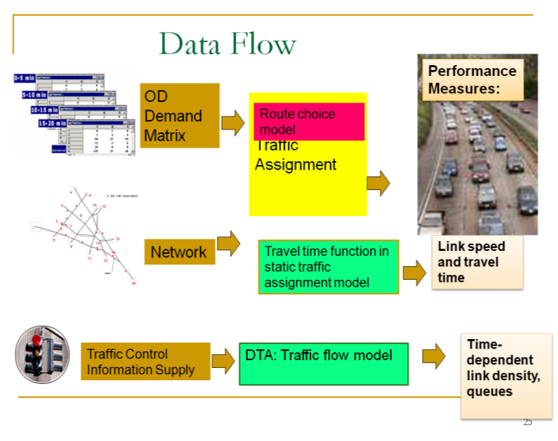

Static Traffic Assignment

There are a number of key components for static traffic assignment methods.

1. input trip table describes the flow per hour from each origin zone to each destination zone
2. a traffic network consisting of nodes, links and link volume delay functions
3. volume delay function such as BPR **(Bureau of Public Roads** **)** relationship that shows increased link travel time as an increase in link volume

*TT* = *FFTT*[1 + 0.15(v/c)4]

where:

*TT* = link travel time

*FFTT*= free-flow travel time of link

v = link flow

c = link capacity

[Remark: the link travel time function typically in only dependent on its own flow, while ignoring link volume on opposing or conflicting directions. The link capacity might not be a strict upper limit on flow, e.g. specified by highway capacity manual. ]

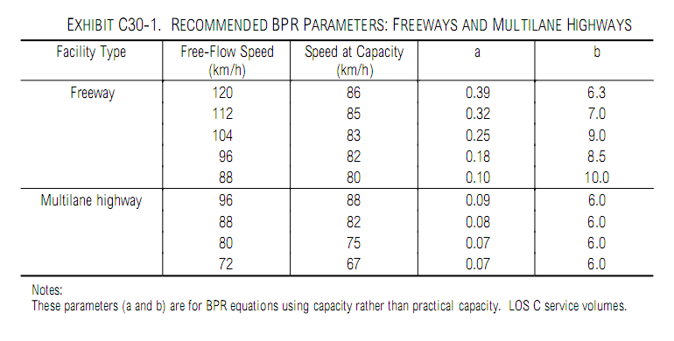

Source: HCM 2000, BPR Parameters for Freeway and Highway

As one of the ***simplest*** cases of behavior, user Equilibrium (UE) Principle assumes users are“greedy” and are familiar with the system. E*quilibrium requires iteration* to reach the following two principles:

* Principle A: No individual trip maker can reduce his path costs by switching routes.
* Principle B: All used routes between an O-D pair have equal and minimum costs

While all unused routes have greater or equal costs *(to the used path costs)*.

Wardrop (1952) proposed the user equilibrium and system optimal principles of route choice behavior in his seminal paper, and Beckman et al. (1956) formulated the static user equilibrium traffic assignment problem as an equivalent convex mathematical programming problem. Since their influential contributions, the development of the static network assignment formulations, algorithms and applications have made remarkable progress. The books by Sheffi (1985) and Patriksson (1994) provide the most comprehensive coverage on the static traffic assignment problem and its variants.

# Task 1: Build a network for static traffic assignment, and configure BPR parameters

This task will help you familiar with basic input for traffic assignment and reproduce the famous Braess paradox.

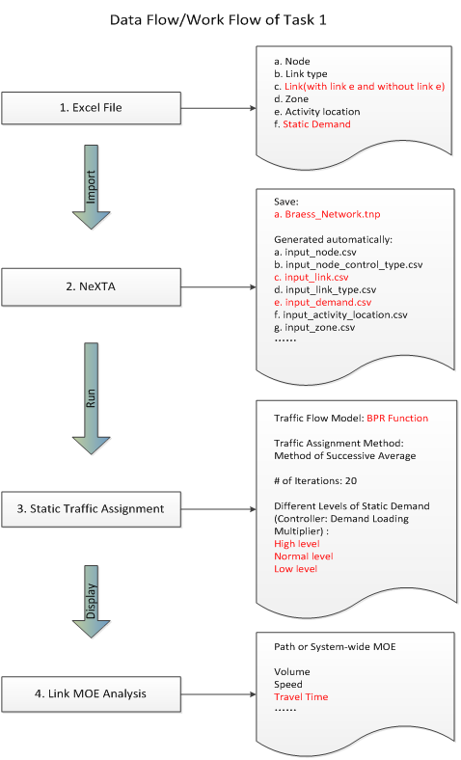

1: Locate NEXTA_32.exe, import “Braess_Network.xls” file into NEXTA to create Braess Network, and save the created network as a “Braess_Network.tnp” file.

Step 1. Locate a file called "NEXTA_32.exe" from folder \Internal_release, and launch the application.

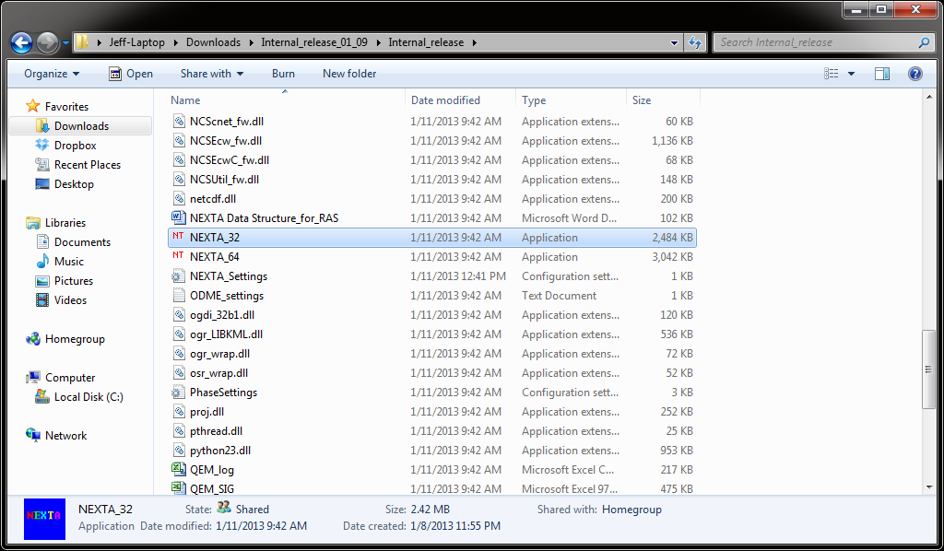

Step 2: Import the “Braess_Network.xls” file in folder “Braess's_Paradox_Network\Task1-Braess_network_without_link34 ” by clicking the “File->Import->Single Excel File(*.xls)

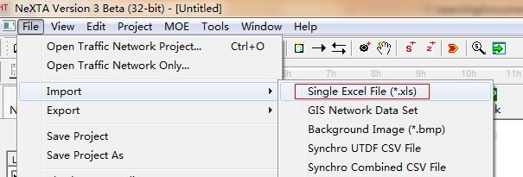

An information dialog named “Import Network and Demand Data Files” appears as below.

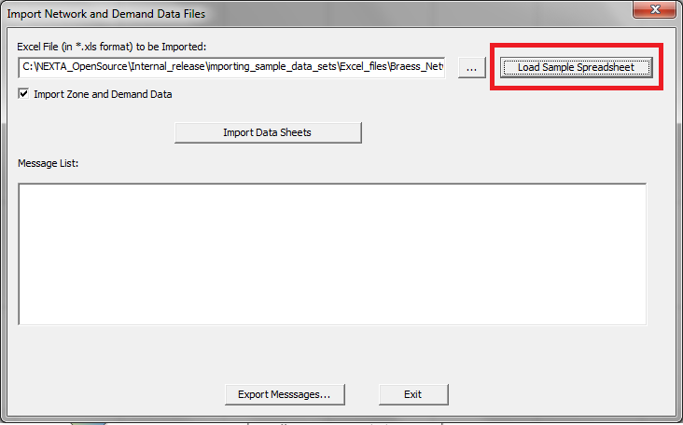

Step 3: Click the button “Load Sample Spreadsheet” to find the excel file (“importing_sample_data_sets\Excel_files\Braess_Network” to be imported. Click “Import All Tables” to build the Braess network.

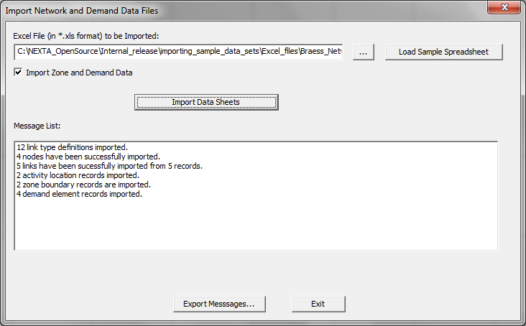

Step 4: Click “Exit” and save the project as “Braess_Network.tnp” into the same folder (as the excel file). A network with 4 nodes and 4 links are displayed in the map as shown below. Try to increase or decrease the size of nodes by using the “PageUp” and “PageDown” buttons in the keyboard respectively.

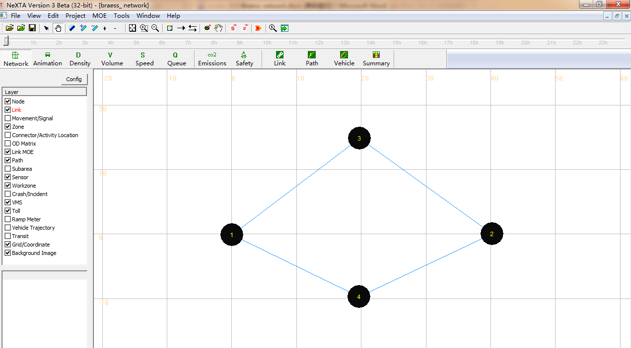

For convenience, we call link1->3; 4->2; 1->4; 3->2; 3->4 as a, b, c, d, e, respectively.



2: Run simulation for the Braess network to carry out traffic assignment using the BPR function.

Step 1: Verify the BPR parameters in the below table ( The table is from the excel file (“Braess's_Paradox_Network\Task1-Braess_network_without_link34\Braess_Network\3-link” ).

|  |  |  |  |  |  |  |
| --- | --- | --- | --- | --- | --- | --- |
|  | Travel time function | FFTT | Lane capacity | # of lanes | alpha | beta |
| Links a, b | (v/100) | 0.01 | 100 | 1 | 1 | 1 |
| Links c, d | 45 min | 45 | 1900 | 3 | 0 | 0 |

Setp 2: Select a traffic flow model and Traffic Assignment Method.

Click the button, then a dialog box named “Review Simulation/Assignment Settings” appears. Choose the option “BPR Function” under the tab “Traffic Flow Model” and “Method of Successive Average” under the tab “Traffic Assignment Method” respectively.

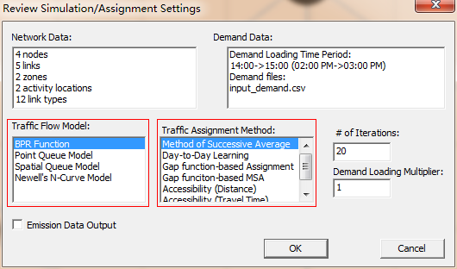

Then click “OK” to start simulation.

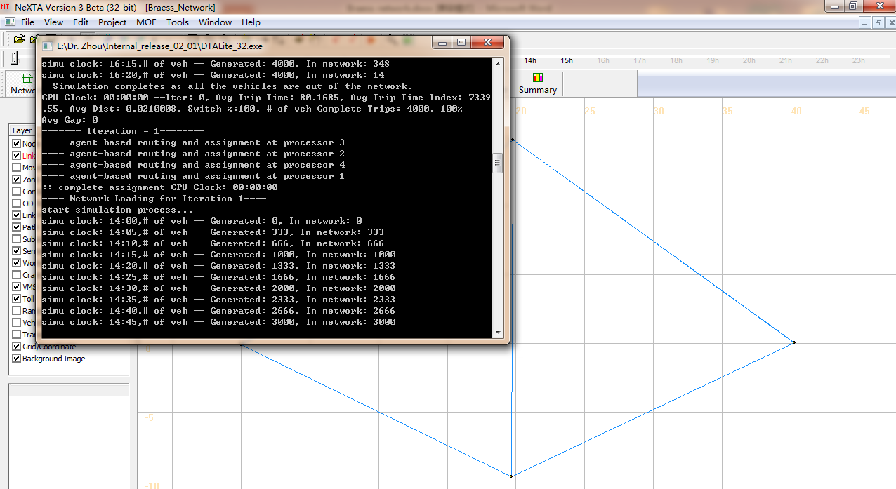

Step 3: Review summary statistics.

When the simulation ends, an information dialog appears, giving users an option of viewing essential simulation statistics.

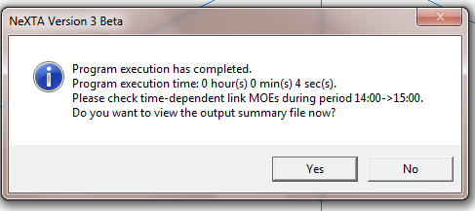

After clicking the option “Yes”, the users can see the output_summary.csv file opened in Excel, which shows detailed information about the simulation results.

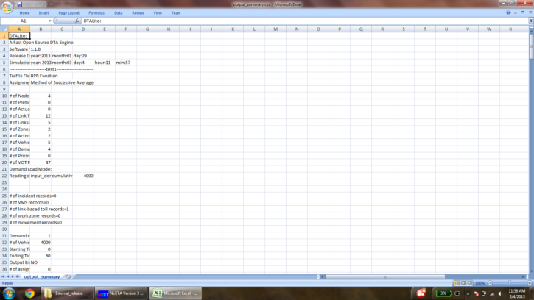

Then close the output_summary.csv file.

Step 4: Display the link volume.

This step is to visualize important link attributes and simulation results on the map. First, click  (the button to the extreme left in NEXTA), which opens up a dialog box named “Display Configuration”.

Selecting the Link Text Label to be displayed: For example, the users want “Total Link Volume” to be displayed on the map. Under the tab “Link Text Label”, choose “Total Link Volume” from the list and click “OK”.

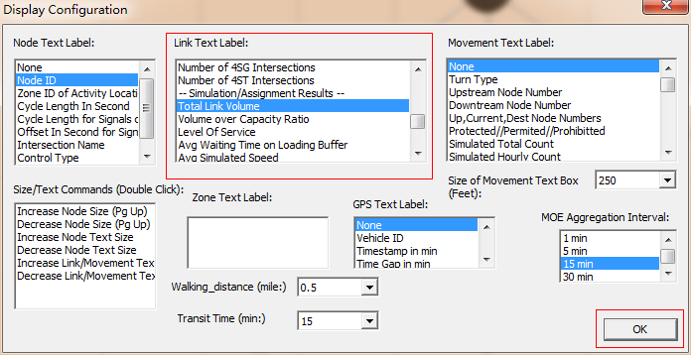

The volume values on each link are shown in the map as shown below.

|  |  |  |  |  |
| --- | --- | --- | --- | --- |
|  | a | b | c | d |
| Total Link Volume(vhc) | 2006 | 1994 | 1994 | 2006 |

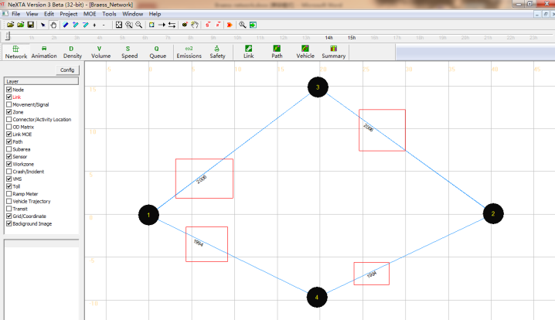

This is a modeless dialog, so users can also change the text label selected. They can select different text labels like Average travel Time(min), Link Capacity Per Hour, # of Lanes, Free Flow Travel Time and so on and see the corresponding display for the text label selected on the background map, without closing the “display configuration” dialog box.

Step 5: Prepare statistics for the base case scenario.

Use the “vehicle” button to verify the path selection information. Click the button  ,then a dialog box named “Find/Filter Vehicles” appears.

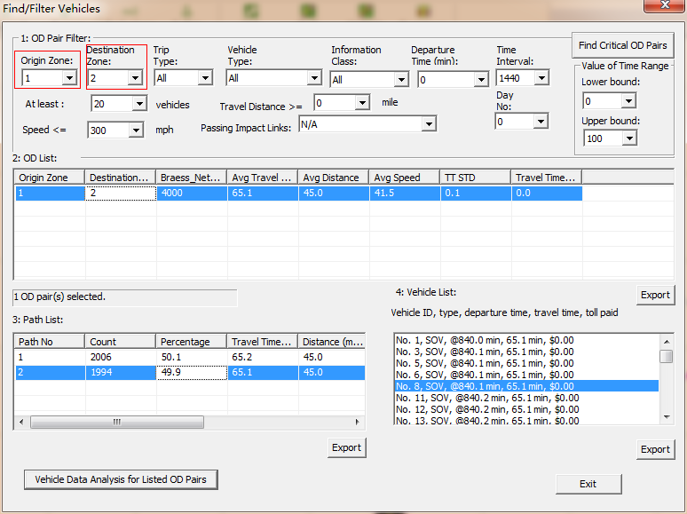

Select “1” under the tab “Origin Zone” and “2” under “Destination Zone”, which displays an OD pair from Zone 1 to Zone 2 under OD list. The Braess_Network Count, Average Travel Time, Average Distance, Average Speed, TT STD and Travel Time per Mile STD are shown in the OD list. Click on the OD list generated and we can see the path list related to the Demand, travel time at paths 1 and 2.

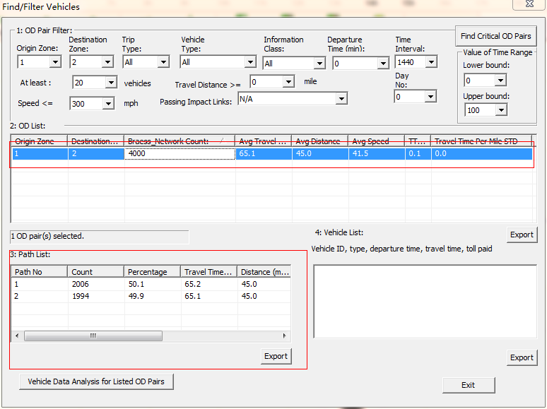

Arbitrarily, choose one path by clicking on one of the options in the “Path List” (either path 1 or path 2), and the count of the vehicles taking the selected path are shown in “Vehicle List”. At the same time, the corresponding path is also highlighted in the map.

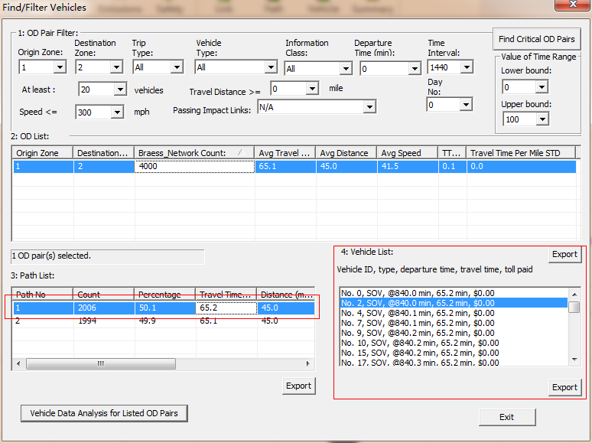

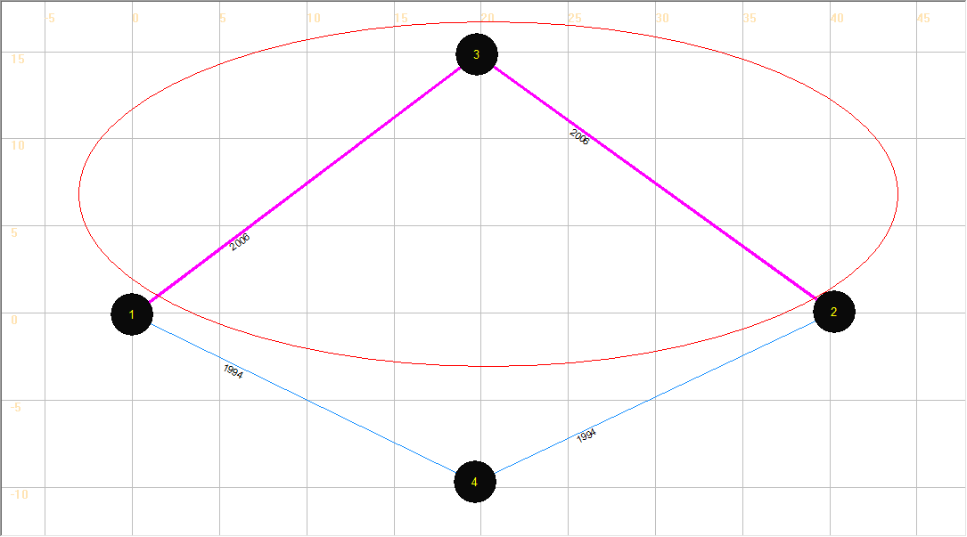

Step 6: Use the “summary” button to verify the overall network performance.

Click the button  in MOE Bar, then a dialog box named “Data Summary Dialog” appears. Select items in X Axis and Y Axis Drop-down lists (For example, select “15-min Departure Time Interval” and “Cumulative Number of Vehicles”, respectively).

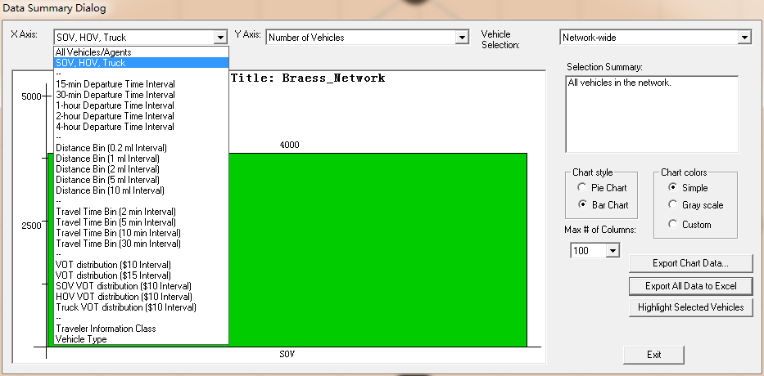

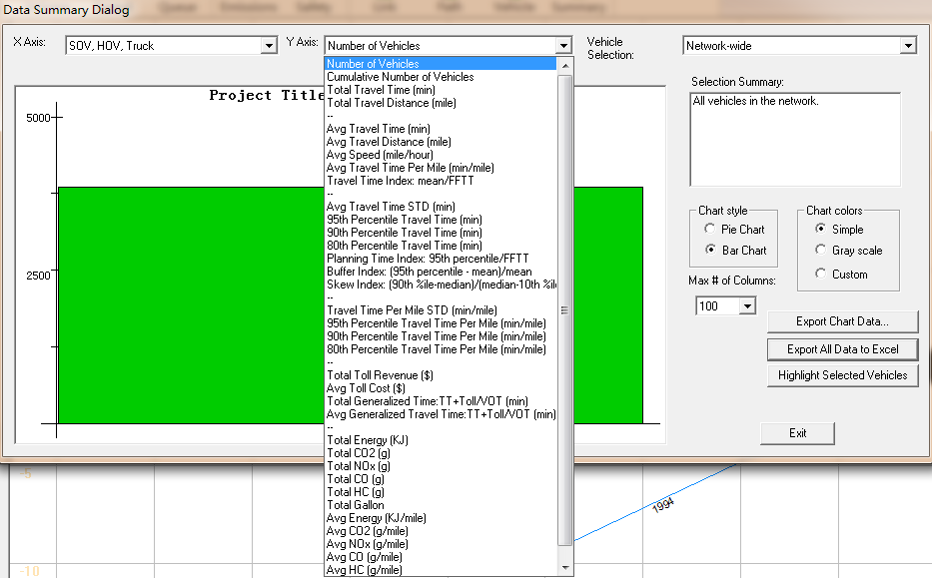

The figure showing the Cumulative Number of Vehicles is displayed as shown below.

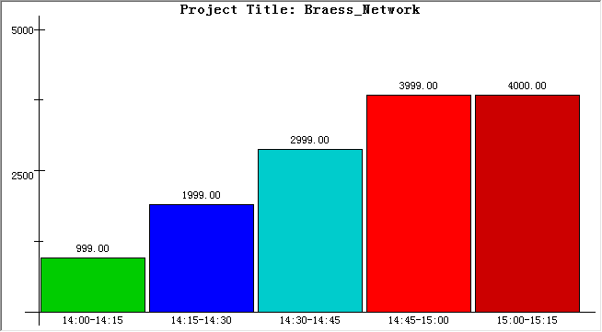

Select the item “Avg Travel Time (min)” under the Y Axis drop-down list to show the average travel time in the network.

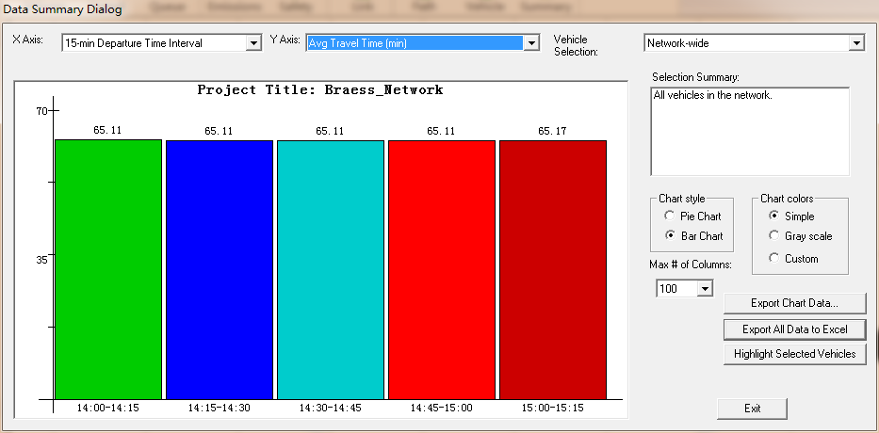

Try to change items in the drop-down lists and figure format to check other network performances.

Step 7: Close the NEXTA.

3: Add a link 3->4, or “e” into the Braess network and run the static simulation.



Step 1: Open the excel file “Braess_Network.xls” (“Braess's_Paradox_ Network \Task1-Braess_network_with_link34-static\Braess_Network.xls)” and add basic information of link 3->4 (e) into the “3-link” sheet, save and close the excel file.

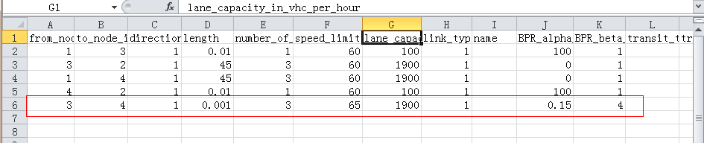

Step 2: Now, import the same excel file “Braess_Network.xls” (the one with the information added in Step 1) into NEXTA to create a new network, and then save it as “Braess_Network.tnp” in the same folder.

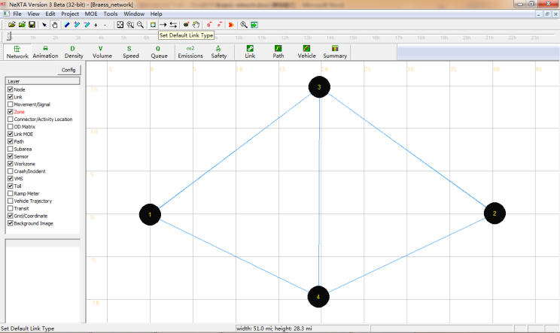

Step 3: Run the simulation for the new network by choosing “BPR Function” under the Traffic Flow Model list and “Method of Successive Average” under the “Traffic Assignment Method” list.

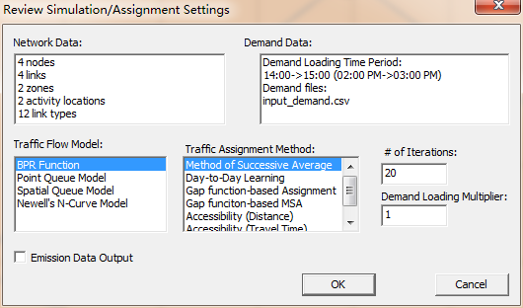

Step 4: Display the volume values on each link in the new network (Using Config).

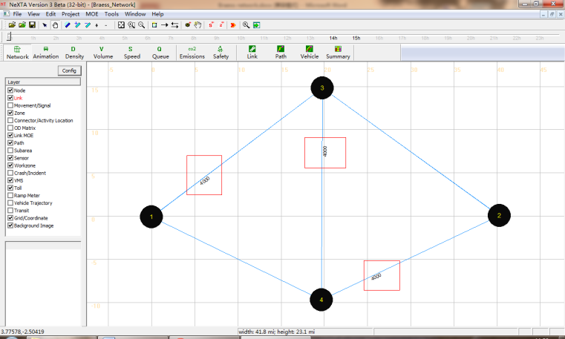

The volumes displayed on each link are shown in the table below.

|  |  |  |  |  |  |
| --- | --- | --- | --- | --- | --- |
|  | a | b | c | d | e |
| Total Link Volume(vhc) | 4000 | 4000 | 0 | 0 | 4000 |

Table: Showing the simulation result

Step 5: Vehicle path dialog.

There are 3 paths from Node 1 to Node 2 in Braess network (shown in different colors). For convenience, we mark them as path 1, path 2 and path 3 in the figure shown below.



Using NEXTA to display the shortest path in Braess network.

Click “Path” on the GIS Layer Panel. Right click on Node 1 to choose the option “Direction from here”. Node 1 becomes highlighted as the start point of the shortest path. Then right click on Node 2 to choose the option “Direction to here”.

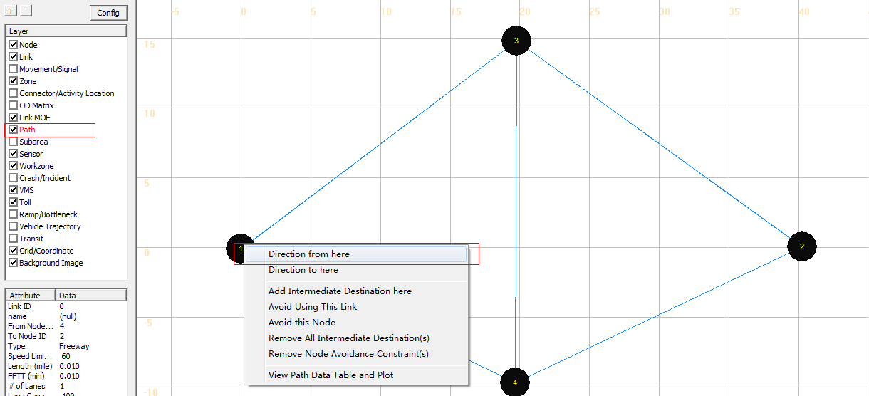

The shortest path from Node 1 to Node 2 is highlighted in the map as shown below.

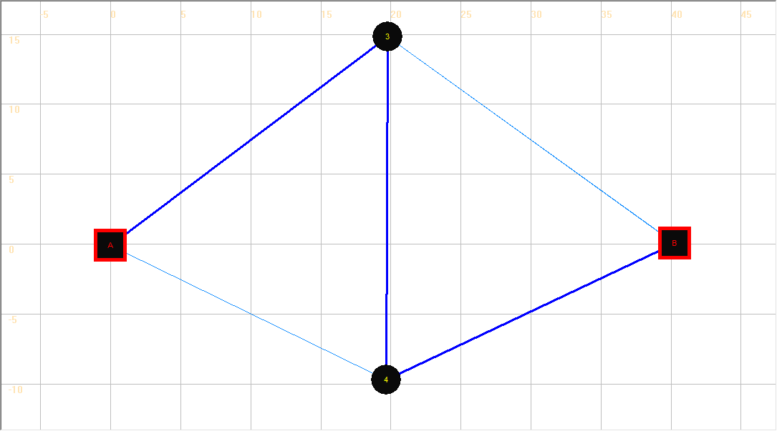

Check the shortest path in the table with the displayed path.2

|  |  |  |
| --- | --- | --- |
|  | Travel time | Flow |
| Path 1 | Link a (40.01)+Link d(45)= 85.01 min | 0 |
| Path 2 | Link c (45)+Link b(40.01)= 85.01 min | 0 |
| *Path 3* | *Link a(40.01)+Link e(0.001)+Link b(40.01)= 80.02 min* | *4000* |

Step 5: Close the NEXTA.

3: Compare system-wide performance differences between two networks.

The Braess paradox is a User Equilibrium system that is not necessarily System Optimal. Under User Equilibrium principles, the users are greedy and selfish to choose their own route for minimum costs, and users are familiar with the system. There are two principles that describe this notion of equilibrium in math formulation:

Principle A: No individual trip maker can reduce his path costs by switching routes.

Principle B: All used routes between an O-D pair have equal and minimum costs; While all unused routes have greater or equal costs (to the used path costs).

From the displayed values of the volume on two different networks mentioned above, we can complete the following table.

|  |  |  |
| --- | --- | --- |
|  | Without adding link e | Adding link e |
| Total number of vehicles | 4000 | 4000 |
| System-wide total travel time | 260040.7 | 320083.8 |
| Average travel time for each vehicles | 65.01 | 80.02 |
| Volume on link a | 2006 | 4000 |
| Volume on link c | 1994 | 0 |
| Path 1 travel time | 65.07 | 85.01 |
| Path 1 volume | 2006 | 0 |
| Path 2 travel time | 64.95 | 85.01 |
| Path 2 Volume | 1994 | 0 |
| Path 3 travel time | —— | 80.02 |
| Path 2 Volume | 0 | 4000 |

If we try to compare the travel times before and after the addition of link e, it is observed that the travel times on path 1 and 2 are shorter, before the addition of link e. After adding link e into the Braess Network, all the vehicles travel through link e, and the system-wide total travel time increases significantly. However, for one single vehicle, the driver does not have an incentive to switch his route, as the travel times for the two paths (Start-A-End and Start-B-End) are 85.01 minutes when all the other vehicles travel through link e(except for that one vehicle). Therefore, there is a paradox on Braess network under reasonable assumptions, necessary and sufficient conditions in a general transportation network.

It should be noted that the length of link e must be short enough to ensure that the travel time on path 3 is less than the travel times on both path 1 and 2.

4: Consider Link e is a Toll Link and run static simulation.

Step 1: Click  in Tool bar to open “Braess_Network.tnp” file. We can see that the Braess network with link e is displayed on the map.

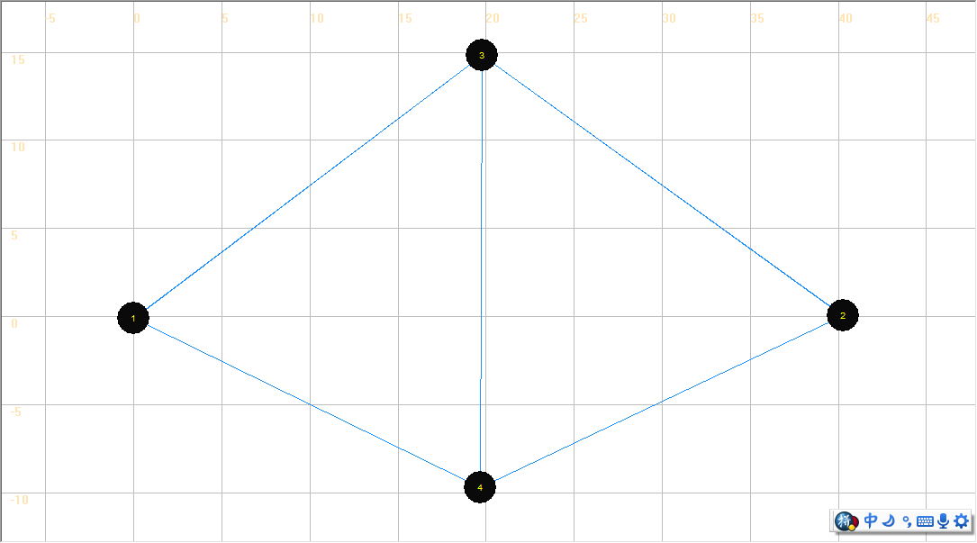

Step 2: Click “Toll” on the GIS Layer Panel, and then click  to select link e. Set link e as a Toll link by clicking “Add Link-based Toll” in the right click drop-down list.

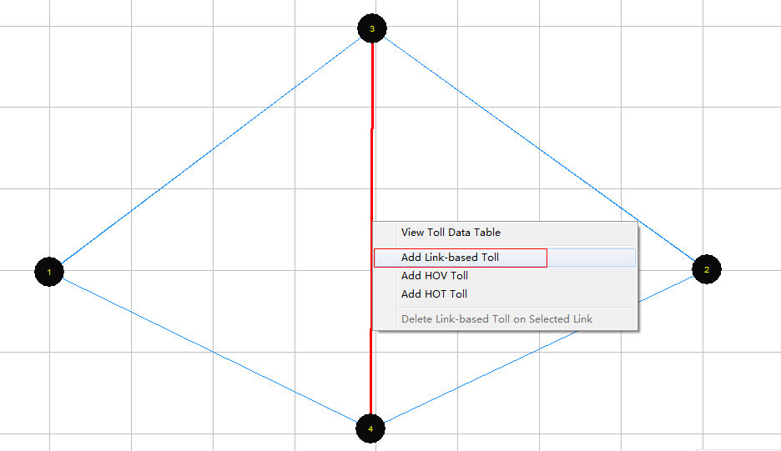

A dialog box named “View/Edit Scenario Configuration” appears. Users can modify the values of the charge of toll on the link. After the input of the desired charge of toll, click “Save Data”.

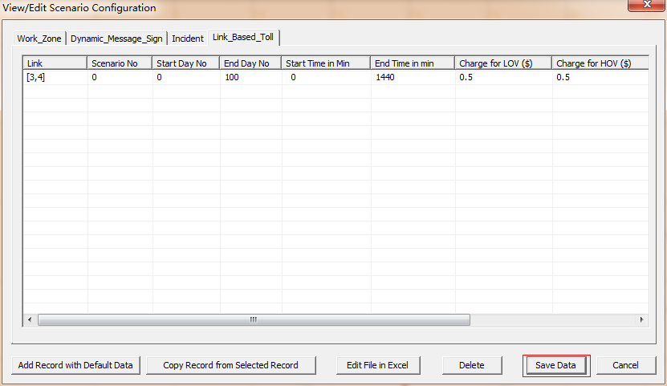

Step 3: Run simulation on the new network and display the volumes on the map.

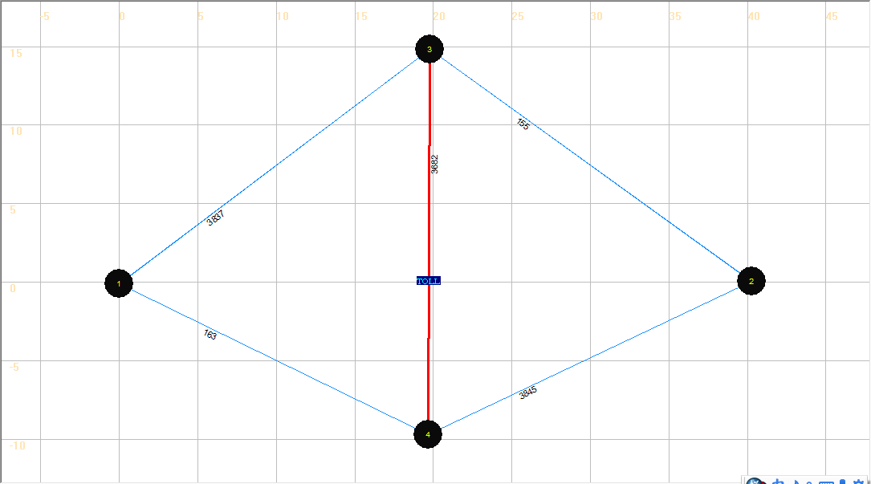

|  |  |  |  |  |  |
| --- | --- | --- | --- | --- | --- |
|  | a | b | c | d | e |
| Total Link Volume(vhc) | 3837 | 3845 | 163 | 155 | 3682 |

We can see some vehicles shifting from Path 3 to Path 1 and Path 2 because of introducing the toll on path 3.

Step 4: Close NEXTA.