Chapter 2: Comprehensive Guide to the User Equilibrium Principle: A Two-Corridor Example and an Exploration of Braess’s Paradox

|  |
| --- |
| In the world of transportation and traffic engineering, the User Equilibrium Principle is a fundamental concept that helps us understand how individuals' selfish choices can impact the overall performance of a network.  Imagine a scenario where you have a road network with different routes connecting various points. Each route has a certain capacity, and cars start from different points and have specific destinations. In this situation, we want to determine how the traffic flow will be distributed throughout the network.  Traditionally, one might assume that adding more capacity to the road network would lead to improved traffic flow. However, Braess's Paradox, discovered by the German mathematician Dietrich Braess, challenges this assumption. It states that when individuals selfishly choose their routes based on what seems best for them, increasing the capacity of the network can sometimes lead to a decrease in overall performance.  Here's why this paradox occurs: The preference for a particular route not only depends on the quality of the road itself but also on the density of traffic flow. If each driver selects the path that appears most favorable to them individually, the resulting travel times may not be minimal for everyone. Surprisingly, Braess's Paradox demonstrates that expanding the road network could cause a redistribution of traffic that ultimately leads to longer travel times for individual drivers.  In this comprehensive guide, we will delve deeper into the User Equilibrium Principle and explore a specific example involving a two-corridor scenario. By understanding the principles behind Braess's Paradox and the User Equilibrium Principle, we can gain valuable insights into traffic behavior and network optimization.  So, let's embark on this journey to uncover the intricacies of the User Equilibrium Principle and explore Braess's Paradox together!  *Source: http://en.wikipedia.org/wiki/Braess%27s_paradox* |

|  |  |
| --- | --- |
| https://lh4.googleusercontent.com/k5G6i4tAaRMu-FP3V4z6fiuGIF4bQo1aMIRIgC_NAAojjiBd3T_Y7EtkFcC1vTeQhmqZSAarIZROkXzMBMnOzKP6pPute1cLSec8A2M5u5-rGvOUNpQ* | https://lh5.googleusercontent.com/eytcObaOy7YedOCRUUV_wnUNmgENflqwlftxlOl3IDuGYq-GD0uBuB1mvLDxEIQ27pb52D6wws5Dak1q-QPrQ8FFf_fngB7rU6yECYxkwe-xt8z1AF4* |

**2.1 Learning objectives:**

1. Creating a GMNS Network in an Excel File for Traffic Assignment In this section, you will learn how to build a GMNS (General Modeling Network Specification) network using an Excel file. This will enable you to perform traffic assignment and analyze the flow of traffic within the network.
2. Modeling Principles of User Equilibrium Understanding the principles of user equilibrium is crucial for comprehending the behavior of individual users in a transportation network. This section will provide you with a solid foundation in the modeling principles of user equilibrium, allowing you to grasp how individuals make route choices based on their preferences.
3. Setting Up BPR Function Parameters for Special Link Types The Bureau of Public Roads (BPR) function is commonly used to represent the relationship between traffic flow and travel time on a road link. However, special link types may require different parameters for accurate modeling. In this section, you will learn how to set up BPR function parameters specifically tailored to these special link types.
4. Analyzing the Impact of Adding a Link on Performance Adding a new link to a transportation network can have significant effects on its performance. In this section, we will explore how the addition of a link influences the network's performance at various levels, including the link level, path level, and network level. This analysis will provide insights into the consequences of network expansion.
5. Examining the Impact of Demand Levels on Braess's Paradox Braess's paradox, as we discussed earlier, reveals that adding capacity to a network may sometimes lead to worse overall performance. In this section, we will investigate how different levels of demand exacerbate or mitigate Braess's paradox, offering a deeper understanding of this counterintuitive phenomenon.
6. Road Pricing and Resolving Braess's Paradox Road pricing, a strategy involving the implementation of fees for road usage, has been proposed as a potential solution to alleviate Braess's paradox. In this section, we will explore the impact of road pricing on Braess's paradox and examine how it can be used to resolve the paradox, ultimately improving the overall efficiency of the transportation network.

By exploring these topics, you will gain valuable insights into network modeling, traffic assignment, and the complexities surrounding Braess's paradox.

**2.2 Teaching sidenotes: Addressing the Challenge: Balancing Visualization Tools and Hand-Computed Results in Traffic Assignment**

Addressing the challenge of managing multiple scenarios with Nexta or QGIS visualization while ensuring students understand their hand-computed results compared to Excel or CSV outputs can be approached in the following way:

1. Emphasize the importance of understanding the underlying computations: Before diving into visualization tools like Nexta or QGIS, it is crucial for students to have a solid understanding of the calculations and methodologies behind the traffic assignment process. This includes comprehending the algorithms, formulas, and data manipulation techniques used to obtain results.
2. Provide hands-on exercises with Excel or CSV outputs: Incorporate practical exercises where students perform traffic assignment calculations using Excel or CSV files. This will help them develop a deep understanding of the computations involved and allow them to gain confidence in interpreting the results.
3. Encourage result comparison and verification: Encourage students to compare their hand-computed results with those obtained through Nexta or QGIS visualization. This comparison will allow them to identify any discrepancies or errors and reinforce their understanding of the underlying concepts. It is important to emphasize that visualization tools serve as aids but should not replace the need to comprehend and verify the computed results manually.
4. Utilize visualization tools as supplementary aids: Introduce Nexta or QGIS visualization as supplementary tools to enhance the students' understanding of the traffic assignment results. These tools can provide visual representations of the data, allowing for easier interpretation and communication of the outcomes. However, it is essential to ensure that students first have a solid grasp of the underlying calculations before relying solely on visualizations.
5. Encourage critical thinking and interpretation: Throughout the learning process, encourage students to think critically and interpret the results obtained from both hand computations and visualization tools. This will help them develop a holistic understanding of the traffic assignment process, its limitations, and the insights gained from different approaches.

By combining hands-on exercises, result comparison, and the gradual integration of visualization tools, students can develop a comprehensive understanding of traffic assignment while effectively managing multiple scenarios. This approach will enable them to gain confidence in their computations and enhance their ability to analyze and interpret results accurately.

**2.3 General descriptions of traffic assignment**

Traffic assignment loads an origin-destination (OD) trip matrix onto links of a traffic network, while satisfying a certain route choice behavioral model, e.g., a deterministic static equilibrium.

Traffic assignment is a vital process that involves distributing trips from their origin to destination onto specific links within a traffic network. This distribution is carried out while adhering to a chosen behavioral model for route selection, such as a deterministic static equilibrium.

The purpose of traffic assignment is to forecast and estimate how individuals making trips may alter their route choices or departure times in response to various strategies or conditions. These strategies could include factors like road pricing, incidents, improvements in road capacity, or adjustments in traffic signal timings.

For instance, implementing tolls on certain routes often leads to a diversion of traffic onto alternative routes or encourages the use of other modes of transportation. In order to accommodate the redirected traffic, it becomes necessary to develop congestion mitigation strategies. These strategies may involve optimizing traffic signal timings, providing traveler information, or enhancing the operation of public transit.

Typically, the analysis of traffic assignment considers different time periods, including morning peak, afternoon peak, and off-peak periods. To calculate the volume of trips during peak hours (e.g., morning peak representing around 11% of the daily traffic), a time of day factor is employed. This factor allows for the estimation of trip demand specifically within the peak hour from the overall 24-hour demand volume.

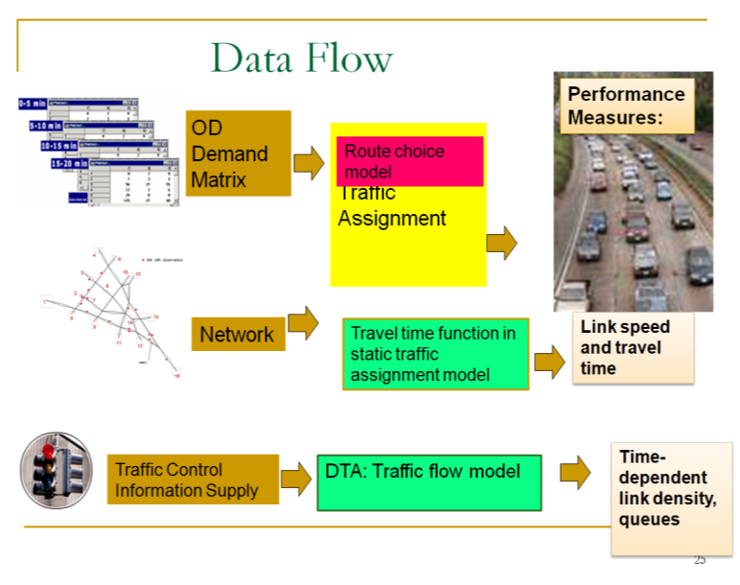

Static Traffic Assignment

There are a number of key components for static traffic assignment methods.

1. input trip table describes the flow per hour from each origin zone to each destination zone
2. a traffic network consisting of nodes, links and link volume delay functions
3. volume delay function such as BPR **(Bureau of Public Roads** **)** relationship that shows increased link travel time as an increase in link volume

*TT* = *FFTT*[1 + 0.15(v/c)4]

where:

*TT* = link travel time

*FFTT*= free-flow travel time of link

v = link flow

c = link capacity

[Remark: the link travel time function typically in only dependent on its own flow, while ignoring link volume on opposing or conflicting directions. The link capacity might not be a strict upper limit on flow, e.g. specified by highway capacity manual. ]

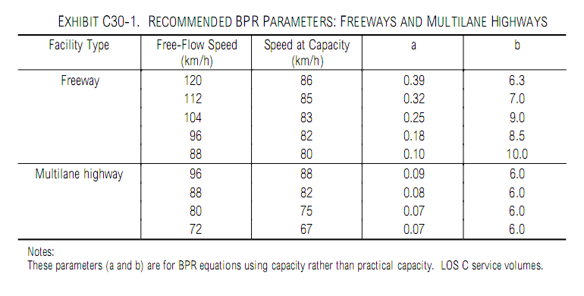

Source: HCM 2000, BPR Parameters for Freeway and Highway

The User Equilibrium (UE) Principle, considered one of the simplest cases of behavior, assumes that users in a transportation system are self-interested ("greedy") and possess knowledge about the network. Achieving equilibrium under this principle involves an iterative process guided by the following two principles:

* Principle A: No individual trip maker can reduce their path costs by switching routes. In other words, each traveler chooses the route that seems most favorable to them based on their own preferences and knowledge of the system.
* Principle B: All used routes between an origin-destination (O-D) pair have equal and minimum costs, while all unused routes have costs that are greater than or equal to the costs of the used paths.

The concept of user equilibrium was first introduced by Wardrop in 1952, who proposed both the user equilibrium and system optimal principles of route choice behavior in his influential paper. Beckman et al. (1956) subsequently formulated the static user equilibrium traffic assignment problem as an equivalent convex mathematical programming problem.

Since these pioneering contributions, significant progress has been made in the development of static network assignment formulations, algorithms, and applications. Notably, Sheffi (1985) and Patriksson (1994) have authored comprehensive books that extensively cover the static traffic assignment problem and its various variants, offering valuable insights into the subject.

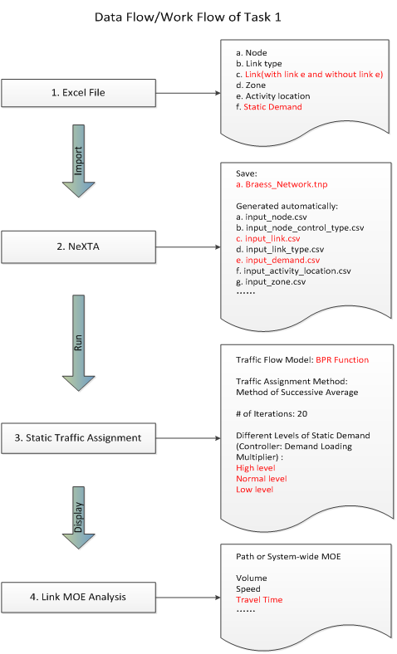

## **2.4** Two-corridor Examples for Computing Static User Equilibrium

This example uses a simple case with a single origin-to-destination pair and two paths p=1 for the primary path, p=2 for the alternative path, see in Figure 3.1 As each path has two links, path 1 has a free-flow travel time of 20 minutes, and path 2 has a free-flow travel time of 30 minutes.

Figure 2.XX illustrative example of two-corridor network

For a given OD demand of 7,000 on this network, we can use the User Equilibrium method to perform traffic assignment. A graphic-based solution process can be described by Figure 3.2. As the path flow changes, the travel time on the two paths reaches the same equilibrium point, which satisfied the requirement of User Equilibrium. User equilibrium solution is reached when the freeway flow is 5400, and arterial flow as 7000-5400=1600, and this leads to the same travel time of 30 min on both routes.

Figure 2.XX illustration of Equilibrium with X axis as freeway path flow.

The detailed parameters are in Table 3.1.

Table 2.XX parameters

|  |  |
| --- | --- |
| **Parameters** | **Value** |
| Freeway flow travel time (min): Freeway: | 20 |
| Freeway flow travel time (min): Arterial: | 30 |
| Capacity (vehicles / hour): Freeway: | 4000 |
| Capacity (vehicles / hour):Arterial: | 3000 |
| Demand | 7000 |
| BPR alpha | 0.15 |
| BPR beta | 4 |

The travel time function is

Freeway_TT = FFTT[1 + 0.15(v/c)4]

Arterial _TT= FFTT[1 + 0.15((demand-v)/c)4]

where:

TT = link travel time

FFTT= free-flow travel time of link

v = link flow

c = link capacity

## 3.2 Detailed data structure description

Generic network files used for DTALite include files for three layers: physical layer, service layer and demand layer.

**Table 3.1 File list for DTALite**

|  |  |  |
| --- | --- | --- |
| File type | Index: file name | Description |
| Input for physical layer | 1a: *node.csv* | Define nodes in the network. |
|  | 1b.: *link.csv* | Define links in the network with essential attributes for assignment. |
| Input for demand layer | 2: *demand.csv* | Define the demand of passengers on each OD pair, which could be extracted by *demand_file_list.csv*. |
| Input configuration file | 3: *settings.csv* | Define basic setting for the Network, it contains five sections. |
|  | Scenario_index | Set the number of iteration and the mode of assignment. |
|  | mode_type | Define attributes of each type of agent, including VOT (unit: dollar per hour) and PCE. |
|  | link_type | Define types of links in the network |
|  | demand_period | Define demand period, which could be extracted by demand_file_list |
|  | demand_file_list | Define demand type, period, and format type. |
| Output file | *link_performance.csv* | Show the performance of each link, including the travel time, volume, and resource balance. |
|  | Route_assignment.csv | Show the results of the assignment, including the volume, toll, travel time and distance of each path of each agent, as well as the link sequence and time sequence. |
|  | Route_assignment.csv | Show the results of the assignment, including the volume, toll, travel time and distance of each path of each agent, as well as the link sequence and time sequence. |
|  | System_performance_summary.csv |  |

The related files used in DTALite are listed below.

**（1）Prepare input data**

* node.csv

1. Table 3.2 node.csv

|  |  |  |  |
| --- | --- | --- | --- |
| **node_id** | **zone_id** | **x_coord** | **y_coord** |
| 1 | 1 | 0.017882 | -0.12518 |
| 2 | 2 | 40.25393 | 0.053648 |
| 3 |  | 19.77825 | 14.80687 |
| 4 |  | 19.68884 | -9.69242 |

* link.csv

1. Table 3.3 link.csv

|  |  |  |  |  |  |  |
| --- | --- | --- | --- | --- | --- | --- |
| **link_id** | **from_node_id** | **to_node_id** | **facility_type** | **dir_flag** | **length** | **lanes** |
| 1003 | 1 | 3 | Freeway | 1 | 10 | 1 |
| 3002 | 3 | 2 | Freeway | 1 | 10 | 1 |
| 1004 | 1 | 4 | arterial | 1 | 15 | 1 |
| 4002 | 4 | 2 | arterial | 1 | 15 | 1 |
| **capacity** | **free_speed** | **link_type** |  | **capcaity** |  |  |
| 4000 | 60 | 1 |  | 4000 |  |  |
| 4000 | 60 | 1 |  | 4000 |  |  |
| 3000 | 60 | 2 |  | 3000 |  |  |
| 3000 | 60 | 2 |  | 3000 |  |  |

* demand.csv

1. Table 3.6 demand.csv

|  |  |  |
| --- | --- | --- |
| **o_zone_id** | **d_zone_id** | **volume** |
| 1 | 2 | 7000 |

* settings.csv

There are different sections in the settings.csv file. And each section starts with the format of [section_name] along with the field names. There are five sections in the settings.csv, see in Table 3.4.

**(2) Check output files**

The files are the output of the previous input data.

* agent.csv

Table 3.10 agent.csv

|  |  |  |  |  |  |
| --- | --- | --- | --- | --- | --- |
| **agent_id** | **o_zone_id** | **d_zone_id** | **path_id** | **o_node_id** | **d_node_id** |
| 1 | 1 | 2 | 0 | 1 | 2 |
| 2 | 1 | 2 | 1 | 1 | 2 |
| **agent_type** | **demand_period** | **agent_type** | **toll** | **travel_time** | **distance** |
| p | AM | p | 0 | 30.3224 | 20 |
| p | AM | p | 0 | 30.3224 | 30 |
|  | **node_sequence** | **link_sequence** | **time_sequence** |  |  |
|  | 1;3;2; | 1003;3002; | 0730:00;0800:19;0800:19; |  |  |
|  | 1;4;2; | 1004;4002; | 0800:19;0830:38;0830:38; |  |  |

The volume in this file represents path volume, and the path is further represented in node_sequence.

For the above example (Table 3.10), when the assignment reaches equilibrium, there are two paths to choose. For path id 0, the origin zone id is 1 and destination zone id is 2, and the node sequence of this path is 1, and travel time on this path is 30.3224 minutes, and distance of this path is 20.

Table x.11 link_performance.csv

|  |  |  |  |  |  |  |  |  |
| --- | --- | --- | --- | --- | --- | --- | --- | --- |
| **link_id** | **from_node_id** | **to_node_id** | **time_period** | **volume** | **travel_time** | **speed** | **VOC** | **notes** |
| 1003 | 1 | 3 | 0700_0800 | 5447.848 | 30.322 | 39.575 | 1.362 | period-based |
| 3002 | 3 | 2 | 0700_0800 | 5447.848 | 0 | 0 | 1.362 | period-based |
| 1004 | 1 | 4 | 0700_0800 | 1552.149 | 30.322 | 59.362 | 0.517 | period-based |
| 4002 | 4 | 2 | 0700_0800 | 1552.149 | 0 | 0 | 0.517 | period-based |

From link_performance.csv, users are able to obtain the link volume, link travel_time, speed and VOC. For the above example (Table 3.11), the first link id is 1003, and the from-node of this link is 1, and the end-node of this link is 3. From 7:00 to 8:00, the volume on this link is 5447.848, and the travel time during this period is 30.322 (min), and the speed is 39.575 mile per hour, and the volume over capacity (VOC) is 1.362.

**（3）Visualize the output in NEXTA**

Open NEXTA, import the network, chose the time period that you set in demand_period.csv, and click volume, you can see the assignment outcome in Figure 3.3.

Figure 3.3 Link volume visualization

## **2.5** Braess Examples for Computing Static User Equilibrium

1. Show the GMNS data set for Braess

1: Locate NEXTA.exe, import “Braess_Network.xls” file into

Step 1. Locate a file called "NEXTA_32.exe" from folder \Internal_release, and launch the application.

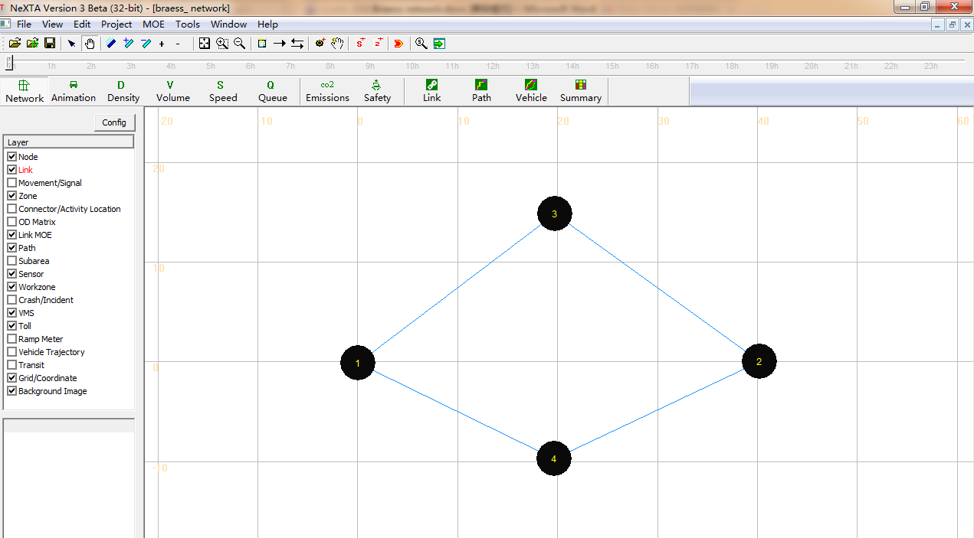

Display in NEXTA

For convenience, we call link1->3; 4->2; 1->4; 3->2; 3->4 as a, b, c, d, e, respectively.



2: Run simulation for the Braess network to carry out traffic assignment using the BPR function.

Step 1: Verify the BPR parameters in the below table ( The table is from the excel file (“Braess's_Paradox_Network\Task1-Braess_network_without_link34\Braess_Network\3-link” ).

|  |  |  |  |  |  |  |
| --- | --- | --- | --- | --- | --- | --- |
|  | Travel time function | FFTT | Lane capacity | # of lanes | alpha | beta |
| Links a, b | (v/100) | 0.01 | 100 | 1 | 1 | 1 |
| Links c, d | 45 min | 45 | 1900 | 3 | 0 | 0 |

Setp 2: Select a traffic flow model and Traffic Assignment Method.

Step 3: Review summary statistics.

Then close the output_summary.csv file.

Please use QGIS

The volume values on each link are shown in the map as shown below.

|  |  |  |  |  |
| --- | --- | --- | --- | --- |
|  | a | b | c | d |
| Total Link Volume(vhc) | 2006 | 1994 | 1994 | 2006 |

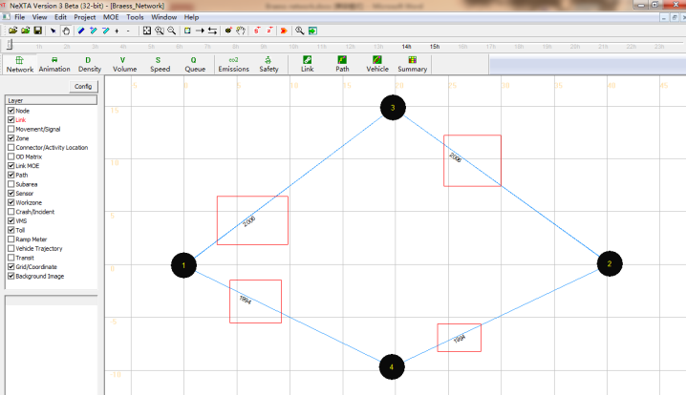

This is a modeless dialog, so users can also change the text label selected. They can select different text labels like Average travel Time(min), Link Capacity Per Hour, # of Lanes, Free Flow Travel Time and so on and see the corresponding display for the text label selected on the background map, without closing the “display configuration” dialog box.

Step 5: Prepare statistics for the base case scenario.

Use the “vehicle” button to verify the path selection information. Click the button  ,then a dialog box named “Find/Filter Vehicles” appears.

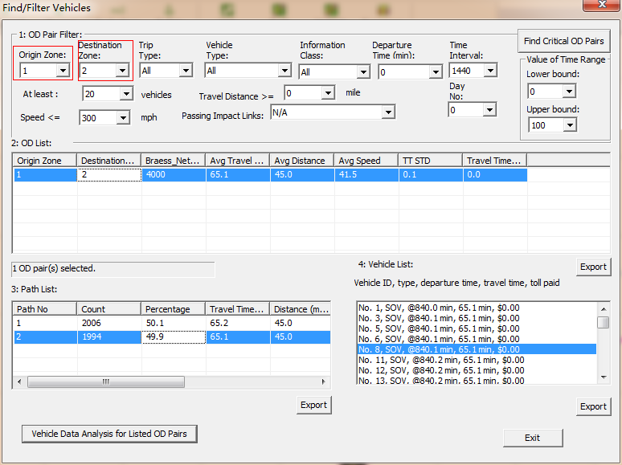

Select “1” under the tab “Origin Zone” and “2” under “Destination Zone”, which displays an OD pair from Zone 1 to Zone 2 under OD list. The Braess_Network Count, Average Travel Time, Average Distance, Average Speed, TT STD and Travel Time per Mile STD are shown in the OD list. Click on the OD list generated and we can see the path list related to the Demand, travel time at paths 1 and 2.

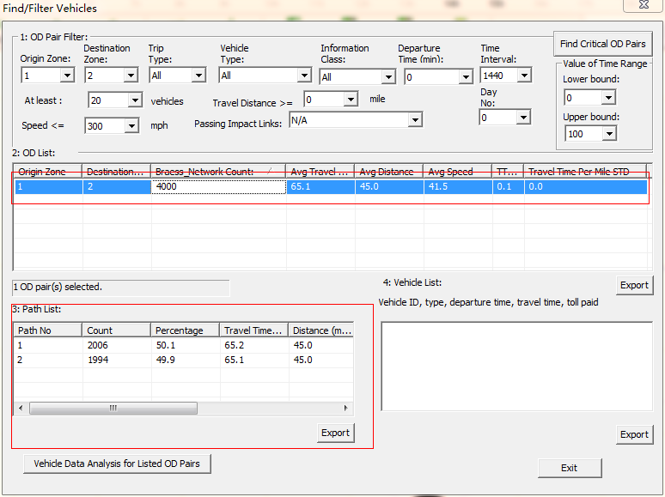

Arbitrarily, choose one path by clicking on one of the options in the “Path List” (either path 1 or path 2), and the count of the vehicles taking the selected path are shown in “Vehicle List”. At the same time, the corresponding path is also highlighted in the map.

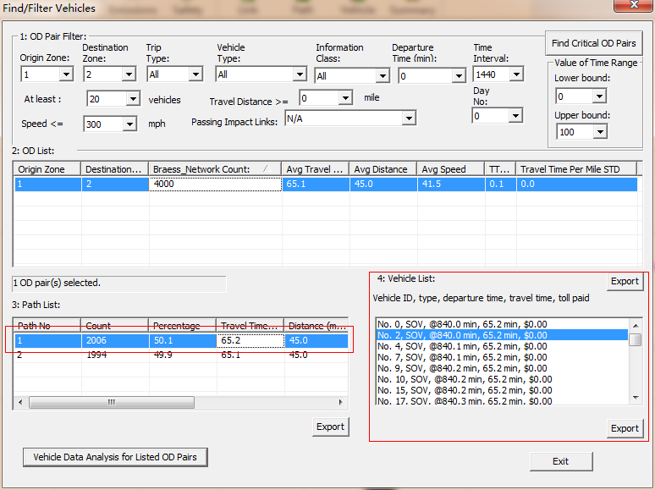

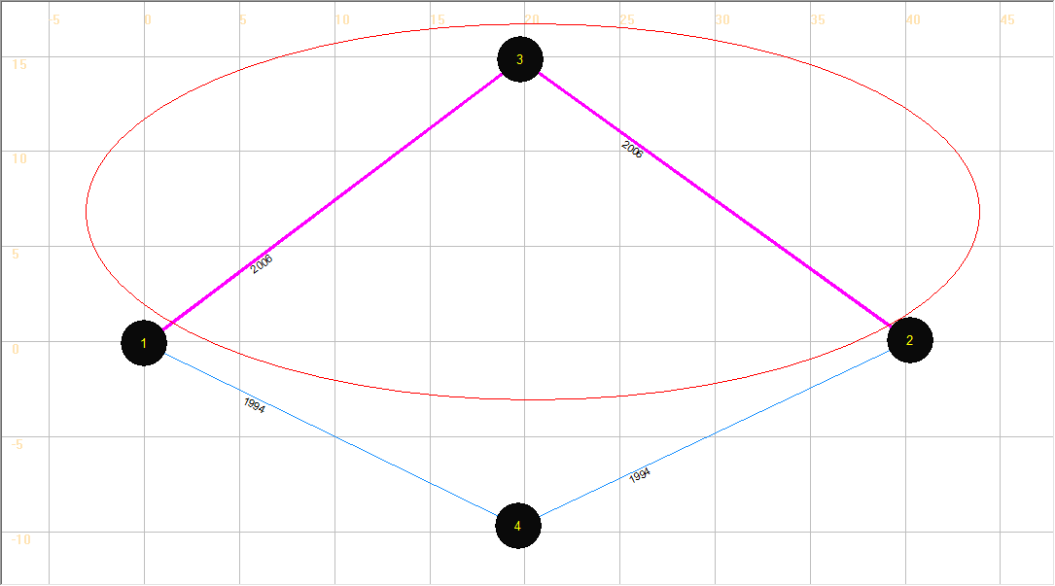

“Avg Travel Time (min)” under the Y Axis drop-down list to show the average travel time in the network.

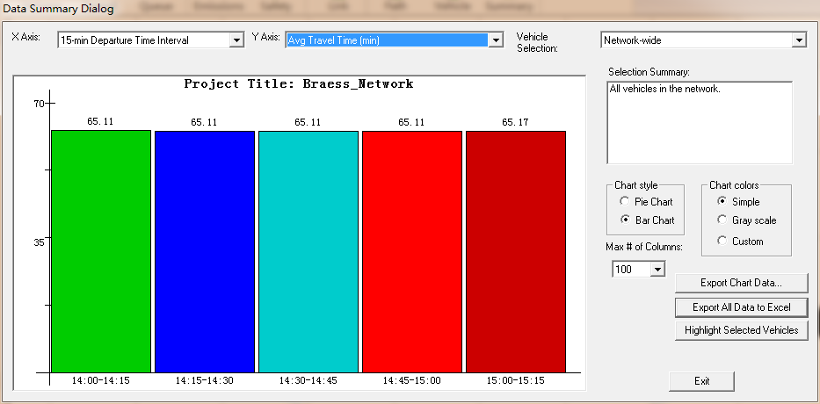

Try to change items in the drop-down lists and figure format to check other network performances.

Step 7: Close the NEXTA.

3: Add a link 3->4, or “e” into the Braess network and run the static simulation.



Step 1: Open the excel file “Braess_Network.xls” (“Braess's_Paradox_ Network \Task1-Braess_network_with_link34-static\Braess_Network.xls)” and add basic information of link 3->4 (e) into the “3-link” sheet, save and close the excel file.

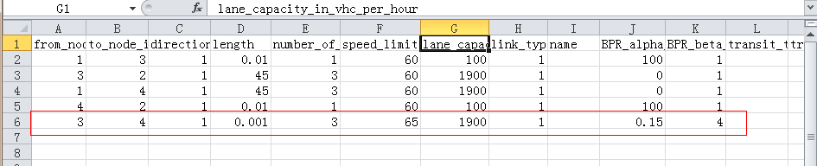

Step 2: Now, import the same excel file “Braess_Network.xls” (the one with the information added in Step 1) into NEXTA to create a new network, and then save it as “Braess_Network.tnp” in the same folder.

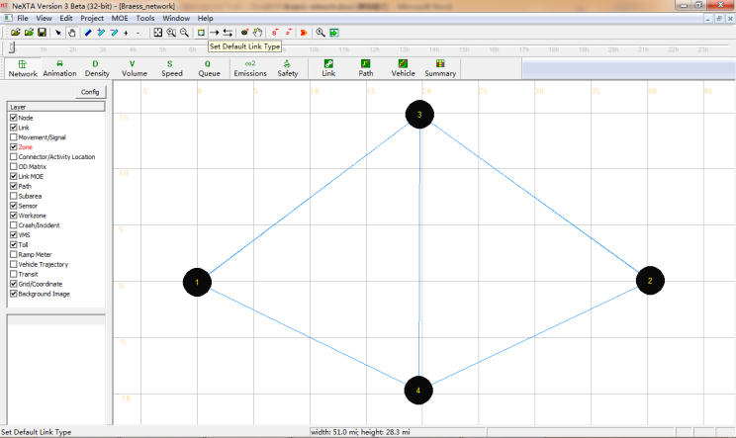

Step 3: Run the simulation for the new network by choosing “BPR Function” under the Traffic Flow Model list and “Method of Successive Average” under the “Traffic Assignment Method” list.

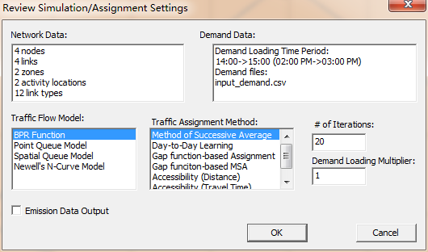

Step 4: Display the volume values on each link in the new network (Using Config).

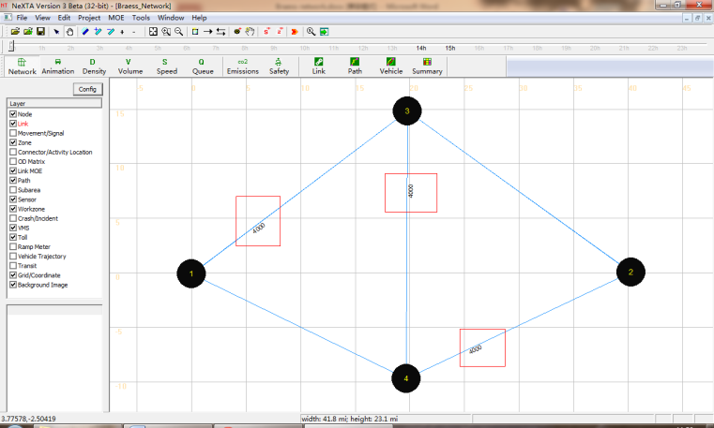

The volumes displayed on each link are shown in the table below.

|  |  |  |  |  |  |
| --- | --- | --- | --- | --- | --- |
|  | a | b | c | d | e |
| Total Link Volume(vhc) | 4000 | 4000 | 0 | 0 | 4000 |

Table: Showing the simulation result

Step 5: Vehicle path dialog.

There are 3 paths from Node 1 to Node 2 in Braess network (shown in different colors). For convenience, we mark them as path 1, path 2 and path 3 in the figure shown below.



Using NEXTA to display the shortest path in Braess network.

Click “Path” on the GIS Layer Panel. Right click on Node 1 to choose the option “Direction from here”. Node 1 becomes highlighted as the start point of the shortest path. Then right click on Node 2 to choose the option “Direction to here”.

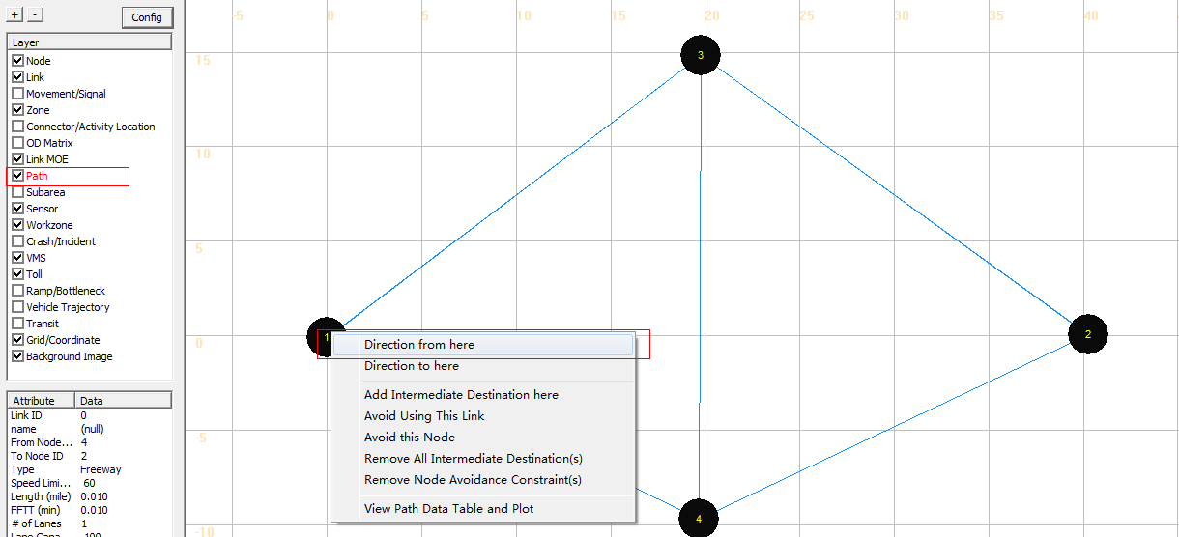

The shortest path from Node 1 to Node 2 is highlighted in the map as shown below.

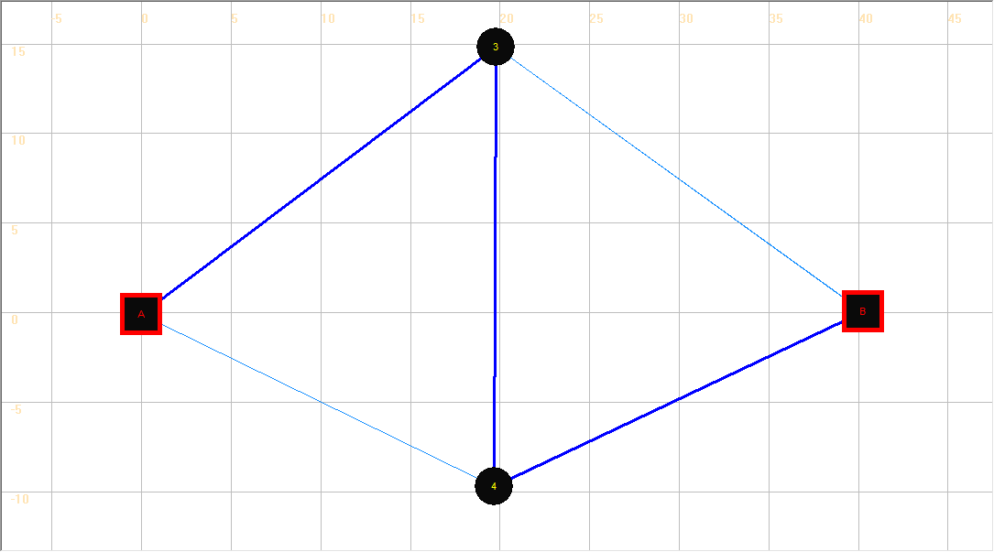

Check the shortest path in the table with the displayed path.2

|  |  |  |
| --- | --- | --- |
|  | Travel time | Flow |
| Path 1 | Link a (40.01)+Link d(45)= 85.01 min | 0 |
| Path 2 | Link c (45)+Link b(40.01)= 85.01 min | 0 |
| *Path 3* | *Link a(40.01)+Link e(0.001)+Link b(40.01)= 80.02 min* | *4000* |

Step 5: Close the NEXTA.

3: Compare system-wide performance differences between two networks.

The Braess paradox is a User Equilibrium system that is not necessarily System Optimal. Under User Equilibrium principles, the users are greedy and selfish to choose their own route for minimum costs, and users are familiar with the system. There are two principles that describe this notion of equilibrium in math formulation:

Principle A: No individual trip maker can reduce his path costs by switching routes.

Principle B: All used routes between an O-D pair have equal and minimum costs; While all unused routes have greater or equal costs (to the used path costs).

From the displayed values of the volume on two different networks mentioned above, we can complete the following table.

|  |  |  |
| --- | --- | --- |
|  | Without adding link e | Adding link e |
| Total number of vehicles | 4000 | 4000 |
| System-wide total travel time | 260040.7 | 320083.8 |
| Average travel time for each vehicles | 65.01 | 80.02 |
| Volume on link a | 2006 | 4000 |
| Volume on link c | 1994 | 0 |
| Path 1 travel time | 65.07 | 85.01 |
| Path 1 volume | 2006 | 0 |
| Path 2 travel time | 64.95 | 85.01 |
| Path 2 Volume | 1994 | 0 |
| Path 3 travel time | —— | 80.02 |
| Path 2 Volume | 0 | 4000 |

If we try to compare the travel times before and after the addition of link e, it is observed that the travel times on path 1 and 2 are shorter, before the addition of link e. After adding link e into the Braess Network, all the vehicles travel through link e, and the system-wide total travel time increases significantly. However, for one single vehicle, the driver does not have an incentive to switch his route, as the travel times for the two paths (Start-A-End and Start-B-End) are 85.01 minutes when all the other vehicles travel through link e(except for that one vehicle). Therefore, there is a paradox on Braess network under reasonable assumptions, necessary and sufficient conditions in a general transportation network.

It should be noted that the length of link e must be short enough to ensure that the travel time on path 3 is less than the travel times on both path 1 and 2.

4: Consider Link e is a Toll Link and run static simulation.

Step 1: Click  in Tool bar to open “Braess_Network.tnp” file. We can see that the Braess network with link e is displayed on the map.

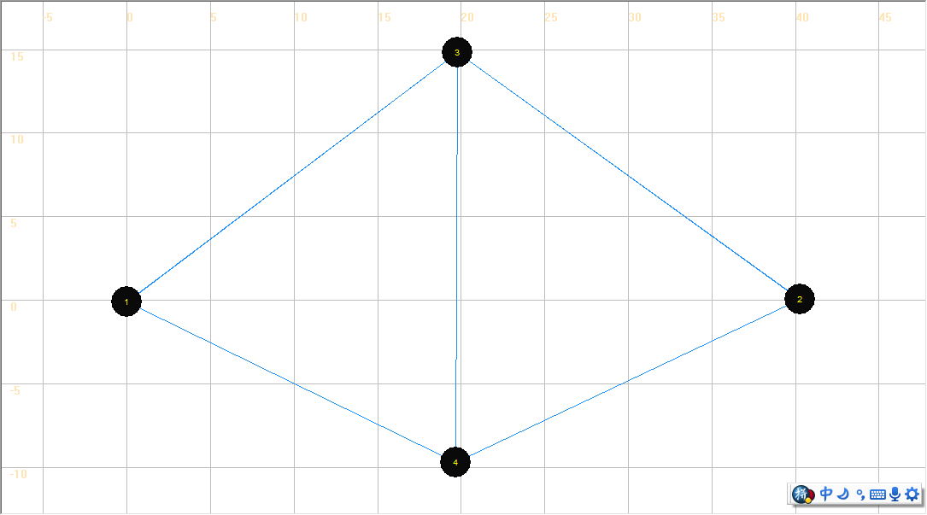

Step 2: Click “Toll” on the GIS Layer Panel, and then click  to select link e. Set link e as a Toll link by clicking “Add Link-based Toll” in the right click drop-down list.

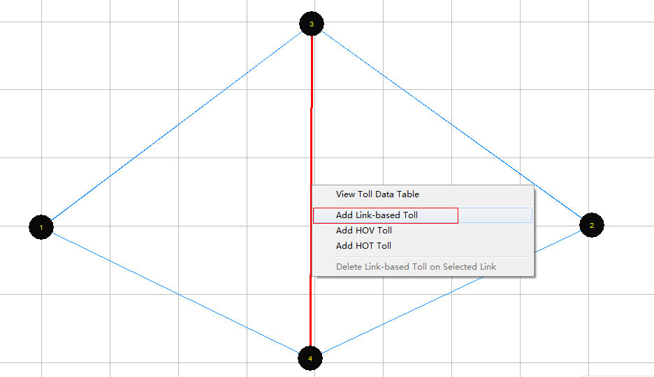

A dialog box named “View/Edit Scenario Configuration” appears. Users can modify the values of the charge of toll on the link. After the input of the desired charge of toll, click “Save Data”.

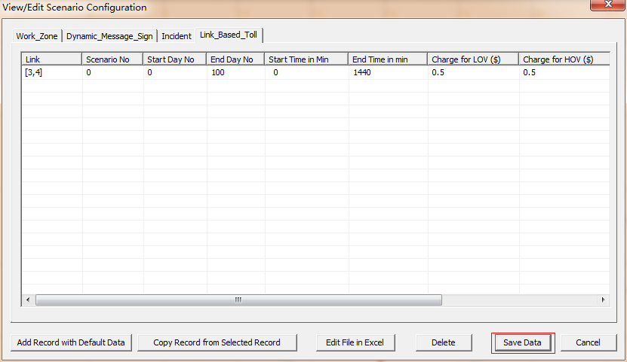

Step 3: Run simulation on the new network and display the volumes on the map.

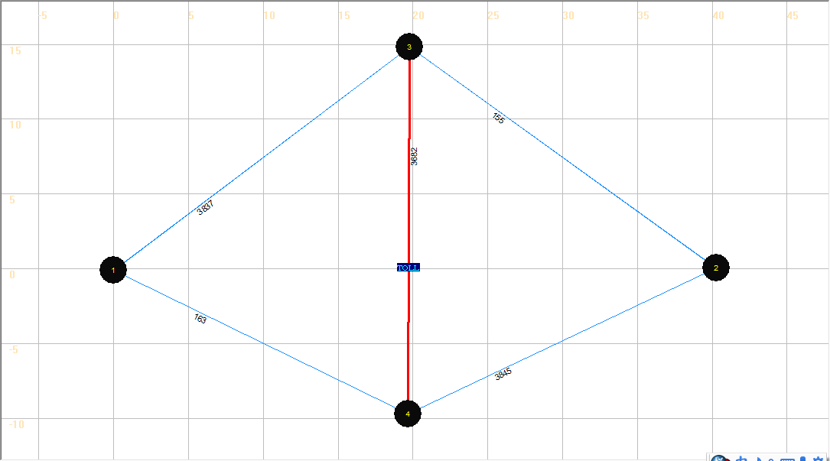

|  |  |  |  |  |  |
| --- | --- | --- | --- | --- | --- |
|  | a | b | c | d | e |
| Total Link Volume(vhc) | 3837 | 3845 | 163 | 155 | 3682 |

We can see some vehicles shifting from Path 3 to Path 1 and Path 2 because of introducing the toll on path 3.