**Instructions for visualizing vehicle trajectories as space-time diagrams using NeXTA**

NGSIM data set

Version 1: Prepared by Xuesong (Simon) Zhou

<https://www.youtube.com/@dlsim-mrm2898> [DLSim-MRM - YouTube](https://www.youtube.com/@dlsim-mrm2898)

maintained by Cafer Avci

Version 2 and revision made by Pan Shang, Zanyang Cui and Roy Luo

Package : <https://github.com/asu-trans-ai-lab/NeXTA4GMNS/blob/gh-pages/2Dtrajectory_visulization/NeXTA4_Trajectory_package.zip>

|  |  |  |
| --- | --- | --- |
| Category | File | Remark |
| Main program | NEXTA_4_Trajectory.exe | Open source NEXTA visualization tool |
| Input | trajectories-0400-0415 | Sample file from NGSIM |
| Input | test_one_line  test_two_lines | Sample file from Pan Shang, for one vehicle’s trajectory |
| Output | Trajectory.csv | Export to more user readable format |

# About Next Generation Simulation (NGSIM)

<https://ops.fhwa.dot.gov/trafficanalysistools/ngsim.htm>

# 2. Install and Data Format

Download the NeXTA tool (NEXTA_4_Trajectory.exe) from

<https://github.com/asu-trans-ai-lab/NeXTA4GMNS>

The vehicle trajectory information is stored in the text file with a ‘.txt’ extension and each line represents a record of a car’s trajectory/path. The fields should be separated by either a space or a comma. The column field are listed below.

|  |  |  |  |  |  |
| --- | --- | --- | --- | --- | --- |
| No | Field Name | Example 1 | Example 2 | Unit | remark |
| 1 | Vehicle_ID | 1 | 1 |  |  |
| 2 | Frame_ID | 12 | 13 |  | 0.1 seconds |
| 3 | Total_Frames | 884 | 884 |  | 0.1 seconds |
| 4 | Global_Time | 1113433136100 | 1113433136200 |  | any value but likely to be unix timestamp |
| 5 | Local_X | 16.884 | 16.938 |  | not used in NeXA |
| 6 | Local_Y | 48.213 | 49.463 | feet |  |
| 7 | Global_X | 6042842.116 | 6042842.012 |  | not used in NeXTA |
| 8 | Global_Y | 2133117.662 | 2133118.909 |  | not used in NeXTA |
| 9 | Vehicle_Length | 14.3 | 14.3 | feet |  |
| 10 | Vehicle_Width | 6.4 | 6.4 | feet |  |
| 11 | Vehicle_Class | 2 | 2 |  | passenger car or truck |
| 12 | Vehicle_Velocity | 12.5 | 12.5 |  |  |
| 13 | Vehicle_Acceleration | 0 | 0 |  |  |
| 14 | Lane_Identification | 2 | 2 |  | important |
| 15 | Preceding_Vehicle | 0 | 0 |  |  |
| 16 | Following_Vehicle | 0 | 0 |  |  |
| 17 | Spacing | 0 | 0 |  |  |
| 18 | Headway | 0 | 0 |  |  |

# 2. Quick Start

## 2.1 Open NeXTA

Double-click the NEXTA_4_Trajectory.exe executable.

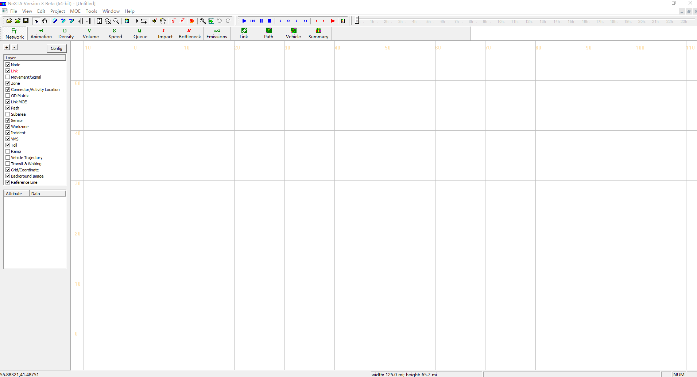

## Load trajectory file

Select menu ‘Tools’ → ‘NGSIM Tools’ → ‘Active Space-Time View’, and then load trajectory file in txt format.

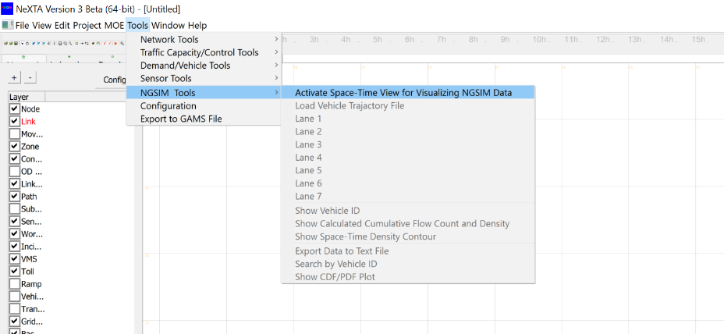

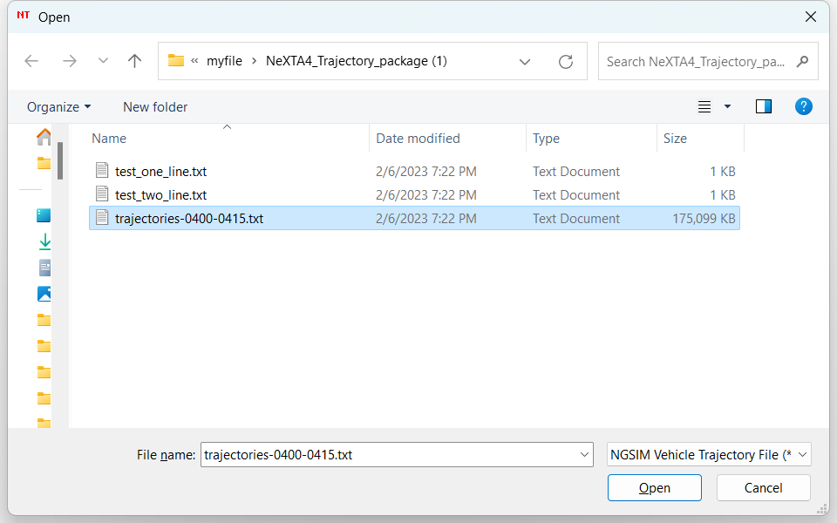

Once the file is loaded, the vehicle trajectories will be displayed in the current active window as shown below.

## Display trajectories for each lane.

Users can choose a lane number to visualize the trajectory using the menu ‘Tools’ → ‘NGSIM Tools’.

For example, the vehicle trajectories of lane 1:

The vehicle trajectories of lane 7:

## Show Vehicle ID

Users can show the vehicle ID in the menu ‘Tools’ → ‘NGSIM Tools’ and use mouse wheeler to zoom in and zoom out the display for the certain area of the space-time diagram.

## 3. Advanced Functions

## 3.1 Calculate the flow by clicking-and-drawing a line in the space-time plane

With the mouse, users can draw a line in the space-time plane, and NeXTA will automatically calculate the flow, density, and speed of vehicles that travel along the line.

## 3.2 Show cumulative flow count and density

Users can show cumulative flow count and density using the menu ‘Tools’ → ‘NGSIM Tools’.

## 3.3 Show the space-time density contour

Users can show cumulative flow count and density using the menu ‘Tools’ → ‘NGSIM Tools’.

## 3.4 Show CDF/PDF plot

Users can show the CDF/PDF plot using the menu ‘Tools’ → ‘NGSIM Tools’.

图形用户界面

## 3.5 Export the data to text files for analysis of individual vehicles.

Users can show the CDF/PDF plot using the menu ‘Tools’ → ‘NGSIM Tools’->Export Data to Text File.

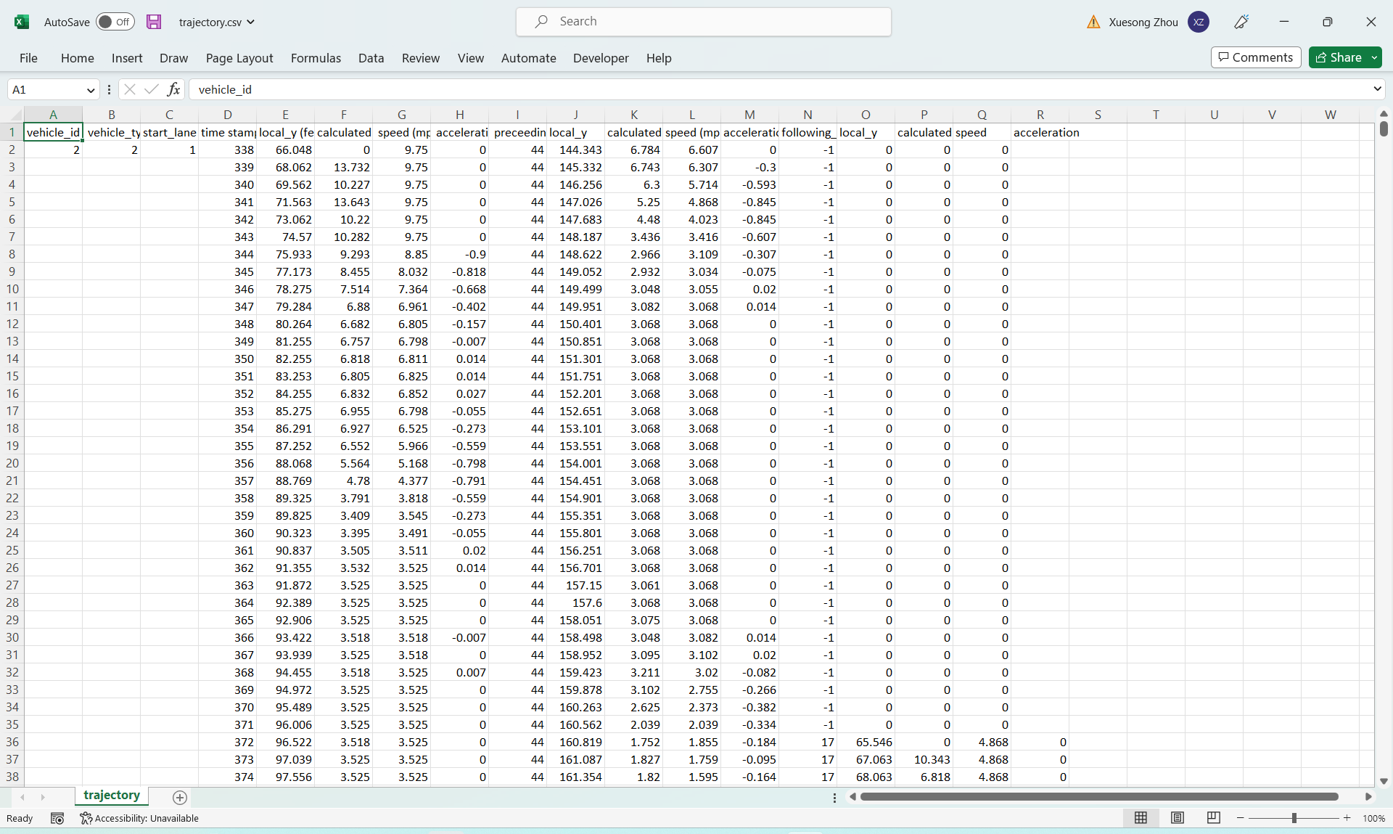

**4. Homework questions:**

1) Find Vehicle id 1757 on lane 4, find the vehicle ids before and after this vehicle.

2) Use the mouse to draw a line to find the speed for vehicle 1757

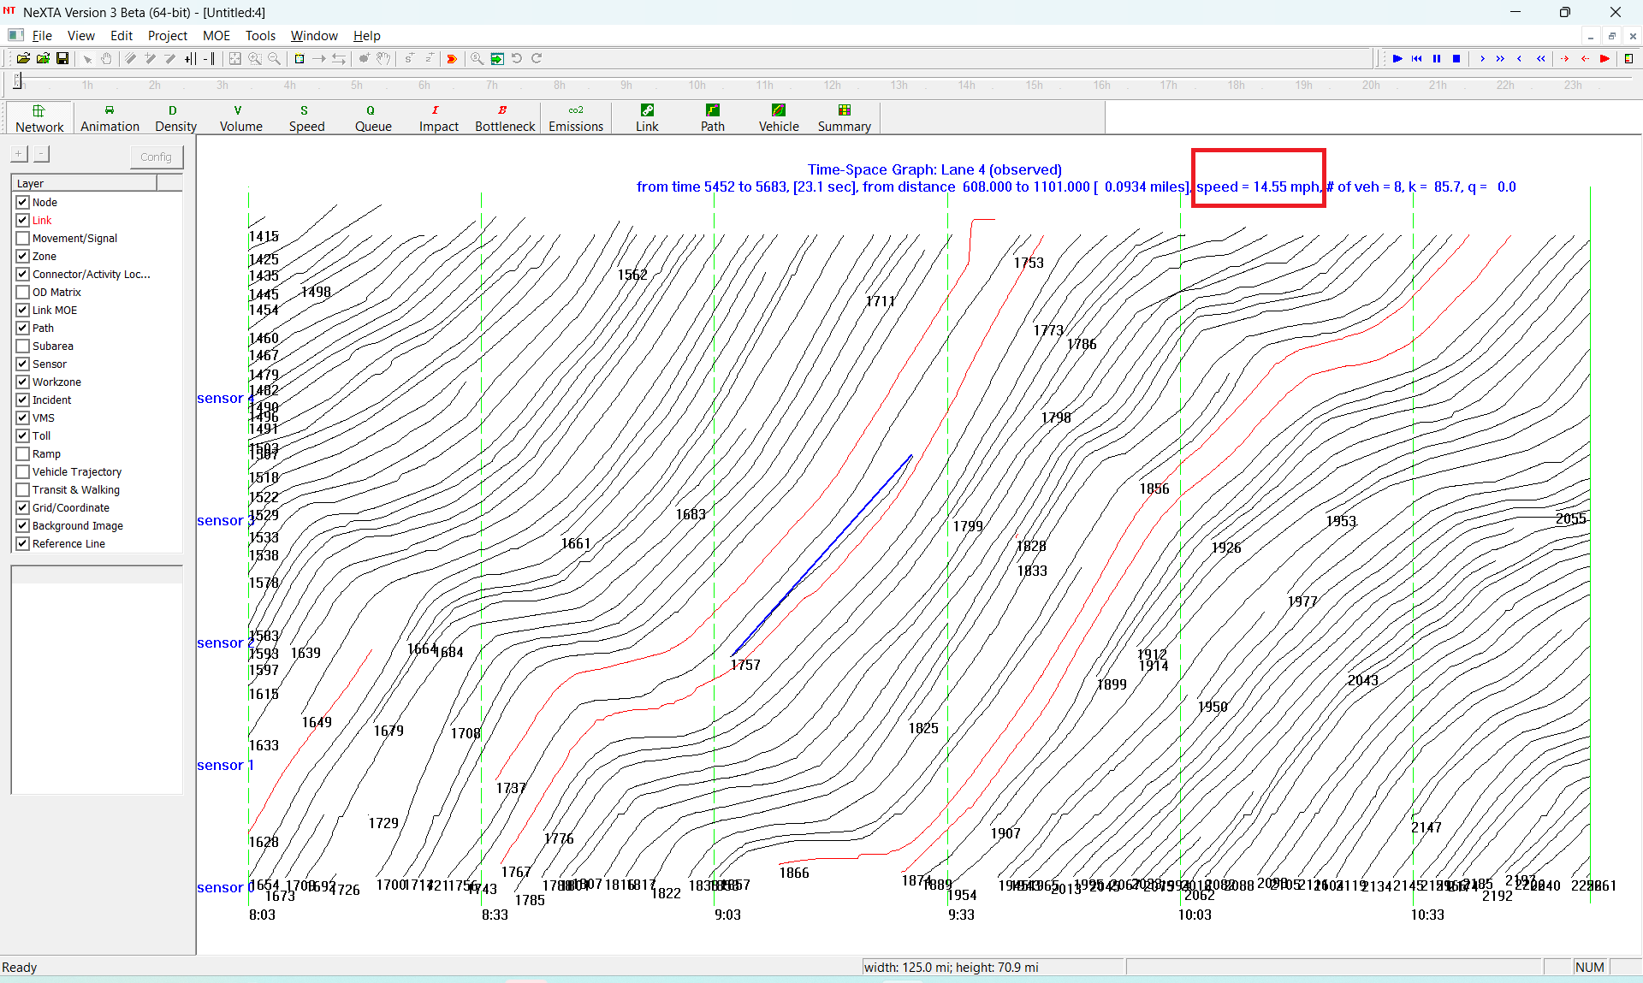

3) Use the mouse to draw a line to find density at timestamps 9:00, 8:30 and 9:30. 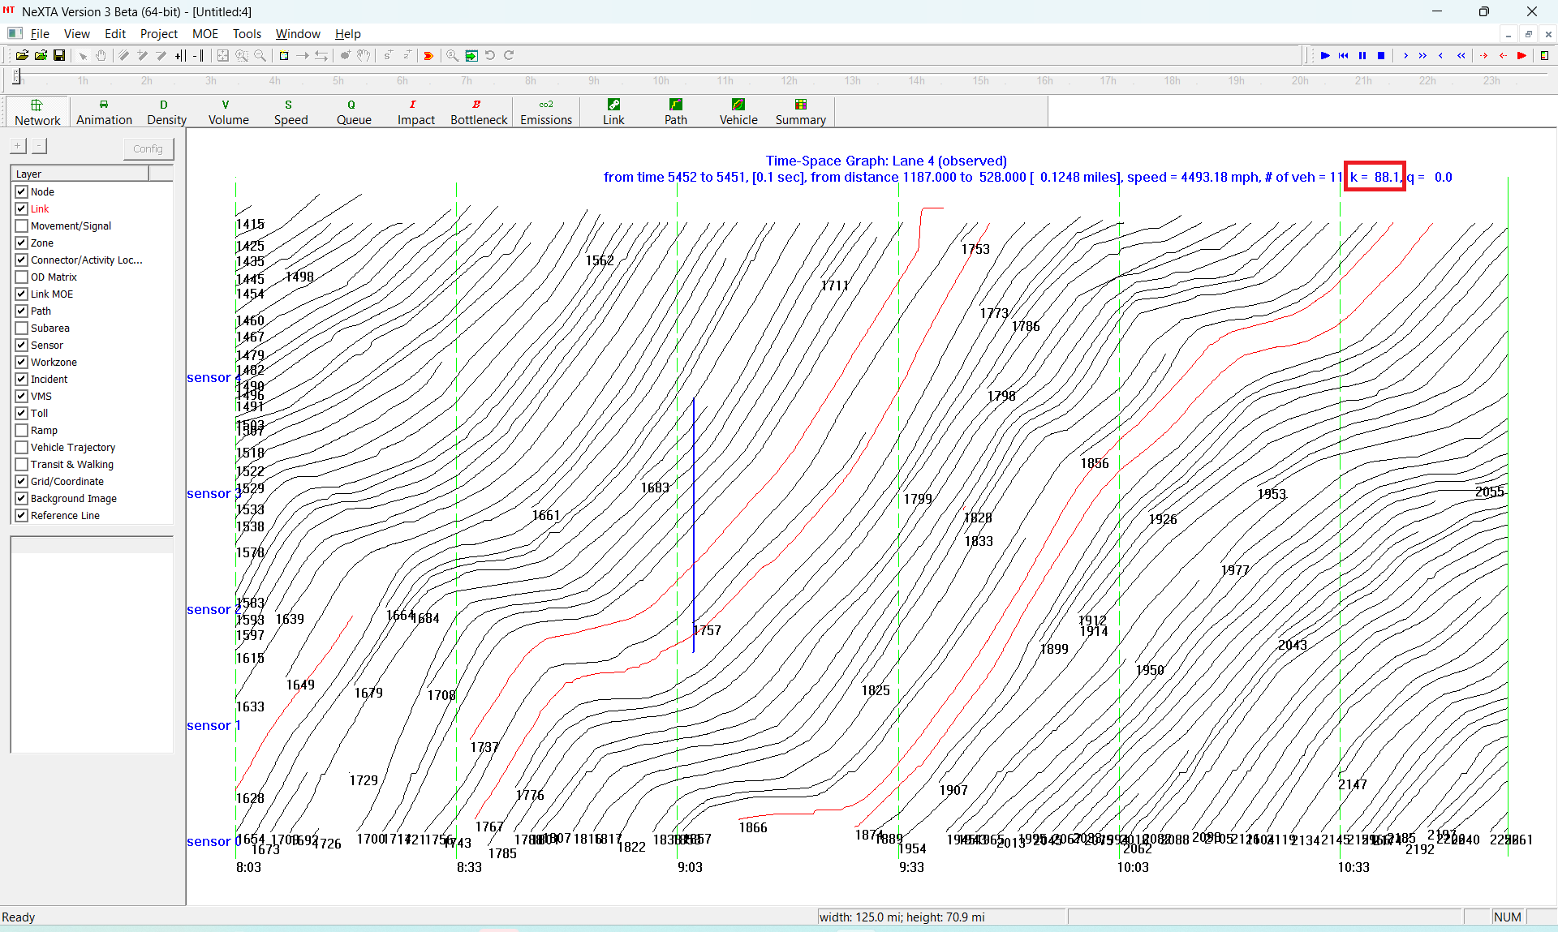

4) Use the mouse to draw a line to find Kjam and backwave speed.



5) Export the vehicle trajectory to a text file, compute the average speed and and maximum acceleration for vehicle 1757 and 1767.

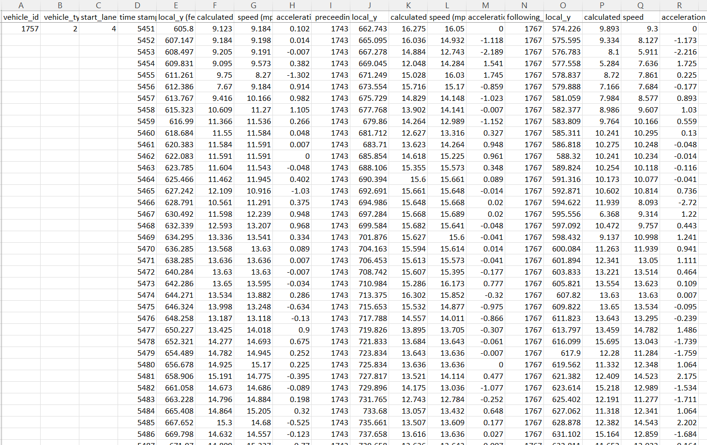

References:

[Full article: DTALite: A queue-based mesoscopic traffic simulator for fast model evaluation and calibration (tandfonline.com)](https://www.tandfonline.com/doi/full/10.1080/23311916.2014.961345)

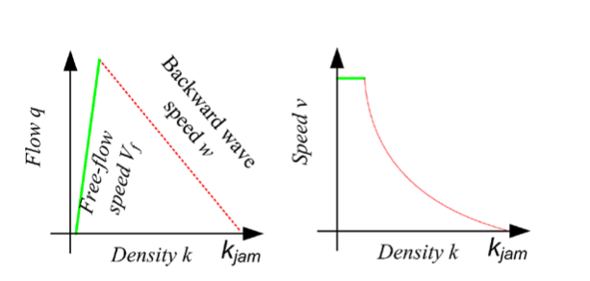

Illustration of forward and backward wave representation in Newell’s simplified KW model.