Instructions for visualizing vehicle trajectories as space-time diagrams using NeXTA
NGSIM data set
Version 1: Prepared by Xuesong (Simon) Zhou
https://www.youtube.com/@dlsim-mrm2898 DLSim-MRM - YouTube
maintained by Cafer Avci

Version 2 and revision made by Pan Shang, Zanyang Cui and Roy Luo

Package : https://github.com/asu-trans-ai-lab/NeXTA4GMNS/blob/gh-pages/2Dtrajectory_visulization/NeXTA4_Trajectory_package.zip

Category | File | Remark
Main program | NEXTA_4_Trajectory.exe | Open source NEXTA visualization tool
Input | trajectories-0400-0415 | Sample file from NGSIM
Input | test_one_line  test_two_lines | Sample file from Pan Shang, for one vehicle’s trajectory
Output | Trajectory.csv | Export to more user readable format

About Next Generation Simulation (NGSIM)
https://ops.fhwa.dot.gov/trafficanalysistools/ngsim.htm

2. Install and Data Format
Download the NeXTA tool (NEXTA_4_Trajectory.exe) from
https://github.com/asu-trans-ai-lab/NeXTA4GMNS
The vehicle trajectory information is stored in the text file with a ‘.txt’ extension and each line represents a record of a car’s trajectory/path. The fields should be separated by either a space or a comma. The column field are listed below.
No | Field Name | Example 1 | Example 2 | Unit | remark
1 | Vehicle_ID | 1 | 1
2 | Frame_ID | 12 | 13 |  | 0.1 seconds
3 | Total_Frames | 884 | 884 |  | 0.1 seconds
4 | Global_Time | 1113433136100 | 1113433136200 |  | any value but likely to be unix timestamp
5 | Local_X | 16.884 | 16.938 |  | not used in NeXA
6 | Local_Y | 48.213 | 49.463 | feet
7 | Global_X | 6042842.116 | 6042842.012 |  | not used in NeXTA
8 | Global_Y | 2133117.662 | 2133118.909 |  | not used in NeXTA
9 | Vehicle_Length | 14.3 | 14.3 | feet
10 | Vehicle_Width | 6.4 | 6.4 | feet
11 | Vehicle_Class | 2 | 2 |  | passenger car or truck
12 | Vehicle_Velocity | 12.5 | 12.5
13 | Vehicle_Acceleration | 0 | 0
14 | Lane_Identification | 2 | 2 |  | important
15 | Preceding_Vehicle | 0 | 0
16 | Following_Vehicle | 0 | 0
17 | Spacing | 0 | 0
18 | Headway | 0 | 0

2. Quick Start

2.1 Open NeXTA
Double-click the NEXTA_4_Trajectory.exe executable.
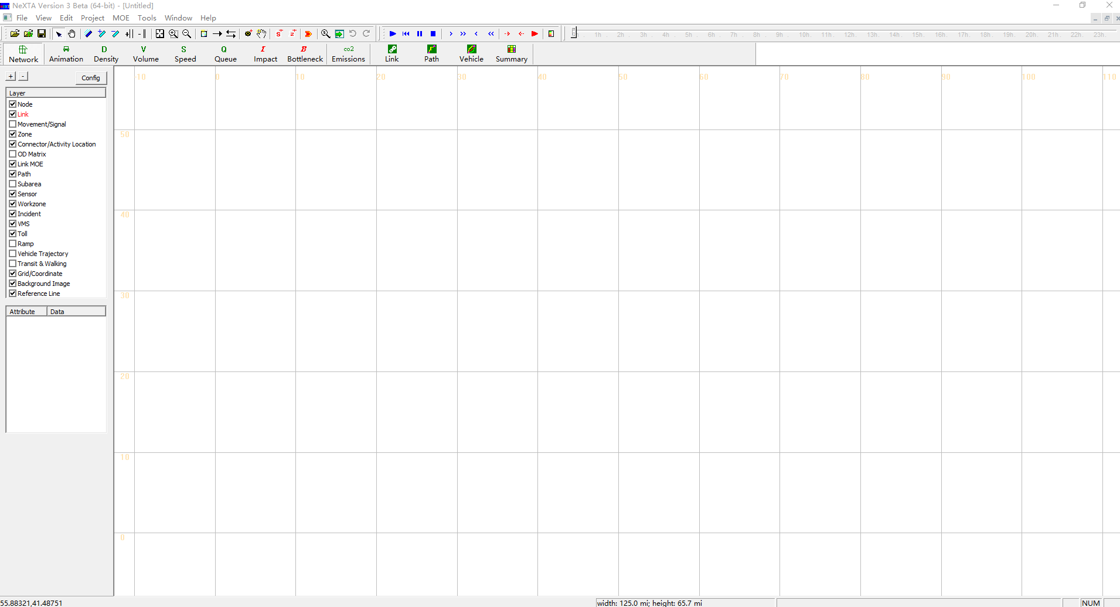

Load trajectory file
Select menu ‘Tools’ → ‘NGSIM Tools’ → ‘Active Space-Time View’, and then load trajectory file in txt format.
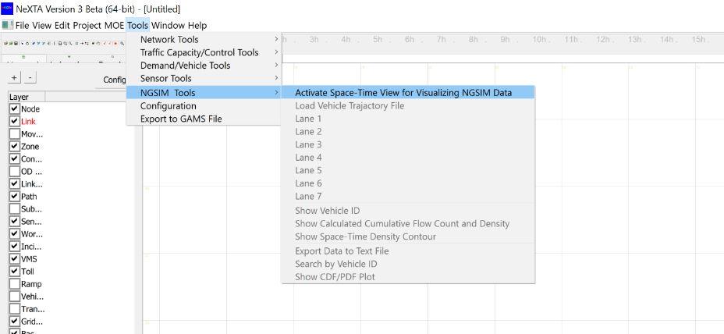
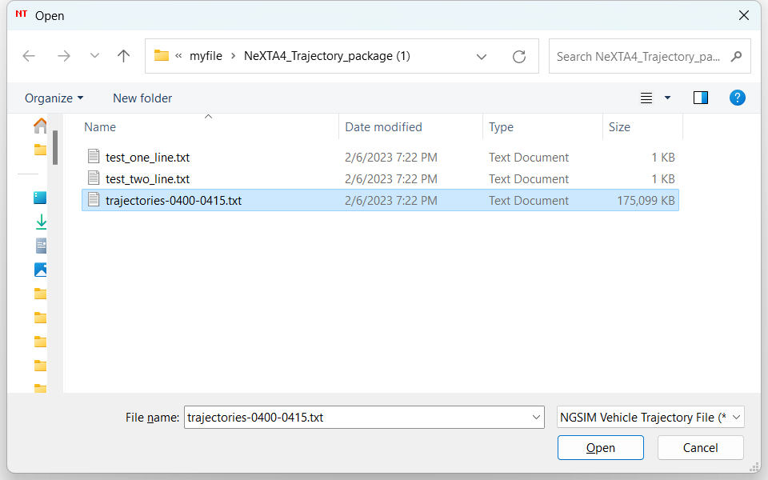
Once the file is loaded, the vehicle trajectories will be displayed in the current active window as shown below. 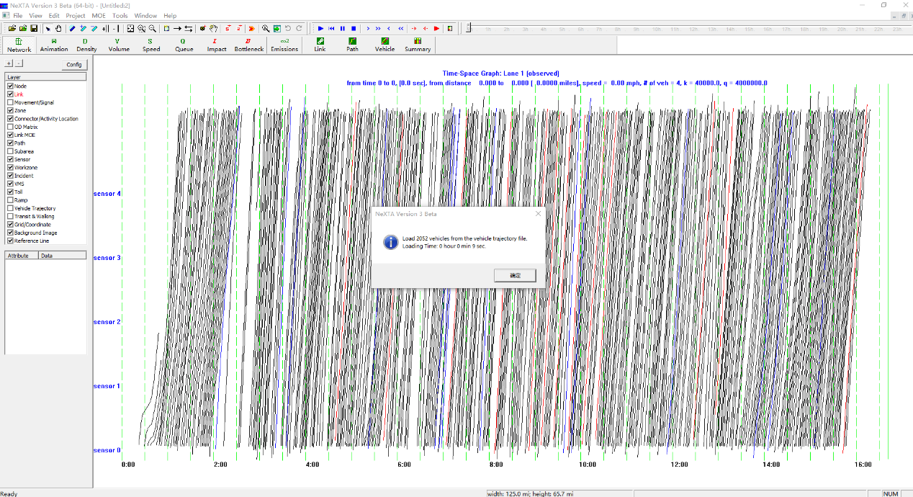

Display trajectories for each lane.
Users can choose a lane number to visualize the trajectory using the menu ‘Tools’ → ‘NGSIM Tools’.
For example, the vehicle trajectories of lane 1:
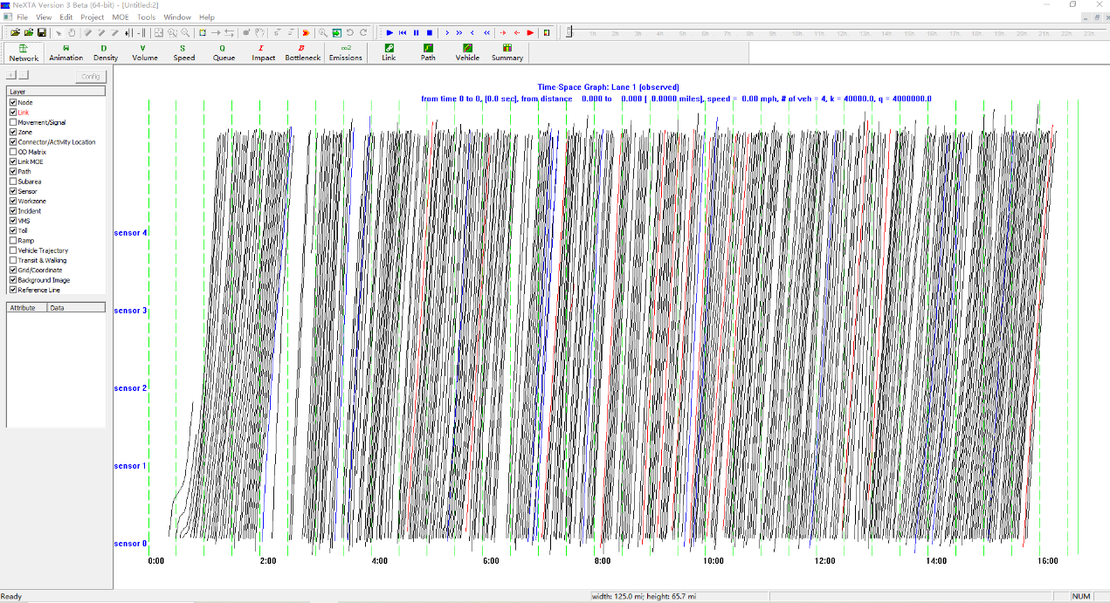
The vehicle trajectories of lane 7:
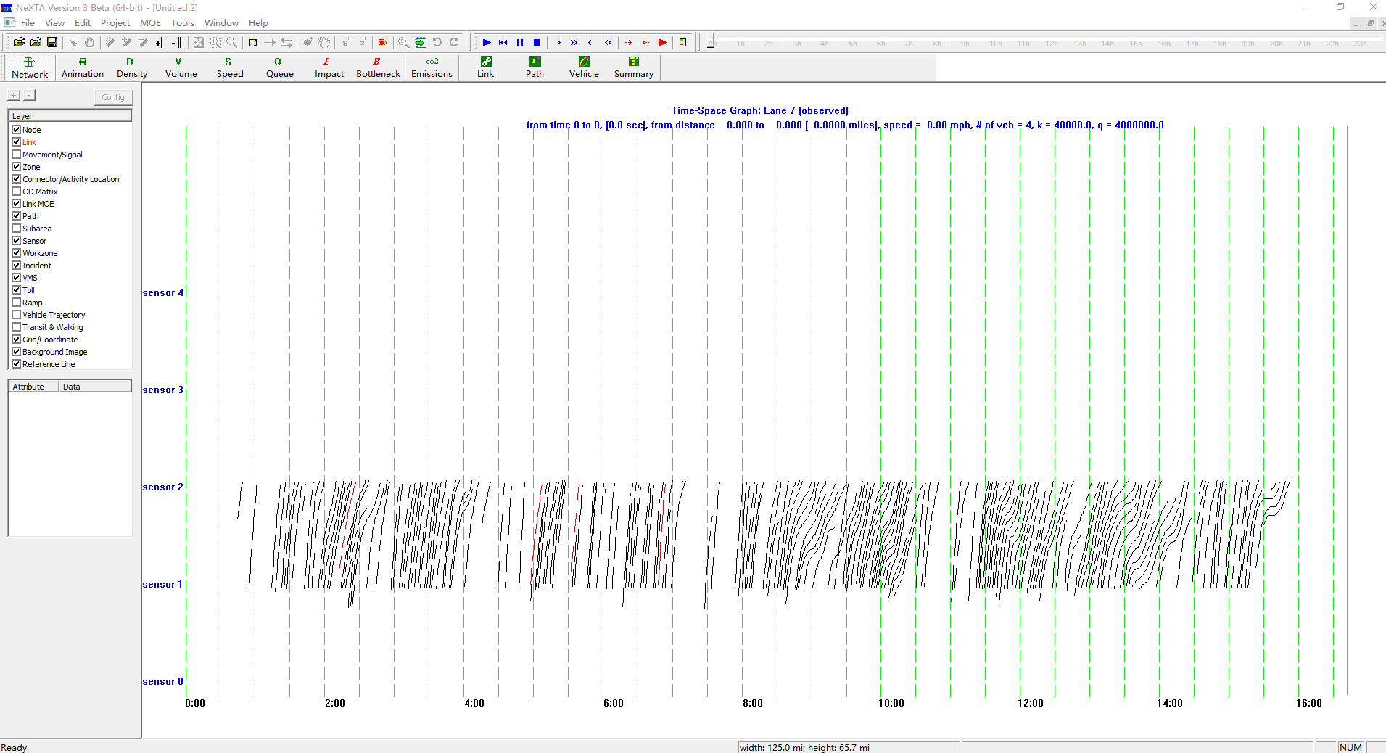

Show Vehicle ID
Users can show the vehicle ID in the menu ‘Tools’ → ‘NGSIM Tools’ and use mouse wheeler to zoom in and zoom out the display for the certain area of the space-time diagram.
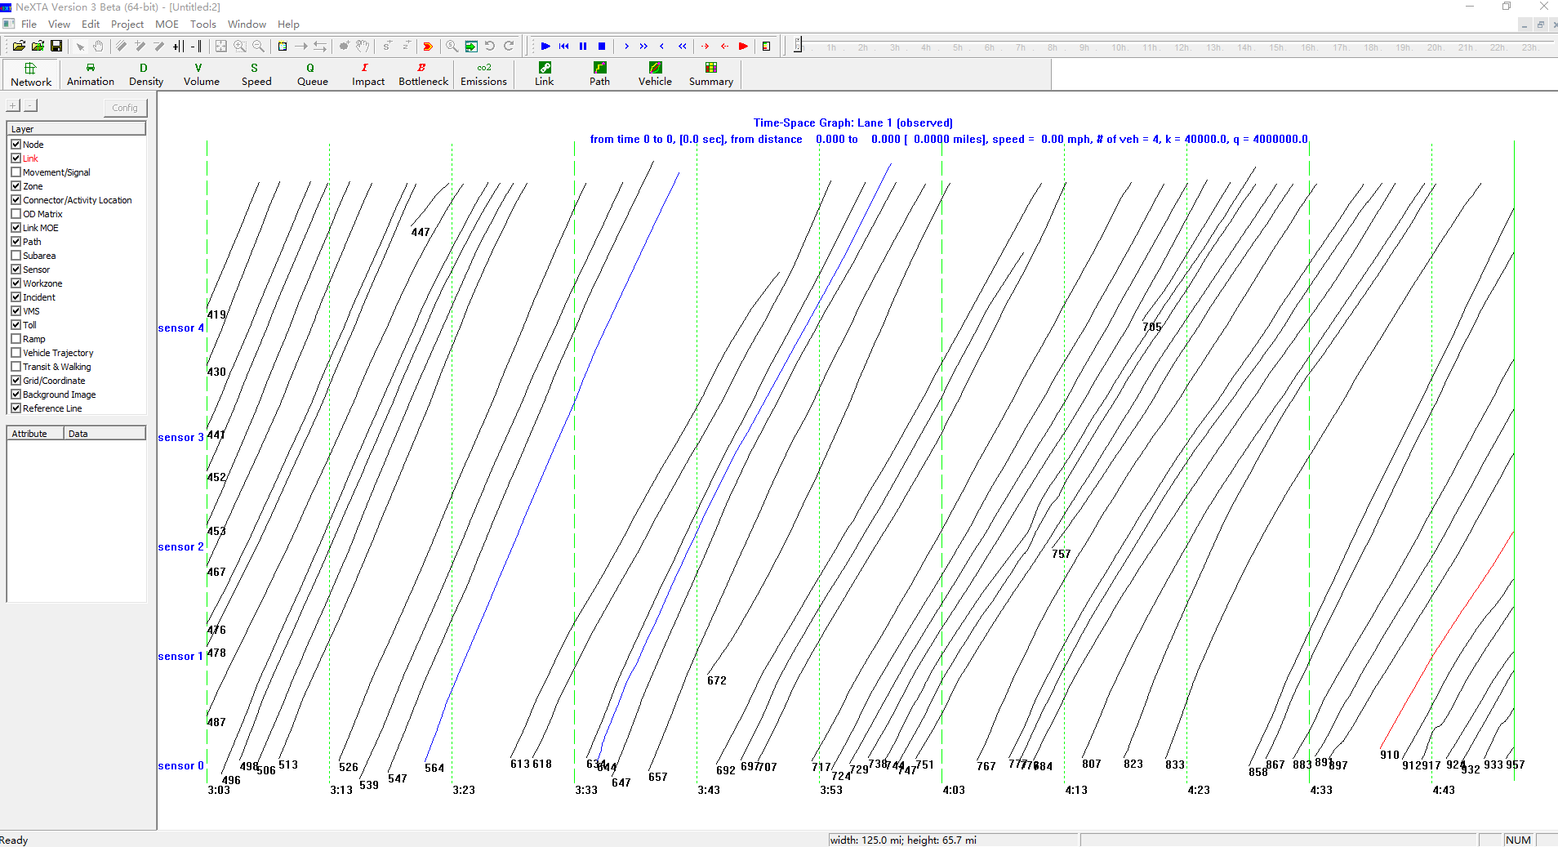

3. Advanced Functions

3.1 Calculate the flow by clicking-and-drawing a line in the space-time plane
With the mouse, users can draw a line in the space-time plane, and NeXTA will automatically calculate the flow, density, and speed of vehicles that travel along the line.
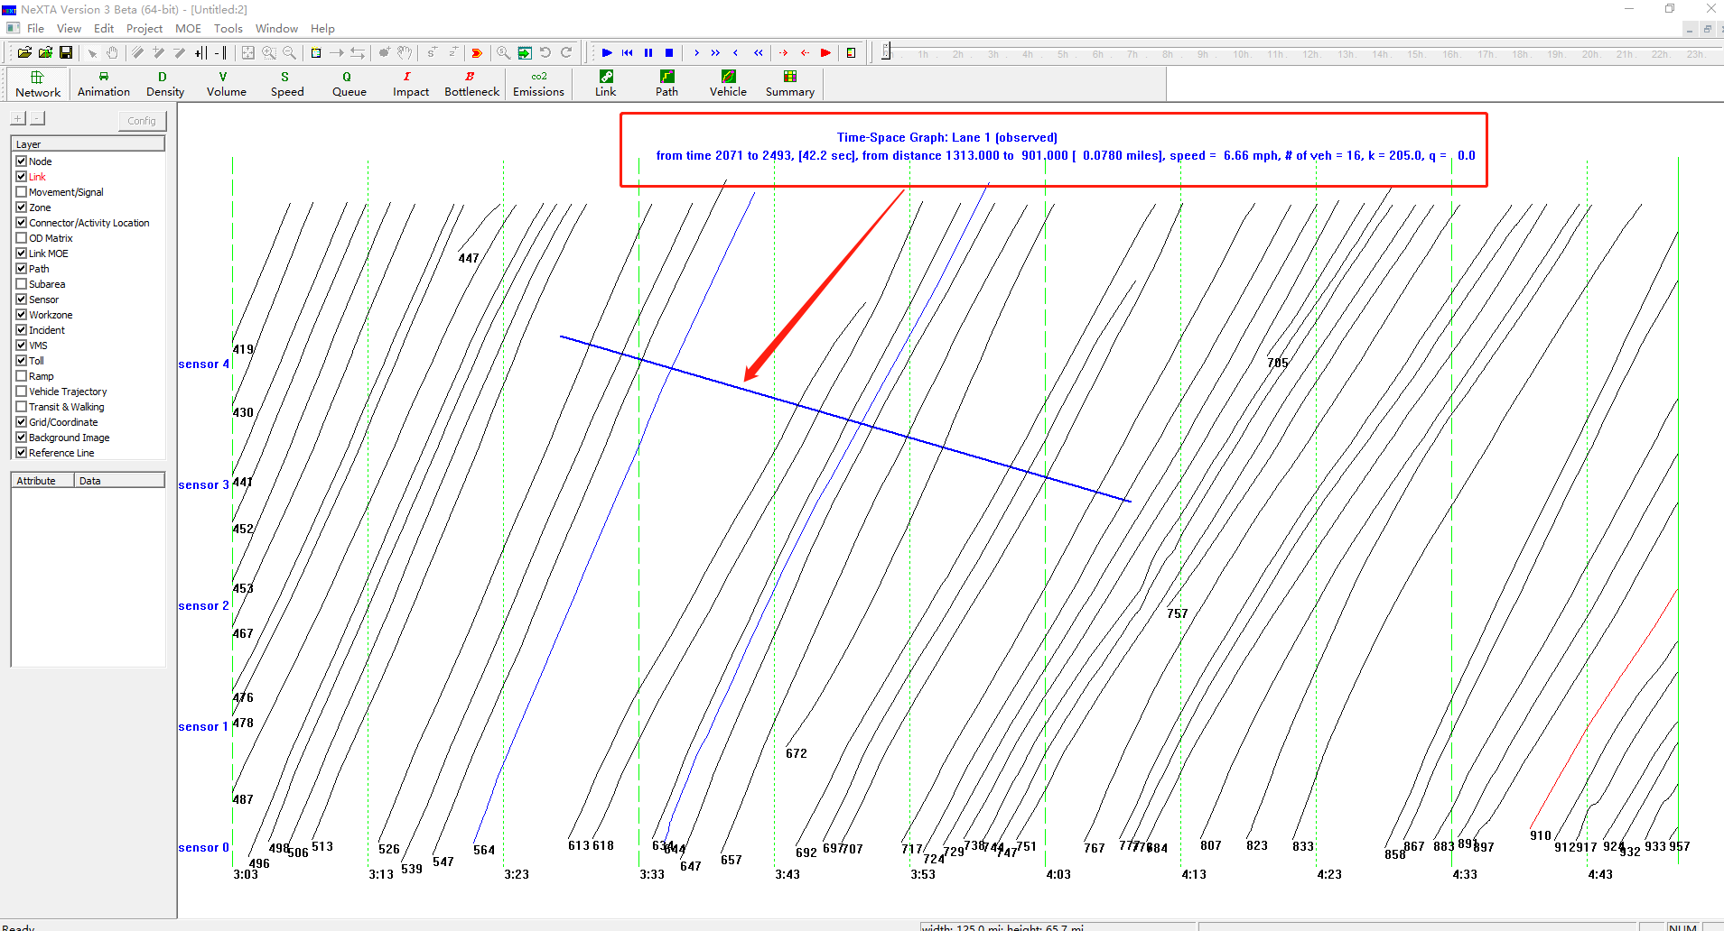

3.2 Show cumulative flow count and density
Users can show cumulative flow count and density using the menu ‘Tools’ → ‘NGSIM Tools’.
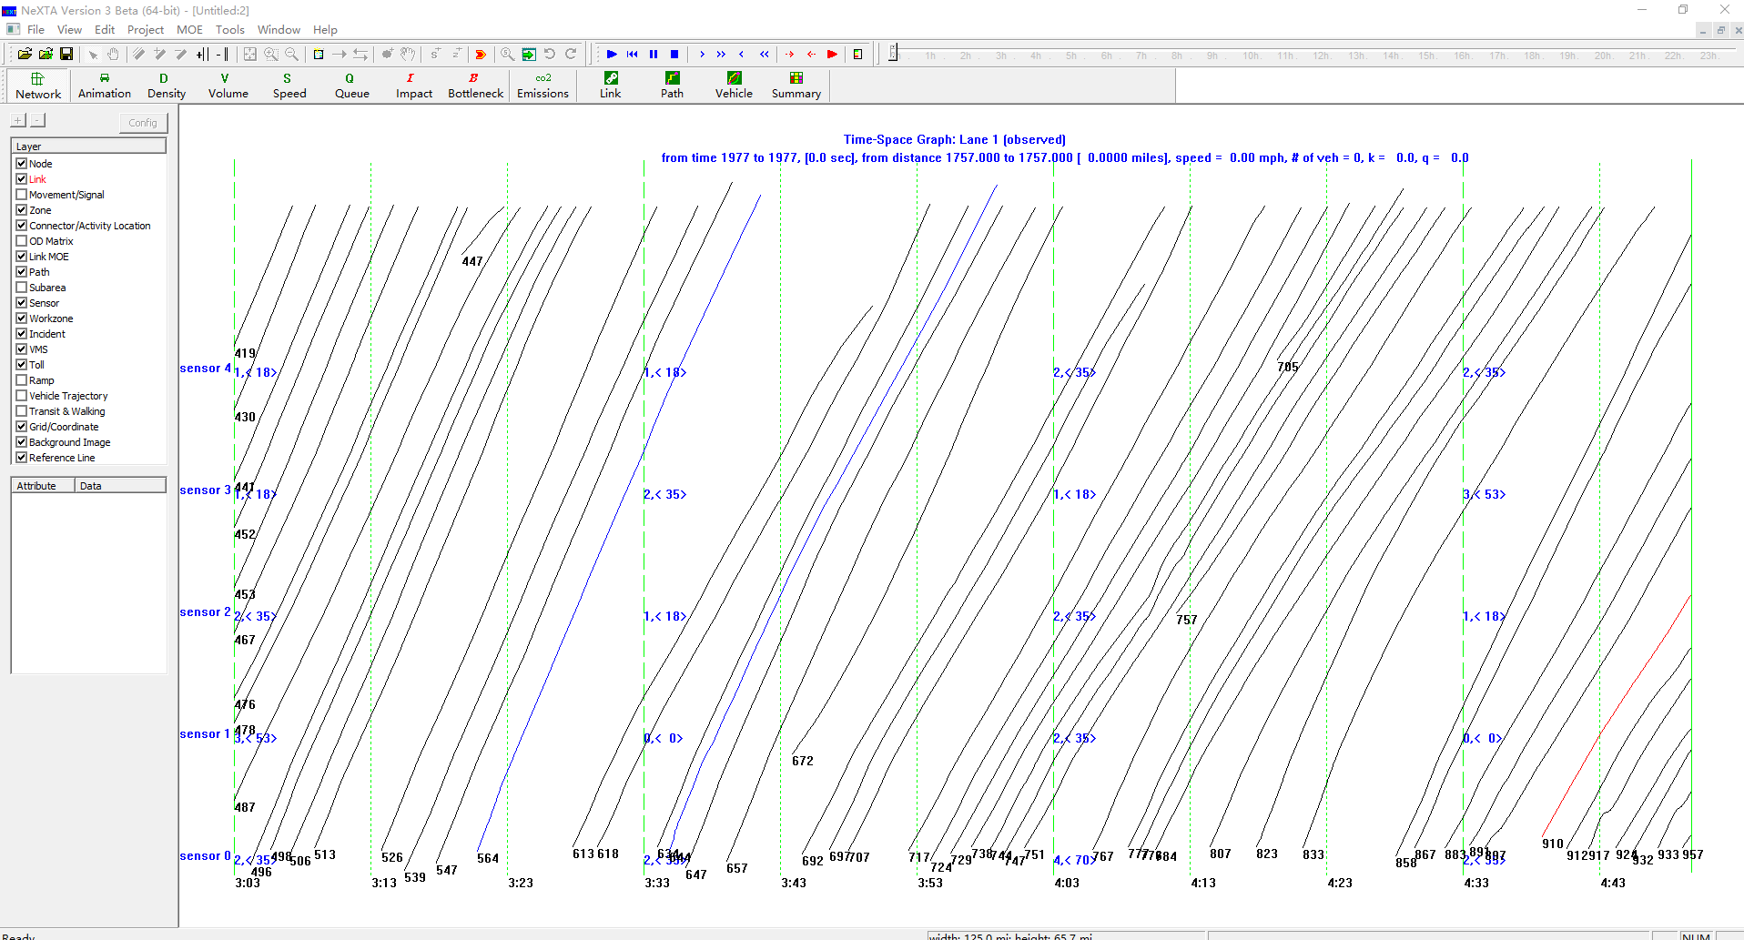

3.3 Show the space-time density contour
Users can show cumulative flow count and density using the menu ‘Tools’ → ‘NGSIM Tools’.
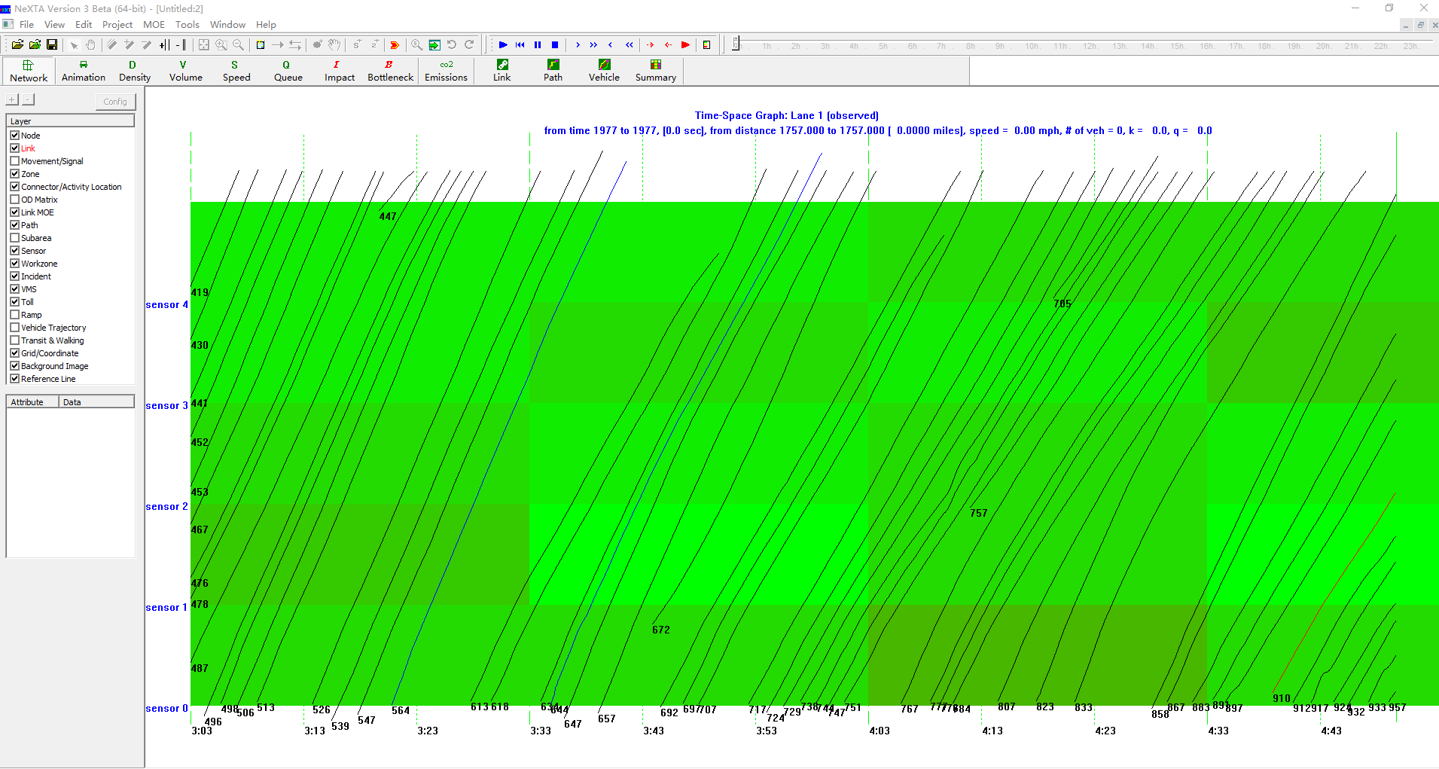

3.4 Show CDF/PDF plot
Users can show the CDF/PDF plot using the menu ‘Tools’ → ‘NGSIM Tools’.
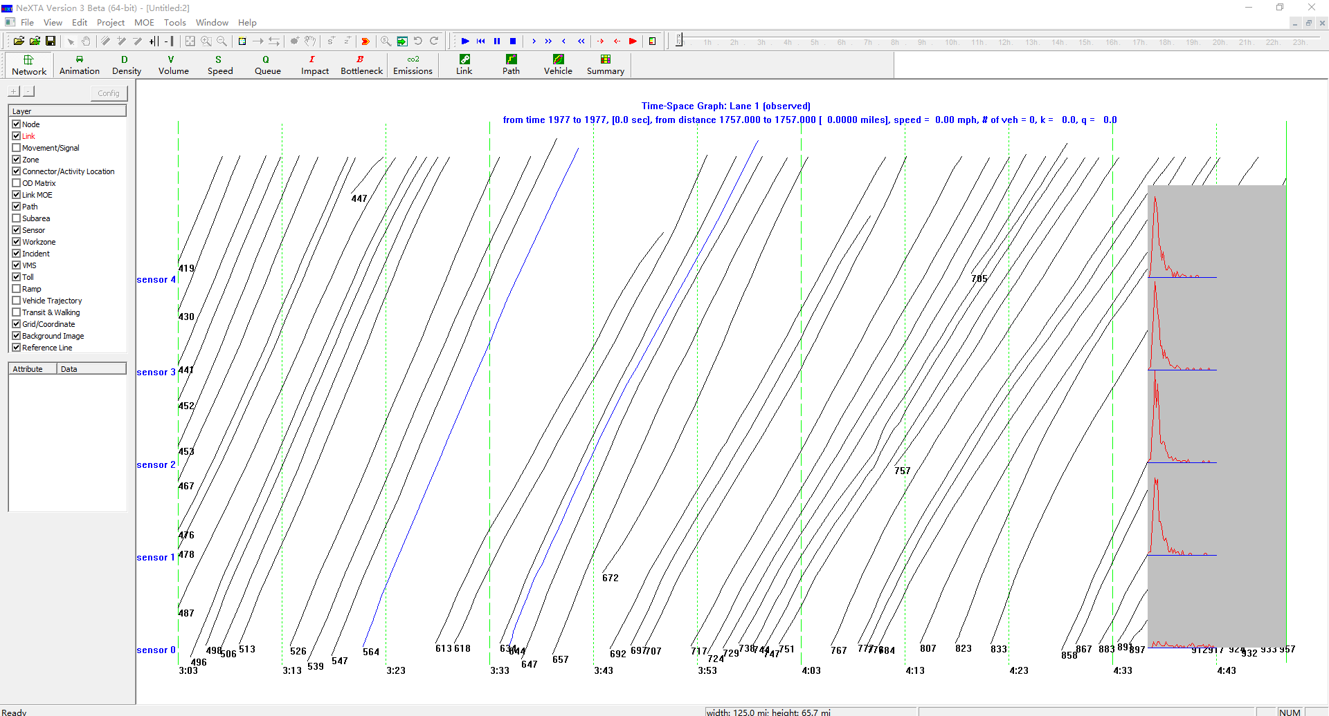

3.5 Export the data to text files for analysis of individual vehicles.
Users can show the CDF/PDF plot using the menu ‘Tools’ → ‘NGSIM Tools’->Export Data to Text File.

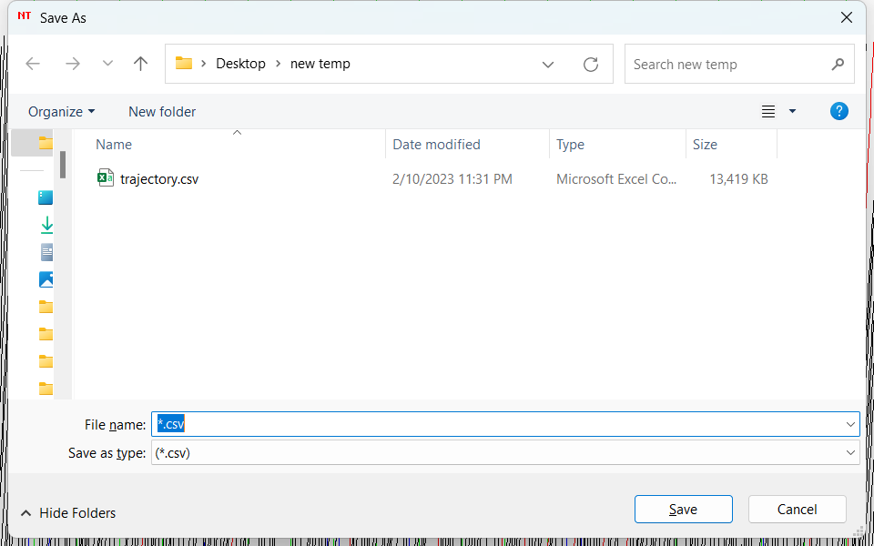
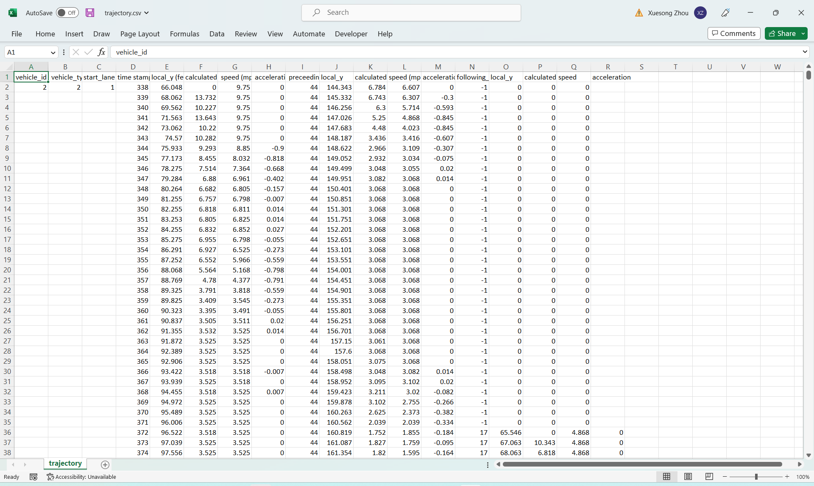

4. Homework questions:
1) Find Vehicle id 1757 on lane 4, find the vehicle ids before and after this vehicle.
2) Use the mouse to draw a line to find the speed for vehicle 1757
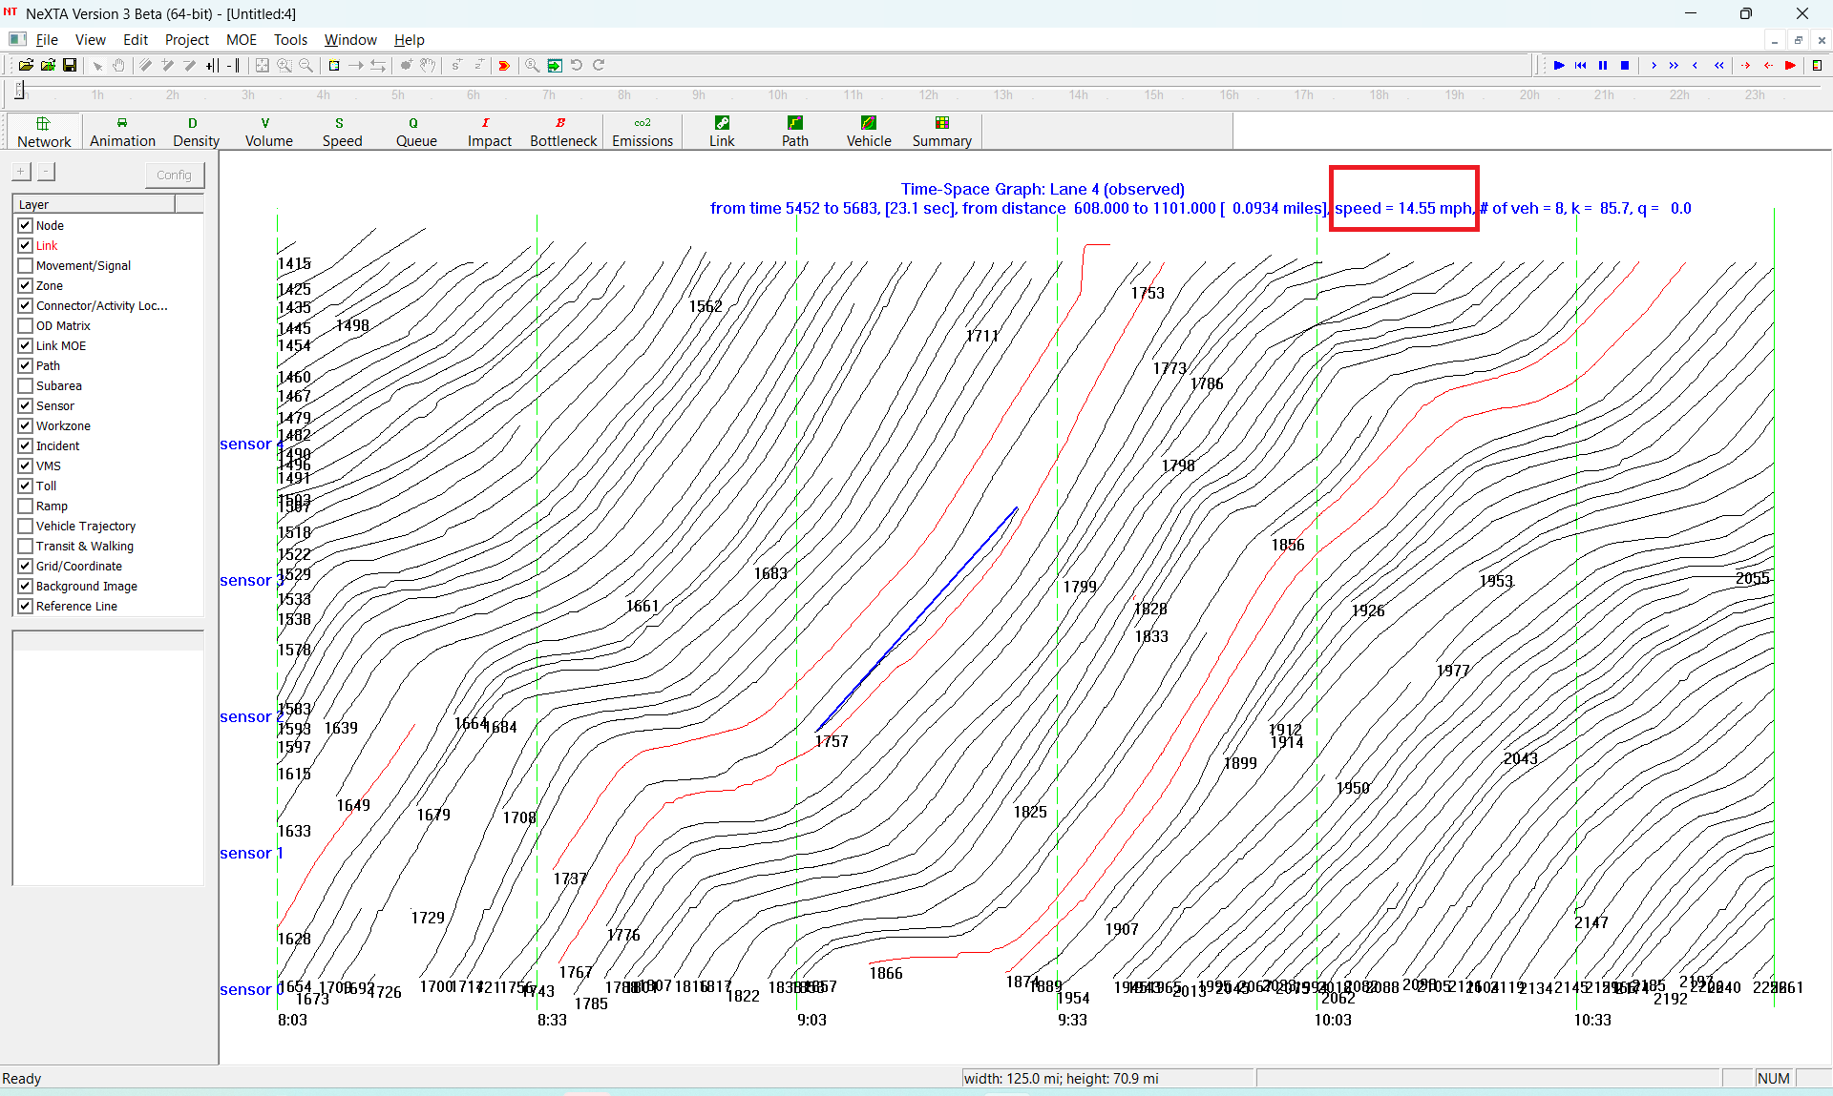

3) Use the mouse to draw a line to find density at timestamps 9:00, 8:30 and 9:30. 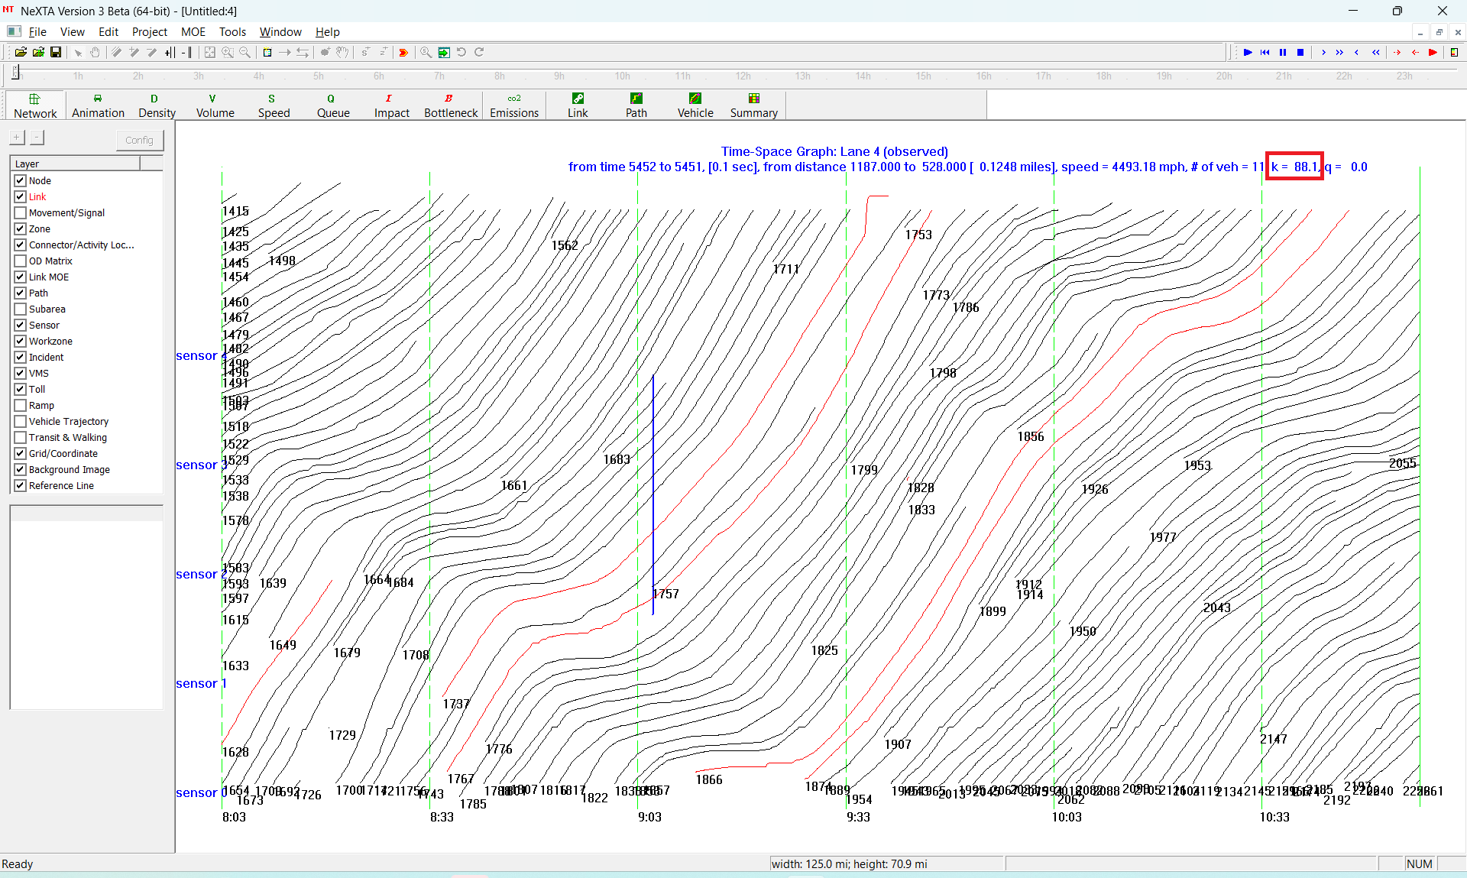

4) Use the mouse to draw a line to find Kjam and backwave speed.
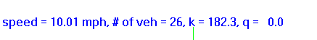
5) Export the vehicle trajectory to a text file, compute the average speed and and maximum acceleration for vehicle 1757 and 1767.

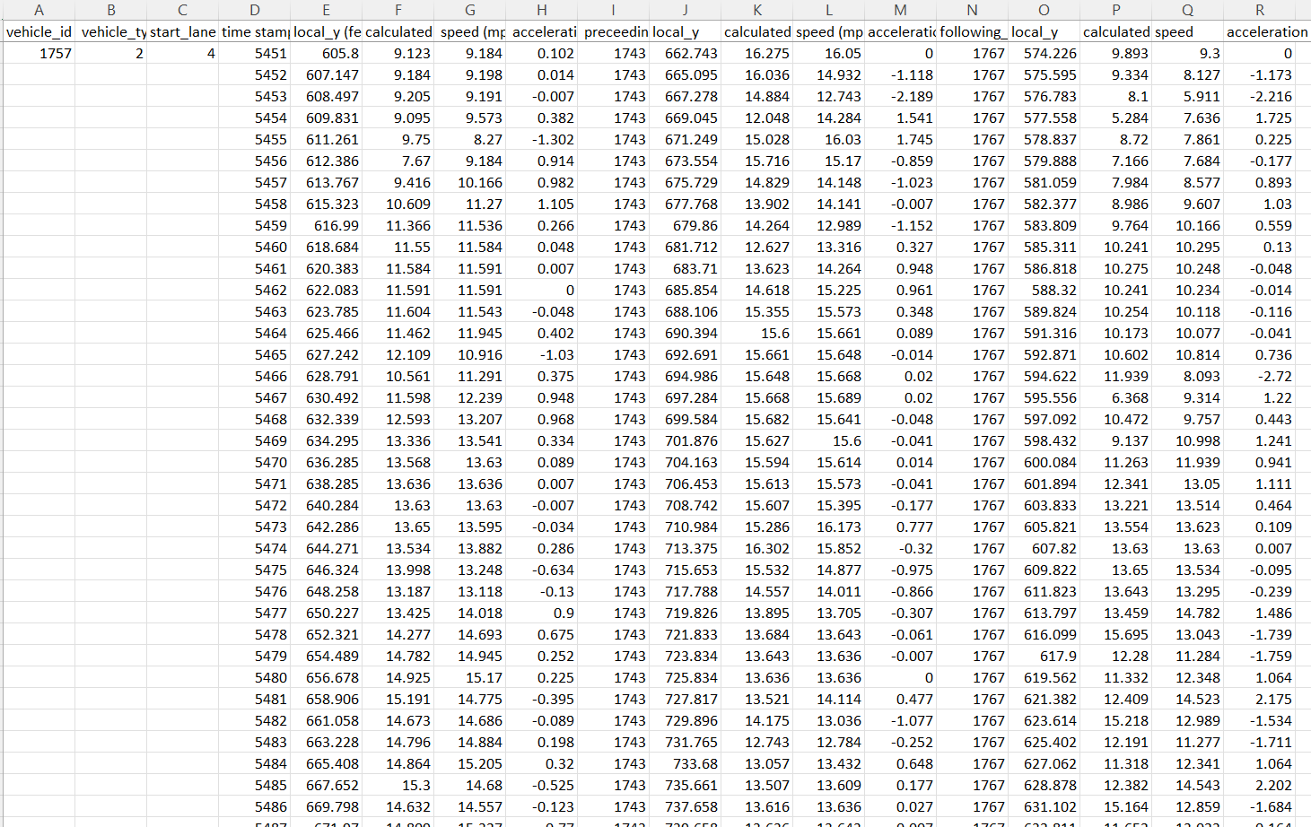

References:
Full article: DTALite: A queue-based mesoscopic traffic simulator for fast model evaluation and calibration (tandfonline.com)
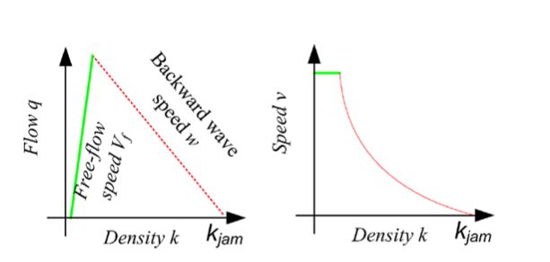
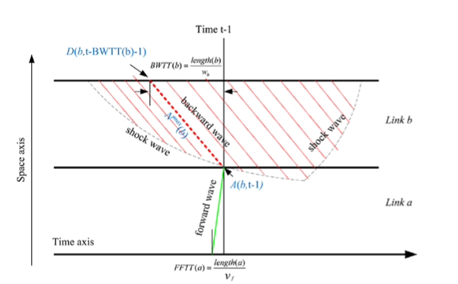
Illustration of forward and backward wave representation in Newell’s simplified KW model.

