# Vol2Timing

This python tool aims to offer a **light-weight computational engine** to generate optimize signal control timing data, and analyze the effectiveness of signal control strategies. Our goal is to **automate** the process of optimizing **movement-based**, **phase-based** signal control strategy and provide the interfaces for other mesoscopic and microscopic Analysis, Modeling and Simulation (**AMS**), based on Highway Capacity Manual’s Quick Estimation Method, and [GMNS](https://github.com/zephyr-data-specs/GMNS) based network files.

The users and students can follow the steps below to learn and use this set of tools.

**Step 1: Excel based Tool**

Please check out the tool developed by Dr. Milan Zlatkovic at University of Wyoming (http://www.uwyo.edu/civil/faculty_staff/faculty/milan-zlatkovic/index.html, mzlatkov@uwyo.edu) for his Excel based Quick Estimation Method

1. Excel files: <https://github.com/milan1981/Sigma-X>

1.2: Youtube teaching video: <https://www.youtube.com/watch?v=Q1CxQFM9D5U>

1.3: Research paper: Zlatkovic, Milan, and Xuesong Zhou. "Integration of signal timing estimation model and dynamic traffic assignment in feedback loops: System design and case study." *Journal of Advanced Transportation* 49, no. 6 (2015): 683-699. ([Open Access](https://onlinelibrary.wiley.com/doi/full/10.1002/atr.1295))

#Highlights:

Planning-level analysis of existing intersections

Estimation of signal timing parameters for known inputs

Major elements: Left-turn treatment; Lane volume; Signal timing; Critical intersection volume-to-capacity ratio; Control delay & LOS

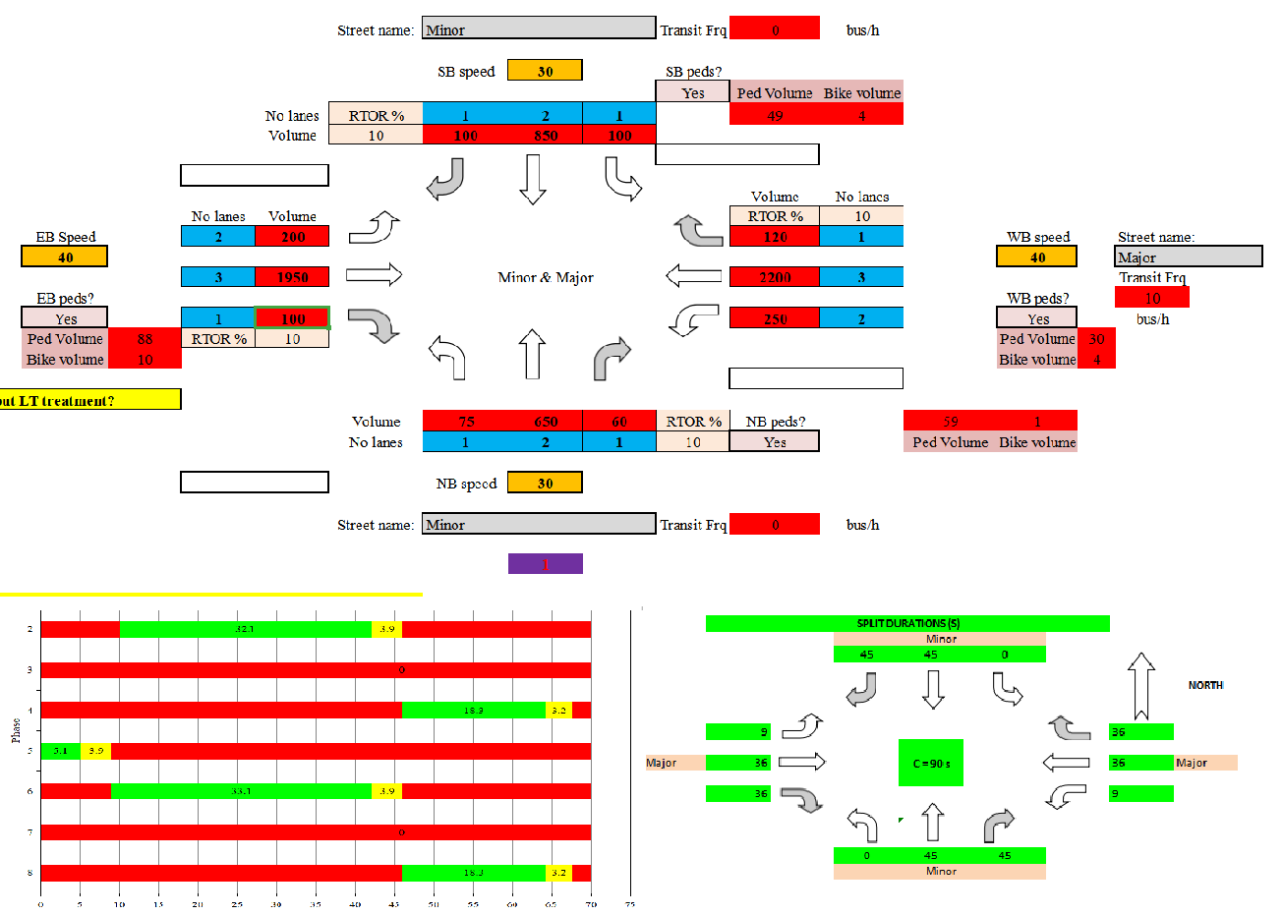

**Step 2:Pathon based, GMNS based Tool**

version for movement-based, phase-based signal control strategy optimization Developed by the research team led by Dr. Xuesong (Simon) Zhou at Arizona State University (xzhou74@asu.edu) and Dr. Milan Zlatkovic at University of Wyoming

Table 1. Folders of Vol2Timing package

|  |  |
| --- | --- |
| **Github Folder Name** | **Contents** |
| Src | source code of Vol2Timing |
| Release | Executable of Vol2Timing.exe in Windows |
| Doc | User’s guide and other documentations for Vol2Timing |
| Dataset | 1. Steps for Signal Control.docx 2. GMNS based network csv files, and additional extension in the **road_link.csv** for additional movement related attributes) 3. Case studies (including 3 cases with QEM Excel file) |

2.1. Check source code at <https://github.com/asu-trans-ai-lab/vol2timing/tree/master/src>

2.2. Data set at

<https://github.com/asu-trans-ai-lab/vol2timing/tree/master/release>

In this release folder, we have input files of (1) node.csv, (2) link.csv (3) movement.csv, and output files of (1) signal_timing_phase.csv, (2) signal_phase_mvmt.csv in GMNS format, as well as (3) timing.csv for quick mesoscopic and microscopic simulation.

To check out the location of signal intersections, please create a node.csv contains only nodes with field osm_highway== “traffic_signals”, and use <https://asu-trans-ai-lab.github.io/index.html#/> to visualize the locations of signalized intersections.

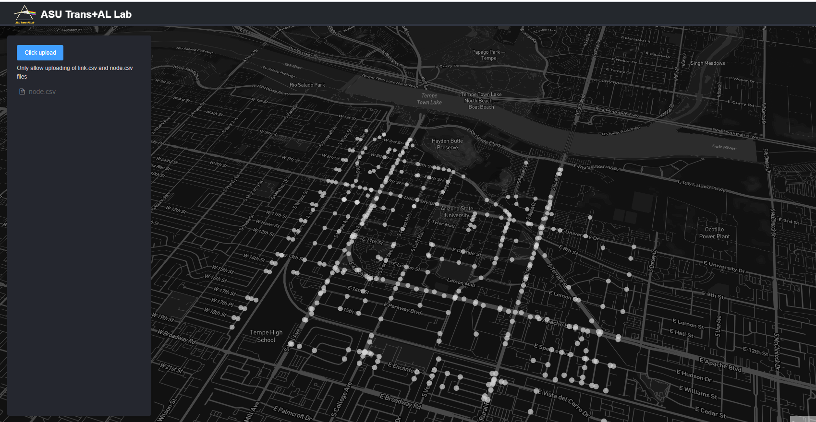

2.3. Try test script at

(1) Python code at https://github.com/asu-trans-ai-lab/vol2timing/blob/master/release/test.py

(2) Jupyter Notebook at https://github.com/asu-trans-ai-lab/vol2timing/blob/master/vol2timing.ipynb

2.4. Learn the steps from the log file (*.log) at https://github.com/asu-trans-ai-lab/vol2timing/tree/master/release

The first field in each table represents the primary reference.

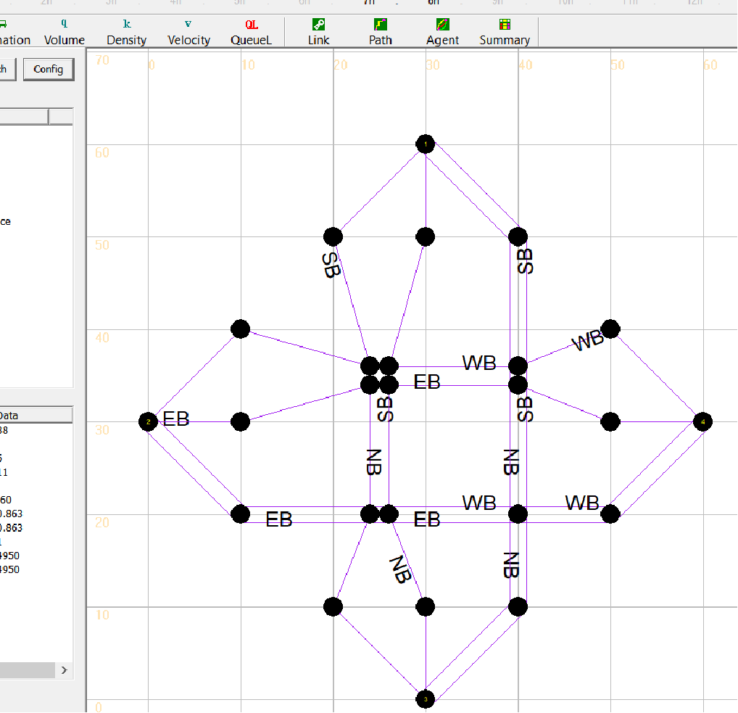

Other useful references:

(1) Nourmohammadi, Fatemeh, Mohammadhadi Mansourianfar, Sajjad Shafiei, Ziyuan Gu, and Meead Saberi. "An Open GMNS Dataset of a Dynamic Multi-modal Transportation Network Model of Melbourne, Australia." *Data* 6, no. 2 (2021): 21.

<https://www.mdpi.com/2306-5729/6/2/21/htm>

Pleas check out the nice [relational structure](https://www.mdpi.com/data/data-06-00021/article_deploy/html/images/data-06-00021-g001.png) of the developed General Modeling Network Specification (GMNS) dataset, in Fig. 1.

**Step 3: Practice problem**

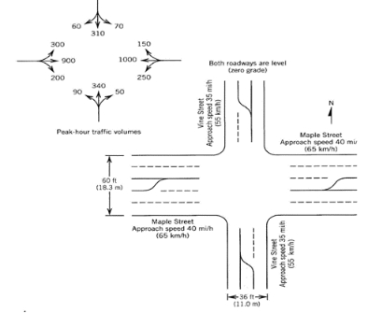

Fig.1 Sample problem from text book

Step 1. Input information

First, we should extract movement, volume, and lane information from Fig.1.

|  |  |  |  |  |  |  |  |  |  |  |  |  |
| --- | --- | --- | --- | --- | --- | --- | --- | --- | --- | --- | --- | --- |
| **Movement** | EBL | EBT | EBR | WBL | WBT | WBR | NBL | NBT | NBR | SBL | SBT | SBR |
| **Volume** | 300 | 900 | 200 | 250 | 1000 | 150 | 90 | 340 | 50 | 70 | 310 | 60 |
| **No. of lanes** | 1 | 1 | 1 | 1 | 1 | 1 | 1 | 1 | 1 | 1 | 1 | 1 |
| **Shared lanes** | - | - | - | - | - | - | - | - | - | - | - | - |

Step 2. Select signal phasing

1. **Determine left-turn treatment**

There are several principles for determining left-turn treatment.

1. **Left-turn lane check**

Criterion: If the number of left-turn lane on any approach exceeds 1, then it is recommended that the left turns on that approach be protected.

1. **Minimum volume Check**

Criterion: If left-turn volume on any approach exceeds 240 veh/h, then it is recommended that the left turns on that approach be protected.

1. **Opposing Through Lanes Check**

Criterion: If there are more than 4 or more through lanes on the opposing approach, then it is recommended that the left turns on that approach be protected.

1. **Opposing Traffic Speed Check**

Criterion: If the opposing traffic speed exceeds 45mph, then it is recommended that the left turns on that approach be protected.

1. **Minimum Cross-Product Check**

Criterion:

Protected+permissive:

|  |  |
| --- | --- |
| **Number of Through Lanes** | **Minimum Cross-Product** |
| 1 | 50000 |
| 2 or more | 100000 |

Protected only:

|  |  |
| --- | --- |
| **Number of Through Lanes** | **Minimum Cross-Product** |
| 1 | 150000 |
| 2 or more | 300000 |

Calculation: cross-product for each left-turn

|  |  |  |  |  |
| --- | --- | --- | --- | --- |
| **Movement** | EBL | WBL | NBL | SBL |
| **Opposing Through Lanes** |  |  |  |  |
| **Cross-Product** |  |  |  |  |
| **Exceed Protected Minimum Cross-Product?(Y/N)** |  |  |  |  |
| **Exceed Protected+Permissive Minimum Cross-Product?(Y/N)** |  |  |  |  |
| **Protected decision** |  |  |  |  |

1. **Comparing results**

Based on the analysis above, we can reach the left-turn final decision.

**QEM result**

|  |  |  |  |  |
| --- | --- | --- | --- | --- |
| **Movement** | EBL | WBL | NBL | SBL |
| **Left-turn Treatment** | Protected+Permissive | Protected+Permissive | Permitted | Permitted |

**Vol2Timing result**

|  |  |  |  |  |
| --- | --- | --- | --- | --- |
| **Movement** | EBL | WBL | NBL | SBL |
| **Left-turn Treatment** | Protected | Protected | Protected | Protected |

1. **Determine phasing sequence**

**QEM result**

|  |  |  |  |  |
| --- | --- | --- | --- | --- |
|  | **Final Ring-Barrier Movement** | | | |
| **Ring1** | 1 | 2 | 3 | 4 |
| **Ring2** | 5 | 6 | 7 | 8 |

**Vol2Timing result**

|  |  |  |  |  |
| --- | --- | --- | --- | --- |
|  | **Final Ring-Barrier Movement** | | | |
| **Ring1** | 1 | 2 |  | 4 |
| **Ring2** | 5 | 6 |  | 8 |

Step 3. Compute flow rates & adjusted saturation flow rate

**Right-turn Movement**

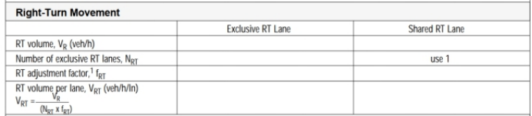

**Left-turn Movement**

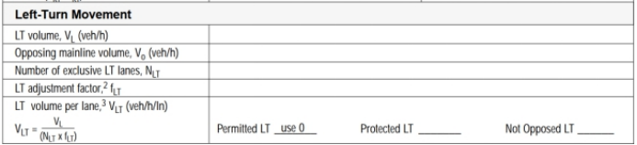

**Through Movement**

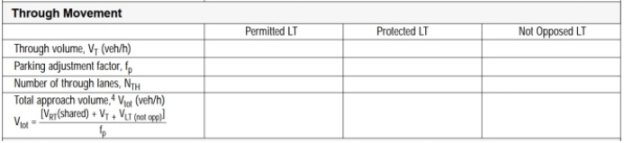

**Through Movement with exclusive LT lane & shared LT lane**

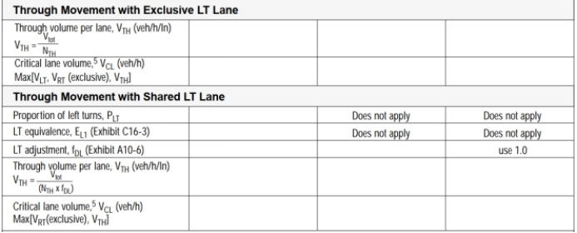

**Saturation flow rate**

**for protected phase:**

The default value of saturation flow rate for protected phase is 1530veh/h/lane



**for permissive phase(for left-turn):**

The default value of saturation flow rate for permissive phase is 150-200veh/h/lane



**Comparing results**

Based on the analysis above, we can calculate saturation flow rate.

**QEM result**

|  |  |  |  |  |  |  |  |  |  |  |  |  |
| --- | --- | --- | --- | --- | --- | --- | --- | --- | --- | --- | --- | --- |
| **Movement** | EBL | EBT | EBR | WBL | WBT | WBR | NBL | NBT | NBR | SBL | SBT | SBR |
| **Saturaion**  **flow rate** | 1530 | 1530 | 1530 | 1530 | 1530 | 1530 | 0 | 1530 | 1530 | 0 | 1530 | 1530 |

**Vol2Timing result**

|  |  |  |  |  |  |  |  |  |  |  |  |  |
| --- | --- | --- | --- | --- | --- | --- | --- | --- | --- | --- | --- | --- |
| **Movement** | EBL | EBT | EBR | WBL | WBT | WBR | NBL | NBT | NBR | SBL | SBT | SBR |
| **Saturaion**  **flow rate** | 1530 | 1530 | 1530 | 1530 | 1530 | 1530 | 1530 | 1530 | 1530 | 1530 | 1530 | 1530 |

Step 4. Determine critical lane groups & total cycle lost time

**（1）Determine critical lane groups**

To determine the critical lane group for each stage, we should select the lane group with maximum v/s(v: volume, s: saturation rate) for each stage.

**QEM result**

|  |  |  |  |
| --- | --- | --- | --- |
| **Stage** | 1 | 2 | 3 |
| **Critical lane group** | EBL | WBT | NBL |

**Vol2Timing result**

|  |  |  |  |  |
| --- | --- | --- | --- | --- |
| **Stage** | 1 | 2 | 3 | 4 |
| **Critical lane group** | EBL | WBT | NBL | NBT |

**（2）Determine total cycle lost time**

The total cycle lost time is given as

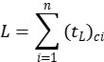

where







**QEM result**

 = 4s*3 = 12s

**Vol2Timing result**

 = 4s*4 = 16s

Step 5. Calculate cycle length

A practical equation for the calculation of the cycle length that seeks to minimize

vehicle delay was developed by Webster (1969). Webster’s optimum cycle length

formula is

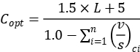

where





**QEM result**



**Vol2Timing result**



Step 6. Allocate green time

There are several strategies for allocating the green time to the various stages. One of the most popular and simplest is to distribute the green time so that the *v*/*c* ratios are equalized for the critical lane groups, as by the following equation:



where









**QEM result**

|  |  |  |  |  |
| --- | --- | --- | --- | --- |
| **Stage** | 1 | 2 | 3 | 4 |
| **Ring1** | 24 | 86 | 0 | 30 |
| **Ring2** | 28 | 82 | 0 | 30 |

**Vol2Timing result**

|  |  |  |  |  |
| --- | --- | --- | --- | --- |
| **Stage** | 1 | 2 | 3 | 4 |
| **Ring1** | 9 | 36 | 5 | 12 |
| **Ring2** | 9 | 36 | 5 | 12 |

Step 7. Calculate capacity and V/C ratio

Capacity can be calculated as follows:



where











Then we can calculate the ratio of V/C.

**QEM results**

|  |  |  |  |  |  |  |  |  |  |  |  |  |
| --- | --- | --- | --- | --- | --- | --- | --- | --- | --- | --- | --- | --- |
| **Movement** | EBL | EBT | EBR | WBL | WBT | WBR | NBL | NBT | NBR | SBL | SBT | SBR |
| **Capacity(veh)** | 338 | 896 | 896 | 294 | 852 | 852 | 65 | 284 | 284 | 65 | 284 | 284 |

**Vol2Timing results**

|  |  |  |  |  |  |  |  |  |  |  |  |  |
| --- | --- | --- | --- | --- | --- | --- | --- | --- | --- | --- | --- | --- |
| **Movement** | EBL | EBT | EBR | WBL | WBT | WBR | NBL | NBT | NBR | SBL | SBT | SBR |
| **Saturaion**  **flow rate** | 280.5 | 969 | 969 | 280.5 | 969 | 969 | 178.5 | 357 | 357 | 178.5 | 357 | 357 |

Step 8. Calculate Signal Delay and LOS

**QEM results**

|  |  |  |  |  |  |  |  |  |  |  |  |  |
| --- | --- | --- | --- | --- | --- | --- | --- | --- | --- | --- | --- | --- |
| Movement | EBL | EBT | EBR | WBL | WBT | WBR | NBL | NBT | NBR | SBL | SBT | SBR |
| Phase | 5 | 2 | 2 | 1 | 6 | 6 | 0 | 8 | 8 | 0 | 4 | 4 |
| UnifDelay (s) | 16.1 | 29 | 13.62 | 19.06 | 31 | 15.06 | 57 | 57 | 47.82 | 57 | 57 | 48.11 |
| IncDelay (s) | 27.65 | 30.07 | 0.5 | 25.25 | 89 | 0.4 | 242.05 | 118.81 | 1.19 | 135.4 | 79.57 | 1.48 |
| ControlDelay (s) | 43.8 | 59.1 | 14.1 | 44.3 | 120.0 | 15.5 | 299.1 | 175.8 | 49.0 | 192.4 | 136.6 | 49.6 |
| LOS | D | E | B | D | F | B | F | F | D | F | F | D |
| Approach Delay (s) | 49.4 |  |  | 95.3 |  |  | 185.7 |  |  | 133.6 |  |  |
| Approach LOS | D |  |  | F |  |  | F |  |  | F |  |  |
|  |  |  |  |  |  |  |  |  |  |  |  |  |
| **Intersection Delay (s)** | **95.1** |  |  |  |  |  |  |  |  |  |  |  |
| **Intersection LOS** | **F** |  |  |  |  |  |  |  |  |  |  |  |
| **Intersection V/C** | **1.07** |  |  |  |  |  |  |  |  |  |  |  |
| **Intersection Status** | **Over Capacity** |  |  |  |  |  |  |  |  |  |  |  |

**Vol2Timing results**

|  |  |  |  |  |  |  |  |  |  |  |  |  |
| --- | --- | --- | --- | --- | --- | --- | --- | --- | --- | --- | --- | --- |
| Movement | EBL | EBT | EBR | WBL | WBT | WBR | NBL | NBT | NBR | SBL | SBT | SBR |
| Phase | 5 | 2 | 2 | 1 | 6 | 6 | 0 | 8 | 8 | 0 | 4 | 4 |
| UnifDelay (s) | 433.7 | 196.0 | 136.5 | 270.0 | -40.3 | 107.2 | 91.1 | 944.3 | 120.7 | 85.2 | 553.5 | 82.6 |
| LOS | D | E | B | D | F | B | F | F | D | F | F | D |
| Approach Delay (s) | 95.8 |  |  | 42.8 |  |  | 640.1 |  |  | 380 |  |  |
| Approach LOS | F |  |  | D |  |  | F |  |  | F |  |  |
|  |  |  |  |  |  |  |  |  |  |  |  |  |
| **Intersection Delay (s)** | **95.1** |  |  |  |  |  |  |  |  |  |  |  |
| **Intersection LOS** | **F** |  |  |  |  |  |  |  |  |  |  |  |
| **Intersection V/C** | **1.07** |  |  |  |  |  |  |  |  |  |  |  |
| **Intersection Status** | **Over Capacity** |  |  |  |  |  |  |  |  |  |  |  |