# Step 2.1: Group the data frame by VDF. Each VDF type is a combination of facility type (FT) and area type (AT)

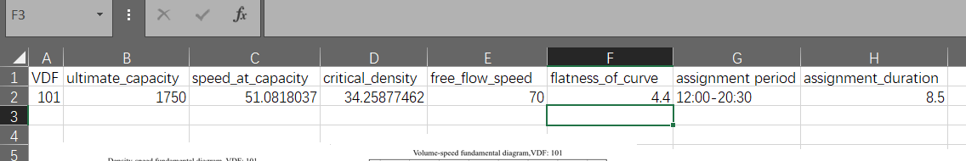

vdf_index = [100 * i + j for i in training_set.AT.unique() for j in training_set.FT.unique()]

