Date : 3/22/2026
Implementing “ Filter and Refresh ”Functionality in Oracle Apex Application.
Problem Statement :
- The report required users to manually click on a Search button after selecting the values from LOVs that act as parameters to the actual source of the interactive report.
Solution :
- Implementation of FILTER AND REFRESH with the help of Dynamic actions , this enables automatic report filtering by eliminating a search button.

Document Content :
Application Components
Applicable Dynamic Actions
Application Front End Overview
Saving an interactive report
Home Page overview
Export the Application

Implementing Filter and Refresh Functionality in Oracle Apex Application.
Application Components
A region has been created in Oracle Apex Application that contains two page-items
- P2_GENERE
- P2_AUTHOR
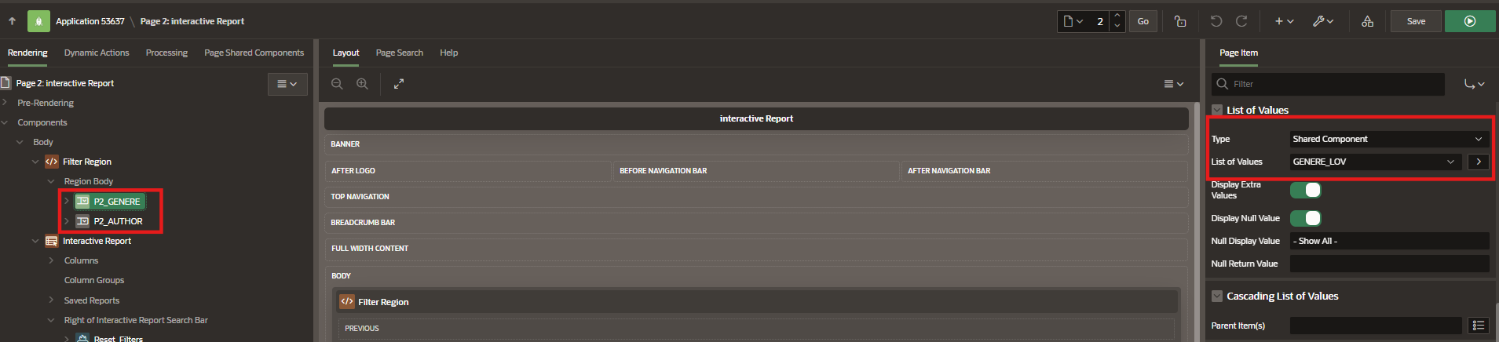
These two Page items are Select lists that allow users to select a value from multiple selection options. The source of these two LOVs are defined from the LOV definitions of the shared components.
Navigation : Shared Components > Other Components > List of Values
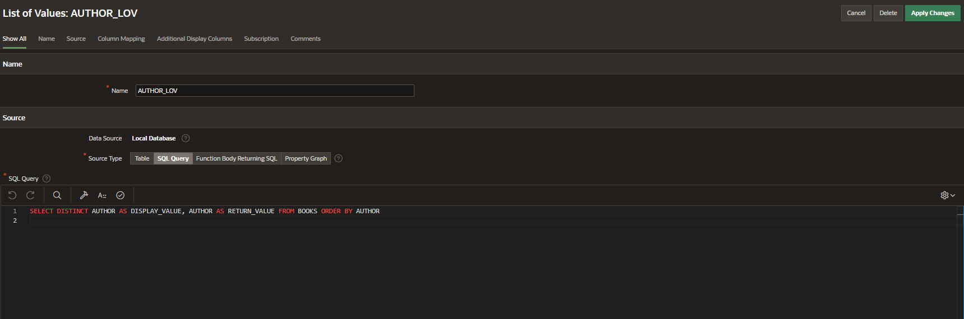
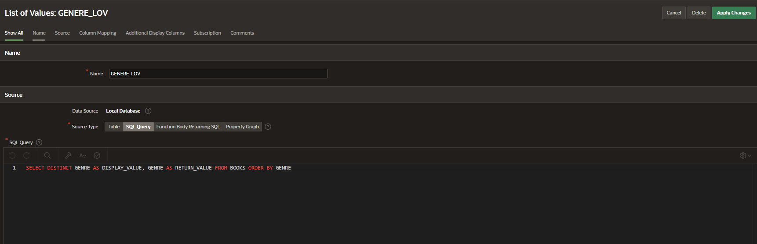
An interactive report has been created which displays information from the table named ‘BOOKS ’ that contains information about the different types of books and the publication details like TITLE, AUTHOR, PUBLISHED YEAR , GENRE.
P2_GENERE , P2_AUTHOR page items are passed as parameters to the SQL query . When these parameter values are provided filters will be applied and the report data changes dynamically based on the values that have been selected from the select lists.
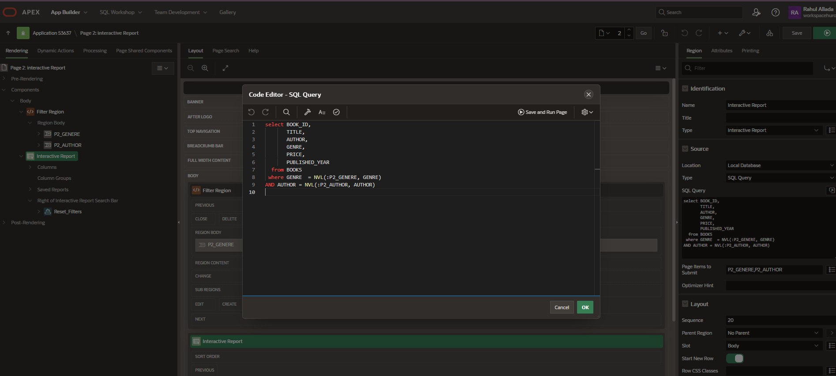
This Query is a simple dynamic filter Query used for the demonstration of “FILTER AND REFRESH” functionality in Oracle Application page components especially in interactive reports and interactive Grids.
Applicable Dynamic Actions
- Refresh the Report
A dynamic action has been added to refresh the report.
- Event : When there is change in page items P2_GENERE, P2_AUTHOR
- True Action : Whenever there is a change in the select list , the event condition gets satisfied and the true action gets triggered that refreshes the interactive report region to reflect the latest applied filters and dynamically display the data on the bases of selected parameters.

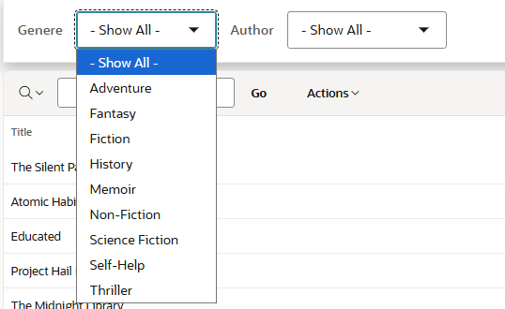


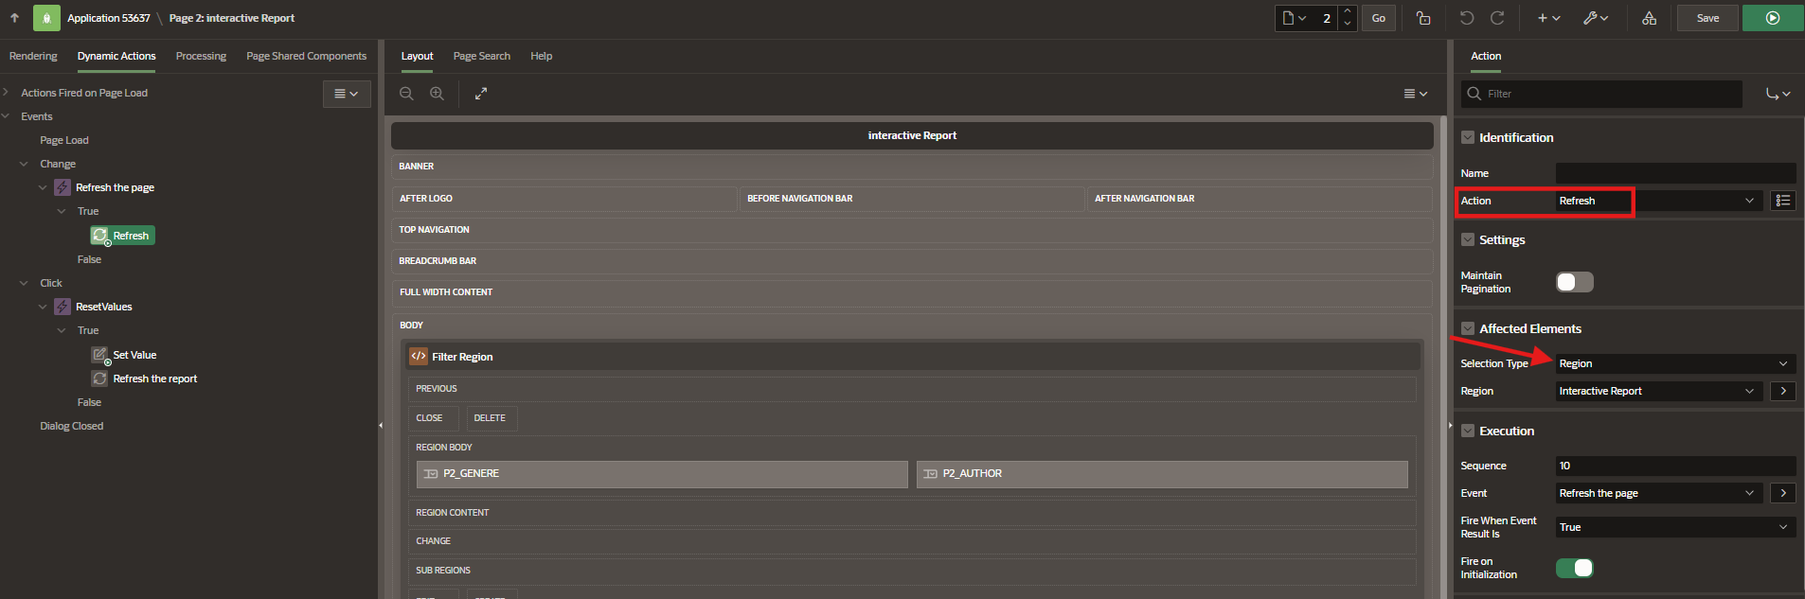

- Reset the Values
How to enable reset button for the interactive report ?
Interactive report> Attributes> Actions Menu> Reset (Enable the button)

A dynamic action has been added to implement the reset button logic
- Event : When user clicks on the reset button
- True Action : Set the corresponding LOV page items P2_GENERE, P2_AUTHOR to null and refresh the report
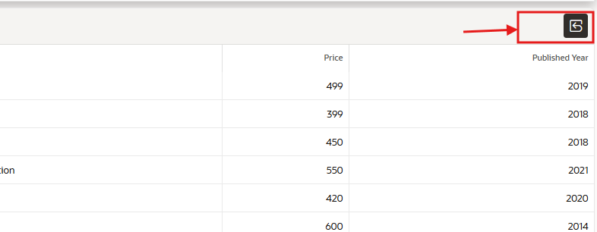

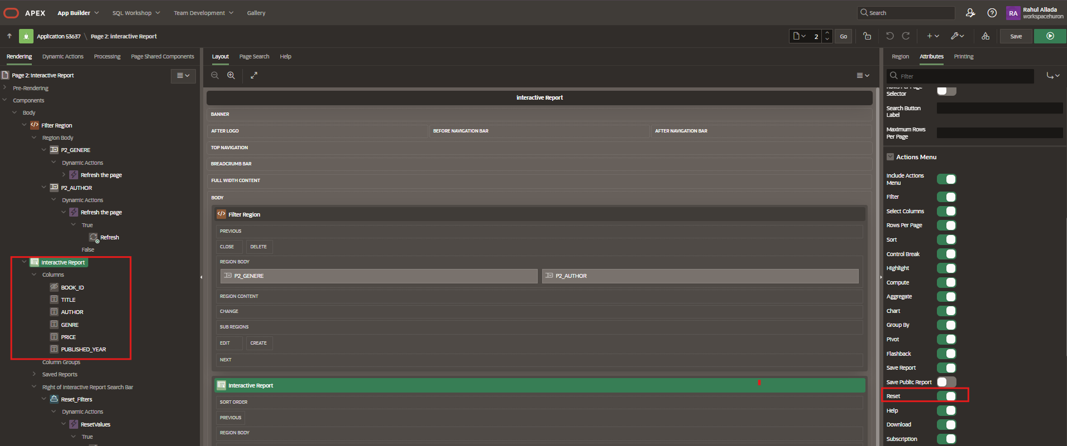

Dynamic action to set the corresponding LOV page items P2_GENERE, P2_AUTHOR to null 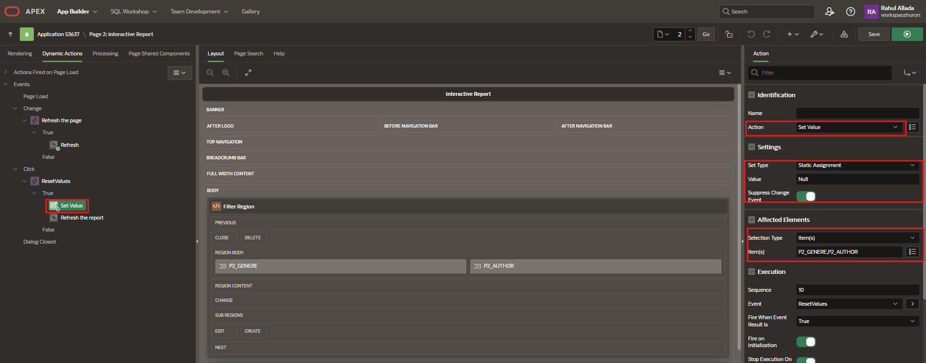
Dynamic action to refresh the report region after setting the page items to null



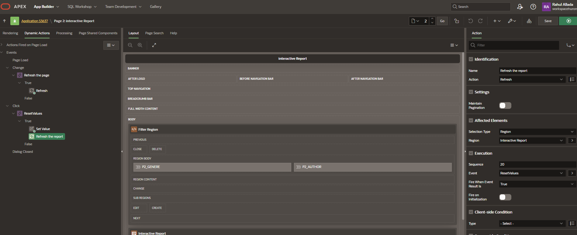

Two true actions have been added to the second dynamic action ; in order to implement them in sequence , Lowest sequence number is given to the action that needed to be implemented first and the highest sequence number has been allotted for the true action that needed to be implemented after the previous action.
Sequence numbering plays a vital role while dealing with multiple true actions that come under the same event. Actions are implemented in sequence of the bases of the specified sequence number.

Application Front End Overview
- Select the Appropriate values from the LOV to filter out the records


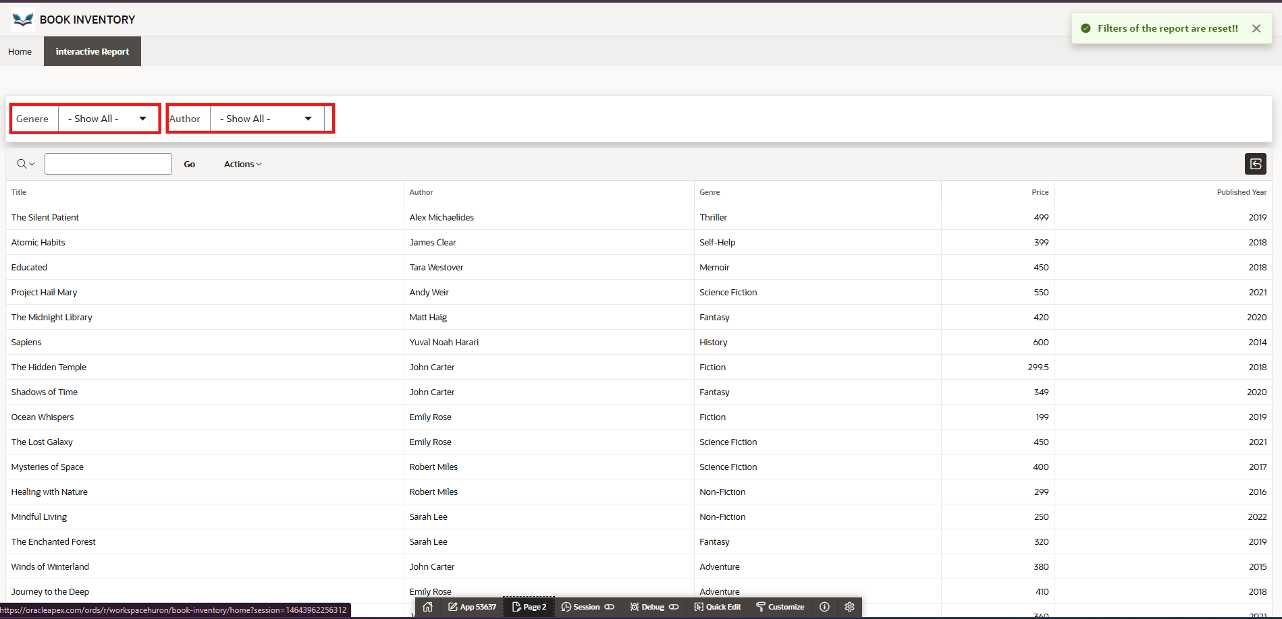



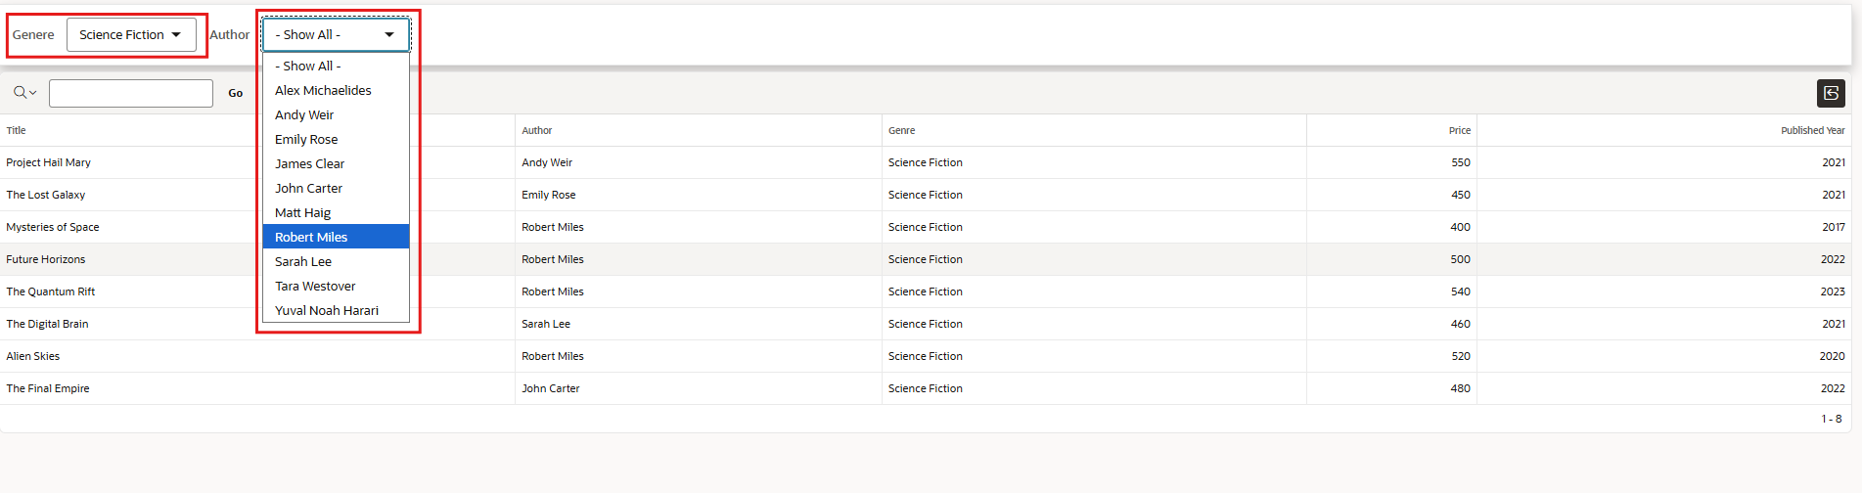
Here we can see that after Applying filters by selecting the appropriate values via LOVs
The report data is dynamically changed based on the values that have been selected. We have managed to achieve this functionality with the help of the specified dynamic actions.
We have opted this functionality to eliminate a submit button to set filters manually after clicking it
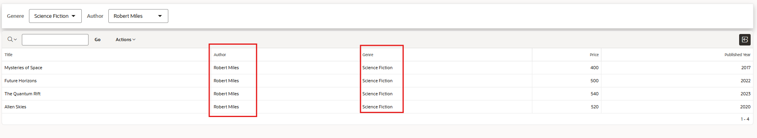
Click on reset button to reset the applied filters :
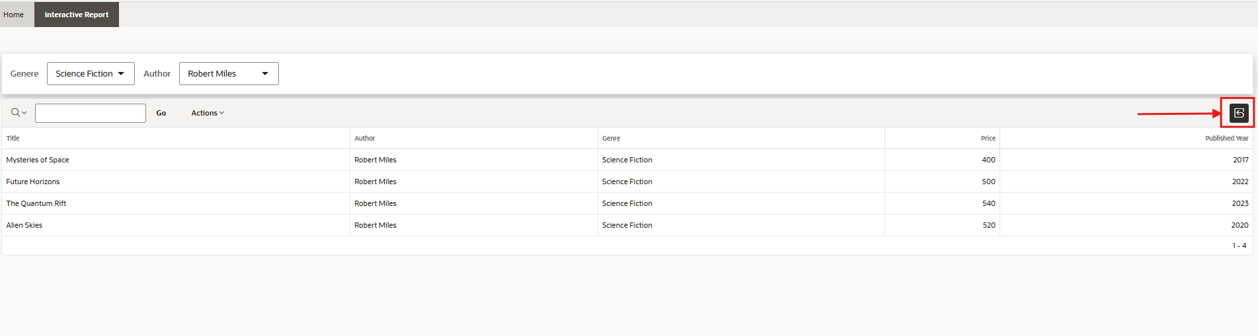
All the Applied filters have been removed after clicking on the reset button.
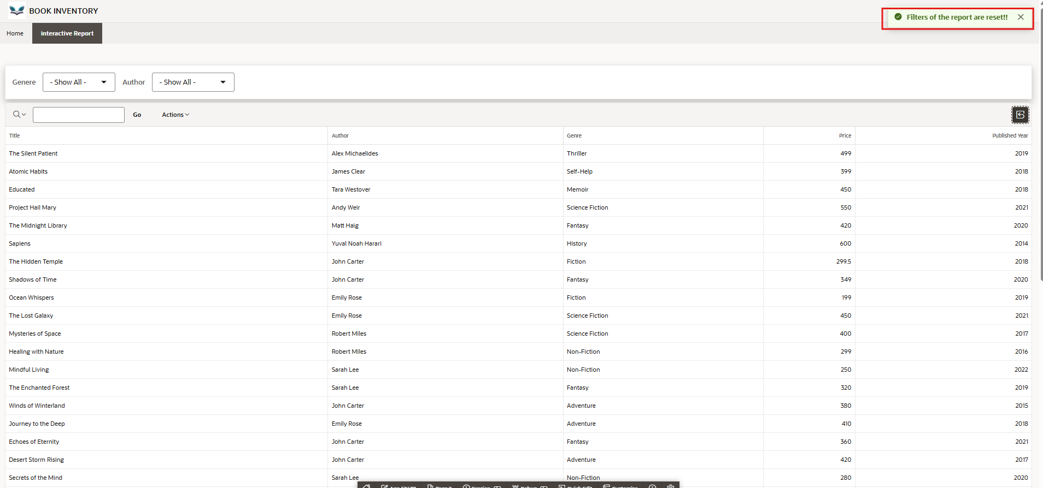

Saving an interactive report
- Aggregation
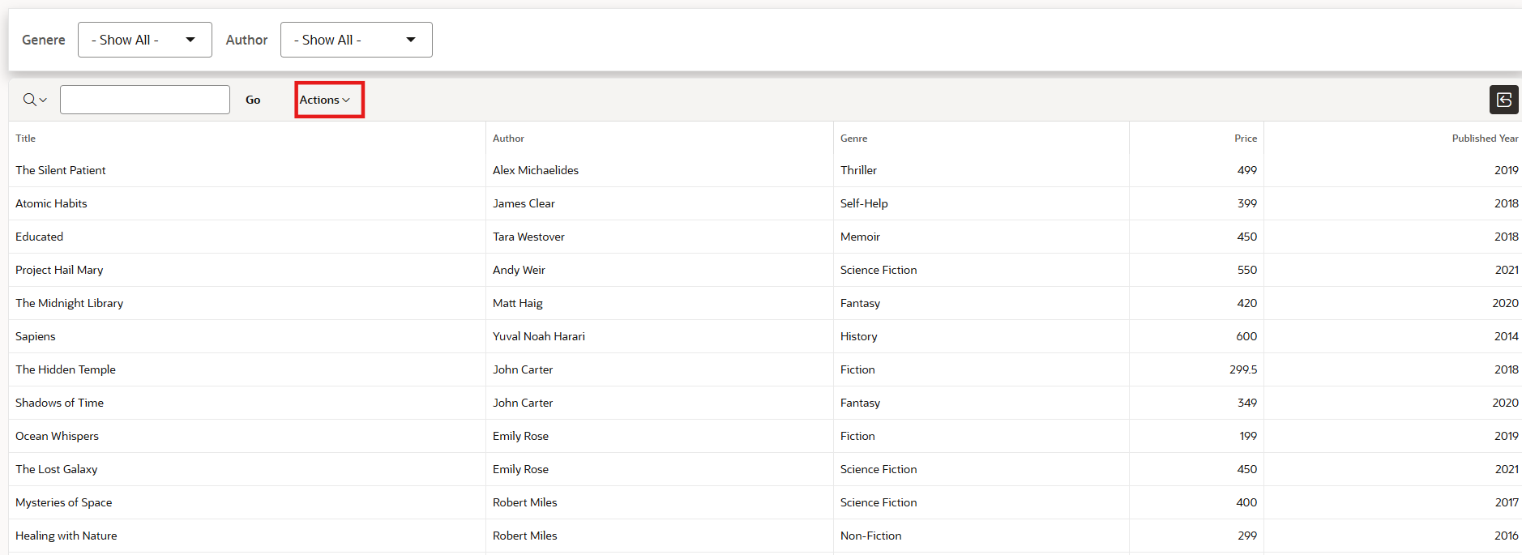

Actions > Data>Aggregation > Select the Appropriate column and function and click on Apply



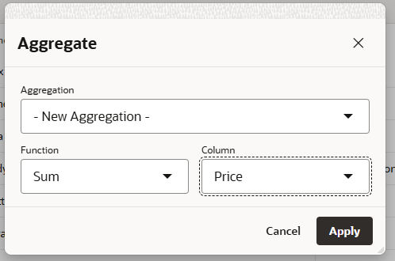
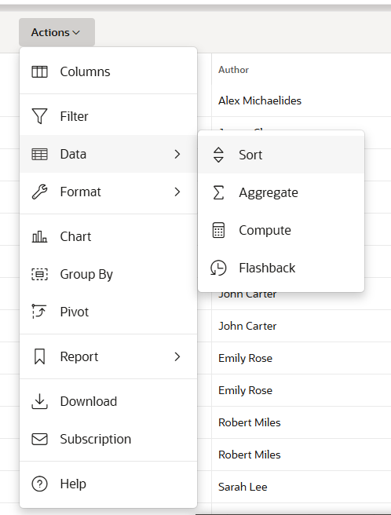

After applying the Aggregation to the Price column :
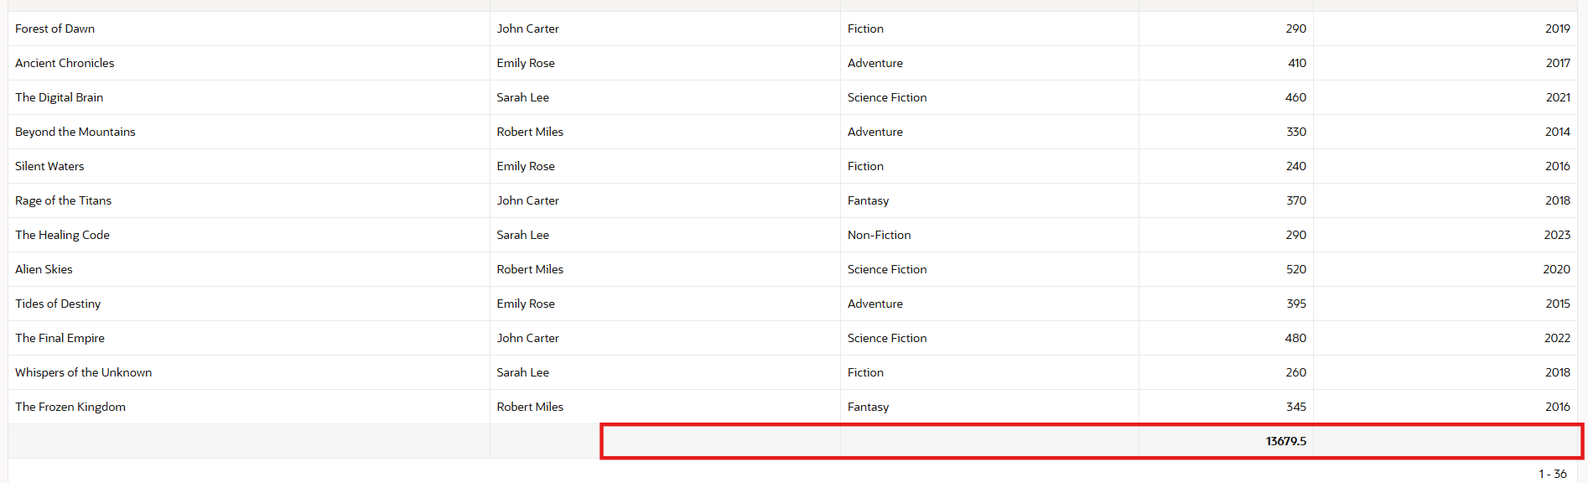

- Sorting the Report
Actions > Data > Sort



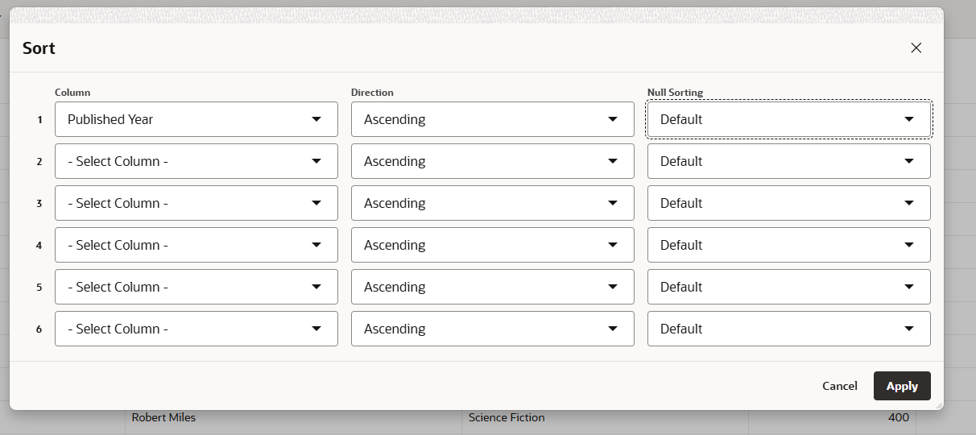
We can see that the data is sorted based on published year
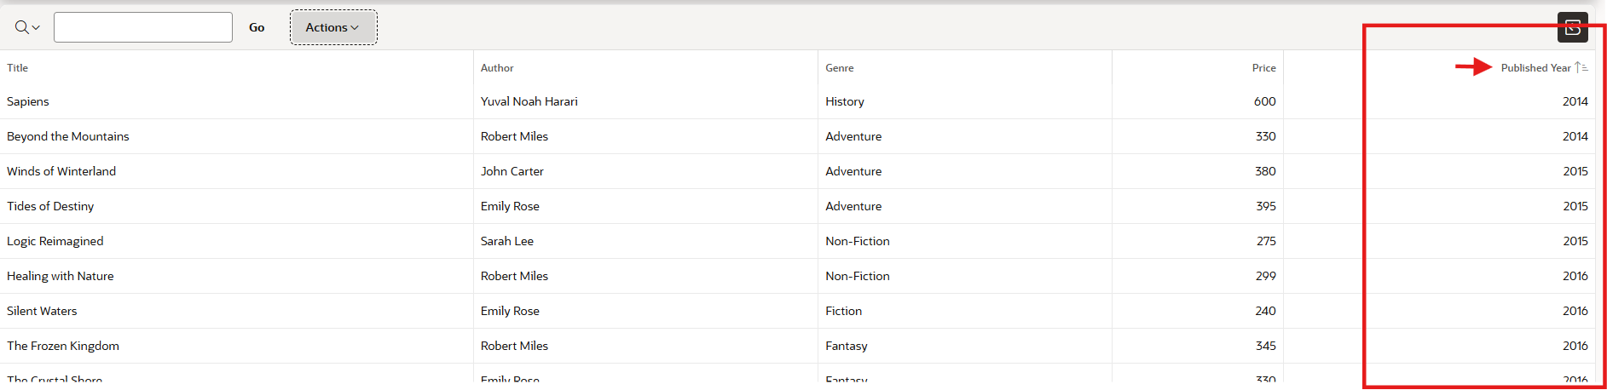
Save the report after making the appropriate changes :

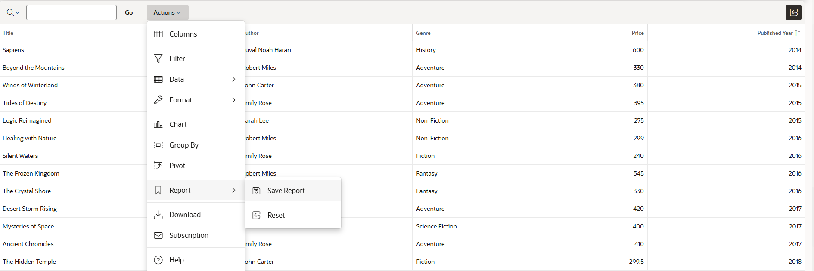

Home Page overview
This is the home screen which is used to analyze the book data
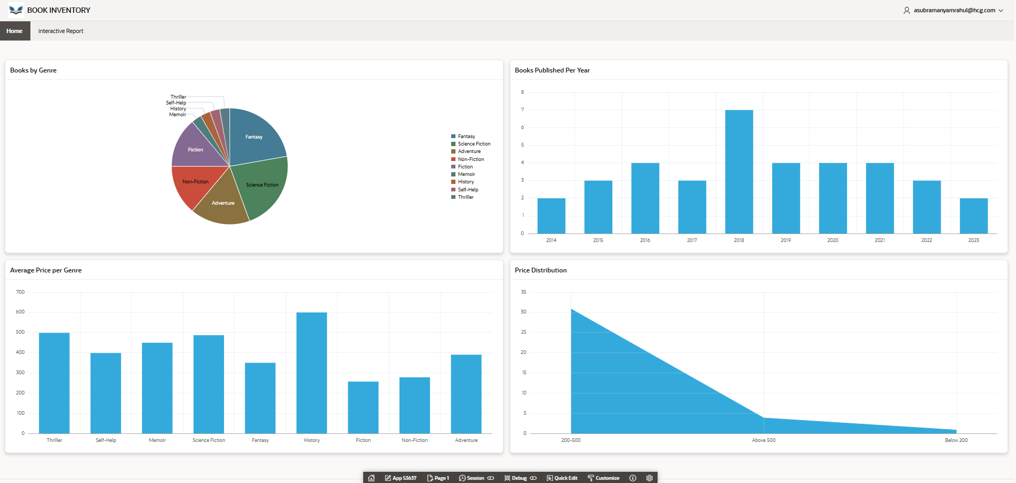

Export the Application (App Builder > Select the Application > Export )
