How to Install VirtualBox (Oracle VM VirtualBox)- A Complete Guide

***We offer you a brighter future with FREE online courses***[***Start Now!!***](https://data-flair.training/)

1. Objective

The below tutorial will help you to easily install VirtualBox on the host OS installed on your machine. In VirtualBox, we can easily run a number of guest operating systems depending upon your hardware configurations. Virtual Box saves system’s memory by configuring a number of OS on it, rather than individually installing them. And we can also install a number of setups and services on it.

So, let’s see how to install VirtualBox(Oracle VM VirtualBox)?

[](https://data-flair.training/blogs/wp-content/uploads/sites/2/2016/06/Installation-of-VirtualBox-01.jpg)

*How to Install VirtualBox (Oracle VM VirtualBox)- A Complete Guide*

2. VirtualBox Download Link

You can download the latest version of VirtualBox from the Virtual Box website: [**https://www.virtualbox.org/wiki/Downloads**](https://www.virtualbox.org/wiki/Downloads)according to the version of your operating system Windows, Mac or Linux.

If you’re running Windows operating system, download the Windows version at the top by clicking “x86/amd64”  
Go to DOWNLOAD folder at your desktop.

Run the VirtualBox-4.3.16-95972-Win.exe file. **Oracle VM Virtual Box Installation** Window will appear.

3. Steps to Install VirtualBox

Below are the very easy steps with screenshots containing the installation procedure of Virtual Box. With the help of the below screenshots, you can install VirtualBox on your system without taking help of anyone for a single time.

3.1. Click Next

[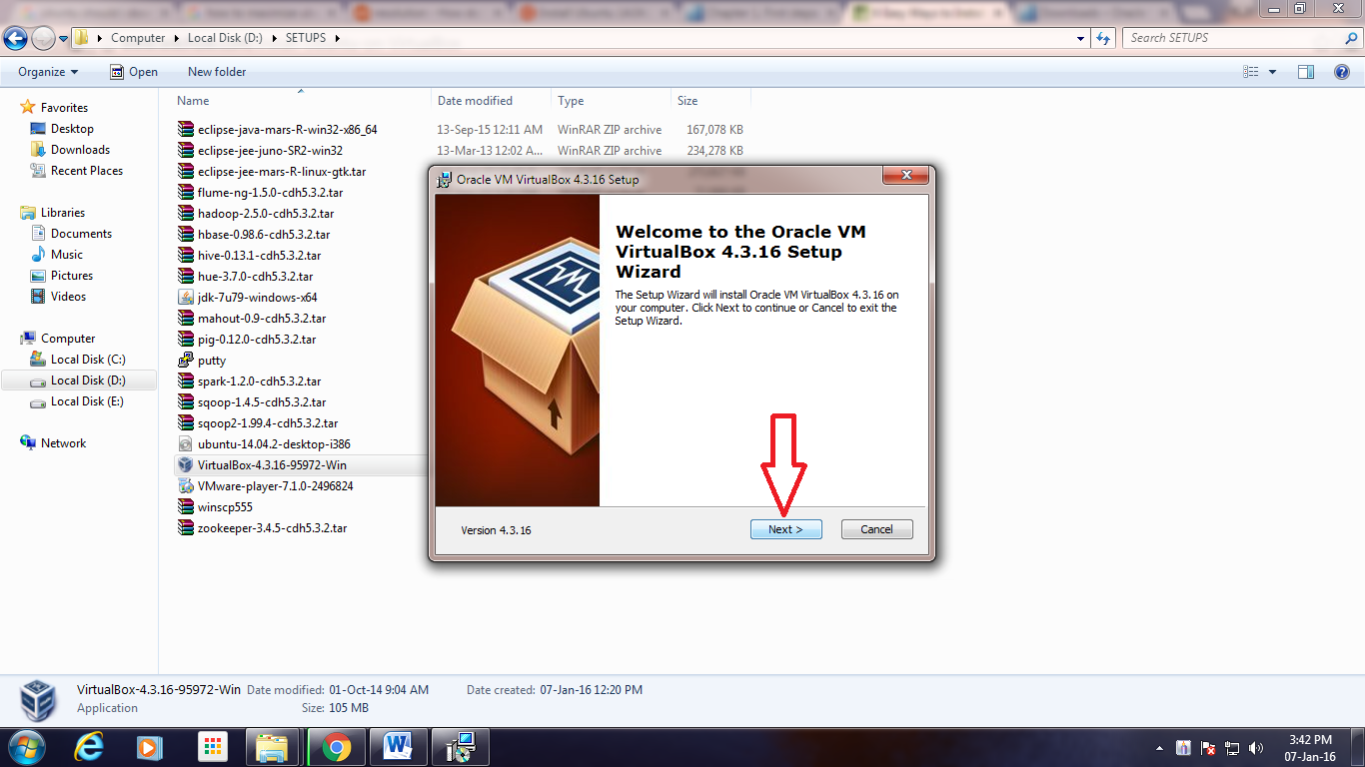](https://data-flair.training/blogs/wp-content/uploads/sites/2/2016/06/Setup-Wizard.png)

*Step 1. To Install VirtualBox – Setup Wizard*

3.2. Click Next

[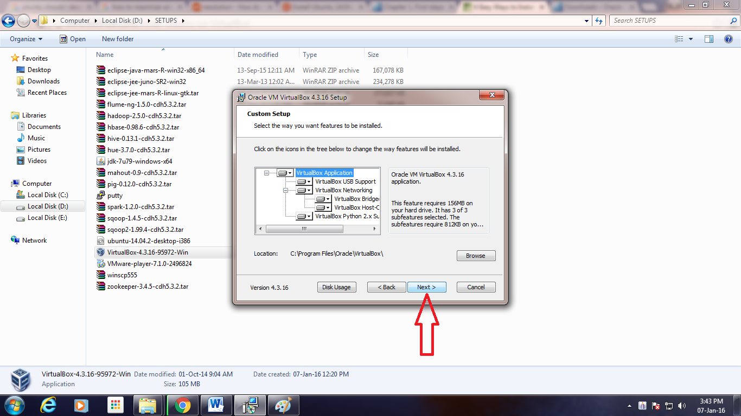](https://data-flair.training/blogs/wp-content/uploads/sites/2/2016/06/Custom-Setup.png)

*Step 2. To Install VirtualBox – Custom Setup*

3.3. Uncheck “Create a shortcut in the Quick Launch Bar” and click “Next”

[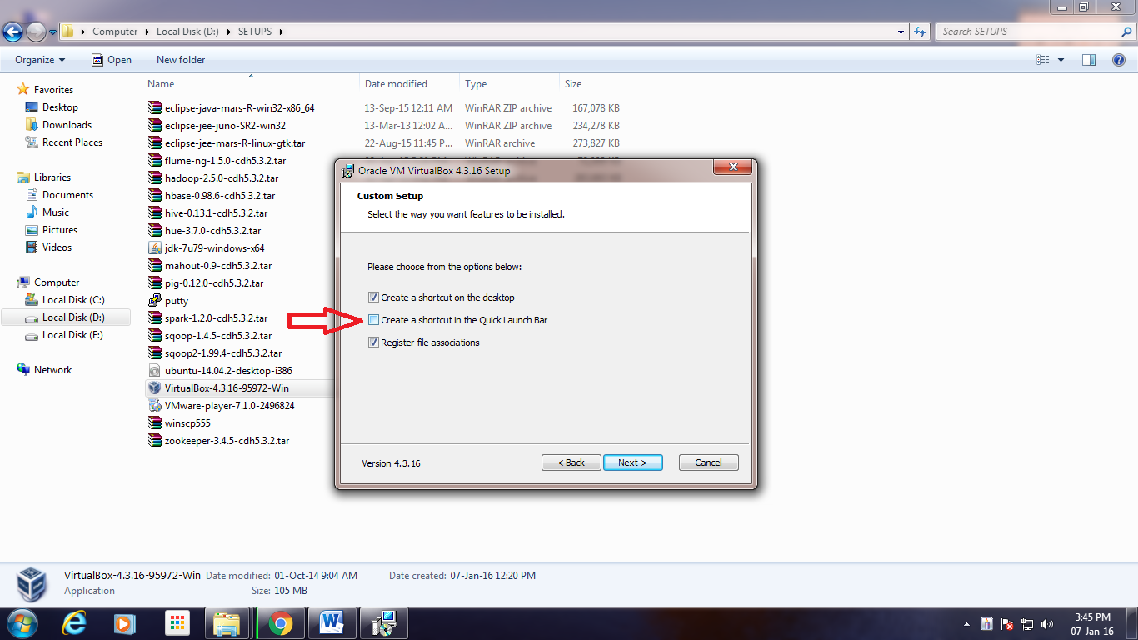](https://data-flair.training/blogs/wp-content/uploads/sites/2/2016/06/Features-Selection.png)

*Step 3. To Install VirtualBox – Features Selection*

3.4. Click “Yes”

[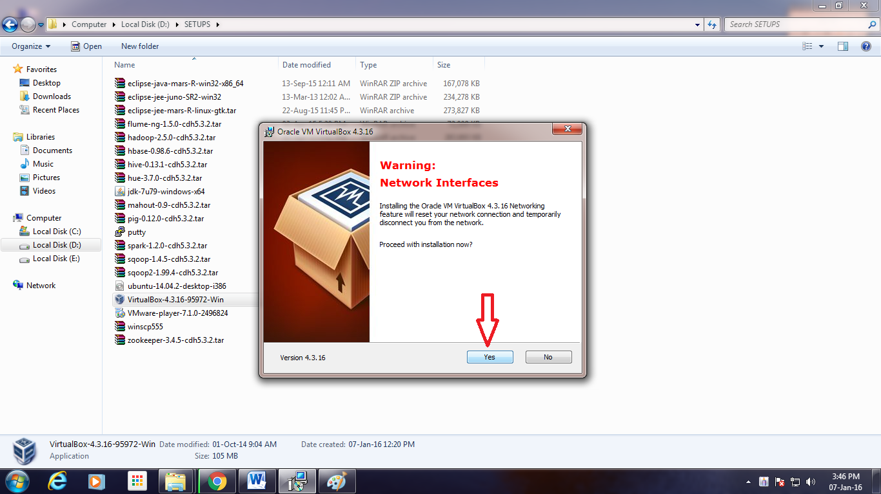](https://data-flair.training/blogs/wp-content/uploads/sites/2/2016/06/Network-Interfaces-Warning.png)

*Step 4. To Install VirtualBox – Network Interfaces Warning*

3.5. Click “Install”

[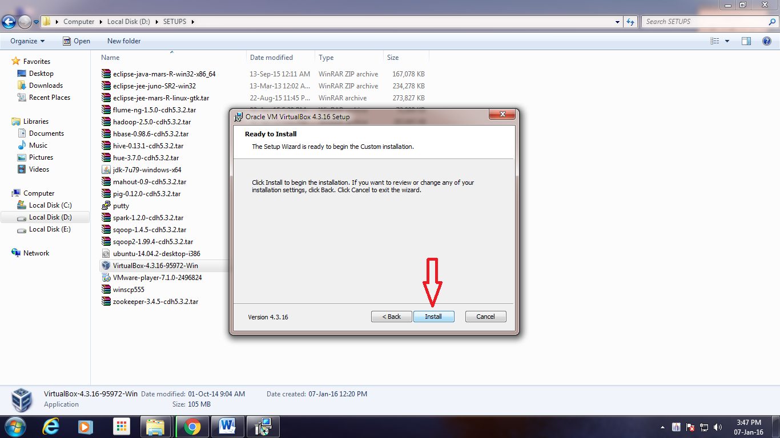](https://data-flair.training/blogs/wp-content/uploads/sites/2/2016/06/Ready-to-Install.png)

*Step 5.Installation of Oracle VM VirtualBox – Ready to Install*

3.6. Click “Install”

[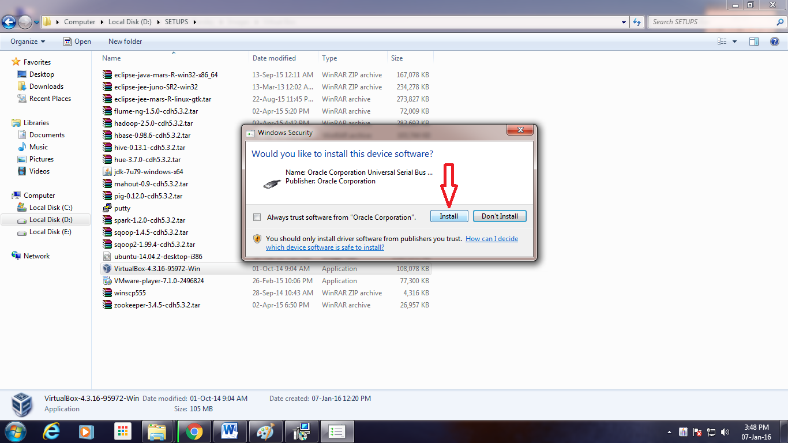](https://data-flair.training/blogs/wp-content/uploads/sites/2/2016/06/Serial-Bus-Software-Installation.png)

*Step 6.Installation of Oracle VM VirtualBox- Serial Bus Software Installation*

3.7. Click “Install”

[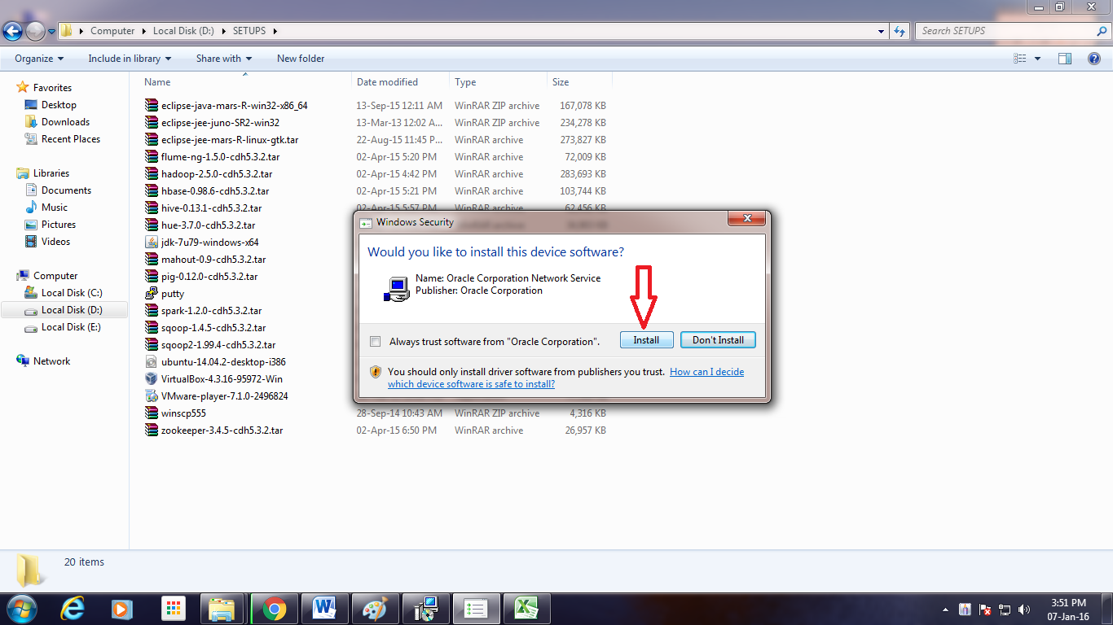](https://data-flair.training/blogs/wp-content/uploads/sites/2/2016/06/Network-Service-Installation.png)

*Step 7.Installation of Oracle VM VirtualBox – Network Service Installation*

3.8. Click “Install”

[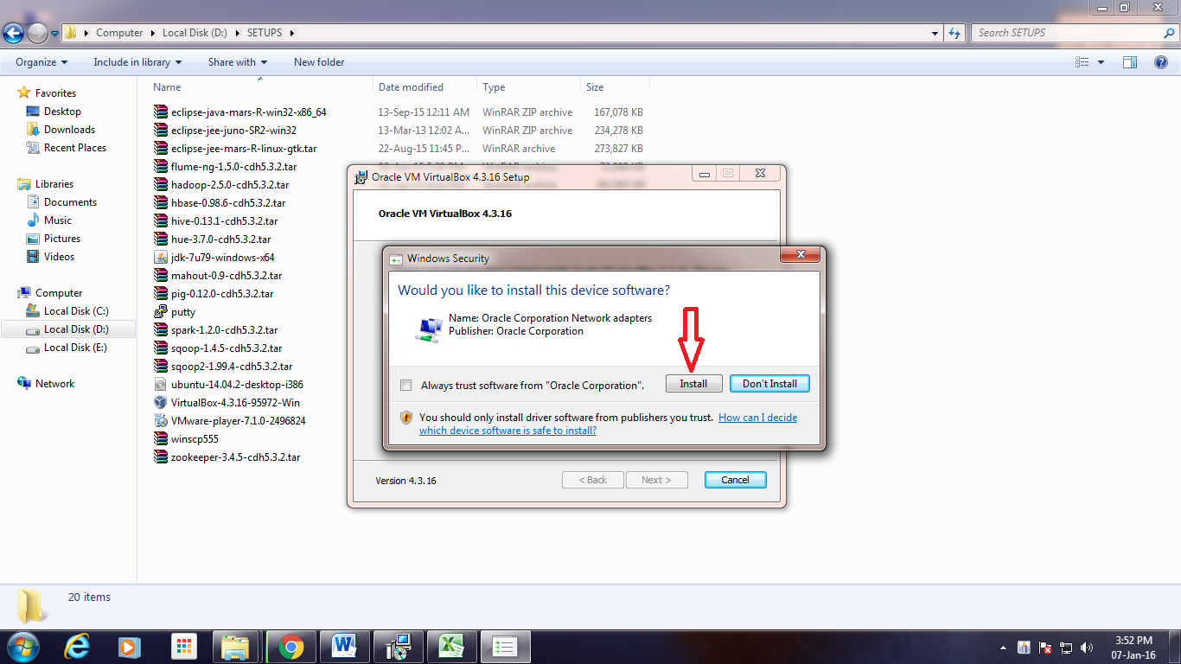](https://data-flair.training/blogs/wp-content/uploads/sites/2/2016/06/Network-Adapters-Installation.png)

*Step 8.Installation of Oracle VM VirtualBox – Network Adapters Installation*

3.9. Click “Finish”

[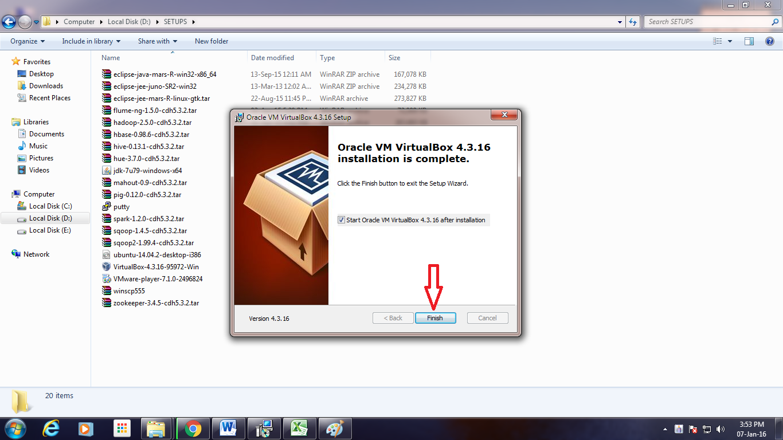](https://data-flair.training/blogs/wp-content/uploads/sites/2/2016/06/Exit-Setup-Wizard.png)

*Step 9. Installation of Oracle VM VirtualBox- Exit Setup Wizard*

3.10. After completion of Installation process, the Virtual Box Window gets opened

[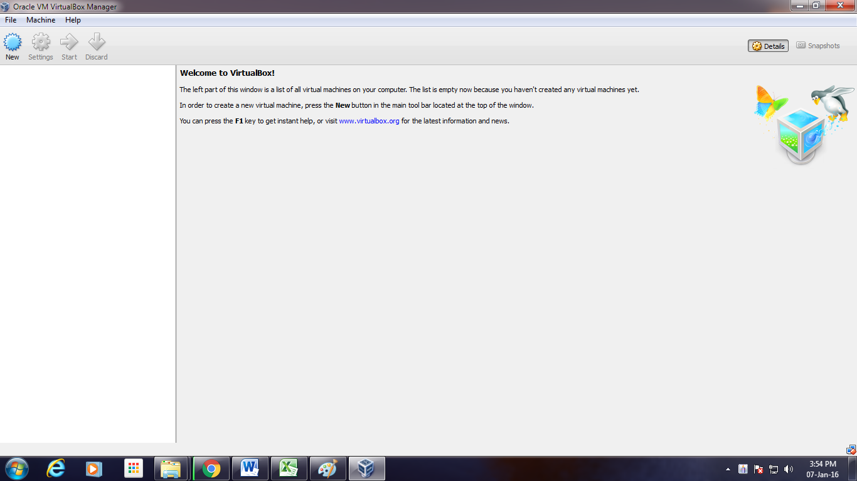](https://data-flair.training/blogs/wp-content/uploads/sites/2/2016/06/Virtual-Box-Window.png)

*Step 10. Installation of Oracle VM VirtualBox – Virtual Box Window gets opened*

***Congratulations “Oracle VM Virtual Box” has been installed successfully, now you can***[***create Virtual Machine and install Operating System***](https://data-flair.training/blogs/step-by-step-installation-of-ubuntu-on-virtual-box/)***.***

So, this was all about Installation of VirtualBox. Hope you like our explanation. Furthermore, if you hvae any query, feel free to ask in the comment section.