Subject: Machine Learning Homework – Assigment 3
Student Name: Asude Aslan

1. Implementation Details
In this assignment, I implemented an ensemble learning framework supporting both AdaBoost and RealBoost algorithms. The implementation adheres to the provided class structure, where weak learners are injected via the constructor.
Weak Learners:
- Weighted CART: I extended the standard shallow CART (Decision Tree) to accept sample weights ("weights" parameter). The split criterion (Entropy) and leaf predictions were modified to account for the weighted distribution of data, which is crucial for the Boosting re-weighting mechanism.
- Bins (Histogram-based): For RealBoost, I implemented a weak learner that selects the single best feature per iteration and discretizes it into B bins. The prediction for each bin is calculated using the log-likelihood ratio formula: 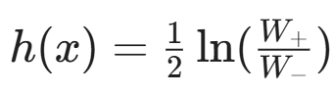
Boosting Algorithms:
- AdaBoost: Implemented with the standard re-weighting scheme. During training, zero-one error, exponential error (Z), and alpha coefficients are computed for each boosting round. Note: We report Z (the normalization factor) which upper-bounds the training exponential loss.
- RealBoost: Implemented using probability estimates from weak learners. The weights are updated based on the probability outputs mapped to the real-valued space using the logit function.
2. Experimental Setup
I performed comprehensive batch experiments on the Olivetti Faces dataset (binary classification: "Glasses" vs. "No Glasses"). To ensure robustness, the experiments covered the full grid of parameters specified in the assignment:
- Dimensionality Reduction (PCA): r = 20, 50, 100
- Boosting Rounds (T): T = 16, 32, 64, 128
- Tree Depths: d = 1, 2, 3
- Number of Bins: B = 4, 8, 16
3. Results
Below are the learning curves (Training vs. Testing Error) for the configurations.
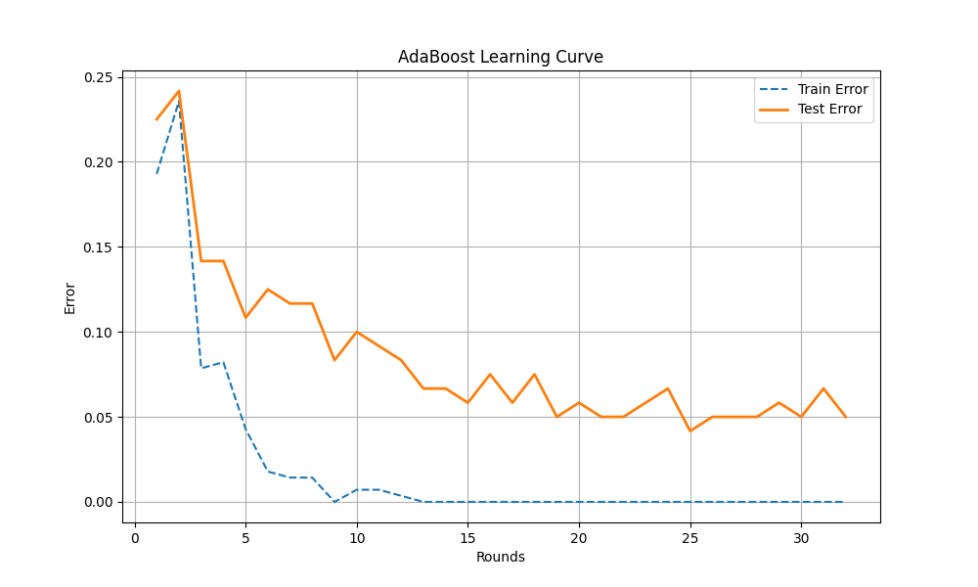Figure 1: Learning curve for AdaBoost coupled with shallow CART.

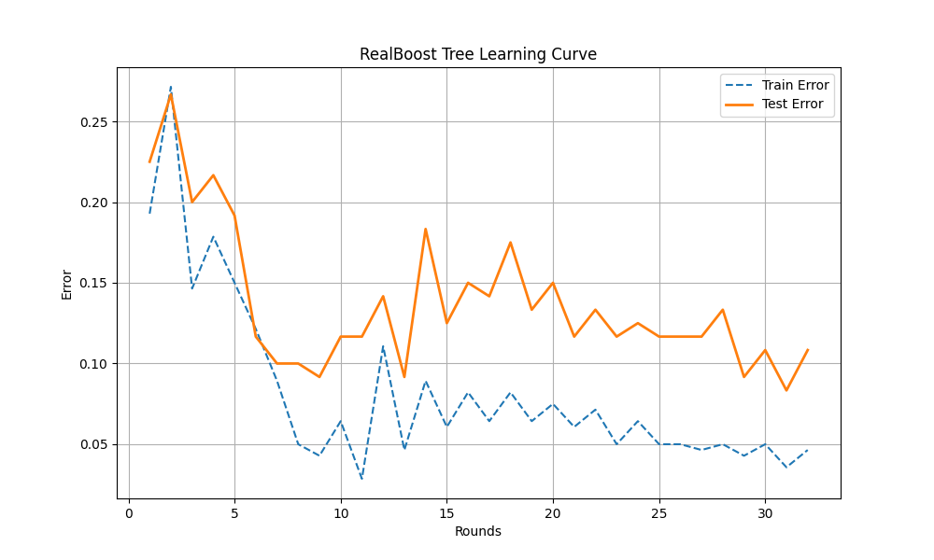Figure 2: Learning curve for RealBoost coupled with shallow CART.
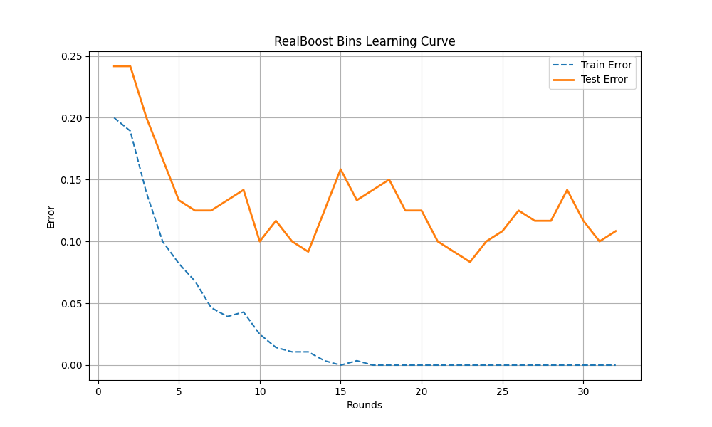Figure 3: Learning curve for RealBoost coupled with Bins.

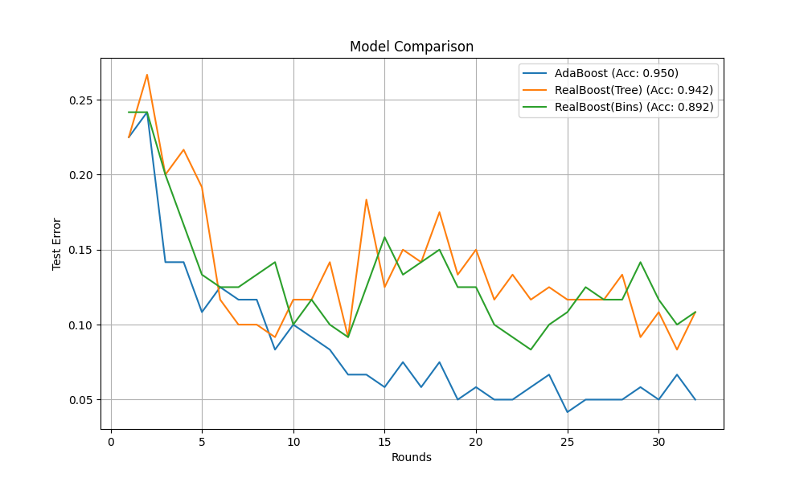Figure 4: Comparison of test errors among different methods.
Top 5 Performing Variants: Based on the batch experiments, the best variants achieving the highest testing accuracy are:
1. AdaBoost (r=20, T=128, d=1) -> Accuracy: 0.9833
2. RealBoost_Tree (r=20, T=128, d=2) -> Accuracy: 0.9750
3. RealBoost_Tree (r=50, T=128, d=1) -> Accuracy: 0.9750
4. AdaBoost (r=100, T=128, d=3) -> Accuracy: 0.9750
5. AdaBoost (r=20, T=32, d=2) -> Accuracy: 0.9667

4. Discussion & Conclusion
Based on the extensive batch experiments, the following observations were made:
- Comparison of Methods: Tree-based methods (AdaBoost and RealBoost-Tree) consistently outperformed the Bins-based method. The Tree methods achieved accuracies above 95%, while the Bins method hovered around 85-90%. This is expected as Decision Trees (even shallow ones) can capture more complex splits than simple histogram binning on a single feature.
- Effect of Boosting Rounds (T): Increasing T generally improved accuracy. However, diminishing returns were observed after T = 64. The models converged relatively quickly, indicating the effectiveness of boosting on this dataset.
- RealBoost vs. AdaBoost: RealBoost coupled with Trees generally provided slightly more stable convergence compared to AdaBoost, likely due to the use of probability estimates rather than hard binary decisions.
- Computation Speed: RealBoost with Bins was significantly faster (training in sub-seconds) compared to Tree-based methods (taking up to several minutes for large T), demonstrating a clear trade-off between computational speed and classification accuracy.

