EEE 304 – Lab 2
Filter Design and Analysis using LabVIEW

Introduction
This lab introduces some fundamental concepts in filter design and analysis using National Instruments LabVIEW, through a simple programming example. This exercise extensively uses LabVIEW functions in the Control Design Toolkit and the Digital Filter Design Toolkit. The objective of this lab exercise is to explore some of the basics in analog and digital filter design using the intuitive interface that LabVIEW provides.
Exercise 1
This exercise provides the basic steps to create and analyze a continuous-time LTI model system and convert it into a discrete-time system. Furthermore, the response of the LTI system to arbitrary signals is computed. Figure 1 provides the block diagram for this exercise.
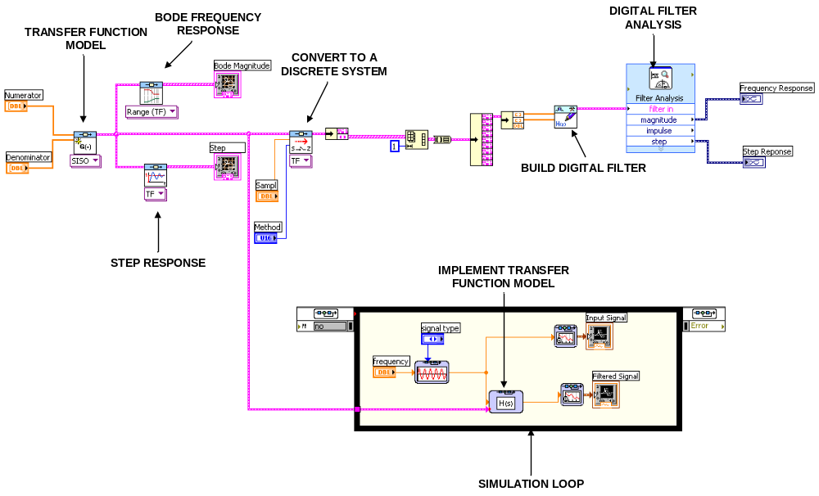
Figure 1. Block Diagram for Exercise 1

1.1 Create a LTI System by Transfer Function Model
A transfer function of an LTI system, given by the Laplace Transform of its impulse response, is a mathematical representation of the relation between the input and output of the system. The function CD Create Transfer Function Model (Addons>>Control Design>>Model Construction) of the Control Design Toolkit can be used to create the transfer function representation of a system. The parameters that are passed to this function are numerator, denominator, Sampling Time and Delay. This VI is a polymorphic VI i.e. it accepts different types of input arguments and returns values corresponding to the input arguments. For this exercise, choose the option SISO (Single Input Single Output) to create a simple LTI system.
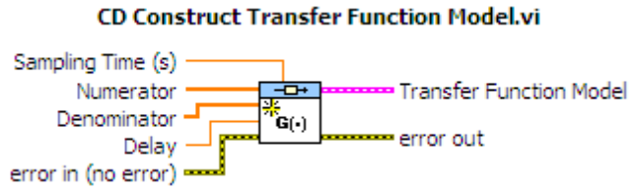
Create a LTI system with the transfer function 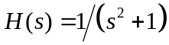 using this function in LabVIEW (set numerator: 1; set denominator: [1 0 1]).
1.2 Bode Frequency Response of the LTI Model
The function CD Bode (Addons>>Control Design>>Frequency Response) produces the Bode magnitude and the Bode phase plots of the system model on an XY graph. This is suitable for models created using CD Construct Transfer Function Model (with a frequency range) or by creating systems using other LabVIEW functions such as state space models, zero-pole gain models etc. You can use the default values for the frequency range and the number of points that LabVIEW provides.
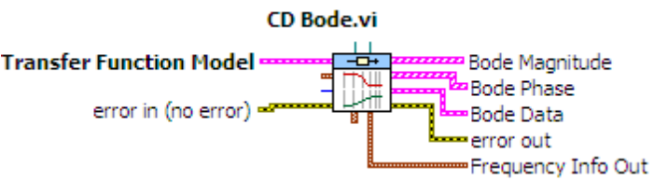
Compute the Bode magnitude plot in your block diagram by using the transfer function model created in the previous step with this VI. From the dropdown menu below the block, choose the option Frequency Range>>Transfer Function. Create a graph to display the magnitude plot in the Front panel. Right Click at the Bode Magnitude output and Create>> Indicator.
1.3 Step Response of the LTI Model
Step response is the output of the system when a unit step signal excites it. The CD Step Response (Addons>>Control Design>>Time Response) block assumes the initial states of the system to be zero unless explicitly provided. For multi-input models, independent step responses are computed for each input channel. In this exercise, the time range and number of points are chosen automatically by LabVIEW. Compute the step response of the transfer function model created in step 1.1. From the dropdown menu below the block, choose the option Transfer Function. Create a graph to display the response in the Front panel.
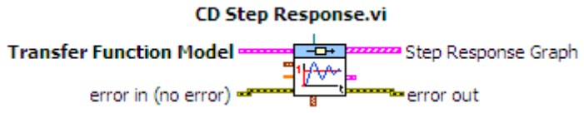

1.4 Continuous to Discrete Time System Conversion
The VI CD Convert Continuous to Discrete (Addons>>Control Design>> Model Conversion) converts the transfer function model (continuous-time) to a discrete-time model. In the drop down for the block select Transfer Function. This is carried out using the sampling time and the conversion method specified. In this exercise you use the ‘Zero-Order-Hold’ method and the Sampling Time is set to 1ms. (Use Control Inputs to set these as shown in Fig 1)
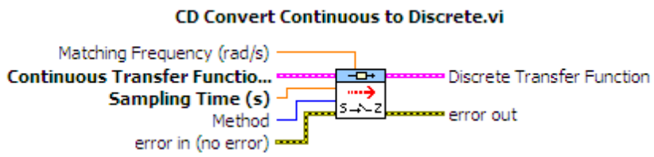
1.5 Compare step responses of the system and its discretization
To do this, you need to understand the data type conversions used to extract the numerator and denominator of the discrete transfer function. You can then generate the step response and the frequency response of the digital system using a filter built using the extracted transfer function. A subVI to extract the numerator and denominator from the discrete transfer function is provided for your reference in the website along with this lab. lab2(SubVI).vi
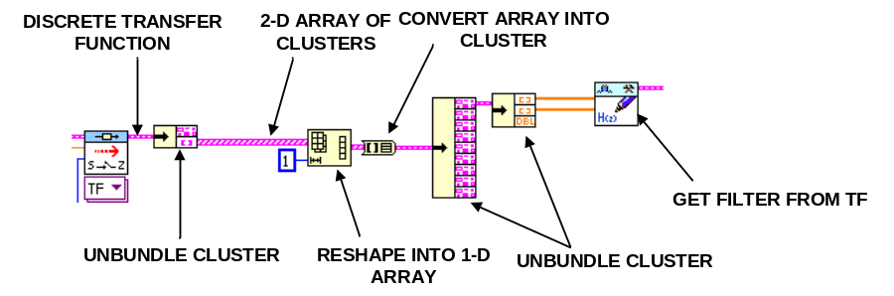
Figure. SubVI to extract discrete time filter coefficients

To create a digital filter from the discrete transfer function, you can use the function DFD Build Filter from Transfer Function. You can find this under the section Addons>>Digital Filter Design>>Utilites. This component accepts the numerator and denominator of the transfer function and returns an output of data type filter. The created filter can be used for further analysis to compute the step response and the frequency response.
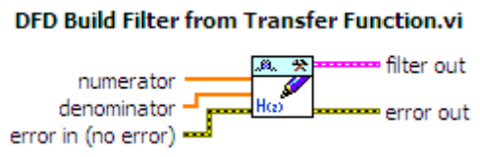
The express VI Filter Analysis can be used to analyze the characteristics of a digital filter such as the impulse response, magnitude response, phase response, step response, pole-zero plot and group delay. This can be found under the section Addons>>Digital Filter Design>>Filter Analysis. Place this function in your block diagram and select magnitude response and step response from the configuration dialog. Choose waveform graphs for both these responses produced by the Filter Analysis block.
1.6 Filtering using the Transfer Function Model
The response of a linear system to arbitrary inputs can be computed using simulation VIs in LabVIEW. You can create a simulation diagram by placing all the simulation functions and subsystems inside the simulation loop. Simulation loop executes the simulation diagram until the Final Time is reached or the simulation is halted programmatically. These functions are found under the category Right Click >> Control Design & Simulation>>Simulation in the Functions Palette. Double click on the configuration dialog on the left side of the simulation loop to set the simulation parameters. Set the parameter Final Time to 10s.
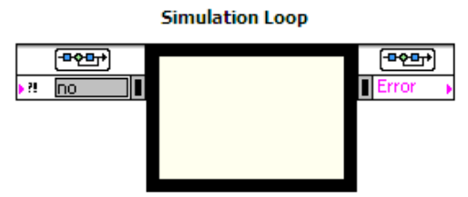
Set simulation time here
The time response of the LTI model to the given input signal can be computed using the function Transfer Function (Control Design & Simulation>>Simulation>>Continuous Linear Systems). This function implements a system model in transfer function form. Create this function inside the simulation loop and double click on it. Select the parameter Transfer Function and the change the parameter source to Terminal (This indicates that an input terminal is created for the function). Connect the transfer function model created in step 1.1 to the input terminal created.
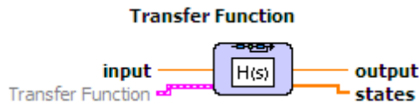
Place the Signal Generator block (Control Design & Simulation>>Simulation>>Signal Generation). As explained in the previous paragraph, change the parameter source to Terminal for the parameters signal type and frequency.
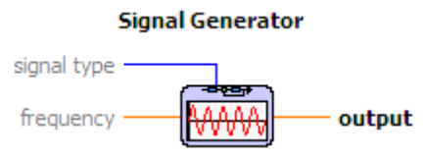
Finally, plot the generated input signal and the time response of the linear system using the graph functions available with the simulation functions. The normal waveform graphs will not work inside a simulation loop. The graph function SimTime Waveform can be found under the section Control Design & Simulation>>Simulation>>Graph Utilities. This plots the value versus the simulation time in a waveform chart (You may need to select Autoscale X-axis to display the graphs properly)
The layout of the Front Panel to be built is shown in Figure 2.
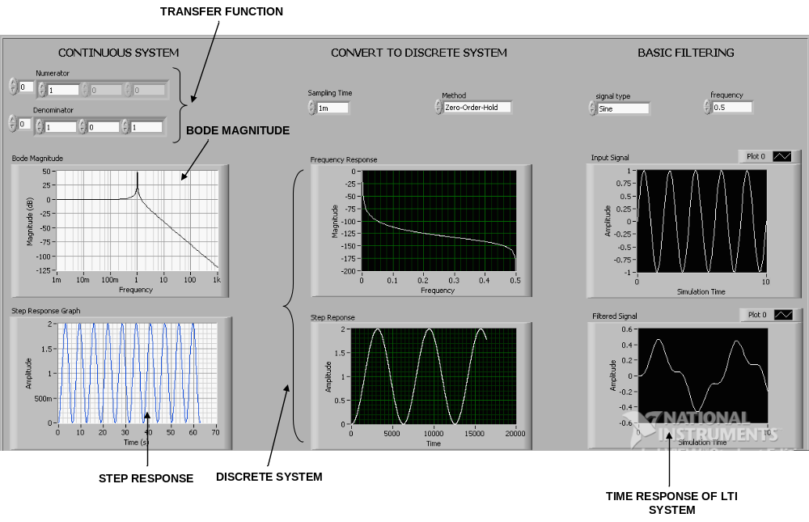
Figure 2. Front Panel for Exercise 1

Exercise 2 This exercise illustrates the steps involved in creating a basic FIR filter (based on windowing) using the Digital Filter Design Toolkit. The filter design functions in LabVIEW need the design parameters as inputs and they output a filter structure which can be used for further processing and analysis. The block diagram for this exercise is illustrated in Figure 3.
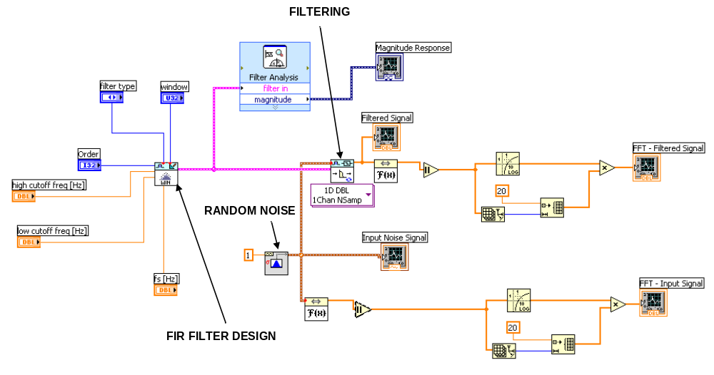
Figure 3. Block diagram for FIR Filter Design

The windowed FIR filter coefficients are generated using the function DFD Windowed FIR Design (Addons>>Digital Filter Design>>Filter Design>>FIR). This function creates a finite impulse response filter with the specified window and the filter specifications.
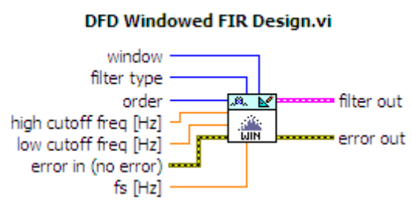
Filtering of an arbitrary input signal using the designed filter can be carried out using the DFD Filtering function found in the category Addons>>Digital Filter Design>>Processing. This function filters an input signal continuously. Place the function and from the dropdown menu that appears under it, choose Single channel>>Multiple Samples>>1D Dbl.
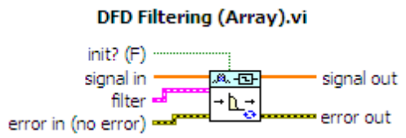
In this exercise, use white Gaussian noise as the input signal to the filter. The function Gaussian White Noise Waveform (Signal Processing>>Waveform Generation) generates white noise for which each sample follows a Gaussian distribution with zero mean and the specified standard deviation.
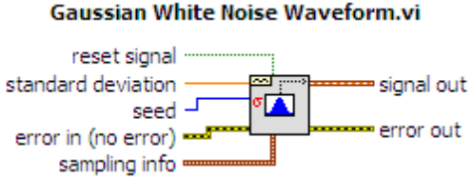
Perform the frequency analysis of the input and the filtered signals by computing the FFT of the signals using the FFT function (Signal Processing>>Transforms). Further, plot the magnitude of the resulting FFT in dB scale.
The decibel (dB) is a logarithmic unit of measurement that expresses the magnitude relative to a specified or implied reference level. When referring to measurements of amplitude it is usual to consider the ratio of the squares of A₁ (measured amplitude) and A₀ (reference amplitude).
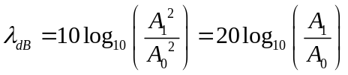
You can plot the magnitude in dB as shown below. Initialize an array of size equal to that of the FFT with a constant value 20. Multiply this array with log of the FFT magnitude. The Log10 function can be found under the category Mathematics>>Elementary & Special functions>>Exponential Functions.
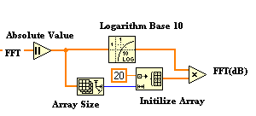
Also, plot the magnitude response of the designed FIR filter using the Filter Analysis(Addons>> Digital Filter Design>> Analysis) block as in the Exercise 1. The Block Diagram and Front panel layout for this exercise is shown in Figure 3& 4 respectively. Execute this VI by using the while loop and creating a stop button (NOT shown in the block Diagram/Front Panel – You will have to do it).
Change the window used and order of the filter and observe the filter magnitude characteristics.
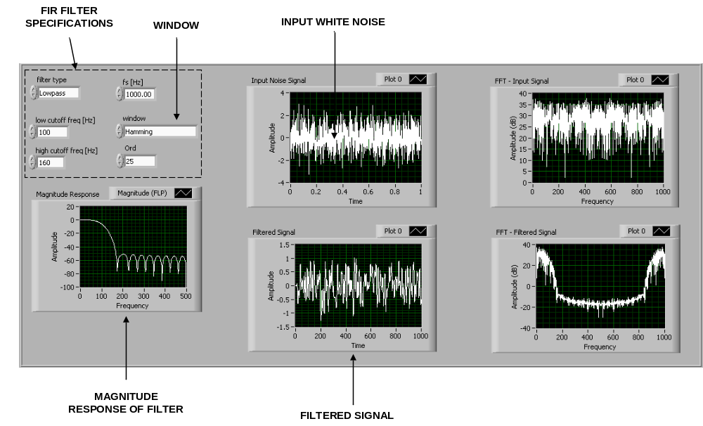
Figure 4. Front Panel for FIR Filter Design

Assignment
1. Explain the following briefly
a) IIR filter
b) FIR filter
c) Butterworth filter
d) Windowing. (e.g. Hamming window, Hanning window)
2. Design a 10th order low pass Butterworth filter using the Digital Filter Design Toolkit for the following specifications:
- Sampling Frequency: 8000 Hz
- Lower cut-off frequency: 1500 Hz
- Use an input Square Wave with input frequencies ranging from 100 Hz – 3000 Hz
- Plot the magnitude response of the filter.
- Plot FFT magnitude of the input and the filtered signals.
Hint: You can use the function DFD Butterworth Design.vi to create a Butterworth function with a specific order. This function can be found under the category Addons>>Digital Filter Design>>Filter Design>>IIR. A sample layout of the Front panel is shown in Figure 5 for reference.
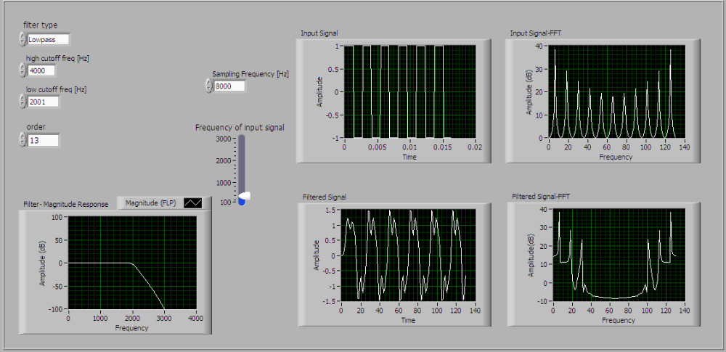
Figure 5. Front Panel for FIR Filter Design

3. Explain briefly your observation for the following :
a) change of order of the filter
b) change of frequency of the input signal (cut-off frequency fixed)
c) change of cut-off frequency (input signal frequency fixed)

- Submit your report on or before the due date posted on the class website.
- Your report should not exceed 5 pages.
- Submit the screenshots of the block diagram and front panel for Question 2. Failure to do so would be subject to losing Pts.

