Lab 1 Sample Report: Getting acquainted with Matlab/Simulink
K.S. Tsakalis
8/24/01

ABSTRACT
This report provides an introduction to MATLAB/SIMULINK and its applications to the solution of problems that arise in the analysis and design of feedback systems.

INTRODUCTION
MATLAB, by MathWorks, is a high level computation and simulation language that allows easy and reliable manipulation of vectors and matrices. The initial core of MATLAB was based on standard linear algebra libraries and, in the 80’s, became a popular tool for working with linear systems. Since then, the software expanded in both capabilities and acceptance.
The high level coding allowed for the quick development of new “macros” and functions, adding new capabilities. These codes (“m-files,” “scripts”) are simply text (ASCII) with a sequence of commands for the MATLAB interpreter. They are virtually machine independent and can be shared or transferred easily. Sets of frequently encountered functions were bundled together in “Toolboxes” focusing on specific applications (Signal processing, Control, Identification, Robust control etc.). The later addition of SIMULINK, a block diagram-based GUI, increased the ease of use of the software.
Further developments were made to improve the speed of execution of repetitive tasks. The MATLAB engine is extremely fast and efficient in handling arrays. However, the use of the interpreter introduces delays that become significant in the execution of long “FOR” loops. The always-recommended vectorization of the code provided a partial remedy but a more complete answer was found in the creation of pre-compiled portions of code (mex- and now dll- files). The ability to use such code was always available but its usefulness increased with the creation of auto-coding programs (translators of MATLAB language to C and then compiled code). Auto-coding from SIMULINK can now produce stand-alone real-time executables that are extremely useful in rapid prototyping applications. The latest version of MATLAB with data structures, excellent graphics, Graphical User Interface (GUI), etc. is an invaluable tool for systems applications from the research level to implementation.
Learning MATLAB has always been an exercise in asking for help. Every m-file contains a contiguous segment of lines beginning with % (comment indicator) with text that is displayed whenever the command <help file_name> is entered. Recent versions also contain searchable help databases with more informative comments and pictures. “Who” and “whos” are another two useful commands in examining what variables are in the workspace. But never ask “why”!
Moving beyond this general introduction of the tool and its history (from a user’s perspective), the more immediate objective of this report is to demonstrate the use of MATLAB in solving common problems in feedback systems. A set of such problems has been defined in the EEE480 Lab 1 Assignment [1]. Their solution requires a variety of computations with the following common themes:
- vector and matrix manipulations
- solutions of differential equations
- dynamical system simulations with SIMULINK
- display of results
The solutions presented in the following sections show that these problems can be handled with relative ease. Moreover, through the use of script and SIMULINK model files, the effects of changes in the problem data or parameters can be investigated with minimal additional effort.
The rest of this document is organized as follows: Section 2 contains the theoretical background necessary to formulate and compute the solutions. The use of suitable MATLAB commands for each item of the assignment is discussed in Section 3. In Section 4, the results for each question are presented. Finally, Section 5 provides concluding comments and suggestions for further work.

THEORETICAL BACKGROUND
Most of the problems in this assignment can be handled directly with an appropriate MATLAB command or function. For the problems requiring the computation of a step response of Linear Time Invariant (LTI), analytical solutions could be obtained using Laplace transforms, e.g., see [2]. Such an approach, however is quite tedious and is not used here. Instead, the solution is computed numerically by integrating the associated ordinary differential equation (ODE). This is also necessary in Problem 9 of the assignment that requires the solution of a nonlinear ODE for which no analytical solution is known. (See [3] and references therein for numerical methods for solving ODEs.)

Least-squares regression
Least-squares regression refers to problems of the form
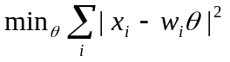
where θ is an (n x 1) vector of parameters over which the minimization is performed and x_{i}, w_{i} are the problem data, x_{i} being a scalar and w_{i} an (1 x n) vector, often referred to as the “regressor” vector. This problem appears frequently in very diverse applications and its solution is well known, e.g., see [4]. Briefly stated, the least squares solution is
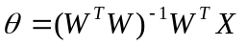
where X is an (m x 1) vector produced by the concatenation of the x_{i}’s and W is an (m x n) matrix produced by the concatenation of the w_{i}’s.

Partial Fraction Expansion
The complete formulae for computing the residues of a partial fraction expansion (PFE) can be found in the textbook [2]. While there is a corresponding MATLAB command that provides an easy answer to most PFE problems, the analytical formulae are not useless. The computation of residues for poles with multiplicities is numerically unstable and the MATLAB function fails to produce the correct result. Depending on the problem at hand, it may be sufficient to perturb the denominator coefficients slightly to destroy any pole multiplicities. But if an exact answer is required, it must be computed the hard way.

State-Space equations
The standard state-space description of finite dimensional LTI systems is the following first order vector ODE
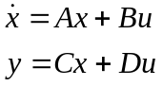
With this definition, statements of the form “the system [A,B,C,D]” should be interpreted as “the system with state-space representation given by the above equations.” State-space descriptions of linear systems are very useful in modeling multivariable systems, understanding geometric properties of their behavior and allow for very efficient computations of system properties, controller design and optimal control problems. It should be mentioned that state-space representations are not unique. There are infinitely many ways to write a system with a given transfer function in state space. Modulo some technical details, all these state space representations are related by a so-called similarity transformation. (These issues are treated in more detail in courses like EEE 482, 582 etc.)

MATLAB COMMANDS FOR LAB 1
The use of most commands is quite clear from the supplied script file [5]. Only a few commands need additional explanations that are listed below.

Left division “\”
The operation “\” means left division and is equivalent to the least-squares formula when the matrix (W^{T}W) is invertible. Internally, the computation is performed in a different, numerically more robust way.

title
Figure titles and axis labels accept strings as arguments. These commands can “understand” TeX commands to produce special symbols, subscripts etc. For example
title(‘Response of \Delta_m (s)’)
produces the text
Response of Δ_{m}(s)
as a figure title.
TeX is a high quality scientific typesetting software; see more details in [3]. The Lab assignments and Class notes have been typeset in TeX. The present document has been processed in Word. While the quality difference is quite obvious, learning TeX has a significant overhead (in Word WYSIWYG).
The new MATLAB versions allow title editing on the figure (double-click on the object) but problems may occur in pause mode.

Working with figures
MATLAB figures can be copied and pasted in a Word document in a Bitmap format (<Edit/Copy Figure and Copy Options>). The Metafile option can offer better quality but causes problems in Word when there are multiple figures in one page. The ultimate is a Postscript/EPSF save of the figure in a separate file using a <print> command from the Command Window. This format can then be imported in a TeX document.
Sometimes a situation arises where an intermediate figure produced by a program should be saved for further processing, e.g., change of the title in a step response or save in EPSF. Assuming that the program is at a pause mode, click on <File/New Figure>. A dialog box will come up: “In pause mode – Execute anyway?” Reply <Yes> to open a new figure. Unless the program contains special figure commands the rest of the plots will appear in the new window (or, in general, the active window). After the program finishes click on the figure and edit or save.

Using SIMULINK
To create a SIMULINK model select <File/New/Model> from the MATLAB window. This creates a new model file where you can define your system in terms of a block diagram. To import new blocks you need to open the SIMULINK library by typing <simulink> at the MATLAB prompt (command window). Then “drag-and-drop” the desired blocks from the library and connect them (double-click-hold-and-drag creates a connection line).
To run a simulation there are a couple of standard ingredients that are common in most cases: Sources (to provide excitation) and Sinks (to record/display/save the results). Most are adequately explained in the SIMULINK Library Browser. However, the following two are very useful and may be initially overlooked: One is the “clock” and the other is the save “to workspace” block. The former generates a time signal that is sent to the workspace after the simulation is finished, stopped or paused. Saving other important variables the same way, makes the signals available for post-processing, plotting, storing in the workspace. Another useful sink is the scope for quick plotting of the results. A multiplexer can be used to plot multiple signals in the same plot. In contrast to the other plotting blocks, the scope is simpler and less powerful but does not slow down the speed of execution. For more details on the use of these blocks, see the supplied model files.
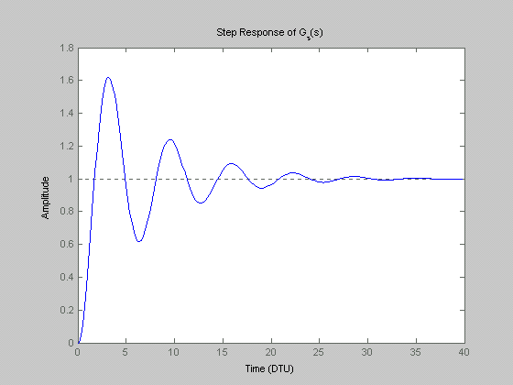
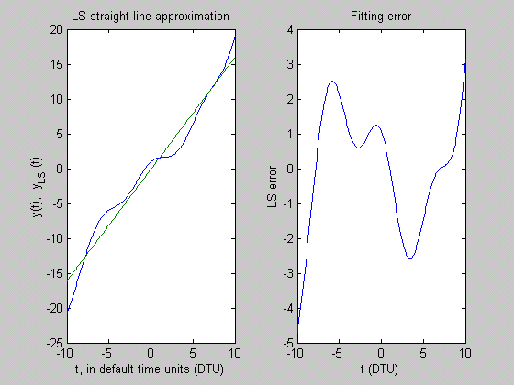
The complexity of block diagrams can become unmanageable very quickly. For this reason, it is convenient to create subsystems out of groups of blocks. This command is found under <Edit> and it helps to maintain a low complexity model at each level. It is easy to visualize the system connectivity, and information flow and allows for an easier debugging or code maintenance. Finally, the numerical attributes of the solver are found under <Simulation/Simulation Parameters>. The final time is typically the one parameter that can vary depending on the application; the rest of the parameters should be left unchanged unless there is a specific reason.
Figure 2: Step response of the second-order system
Figure 1: Least-squares straight-line fit of the given function and the associated fitting error

RESULTS
The script file “lab1.m” was used to generate all the MATLAB-related results that are included in this section. In general, it is not necessary to perform all of the Lab experiments with a single script file but in this case it facilitates the dissemination of the results.

Using help
>> help tfdata
was used to recall how to extract numerator/denominator information from a transfer function system model.

Vectors matrices and plots
The fitting results are shown in Figure 1. Notice that the fitting error is not negligible since the given function contains significant nonlinear terms. Moreover, if the fitting range changes then the best approximation will change as well as the fitting error.

Working with figures
Figure 1 was produced by a set of commands that are included in the script file. Notice that the quality is not very good because the figure was saved as a Bitmap. This format is easier to manage in Word and Powerpoint.

System responses
After defining the transfer function as system objects (“tf” command) the desired results are automatically generated by the “step” function (Figure 2). Notice that the time vector of the step response can be obtained as an additional output argument and it can be user defined as an additional input argument. Figure 2 shows the step response of G₂(s). As expected from the low damping ratio (ζ=0.15), the response is very oscillatory with large overshoot. The other responses are not shown here since they do not offer any additional insight.
MATLAB can also produce the response of an LTI system to an arbitrary input (“lsim” function/command).

System responses with Simulink
The block diagram shown in Figure 3 was created in a new SIMULINK window.
After running the simulation for 40 time units, the command <plot(T,Y)> was issued in the Command Window to generate the plot of the step response shown in Figure 4. Notice that the plot is not as smooth as the one obtained from the “step” command. This is because the SIMULINK solver used a coarse grid of points to compute the solution. If necessary, this can be adjusted by changing the tolerance in the Simulation Parameters, or even enforcing a maximum step size. In general, such modifications will slow down the simulation.

Composite systems
The step responses of the cascade and feedback connections of the given systems are shown in Figure 5. These systems were generated with the commands included in the script file [5]. Observe that in the cascade connection case, the oscillatory behavior of G₂(s) is attenuated significantly by the low-pass nature of G₁(s). On the other hand, in the feedback case the relationship between closed-loop poles and open-loop poles is not as simple and a full justification of the response characteristics requires a more detailed analysis (e.g., see root locus in [2]).

State-space representations
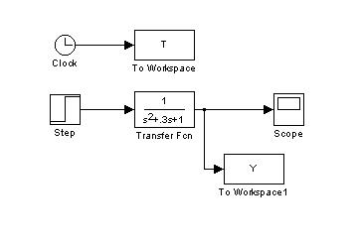
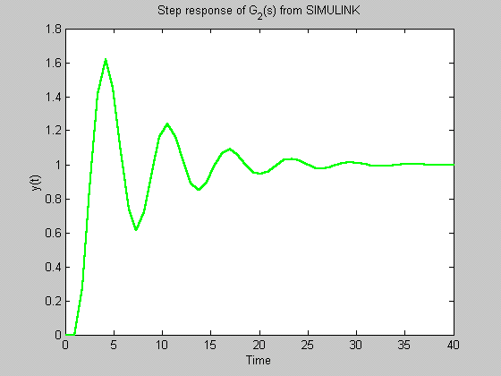
The state-space representation of a system can be obtained with the “ss” command (e.g., <Gss=ss(G)>). After that, the variable Gss is an object that contains the A,B,C,D matrices of the representation and other pertinent information about the system. The matrices A,B,C,D can be extracted simply by typing “Gss.a” or “Gss.b” etc. For example, the C-matrix for the feedback system has dimensions (1 x 3) and value [0 0 0.4].
Figure 3: SIMULINK block diagram for generating a step response.
Figure 4: Step response of G₂(s) generated with SIMULINK.

Roots, eigenvalues and PFE
To compute the roots of the denominator of a transfer function, the polynomial coefficients are first extracted in a vector form by using the command
>> [num,den]=tfdata(G,’v’)
where G is a system in transfer function format. Then entering the command <roots(den)> will display the roots of the denominator. For example, for the feedback system
numf=[0 0 0 1]
denf=[5.0000 2.5000 5.3000 2.0000]
and the roots of the denominator are
-0.0535 - 1.0075i, -0.0535 + 1.0075i, -0.3930
Matrix eigenvalues can be computed with the “eig” function. Using <eig(Gss.a)>, where Gss is a system in state-space format, will display the eigenvalues of the A-matrix of the system. As expected, executing this command for the state-space version of the feedback system yields the same result as the roots of the transfer function denominator.
Finally, the PFE of a transfer function is easily computed using the “residue” command. For the feedback system the PFE was found to be:
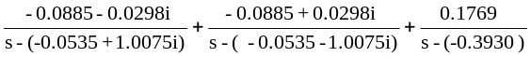

ODE solution in SIMULINK
The block diagram implementation of the differential equation can be found in the model file “lab1_9.mdl” in [5]. The key principle in constructing such implementations is to begin with a sequence of integrators whose outputs are a variable of interest and its derivatives. For a 2nd order ODE, two integrators are needed to generate the signals y, y’. The input of the first integrator is y’’ which is then constructed by using functions of y, y’ and u according to the ODE. Initial conditions can be set for each integrator by double-clicking on the block. In this manner, one can create models for arbitrary ODEs.
The step response of this system (which is a modification of the well-known Van der Pol nonlinear oscillator) can be seen by running the “lab1” script [5] and is not included here.

CONCLUSIONS
This report demonstrated the use of MATLAB for solution of various problems arising in Feedback Systems. These problems included the computation of system responses, system properties (e.g., poles), construction of simulation models, and the handling of figures. Of course, this document provides only a quick overview of the tool capabilities. It should be understood that expertise can only be achieved through continuous use and frequent applications of the “help” command.
As a last comment, the intent of this document is both to provide an introduction to MATLAB and serve as a Lab Report template. For the first, it contains significantly more information than a typical Lab Report. For the second, it contains detailed answers to only a few of the stated problems.
Normally, a Lab Report are expected to contain:
- Abstract (or scope)
- A much shorter Introduction with the student’s understanding of the experiment.
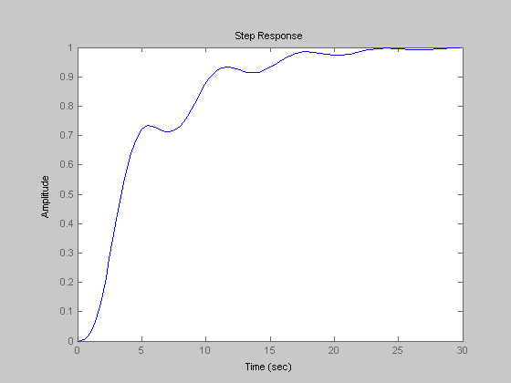
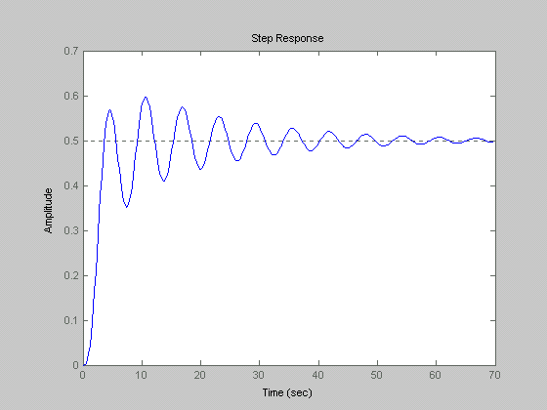
- A short Background section, if any, with mostly textbook references for the pertinent theory. Typically, the theoretical background will be contained in the textbook and any references (e.g., design equations) can be given directly in the Analysis section. In such a case, the Background section can be omitted.
Figure 5: Step responses of the cascade system (top) and the feedback system (bottom) for Lab 1.6.
- An Analysis section of varying length, containing block diagrams, lists of design equations, and an outline of the design procedure. (Bullet- or number- lists are often adequate.) Notice that in Lab 1, the block diagrams are part of the results and therefore presented in the Results section.
- A more detailed report on the Results with answers on all of the assigned questions. A suitable level of detail should be similar to Sections 4.2, 4.4 (2nd order system) of this report.
- A short (one-paragraph) Conclusions section
- References
Creating the report document with many figures can be quite painful because Word is not well suited for this task. To simplify the editing of the report, it is strongly recommended that you place all the figures in sequence at the end of the document. As you paste each figure, select it, then click on <Insert/Caption> and edit the caption. Then group the figure with the caption so that they always move together. After you finish with the editing of the text, return to the figures and adjust their location.

REFERENCES
- K. Tsakalis, “EEE 480 Lab Experiments,” http://www.eas.asu.edu/~tsakalis/coursea/lab.pdf, Arizona State University, Aug. 2001.
- Franklin, Powell, Emami-Naeini, Feedback Control of Dynamic Systems, 3rd Ed., Addison Wesley, 1994.
- MATLAB Help, (On-line documentation, Release 12), Copyright 1984-2000, The MathWorks.
- G. Strang, Linear Algebra and its applications. 2nd Ed. Academic Press, NY, 1980
- K. Tsakalis, “Sample Simulink models and Matlab scripts for the Lab,” in http://www.eas.asu.edu/~tsakalis/coursea, Arizona State University, Aug. 2001.

