Lab 1 Sample Report: Getting acquainted with Matlab/Simulink
K.S. Tsakalis
8/24/01

ABSTRACT
This document is a sample Lab 1 report on the applications of MATLAB/SIMULINK to the solution of problems that arise in the analysis and design of feedback systems.

INTRODUCTION
The objective of this report is to demonstrate the use of MATLAB in solving common problems in feedback systems. A set of such problems has been defined in the EEE480 Lab 1 Assignment [1]. Their solution requires a variety of computations with the following common themes:
- vector and matrix manipulations
- solutions of differential equations
- dynamical system simulations with SIMULINK
- display of results
The solutions presented in the following sections show that these problems can be handled with relative ease. Moreover, through the use of script and SIMULINK model files, the effects of changes in the problem data or parameters can be investigated with minimal additional effort.
The rest of this document is organized as follows: Section 2 contains the theoretical background necessary to formulate and compute the solutions. The use of suitable MATLAB commands for each item of the assignment is discussed in Section 3. In Section 4, the results for each question are presented. Finally, Section 5 provides concluding comments and suggestions for further work.

THEORETICAL BACKGROUND
Most of the problems in this assignment can be handled directly with an appropriate MATLAB command or function. For the problems requiring the computation of a step response of Linear Time Invariant (LTI), analytical solutions could be obtained using Laplace transforms, e.g., see [2]. Such an approach, however is quite tedious and is not used here. Instead, the solution is computed numerically by integrating the associated ordinary differential equation (ODE). This is also necessary in Problem 9 of the assignment that requires the solution of a nonlinear ODE for which no analytical solution is known. (See [3] and references therein for numerical methods for solving ODEs.)

Least-squares regression
Least-squares regression refers to problems of the form
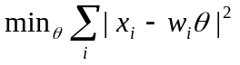
where θ is an (n x 1) vector of parameters over which the minimization is performed and x_{i}, w_{i} are the problem data, x_{i} being a scalar and w_{i} an (1 x n) vector, often referred to as the “regressor” vector. This problem appears frequently in very diverse applications and its solution is well known, e.g., see [4]. Briefly stated, the least squares solution is
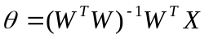
where X is an (m x 1) vector produced by the concatenation of the x_{i}’s and W is an (m x n) matrix produced by the concatenation of the w_{i}’s.

Partial Fraction Expansion
The complete formulae for computing the residues of a partial fraction expansion (PFE) can be found in the textbook [2]. In MATLAB this computation can be performed with the “residue” command as long as the poles have multiplicity one.

State-Space equations
The standard state-space description of finite dimensional LTI systems is the following first order vector ODE
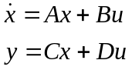
With this definition, statements of the form “the system [A,B,C,D]” should be interpreted as “the system with state-space representation given by the above equations.”

MATLAB COMMANDS FOR LAB 1
The use of most commands is quite clear from the supplied script file [5]. Only a few commands need additional explanations that are listed below.

Left division “\”
The operation “\” means left division and is equivalent to the least-squares formula when the matrix (W^{T}W) is invertible. Internally, the computation is performed in a different, numerically more robust way.

RESULTS
The script file “lab1.m” was used to generate all the MATLAB-related results that are included in this section. In general, it is not necessary to perform all of the Lab experiments with a single script file but in this case it facilitates the dissemination of the results.

Using help
>> help tfdata
was used to recall how to extract numerator/denominator information from a transfer function system model.

Vectors matrices and plots
The fitting results are shown in Figure 1. Notice that the fitting error is not negligible since the given function contains significant nonlinear terms. Moreover, if the fitting range changes then the best approximation will change as well as the fitting error.

Working with figures
Figure 1 was produced by a set of commands that are included in the script file. Notice that the quality is not very good because the figure was saved as a Bitmap. This format is easier to manage in Word and Powerpoint.

System responses
After defining the transfer function as system objects (“tf” command) the desired results are automatically generated by the “step” function (Figure 2). Notice that the time vector of the step response can be obtained as an additional output argument and it can be user defined as an additional input argument. Figure 2 shows the step response of G₂(s). As expected from the low damping ratio (ζ=0.15), the response is very oscillatory with large overshoot.
The rest of the responses should be included here.

System responses with Simulink
The block diagram shown in Figure 3 was created in a new SIMULINK window.
After running the simulation for 40 time units, the command <plot(T,Y)> was issued in the Command Window to generate the plot of the step response shown in Figure 4. Notice that the plot is not as smooth as the one obtained from the “step” command. This is because the SIMULINK solver used a coarse grid of points to compute the solution.

Composite systems
The step responses of the cascade and feedback connections of the given systems are shown in Figure 5. These systems were generated with the commands included in the script file [5]. Observe that in the cascade connection case, the oscillatory behavior of G₂(s) is attenuated significantly by the low-pass nature of G₁(s). On the other hand, in the feedback case the relationship between closed-loop poles and open-loop poles is not as simple and a full justification of the response characteristics requires a more detailed analysis.

State-space representations
The state-space representation of a system can be obtained with the “ss” command (e.g., <Gss=ss(G)>). After that, the variable Gss is an object that contains the A,B,C,D matrices of the representation and other pertinent information about the system. The matrices A,B,C,D can be extracted simply by typing “Gss.a” or “Gss.b” etc. For example, the C-matrix for the feedback system has dimensions (1 x 3) and value [0 0 0.4]. Add a few more matrices here.

Roots, eigenvalues and PFE
To compute the roots of the denominator of a transfer function, the polynomial coefficients are first extracted in a vector form by using the command
>> [num,den]=tfdata(G,’v’)
where G is a system in transfer function format. Then entering the command <roots(den)> will display the roots of the denominator. For example, for the feedback system
numf=[0 0 0 1]
denf=[5.0000 2.5000 5.3000 2.0000]
and the roots of the denominator are
-0.0535 - 1.0075i, -0.0535 + 1.0075i, -0.3930
Matrix eigenvalues can be computed with the “eig” function. Using <eig(Gss.a)>, where Gss is a system in state-space format, will display the eigenvalues of the A-matrix of the system. As expected, executing this command for the state-space version of the feedback system yields the same result as the roots of the transfer function denominator.
Finally, the PFE of a transfer function is easily computed using the “residue” command. For the feedback system the PFE was found to be:
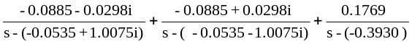
Report the rest of the computations here.

ODE solution in SIMULINK
The block diagram implementation of the differential equation can be found in the model file “lab1_9.mdl” in [5].
The step response of this system should be included here.

CONCLUSIONS
This report demonstrated the use of MATLAB for solution of various problems arising in Feedback Systems. These problems included the computation of system responses, system properties (e.g., poles), construction of simulation models, and the handling of figures.
Future work should focus on the report of the missing results…

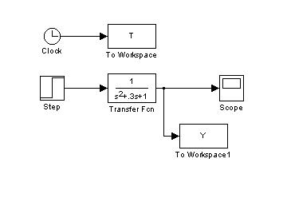
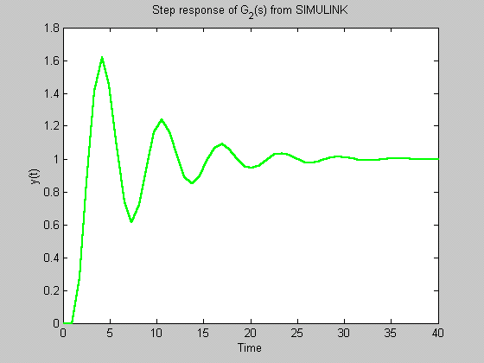
REFERENCES
Figure 3: SIMULINK block diagram for generating a step response.
Figure 4: Step response of G₂(s) generated with SIMULINK.
- K. Tsakalis, “EEE 480 Lab Experiments,” http://www.eas.asu.edu/~tsakalis/coursea/lab.pdf, Arizona State University, Aug. 2001.
- Franklin, Powell, Emami-Naeini, Feedback Control of Dynamic Systems, 3rd Ed., Addison Wesley, 1994.
- MATLAB Help, (On-line documentation, Release 12), Copyright 1984-2000, The MathWorks.
- G. Strang, Linear Algebra and its applications. 2nd Ed. Academic Press, NY, 1980
- K. Tsakalis, “Sample Simulink models and Matlab scripts for the Lab,” in http://www.eas.asu.edu/~tsakalis/coursea, Arizona State University, Aug. 2001.
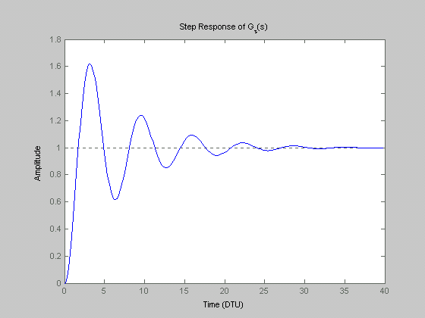
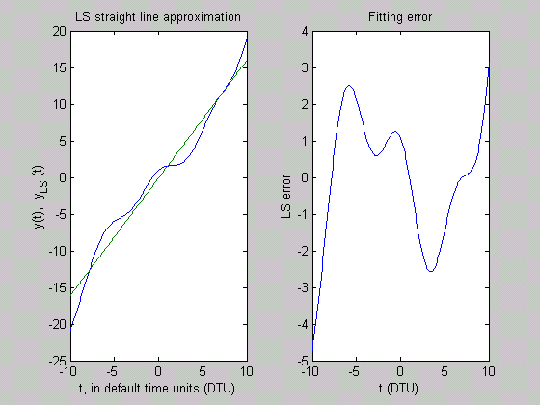
Figure 2: Step response of the second-order system
Figure 1: Least-squares straight-line fit of the given function and the associated fitting error

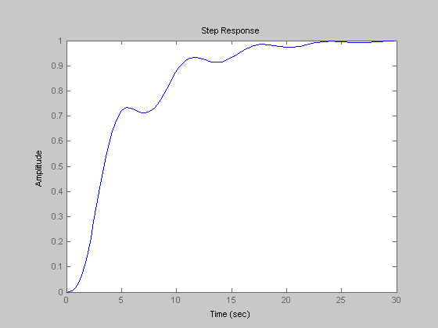
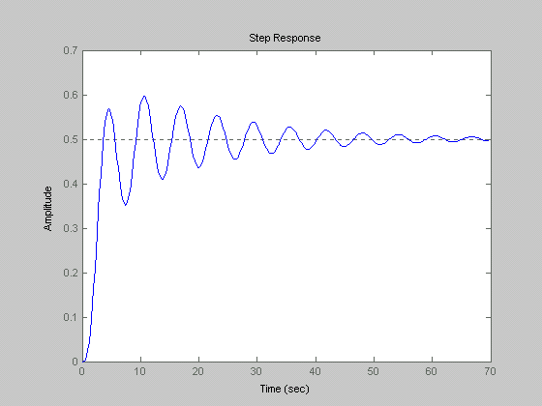
Figure 5: Step responses of the cascade system (top) and the feedback system (bottom) for Lab 1.6.

