Review of LEAD/LAG Compensator Design
K.S. Tsakalis
9/12/01

LEAD (Nyquist/Bode)

Required phase lead

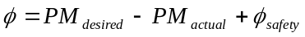
PM: Phase margin, φ_{safety} ~ 5º – 15º. If φ > 75º, then more than one lead elements are required.
- Ratio z/p 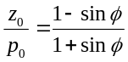
- New crossover: Place gain crossover at 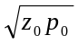.
Case 1: Leave low frequencies unaffected
- Find w_{m} such that 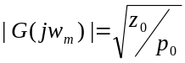, where G(s) is the t.f. of the uncompensated system.
- With w_{GC} the old gain crossover, check 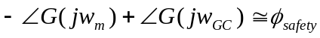 If greater, or much smaller, adjust φ_{safety} in the required lead expression (top) and iterate.
- Pole-zero calculations
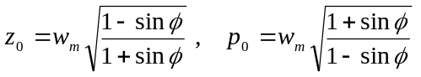
- Implementation 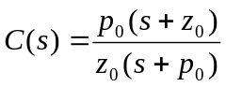
Case 2: Leave high frequencies unaffected
- Find w_{m} such that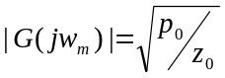, where G(s) is the t.f. of the uncompensated system.
- With w_{GC} the old gain crossover, check If greater, or much smaller, adjust φ_{safety} in the required lead expression (top) and iterate.
- Pole-zero calculations: same as Case 1.
- Implementation 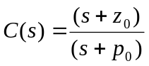

LAG (Nyquist/Bode)
1. Gain for Stability:
Find K₀ such that K₀G(s) has the desired phase margin with 5º safety. (Must be possible, otherwise lead compensation is required.) That is, find 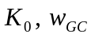, s.t.:
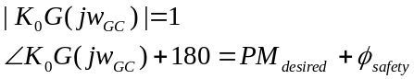
NOTE: In a lead-lag design,
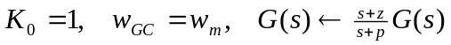.
2. Gain for Performance:
Find K₁ such that K_{i}G(s) meets the low-frequency performance specifications (steady-state error, disturbance attenuation, etc.)
NOTE: In a lead-lag/loop shaping design the original G(s) is usually selected to satisfy the low frequency specifications, so
K₁ = p_{Lead} / z_{Lead.}
3. Pole-zero calculations: Find z₁, p₁ such that
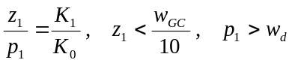
w_{d}: the largest frequency for the performance specs.
4. Implementation: 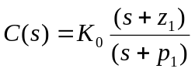

LEAD (Root-Locus)
1. Desired Poles: Select the location of the Dominant closed-loop pole-pair, s₁, s₁*. (Usually from overshoot, settling, rise-time specs.)
2. Angle Contributions: Find the angle contributions of the open-loop t.f. at s₁.
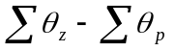
3. Required Lead: Use the argument criterion:
4. Pole-zero calculations: Choose p₀ such that θ_{p0} > 5º, or more. Calculate z₀ from the required lead (3).
5. Gain calculations: Compute
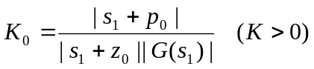
Check compensated root-locus for stability.
(More than one lead may be required; also, z₀ should not be too close to the dominant pair due to overshoot amplification; if so, adjust s₁ and iterate.)
6. Implementation: 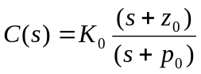

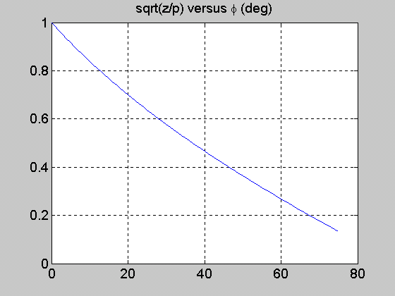
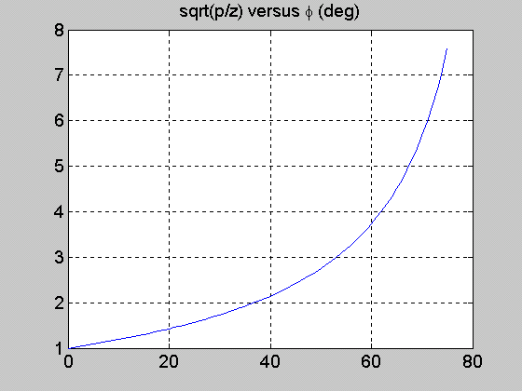

LAG (Root-Locus)
1. Desired Poles: Select the location of the Dominant closed-loop pole-pair, s₁, s₁*. (Usually from overshoot, settling, rise-time specs. Must be achievable with pure gain, otherwise lead compensation is required)
Allow for some safety margin!
2. Gain for stability: Find K₀ such that 1+K₀G(s) has a root at s₁.
3. Gain for performance: Find K₁ such that the closed-loop of K₁G(s) meets the low-frequency performance specs (steady-state error, disturbance attenuation, etc.).
4. Pole-zero calculations: Find z₁, p₁ such that
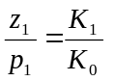
Choose z₁ small with respect to Re(s₁) and calculate p₁ from the above equation. For a largest frequency of the low frequency specs w_{d}, it must be p₁ > w_{d}; if not, select a new dominant pair and iterate.
5. Implementation:

CROSSOVER-BASED LEAD-LAG (Nyquist/Bode)
1. LEAD
- Pick w_{m}: Select the crossover frequency (observing possible constraints from RHP poles/zeros).

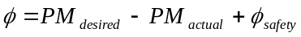
PM: Phase margin, actual = PM of G(s) at w_{m}. φ_{safety} ~ 5º – 15º (Needed in lead-lag designs only.) If φ > 75º, then more than one lead elements are required.
- Ratio z/p
- Crossover: Place gain crossover at 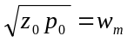.

Pole-zero calculations:
- Plant gain: Compute 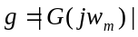, where G(s) is the t.f. of the uncompensated system.
- Implementation: 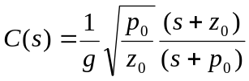
2. LAG (of Lead-Lag)
- Preserve the crossover w_{m}
- Implementation: 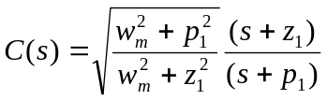
- Select z₁, p₁ such that:
- 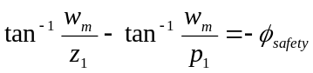
- Satisfy low frequency specs.
- Simplified design: 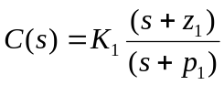
where, 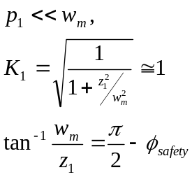
Also valid for 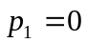. Here, adjust φ_{safety} (and possibly PM) to meet low frequency specs.

PID
1. Choose pseudo-differentiator pole one decade faster than intended bandwidth.
2. Augment plant transfer function with 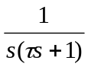
3. Select the PID zeros as 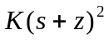 with K and z to achieve the desired R/L or N/B objectives.
4. Convert controller transfer function to standard PID form: 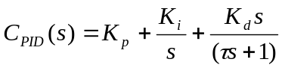

PID (Ziegler-Nichols)
1. From step response data: R = effective slope (e.g., 10%-90%), L = delay (Lag, dead-time).
 | P | PI | PID
Kp | 1/RL | 0.9/RL | 1.2/RL
Ki | - | 0.27/RL² | 0.6/RL²
Kd | - | - | 0.5/R

2. Experimentally, based on ultimate sensitivity: Ku = ultimate gain, Pu = ultimate period.
 | P | PI | PID
Kp | 0.5Ku | 0.45Ku | 0.6Ku
Ki | - | 0.54Ku/Pu | 1.2Ku/Pu
Kd | - | - | 0.075KuPu

Note: Z-N tunings are such that the ideal PID (with τ = 0) has a double zero, i.e., Kp² = 4KiKd.

