Living cortical networks at the critical point may optimize information transmission and storage simultaneously

John M. Beggs
Indiana University Department of Physics, Biocomplexity Institute
jmbeggs@indiana.edu

Abstract
Previous work showed that cultured cortical networks recorded on 60 channel microelectrode arrays displayed many stable attractors, and operated at the critical point where they had a power law distribution of neuronal avalanche sizes. To examine the implications of the critical point on information transmission and storage, network simulations were tuned through subcritical, critical and supercritical regimes. Simulations showed that both information transmission and the number of significant attractors were maximized simultaneously, and that this occurred only at the critical point. These results suggest that living cortical networks self-organize to the critical point to optimize both information transmission and storage.

Keywords: culture, simulation, network, microelectrode array, cortex, attractor, critical, power law, fractal, avalanche

Introduction
While many studies have explored cortical function at the synaptic and systems levels, much less experimental work has been done to uncover how information could be transmitted and stored at the local network level. This gap is unfortunate, since many of the most important emergent properties of the brain are predicted by theory to arise first at the local network level.

Recent advances in technology, however, have allowed cultured networks of cortical neurons to be grown on 60 channel microelectrode arrays where their spontaneous activity has been monitored for hours or weeks at a time (Gross, Williams et al. 1982; Jimbo, Kawana et al. 2000; Potter and DeMarse 2001; Segev, Shapira et al. 2001; Eytan, Brenner et al. 2003) (Figure 1A). Results from these experiments have revealed several features of local cortical network dynamics. First, the number of electrodes activated by these spontaneous patterns follows a power law, a hallmark of systems in the critical state (Beggs and Plenz 2003) (Figure 1B). Second, activity in these patterns propagates according to a critical branching process, which means that on average, activity at one electrode leads to activity at one other electrode in the next time step (Beggs and Plenz 2003). Third, cultured cortical slices spontaneously produce on average 30 ± 14 (mean ± s.d.) families of repeating spatio-temporal activity patterns that satisfy many of the requirements of attractors (Beggs and Plenz, 2001; Cossart, Aronov et al. 2003) (Figure 1C, D).

These experimental results are in agreement with several neural network models that have hypothesized criticality and attractors. Criticality is seen in many complex physical systems like avalanches, forest fires, earthquakes and nuclear chain reactions. Critical systems undergo phase transitions when a control parameter is swept through a range of values. For example, as temperature is increased, water goes from ice to liquid to gas; as tree density is increased, forest fires go from damped to sustaining to expanding. The critical point occurs between phases and is characterized by clusters whose sizes are distributed according to a power law. Several models have predicted that neural networks should operate near the critical point to allow maximum adaptability (Herz and Hopfield 1995; Sole, Manrubia et al. 1999; Bak and Chialvo 2001; Eurich, Herrmann et al. 2002). It has also been shown that feed-forward networks tuned to the critical point optimize information transmission (Beggs and Plenz 2003). With respect to attractors, Hopfield (Hopfield 1982) and Grossberg (Cohen and Grossberg, 1983) have described them as states of activity into which a network settles, and have noted that attractors could be used to store information or perform computations. Their work suggested that networks of living neurons would demonstrate stable, repeatable activity patterns.

While the critical point has implications for adaptability and information transmission, its effect on information storage has been less clear. We hypothesized that network simulations tuned to the critical point would maximize the number of stable, repeating activity patterns that were statistically significant (attractors).
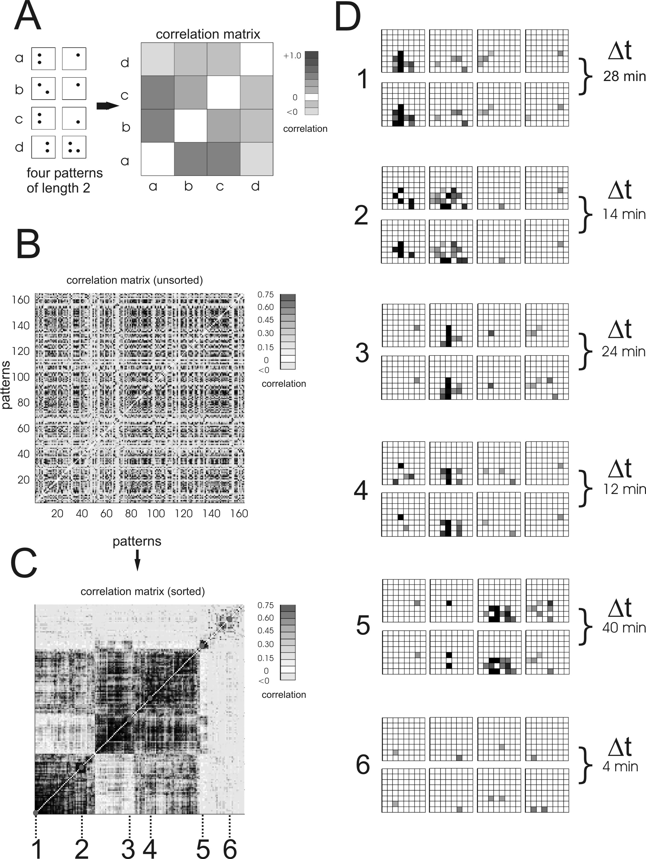
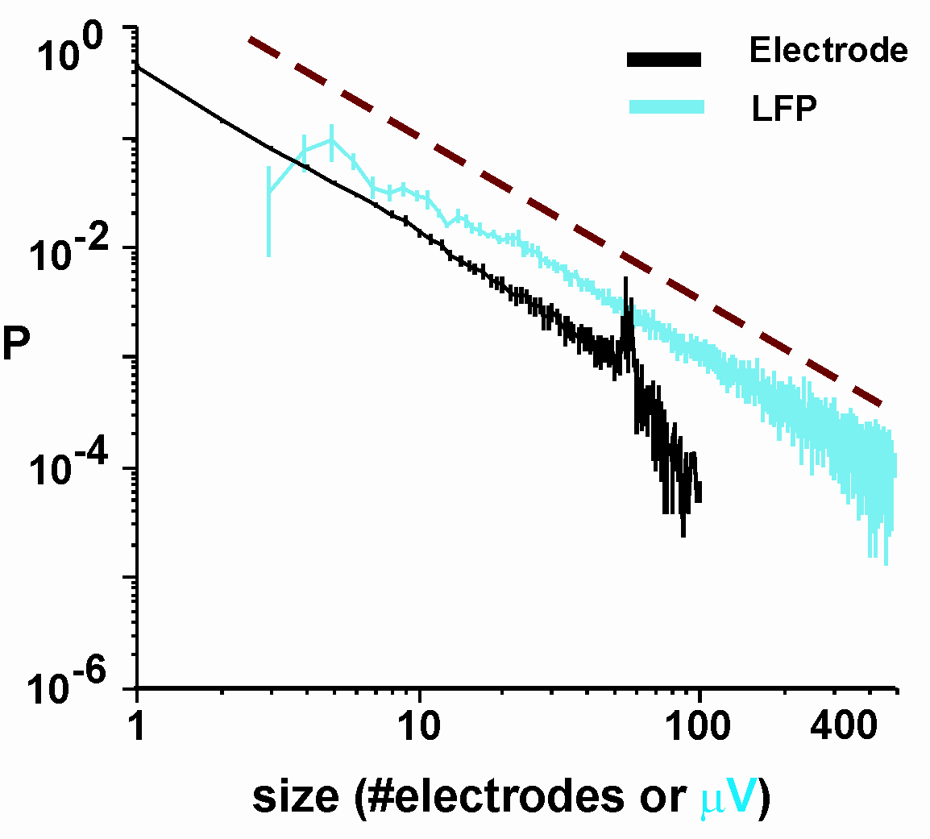
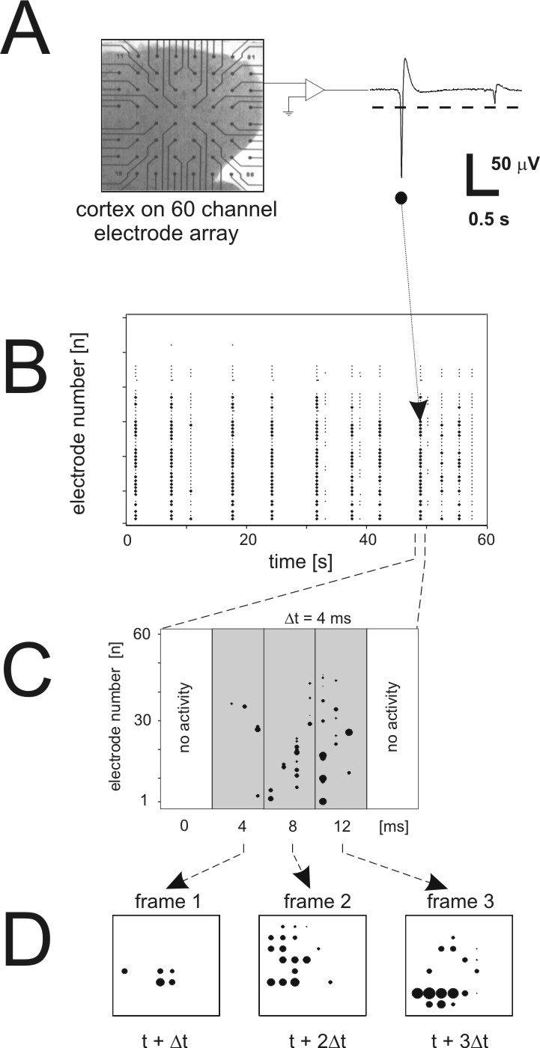
C
D
B
A
Figure 1. Cortical cultures are critical and produce many attractors. A, cortical culture on microelectrode array spontaneously produces local field potentials. Voltage trace from one electrode is thresholded and marked in time. Suprathreshold activity is shown by darkened pixels on 8 x 8 grids. Each grid gives activity during one 4 ms time bin. Four grids show a spatio-temporal pattern produced by the culture. B, the number of electrodes activated by spontaneous patterns follows a power law: P(n) = n^{-α}, where P is the probability of observing a pattern of size n, and n is the total number of electrodes activated in the pattern. For a critical branching process, the exponent of the power law, α, is predicted to be -3/2, shown by dashed line. Best fit for actual data produced an exponent of -1.50 ± 0.13, indicating that the cultures were in the critical state. C, when all activity patterns are put into correlation matrix and sorted, clusters appear as dark boxes along the diagonal. These boxes contain patterns of mutual similarity greater than expected by chance. D, examples of nearly identical activity patterns produced 24 and 14 minutes apart. Each culture typically produced 30 ± 14 significant groups of patterns per hour. Figures A and B adapted from Beggs and Plenz, 2003. C and D from Beggs and Plenz, 2001.

Methods
To address this issue, we constructed neural network simulations that could be tuned through subcritical, critical and supercritical states. To model propagation of activity in the cortical cultures, we used a feed-forward, rather than a recurrent, network architecture. This choice was motivated by the fact that 98% of all electrodes became refractory for 20 ms after experiencing local field potential activity (Beggs and Plenz, 2003). Thus, no active electrode was ever immediately reactivated by a recurrent connection in the next time step (4 ms), or even four time steps later.

Another experimental finding was that, on average, a single active electrode was followed by only one other active electrode in the next time step. This means that activity propagated within the networks with a branching parameter, σ, at the critical value of unity (Beggs and Plenz 2003). If the branching parameter were less than one (σ < 1), activity in one electrode would lead to activity in less than one electrode in the next time step, and activity in the network would eventually die out. On the other hand, if the branching parameter were greater than one (σ > 1), activity in one electrode would lead to activity in more than one electrode in the next time step, and activity in the network would eventually explode.

Feed-forward networks had N processing units per layer and L layers. Binary units (on or off) made C randomly assigned connections to units in the next layer. Each connection had a probability  of transmitting, that was randomly chosen, but the sum of probabilities emanating from a unit was constrained to be equal to
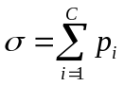 ,
where 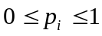 and 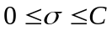. Note that this formulation allows the branching parameter σ to be adjusted in the network by changing the sum of probabilities. A unit in the next layer became active only if a unit in the previous layer was active and the connection between them transmitted. A given network type was determined by the choice of N (number of input units), L (number of layers), and C (connections). Results from 24 network types are reported: (N: 4, 6, 8, 10, 12, 14; L: 3, 4; C: 2, 3). Ten networks of each type were constructed, and each network was run a thousand times for each value of σ from 0.2 to 2.0, in increments of 0.2. A run was initiated by a randomly chosen binary string applied to the input layer. This pattern of activity was propagated through the network for several time steps until it reached the last layer. The output of the network was considered to be the activity state of the units in this last layer. To search for patterns that a network might consistently settle into (potential attractors), all the output states of a network were represented in vector form and a correlation matrix was constructed. Correlation matrices were then clustered by a greedy algorithm and compared to twenty sets of clustered correlation matrices constructed from shuffled network output. Network output was shuffled using event count matched shuffling, currently thought to be the most stringent approach (Oram, Wiener et al. 1999). Clusters of activity patterns that correlated with each other more strongly than those in any of the 20 shuffled data sets were declared significant at the p < 0.05 level.

Event size distributions for different networks were constructed by counting the number of units that became active after random stimulation. To make these simulations more comparable to output from physiological experiments, branching networks were constructed as described above with two important modifications. First, networks were composed of 64 units (to approximate the 8 x 8 electrode grid) that had all-to-all connectivity. This agreed with experimental data which showed that activity on one electrode could be followed by activity on any other electrode, indicating possible functional connectivity. Second, a refractory period of four time steps was imposed at each electrode, again in agreement with experimental data as described above.

Results
Three different types, or phases, of correlation matrices were produced as the branching parameter, σ, was tuned from 0.2 to 2.0. After several time steps, activity in subcritical networks (σ < 1) was typically sparse and random. This led to correlation matrices that had few elements and little or no clustering (Figure 2A). Critical networks (σ = 1) had many active units even after several time steps, and these formed numerous clusters that could be seen as dark boxes along the diagonal, some boxes containing many elements (Figure 2B). Supercritical networks (σ > 1) had abundant activity that only increased over time, causing the network to settle into essentially one fully active state with a few minor variations. These correlation matrices typically contained one large cluster that could be seen as a single dark box as large as the matrix itself (Figure 2C).

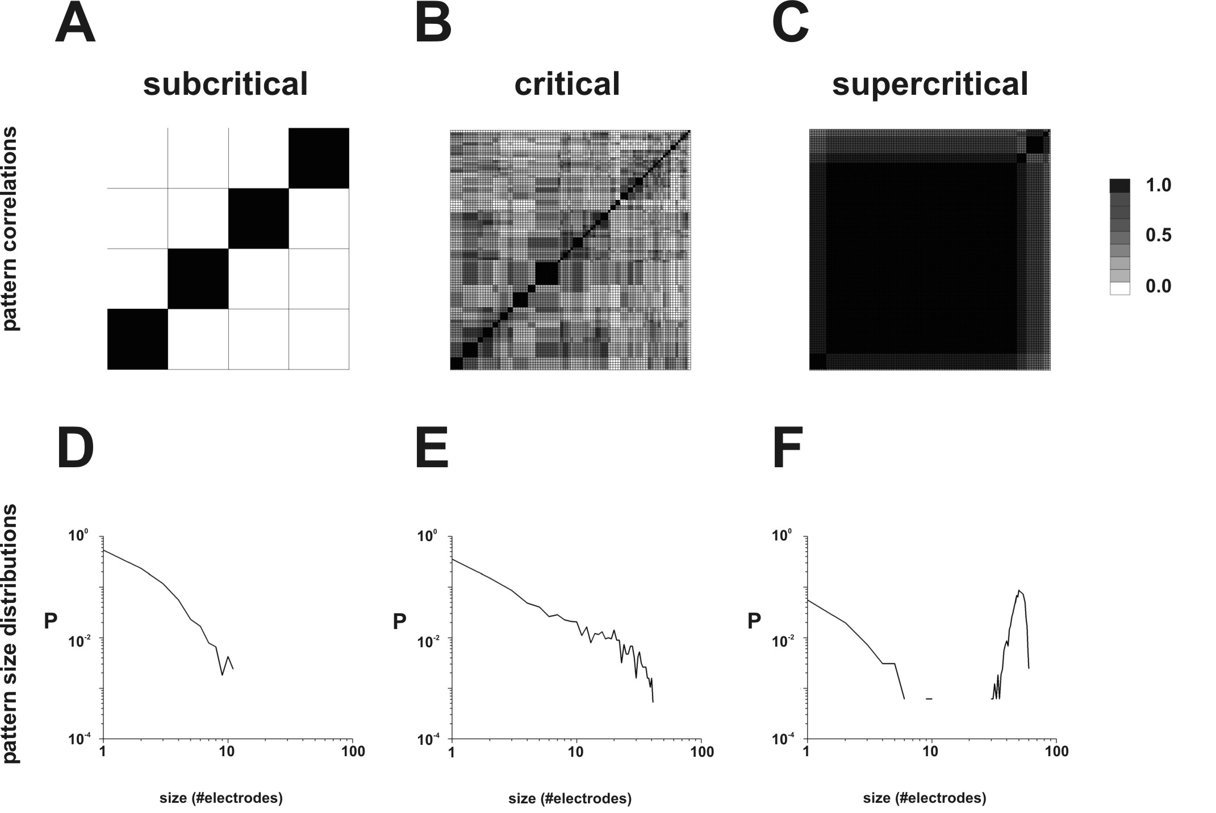
Figure 2. Output from three network phases qualitatively compared. A, subcritical networks have few active output units, and activity does not cluster. B, critical networks have more activity and form correlated clusters along the diagonal, seen as dark boxes. C, supercritical networks form one large correlated cluster with minor variations. D, event sizes in subcritical networks resemble random curving distributions. E, critical networks are characterized by a linear power law. F, supercritical networks are bimodal, reflecting random activation (left curve) and total activation (hump at right).

The event size distributions of these three classes of networks reflected their correlation matrices. Most of the activity patterns produced by subcritical networks had few active electrodes, almost never more than 10. Subcritical distributions curved downward in log-log space (Figure 2D), similar to the plot produced by a binomial process. In contrast, critical networks displayed a power law distribution, seen as a straight line that had an abrupt cutoff near 64, the maximum number of units that could be activated in a single pattern (Figure 2E). This is in agreement with power laws observed experimentally in cortical cultures (Figure 1B). Finally, supercritical networks had a bimodal distribution. The first portion was downwardly curving, reflecting random activity that failed to spread, while the second portion was a large hump located near 64 units, reflecting total network activation (Figure 2F). This is in agreement with bimodal distributions produced in actual cortical cultures that have been made supercritical by application of picrotoxin (Beggs and Plenz 2003).

As expected, the average correlation among patterns produced by subcritical networks was small, while it was larger for critical networks and larger still for supercritical networks. When compared to correlation matrices from shuffled output, however, only the critical networks showed significant differences (Figure 3A). This is because output from subcritical networks is nearly random anyway, so shuffling produces little differences. Output from supercritical networks was almost always the same, so shuffling did not produce much variation. It was only in the critical case, midway between randomness and order, that statistically significant correlations began to emerge. This could be further understood by looking at the number of statistically significant clusters of patterns that were produced by a network as the branching parameter σ was varied from 0 to 2. As can be seen from Figure 3B, there is a peak in the data at the critical point where σ = 1. This means that critical networks produced the largest number of significant activity patterns. Subcritical networks, where the sum of connection probabilities was low, were too weakly connected to produce any patterns that repeated above chance, as can be seen from the dots near zero for values of σ below 0.5. Supercritical networks, in contrast, were too strongly connected to produce anything besides one pattern that was always the same. Although this pattern could sometimes become significant, as seen in the dots near one for values of σ greater than 2, it crowded out other patterns from reaching significance. The value of σ at which the largest number of significant patterns was produced varied somewhat with network size. For small networks, slightly supercritical values of σ produced the most significant patterns. As network size was increased, however, the value of σ at which the most significant recurring patterns were produced asymptotically approached σ = 1.07, close to the critical value of 1.0 (Figure 3C). This result suggests that extremely large network simulations would maximize their number of attractors only when they were at the critical point.
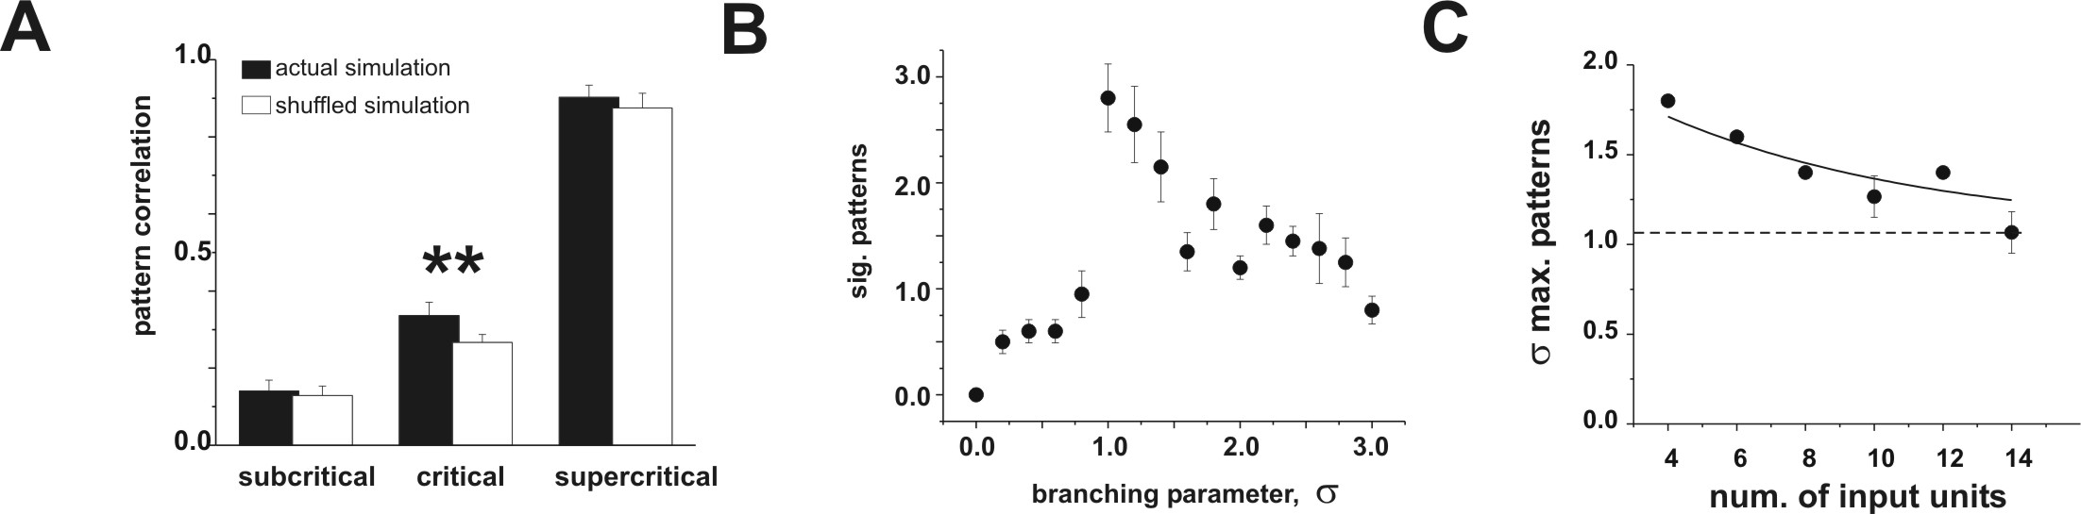
Figure 3. Networks in the critical state produce the most attractors. A, average correlation values in matrices produced by three network phases. Subcritical networks produced low correlations, and shuffling did not reduce correlations, indicating essentially random output. Critical networks had moderate correlations, and shuffling produced a significant difference (T-test, t = 5.48, DF = 18, p < 0.00003). Supercritical networks had such highly correlated output that even shuffling could not reduce their structure. Each network had 4 layers, 14 input units, and 2 connections per unit. Output from 10 actual networks was compared to 10 shuffled networks. Subcritical, critical and supercritical networks had σ = 0.5, 1.0, 2.0, respectively. B, the number of statistically significant activity patterns that the network settles into over time is maximized when the branching parameter, σ, is at the critical value of 1.0. Network with 3 layers, 14 input units, and 3 connections per unit shown. Error bars indicate standard error. C, the branching parameter at which the number of significant patterns is maximized asymptotically approaches 1.07 as network size is increased. Shown is a composite graph that averages output from all networks tested.

Discussion
Experiments with cortical cultures have shown that they self-organize into the critical state and produce many repeating activity patterns. It is perhaps natural to wonder why these networks would consistently arrive at the critical state without any external instructive signal. Previous simulation work had shown that the critical state is optimum for information transmission (Beggs and Plenz 2003). The present study was undertaken to probe the impact of the critical state on information storage by looking at the number of significant attractors. These results show that network simulations maximize the number of significant attractors when they are in the critical state, suggesting that both information transmission and information storage are simultaneously optimized when the network is critical. These findings strongly suggest a general principle of cortical network operation and hint that by studying other complex nonlinear phenomena like avalanches and forest fires, we may actually gain insights into neural function.

Bibliography

Bak, P. and D. R. Chialvo (2001). "Adaptive learning by extremal dynamics and negative feedback." Phys Rev E Stat Nonlin Soft Matter Phys 63(3 Pt 1): 031912.
Beggs, J. M. and D. Plenz (2003). "Neuronal avalanches in neocortical circuits." J Neurosci 23(35): 11167-77.
Beggs, J.M. and Plenz, D. Diversity and stability of elementary activity patterns that spontaneously form in isolated cortex. Society for Neuroscience Abstracts. 27: 64.7, 2001.
Cossart, R., D. Aronov, et al. (2003). "Attractor dynamics of network UP states in the neocortex." Nature 423(6937): 283-8.
Eurich, C. W., J. M. Herrmann, et al. (2002). "Finite-size effects of avalanche dynamics." Phys Rev E Stat Nonlin Soft Matter Phys 66(6 Pt 2): 066137.
Eytan, D., N. Brenner, et al. (2003). "Selective adaptation in networks of cortical neurons." J Neurosci 23(28): 9349-56.
Gross, G. W., A. N. Williams, et al. (1982). "Recording of spontaneous activity with photoetched microelectrode surfaces from mouse spinal neurons in culture." J Neurosci Methods 5(1-2): 13-22.
Herz, A. V. and J. J. Hopfield (1995). "Earthquake cycles and neural reverberations: Collective oscillations in systems with pulse-coupled threshold elements." Physical Review Letters 75(6): 1222-1225.
Hopfield, J. J. (1982). "Neural networks and physical systems with emergent collective computational abilities." Proc Natl Acad Sci U S A 79(8): 2554-8.
Jimbo, Y., A. Kawana, et al. (2000). "The dynamics of a neuronal culture of dissociated cortical neurons of neonatal rats." Biol Cybern 83(1): 1-20.
Oram, M. W., M. C. Wiener, et al. (1999). "Stochastic nature of precisely timed spike patterns in visual system neuronal responses." J Neurophysiol 81(6): 3021-33.
Potter, S. M. and T. B. DeMarse (2001). "A new approach to neural cell culture for long-term studies." J Neurosci Methods 110(1-2): 17-24.
Segev, R., Y. Shapira, et al. (2001). "Observations and modeling of synchronized bursting in two-dimensional neural networks." Phys Rev E Stat Nonlin Soft Matter Phys 64(1 Pt 1): 011920.
Sole, R. V., S. C. Manrubia, et al. (1999). "Criticality and scaling in evolutionary ecology." Trends in Ecology and Evolution 14(4): 156-160.


John Beggs received his B.S. in applied physics from Cornell, and later got his PhD from Yale in neuroscience, where he did electrophysiological experiments in acute cortical slices under the guidance of Tom Brown. He went on to do a postdoctoral fellowship at the National Institutes of Health, studying spontaneous activity in cortical slice cultures using multielectrode arrays while working in the lab of Dietmar Plenz. He is currently an assistant professor of Physics at Indiana University in the Biocomplexity Institute, where he is interested in properties of local cortical networks.

