Put a frame on PCB.(Make sure that wall that has a depression become inside of PCB.)

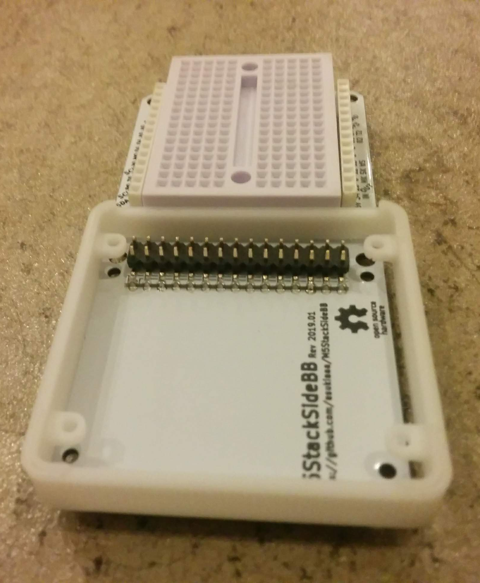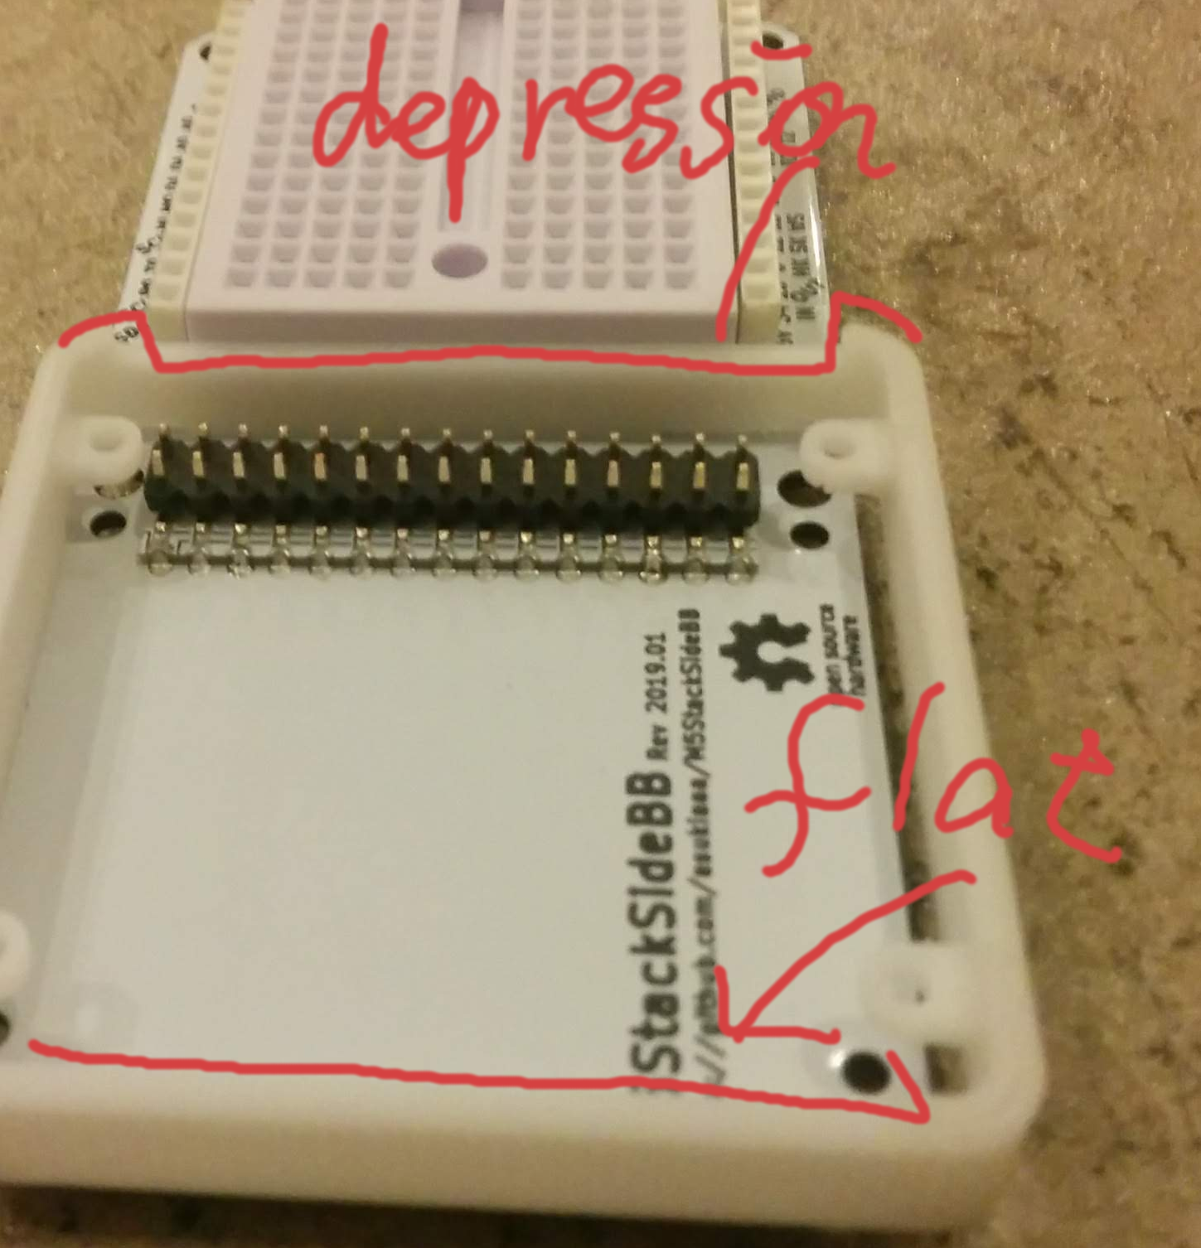
Put nuts(M3 *2) and spacers(M3 5mm * 2, M3 7mm * 2) inside of a frame.
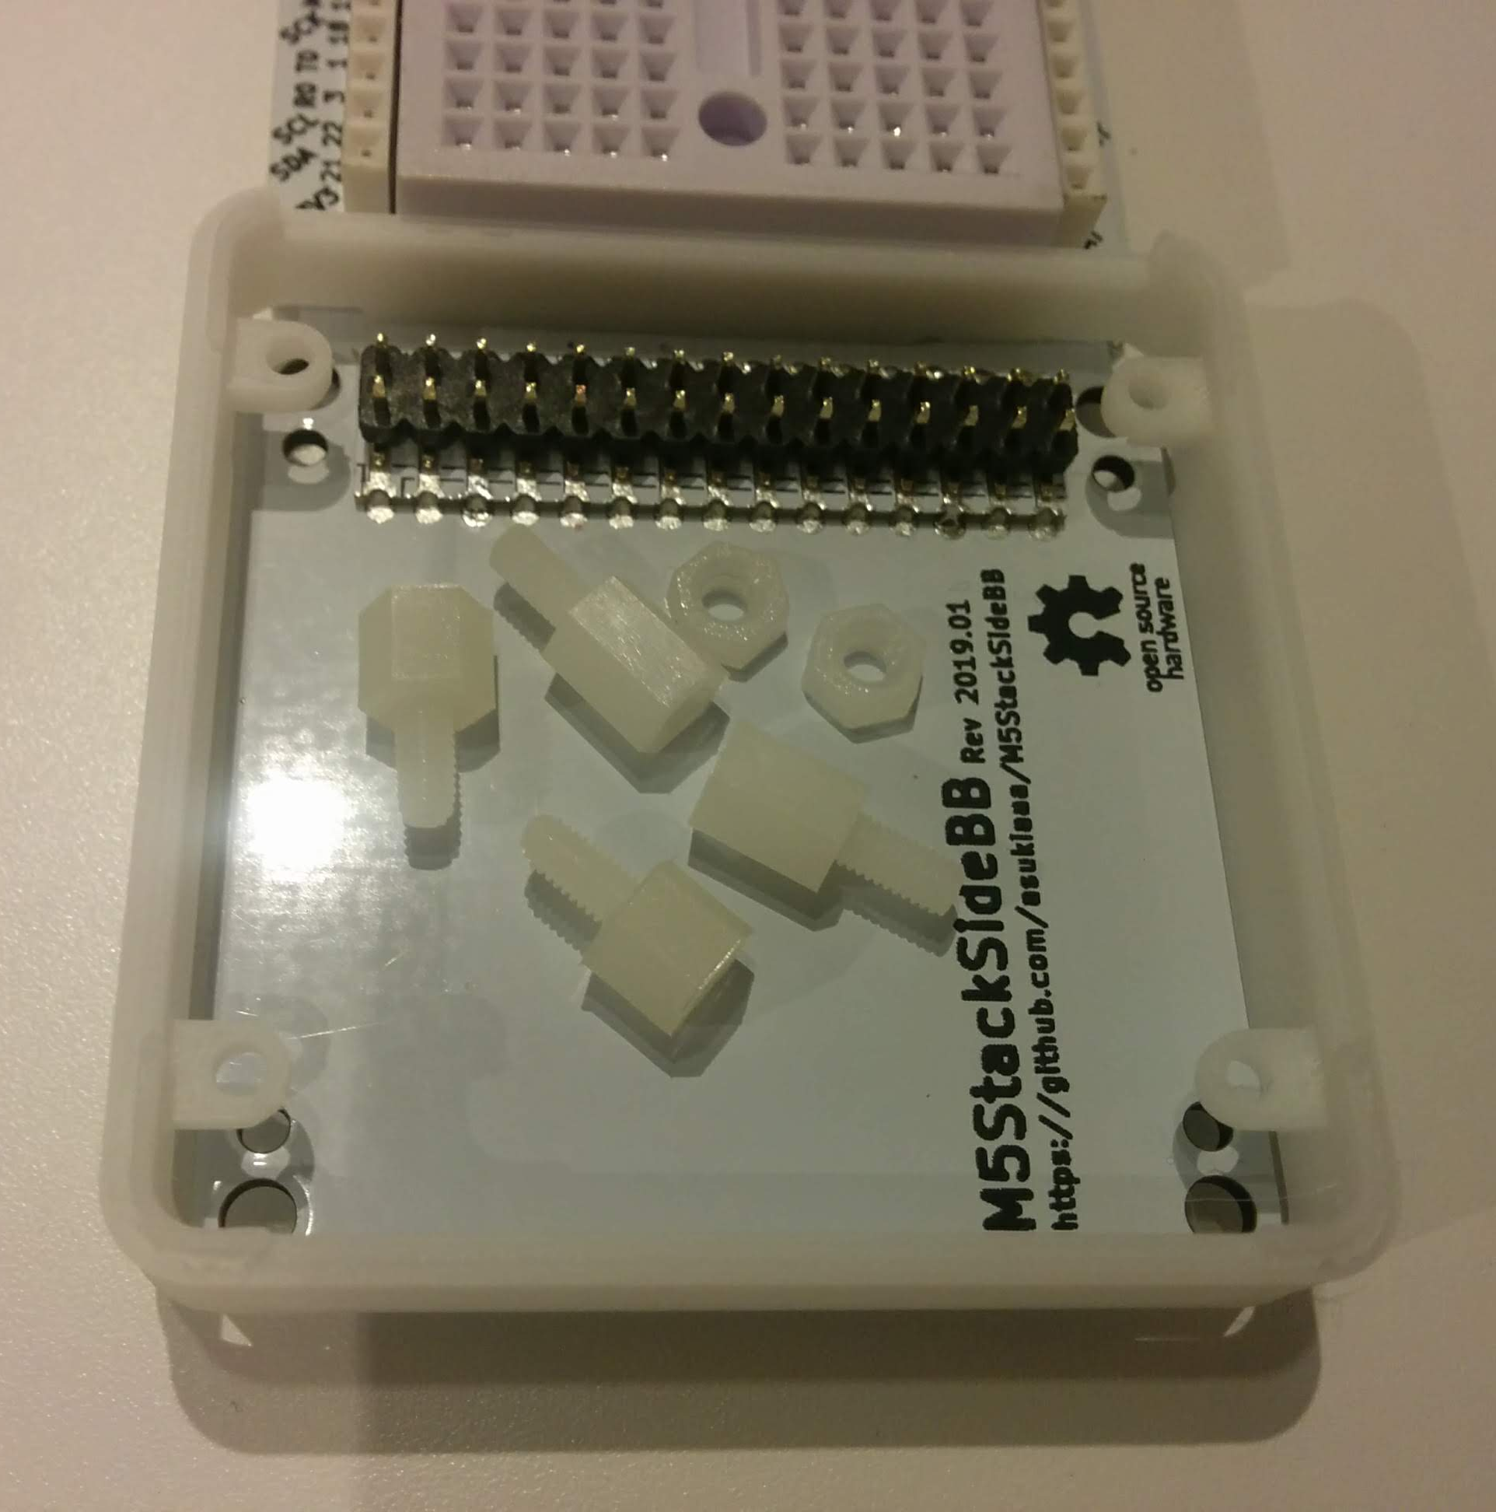

Put the pcb, frame, nuts and spacers into bug.
No need to close with some tape
