Requirements for cable assembling for grove compatible.

Components for a cable.
- Cable: 22 AWG 4 lines sheld cable
- Connector: HY2.0-4P
- Contacts: 4 contacts for HY2.0-4P
- A Plastic bag
1. Cut length of cable + 5cm±2cm. Ex 100cm cable: 105±2cm.
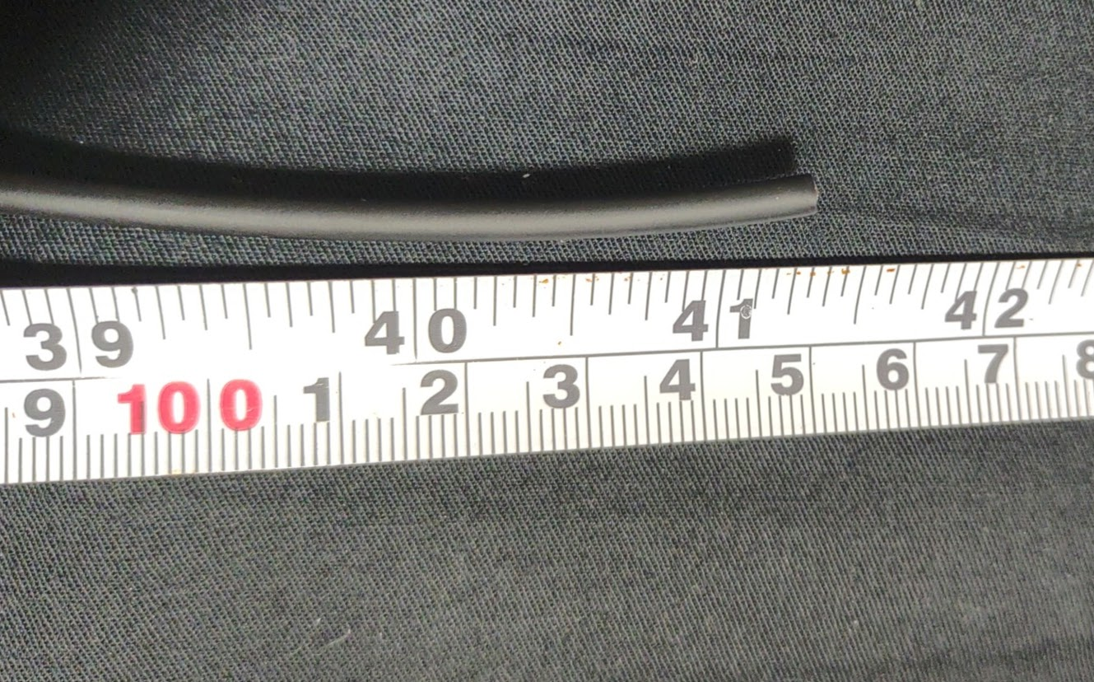
2. Remove out side covering material 2cm±1cm at both end.
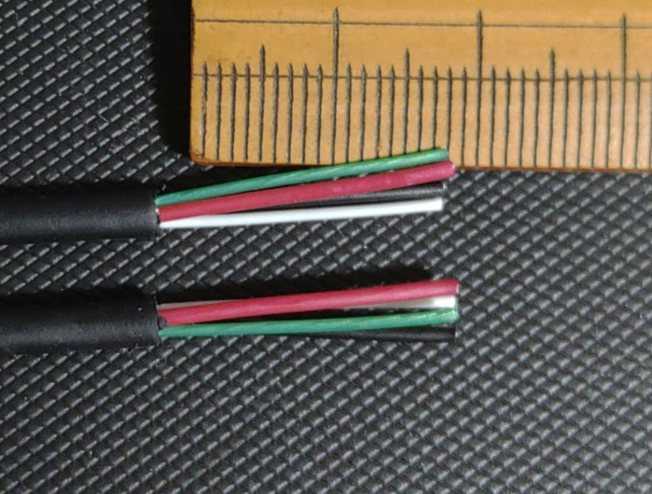

3. Put 2cm cover tube at both end.
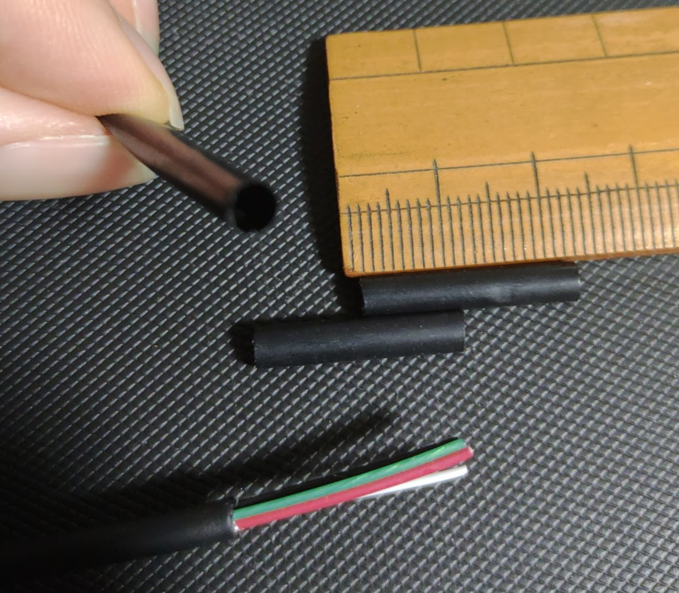
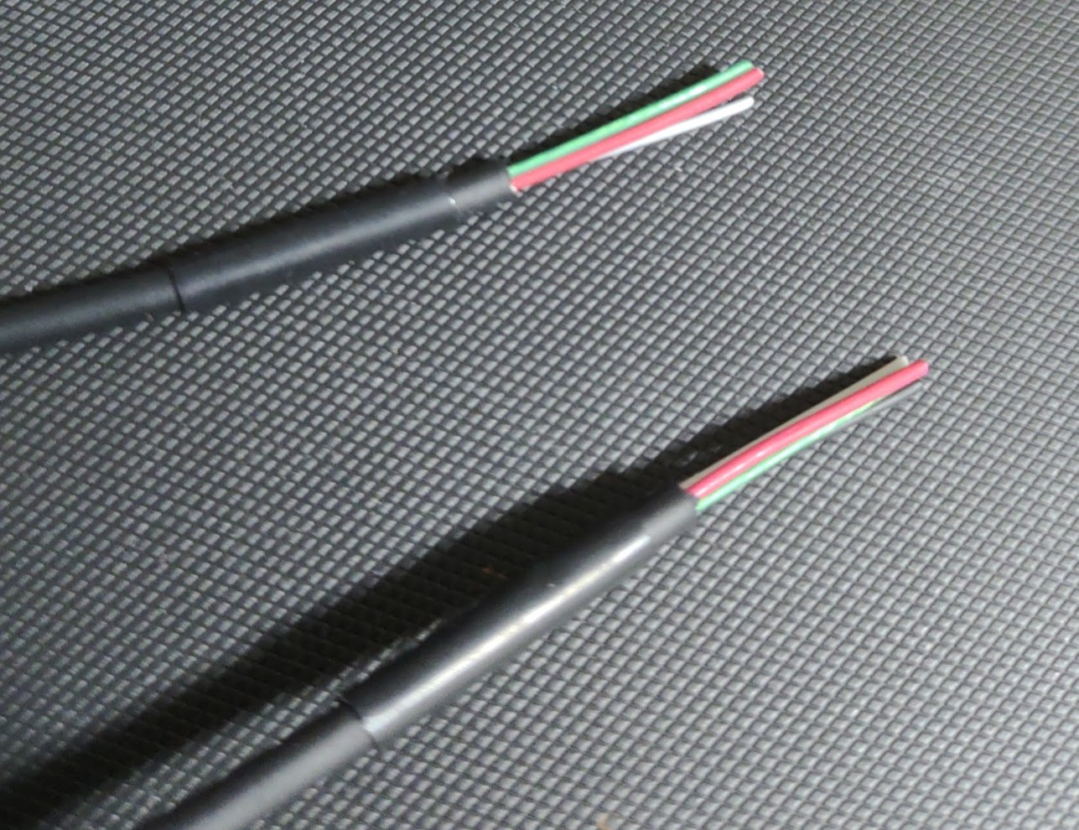

4. Remove inner covering material 1〜2mm.
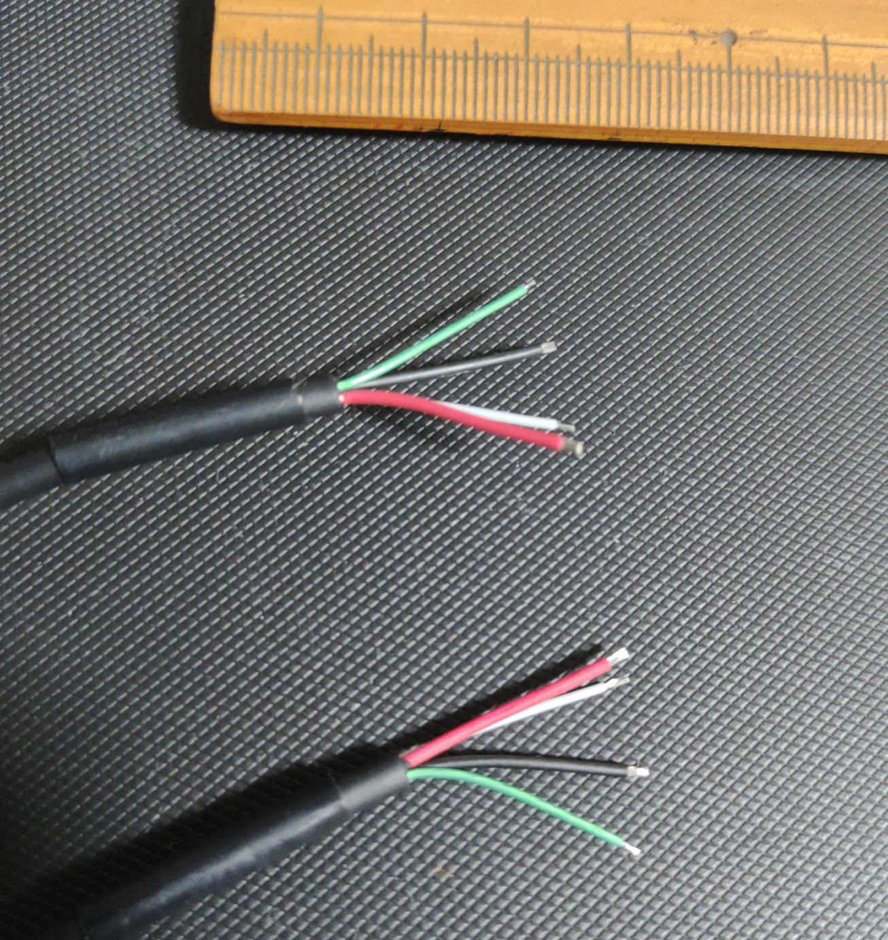
5. Put contacts to all 8 wires.
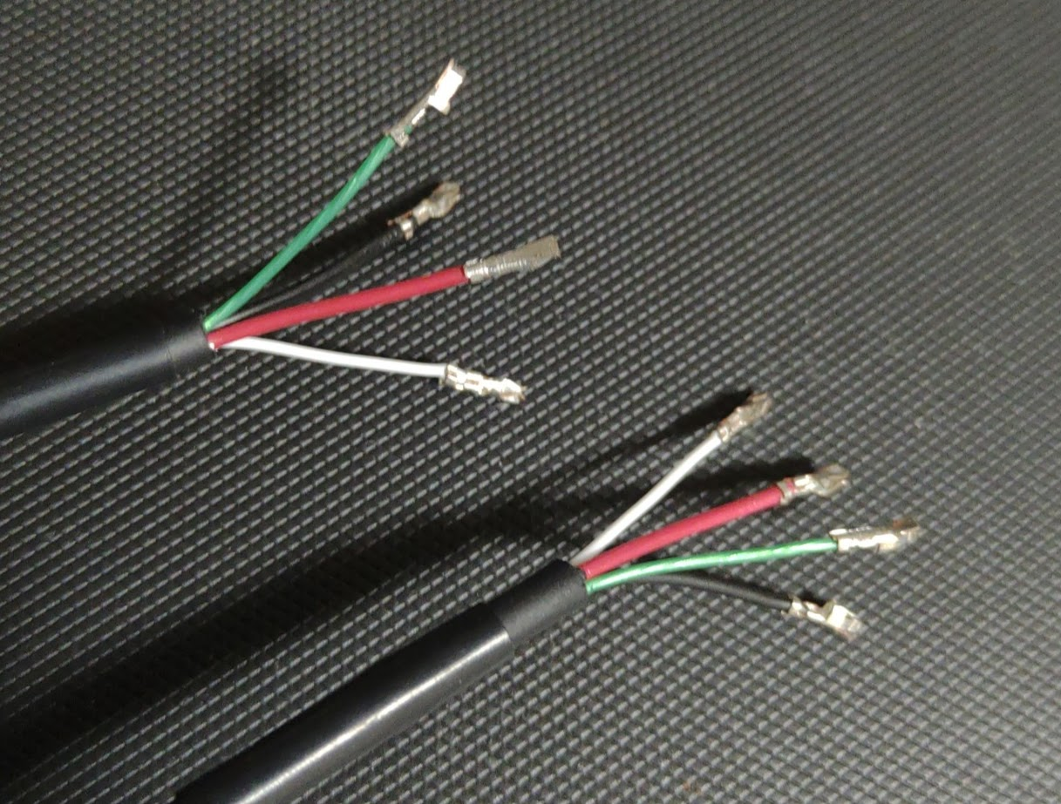

6. Cut off hook of housing.
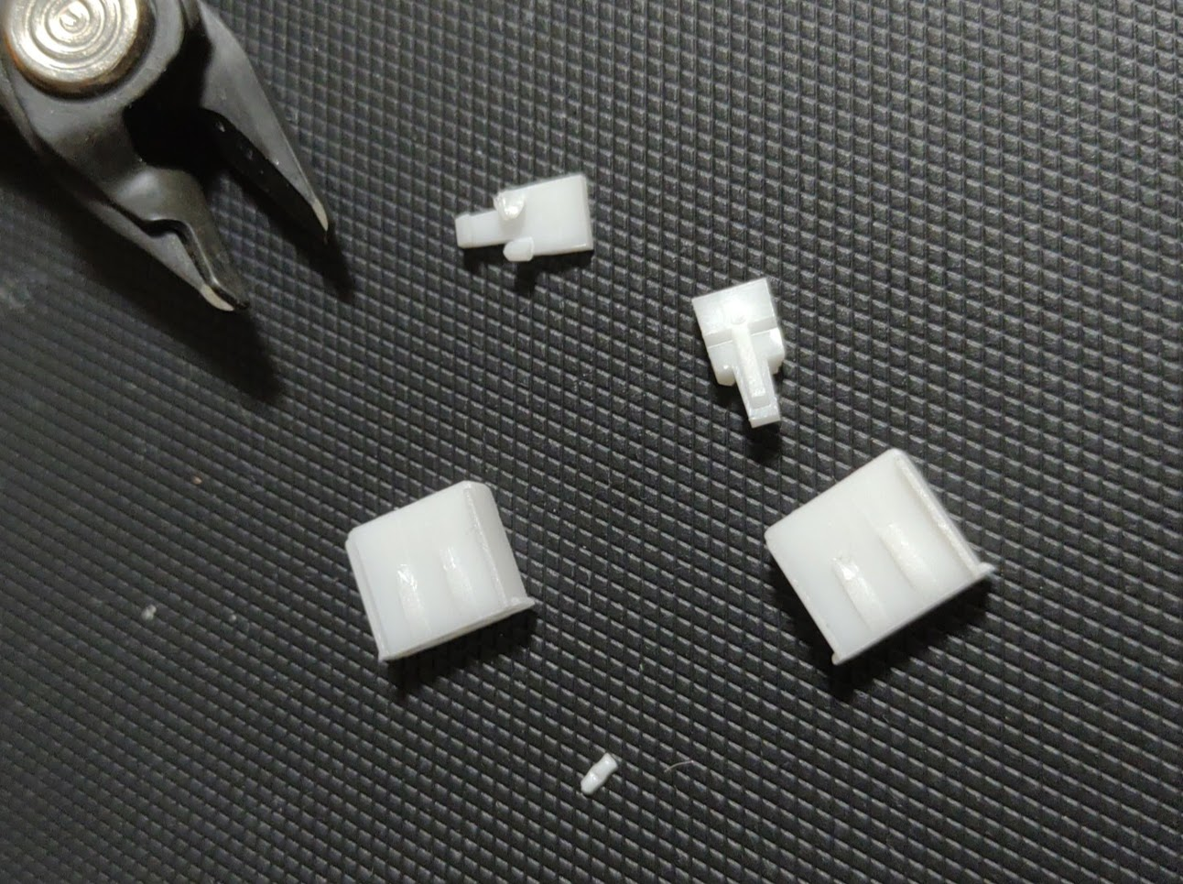
7. Inject contacts to housing.
Make sure that hooks for contact become flat by injecting.

It’s not enough
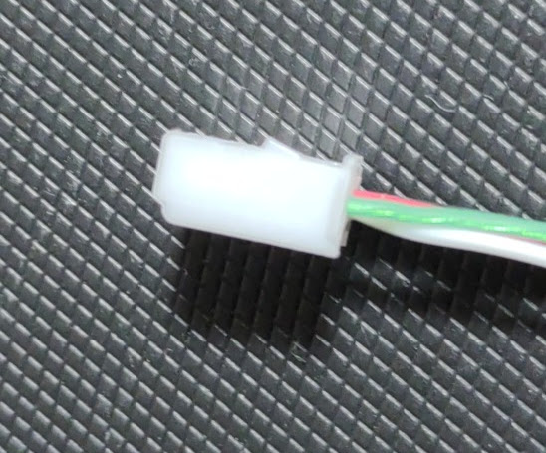

It’s enough.
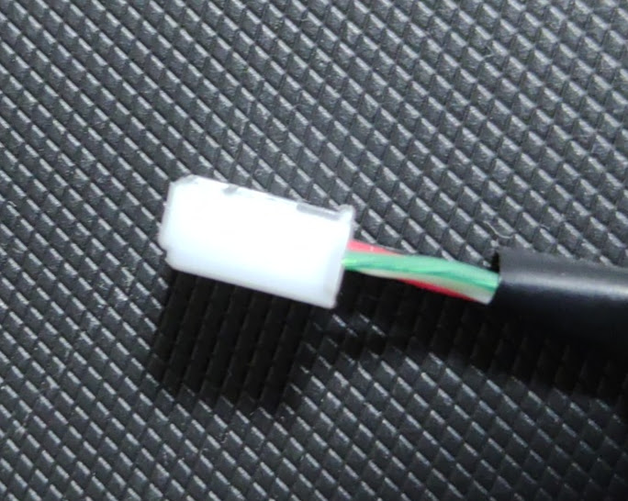

Make sure that the order of color become similar to Grove cable. Black, red, white and green.
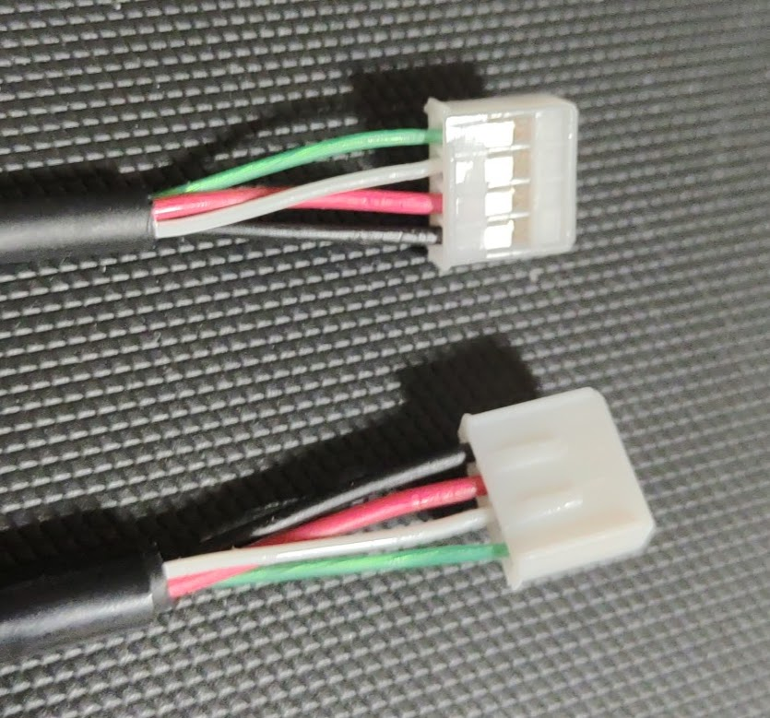

8. Make shrink cover tube by heating.
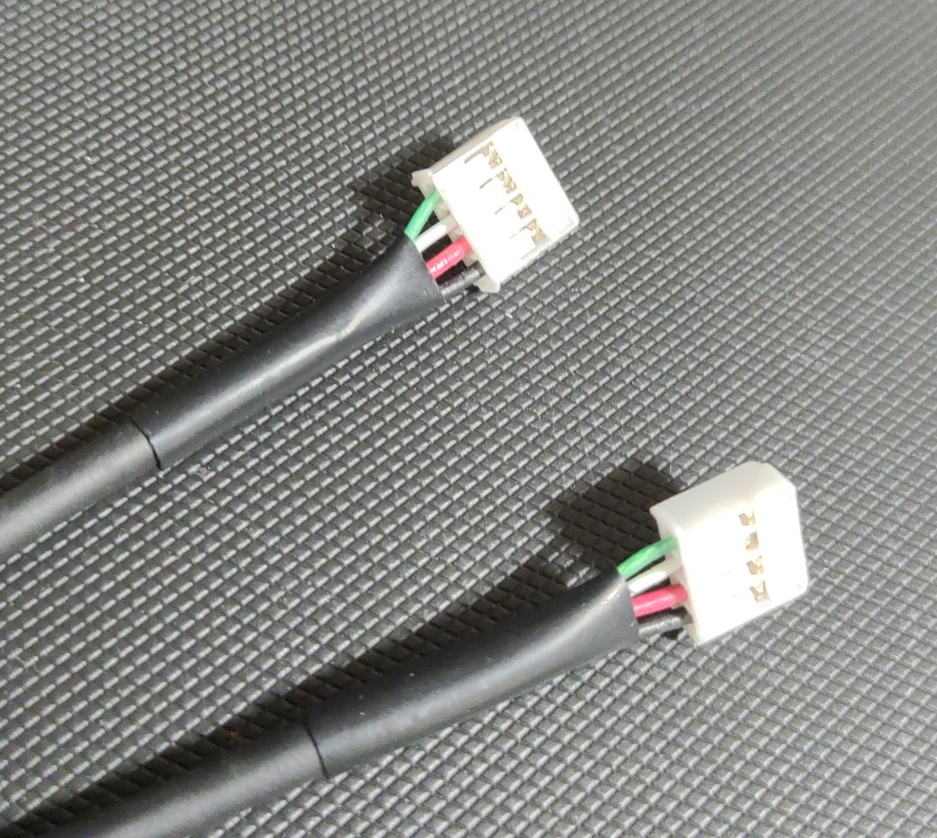
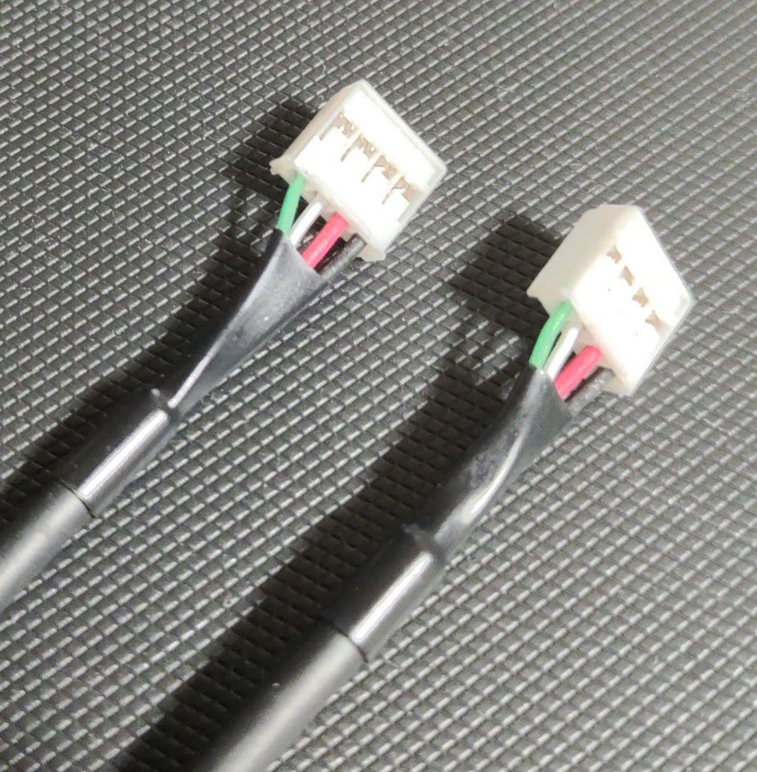

9. Put the cable into a plastic back.
