Verilog & Sytem Verilog

Table of Contents
1 Delays 2
2Event Regions. 2
3Races: 3
4Assertions: 5
5Binding Assertions: 8
6Interview Questions 9

Delays

Blocking | LHS
Non-Blocking | LHS
Blocking | RHS
Non-Blocking | RHS

Event Regions.

Figure 1 - Verilog-2001 event regions
Preponded -> Active -> Inactive -> NBA -> Observation -> Reactive
Ask yourself:
1. Which blocks get active in which region. eg. Always block, Initial block, bind, Program....
2. Blocking and Non blocking assinment sampling and update happens in which region.
3. Assertion uses previous or

Active Events Region
The Active Events Region, also commonly called the Active region, is part of the Active Region Set. The principal function of this region is to evaluate and execute all current module activity. Including (in any order2):
• Execute all module blocking assignments. • Evaluate the Right-Hand-Side (RHS) of all nonblocking assignments and schedule updates into the NBA region.
• Execute all module continuous assignments • Evaluate inputs and update outputs of Verilog primitives. • Execute the $display and $finish commands.
Sunburst Design Race Avoidance Guideline #3 dictates that all RTL combinational logic modeled using an always block should be coded using blocking assignments to ensure that combinational logic executes in the Active region and correctly models real combinational hardware behavior.

Races:
Good Source :
http://www.testbench.in/TB_16_RACE_CONDITION.html (summarize this page)
Breifly if there is race condition then it is a race condition.

Case Study: (Above link can be used to understand this scenario).
Below code tries to check following sequence of execution:
1. DUT uses assign statement for updating the output.
2. Inputs are initiallised from TB.
3. Output from DUT is not seen to be updated .
4. Need to Understand the sequence in which the blocks are executed.

Guide lines to remove races from the environment. [http://www.testbench.in/TB_16_RACE_CONDITION.html]
(A). Do not mix blocking and nonblocking statements in same block.
(B). Do not read and write using blocking statement on same variable.( avoids read write race)
(C). Do not initialize at time zero.
(D). Do not assign a variable in more than one block.( avoids write-write race)
(E). Use assign statement for inout types of ports & do not mix blocking and nonblocking styles of declaration in same block. It is disallow variables assigned in a blocking assignment of a clocked always block being used outside that block and disallow cyclical references that don't go through a non-blocking assignment. It is require all non-blocking assignments to be in a clocked always block.
(F). Use blocking statements for combinational design and nonblocking for sequential design. If you want gated outputs from the flops, you put them in continuous assignments or an always block with no clock.

Assertions:
In SystemVerilog there are two kinds of assertions: immediate (assert) and concurrent (assert property).

[Ref http://www.testbench.in/AS_03_ASSERTION_TYPES.html]
There are two types of assertions.
Immediate assertions are useful for checking combinational expression.
Concurrent assertions

severity levels:
$fatal is a run-time fatal.
$error is a run-time error.
$warning is a run-time warning, which can be suppressed in a tool-specific manner.
$info indicates that the assertion failure carries no specific severity.

Properties constructs:
Disable iff
Implication (if ..else)
overlapping implication (|->)
Non overlapping implication(||->)
not

Implication[Ref : https://www.doulos.com/knowhow/sysverilog/tutorial/assertions/]
The implication construct (|->) allows a user to monitor sequences based on satisfying some criteria, e.g. attach a precondition to a sequence and evaluate the sequence only if the condition is successful. The left-hand side operand of the implication is called the antecedent sequence expression, while the right-hand side is called the consequent sequence expression.

There are two forms of implication: overlapped using operator |->, and non-overlapped using operator |=>.

For overlapped implication, if there is a match for the antecedent sequence expression, then the first element of the consequent sequence expression is evaluated on the same clock tick.
s1 |-> s2;

There are two forms of implication: overlapped using operator |->, and non-overlapped using operator |=>.

s1 |=> s2;

[Ref: ]
Sample 4.34 Simple immediate assertion
bus.cb.request <= 1;
repeat (2) @bus.cb;
a1: assert (bus.cb.grant == 2Õb01);
// rest of the test

Sample 4.34 Simple immediate assertion
bus.cb.request <= 1;
repeat (2) @bus.cb;
a1: assert (bus.cb.grant == 2Õb01);
// rest of the test

Sample 4.38 Creating a custom error message
a1: assert (bus.cb.grant == 2Õb01)
grants_received++;
// Another succesful result
else
$error("Grant not asserted");

Sample 4.39 Concurrent assertion to check for X/Z
interface arb_if(input bit clk);
logic [1:0] grant, request;
logic rst;
property request_2state;
@(posedge clk) disable iff (rst)
$isunknown(request) == 0;
// Make sure no Z or X found
endproperty
assert_request_2state: assert property (request_2state);
endinterface

assert property countConq;
(@posedge clk ) (out==1) |-> ##1(out==2);

endproperty

Binding Assertions:
This is used when assertions for Design are kept separate from the actual design.
Steps for binding assertions:
1. put assertions in a module . Declare all the ports similar as DUT with similaar input/output attributes.
2. now inside of bind block , bind the assrtion module and DUT odle ports.

eg.

Interview Questions
After collecting sufficient questions organize them based on topis.

How to write FSM is verilog?
there r mainly 4 ways 2 write fsm code
1) using 1 process where all input decoder, present state, and output decoder r combine in one process.
2) using 2 process where all comb ckt and sequential ckt separated in different process
3) using 2 process where input decoder and persent state r combine and output decoder seperated in other process
4) using 3 process where all three, input decoder, present state and output decoder r separated in 3 process.

21)What is difference between freeze deposit and force?

Will case infer priority register if yes how give an example?

case(1'b1)
A[3]: Y<=4'b1000;
A[2]: Y<=4'b0100;
A[1]: Y<=4'b0010;
A[0]: Y<=4'b0001;
default:Y<=4'b0000;
endcase

casez(A)
4'b1???: Y<=4'b1000;
4'b01??: Y<=4'b0100;
4'b001?: Y<=4'b0010;
4'b0001: Y<=4'b0001;
default: Y<=4'b0000;
endcase

Casex,z difference,which is preferable,why?
CASEZ :
Special version of the case statement which uses a Z logic value to represent don't-care bits. CASEX :
Special version of the case statement which uses Z or X logic values to represent don't-care bits.
CASEZ should be used for case statements with wildcard don’t cares, otherwise use of CASE is required; CASEX should never be used.
This is because:
Don’t cares are not allowed in the "case" statement. Therefore casex or casez are required. Casex will automatically match any x or z with anything in the case statement. Casez will only match z’s -- x’s require an absolute match.

Given the following Verilog code, what value of "a" is displayed?
always @(clk) begin
a = 0;
a <= 1;
$display(a);
end
This is a tricky one! Verilog scheduling semantics basically imply a
four-level deep queue for the current simulation time:
1: Active Events (blocking statements)
2: Inactive Events (#0 delays, etc)
3: Non-Blocking Assign Updates (non-blocking statements)
4: Monitor Events ($display, $monitor, etc).
Since the "a = 0" is an active event, it is scheduled into the 1st "queue".
The "a <= 1" is a non-blocking event, so it's placed into the 3rd queue.
Finally, the display statement is placed into the 4th queue. Only events in the active queue are completed this sim cycle, so the "a = 0" happens, and then the display shows a = 0. If we were to look at the value of a in the next sim cycle, it would show 1.

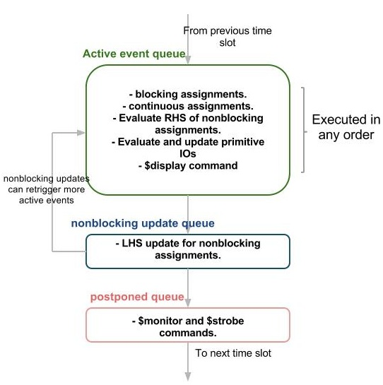

What is the difference between the following two lines of Verilog code?
#5 a = b;
a = #5 b;
#5 a = b; Wait five time units before doing the action for "a = b;".
a = #5 b; The value of b is calculated and stored in an internal temp register,After five time units, assign this stored value to a.

What is the difference between:
c = foo ? a : b;
and
if (foo) c = a;
else c = b;
The ? merges answers if the condition is "x", so for instance if foo = 1'bx, a = 'b10, and b = 'b11, you'd get c = 'b1x. On the other hand, if treats Xs or Zs as FALSE, so you'd always get c = b.

What are Intertial and Transport Delays ??

Inertial Delay Used to model net delay.

Transport Delay used to model primitives.

