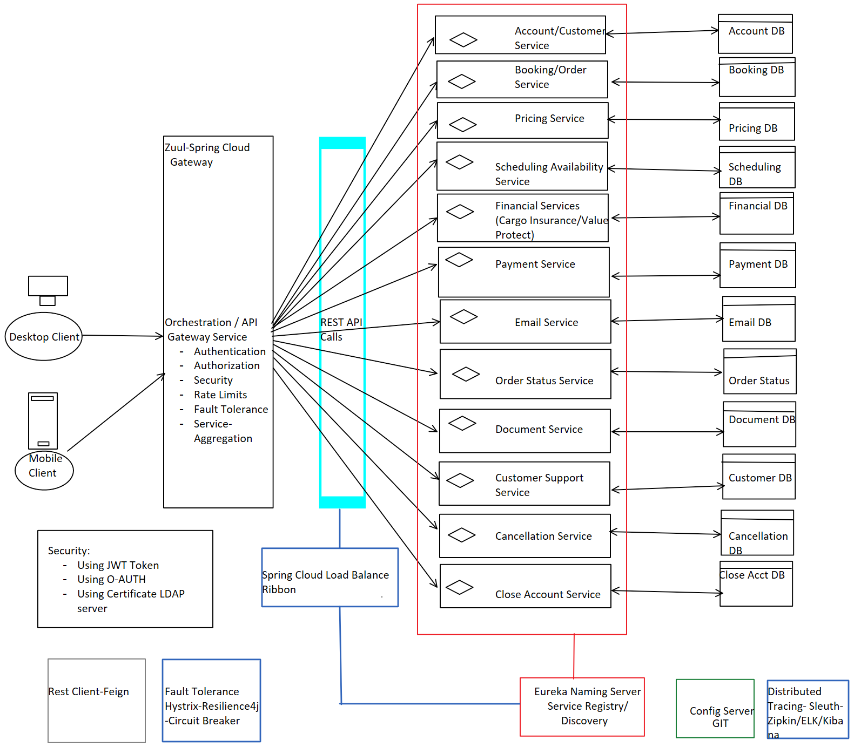

**List of Microservices is required to implement Supply chain Customer container booking:**

-------------------------------------------------------------------------------------------------------------------------------

1. Account/Customer Management Service
2. Booking/Order Management Service
3. Pricing Service (based on)
   * Ocean Freight
   * Air Freight
   * Small/Medium/Big container
   * Oversized Cargo
   * Cold chain Logistics
   * Warehouse Distribution
   * Custom Clearance Service (Our Customs Services can help every importer and exporter that to have customs clearance and expedite this process at both origin and destination)
4. Scheduling availability (routes to find the schedule which fits your supply chain)

1. Financial Services

- Cargo Insurance Service (Supply Chain Insurance is meant to cover financial losses you

incur as a result of an interruption to your supply chain. Such coverage

allows you to work confidently with suppliers who face exposures beyond

your control)

- Value Protect

1. Payment Service
2. Email Service
3. SMS Service
4. Order Status Service
5. Document Management Service
6. Contact Us/Support management service/Customer Service
7. Container Tracking Service
8. Cancellation Service
9. Close Account Service

**We can use below Design patterns to implement above microservices design:**

---------------------------------------------------------------------------------------------------------------

1. Aggregator design pattern
2. Asychronous design pattern
3. DB per service/Shared DB design pattern
4. Chain Of Responsibility design pattern
5. API Gateway design pattern
6. Event Sourcing design pattern
7. CQRS design pattern
8. SAGA design pattern
9. Circuit Breaker design pattern
10. Service Registry design pattern
11. Access Token design pattern