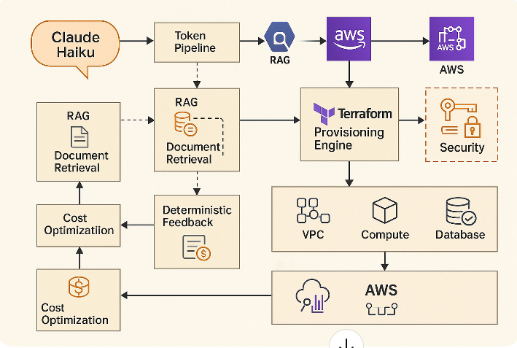

Below is a clean, production-friendly, component-wise functional breakdown of the Hybrid Deterministic LLM-Backed IaC System you asked for.
This mirrors the architecture from the images and describes exactly what each component does, how it integrates with AWS, and how it enables AI-assisted Terraform provisioning + deterministic feedback loops + cost optimization.

✅ Component-Wise Functions of the Hybrid Deterministic IaC + LLM System

1. Claude Haiku (LLM Entry Point)
Function
- Accepts natural-language prompts from operators or automation pipelines.
- Converts high-level infra intent → deterministic IaC actions.
- Produces token-optimized Terraform code.
- Responds and adjusts based on the provisioning success feedback loop.
Key Features
- Extremely low latency → ideal for CI triggers.
- Deterministic templated prompting to avoid code drift.
- Uses cost-aware constraints (e.g., “cheapest multi-AZ config”).

2. Token Pipeline (Tokenizer + Feedback Loop + Optimizer)
Function
- Breaks down prompts, Terraform state diffs, and CloudWatch logs into token-efficient structured input.
- Reduces cost by shortening prompt length and compressing historical provisioning logs.
- Sends feedback (success/failure) back into Claude Haiku for future optimization.
Subcomponents
- Token Compressor – summarises Terraform plan/apply logs.
- Policy Enforcer – removes sensitive values (keys, access tokens).
- Deterministic Input Builder – ensures same input → same output.

3. RAG Engine (Retrieval-Augmented Generation Layer)
Function
- Stores past successful Terraform modules, remediation steps, resource patterns.
- Provides deterministic reference artifacts to Claude for reuse.
- Allows model to incorporate infrastructure history without retraining.
Sources
- Terraform Registry modules
- Internal company modules
- CloudWatch logs + provisioning outcomes
- Cost Explorer data for optimization patterns

4. Document Retrieval Layer
Function
Retrieves:
- VPC templates
- EKS addons
- ECS/Fargate patterns
- Interface/Gateway endpoint modules
- Security baselines
- IAM least privilege patterns
This ensures Claude Haiku never generates code from scratch → always reuses existing proven patterns.

5. Terraform Provisioning Engine
Function
- Runs terraform plan → parses output → sends back to feedback module.
- On approval or auto-confidence trigger:
  - Performs terraform apply
  - Sends results, failures, drift reports back up to the LLM → used for optimization & correction.
Enhancements
- Auto-correcting feedback loop with Claude:
  - Missing variables
  - Wrong provider versions
  - Undeclared modules
  - Dependency cycles
- Claude automatically repairs the tf files and retries.

6. AWS VPC Layer
Function
- Provides production-grade networking:
  - 3–6 AZ support
  - NAT gateways with cost-optimized route strategies
  - Gateway/Interface endpoints
  - TGW routing if needed
Hybrid Deterministic Behavior
- Past successful subnets, CIDR success patterns, and endpoint combinations get reused.

7. AWS Compute Layer (EKS/ECS/Fargate/EC2)
Function
- Runs microservices, system workloads, or control plane components.
AI Advantages
- Claude evaluates:
  - right sizing
  - node types
  - spot/OD mix
  - autoscaling rules
Uses CloudWatch + Cost Explorer feedback → propose cheaper or better configs.

8. Database Layer
RDS / Aurora / DynamoDB
Function
- Reliable DB tier for IaC state (optional)
- Stores provisioning outcomes and historic data for RAG
AI Feedback
- Tracks connection limits, CPU usage, storage → recommends:
  - downsizing
  - switching to serverless
  - adjusting auto-scaling

9. Observability Layer (CloudWatch + X-Ray + Cost Explorer)
Function
- Supplies the system with telemetry:
  - Terraform failures
  - Drift detection
  - Infra cost spikes
  - Latency metrics
- Sends logs to token pipeline.
Claude Optimization
- Claude recommends:
  - removing unused endpoints
  - downsizing NAT
  - replacing expensive resources
  - converting EC2 → Fargate or Lambda

10. Deterministic Feedback System (Core Component)
Function
This is the "brain" enabling continuous improvement.
Collects:
- Terraform plan failures
- Terraform apply failures
- Cost overruns
- Successful deployment patterns
- Historical infra updates
Processes data → feeds back into LLM → improves the next run.
Deterministic Behavior
- Patterns that once worked are cached and reused.
- Failed patterns are blacklisted.
- Model output becomes more predictable with every provisioning cycle.

11. Cost Optimization System (AI-driven)
Function
- Evaluates:
  - Cost Explorer data
  - AWS CUR (Cost Usage Report)
  - Resource idle time
  - Overprovisioned clusters
  - EKS node group sizing
- Suggests or directly provisions:
  - cheaper instance families
  - spot percentages
  - reduced NAT count
  - smaller subnets for non-prod
  - autoscaling based on actual usage
Long-term Benefit
The system becomes self-tuning, always improving cost posture.

12. Security Layer (IAM + KMS + Secrets Manager)
Function
- Ensures the AI never leaks keys or uses unsafe patterns.
- LLM output runs through:
  - Policy sanitizer
  - Secret scrubber
  - IAM least privilege analyzer
- Before Terraform apply, output is validated.

13. Step Functions / EventBridge Orchestrator
Function
- Manages:
  - retries
  - parallel Terraform module provisioning
  - error recovery pipelines
  - auto-summarization triggers to Claude

🔥 FINAL SYSTEM BEHAVIOR
The system becomes:
✔ Self-healing
✔ Deterministic
✔ Cost-optimized
✔ LLM-enhanced
✔ Continuously improving
✔ Production ready
It provisions reliably at scale and gets smarter with every run, using:
- Claude Haiku
- RAG
- Tokenization
- Terraform
- Observability
- AWS native services

