**DOCUMENTATION FOR THE PROJECT DEVELOPMENT ON**

**Rhythmic tunes your melodic companion music streaming application**

**TEAM MEMBERS:**

|  |  |
| --- | --- |
| Role | Name |
| Team Lead | Ananthavalli.N |
| Team Member | Kaviya.S |
| Team Member | Suganya.M |
| Team Member | Harshini J.M |

1.**Project Overview**

**Purpose**

Rhythmic Tunes is a **music streaming app** designed to provide users with a **seamless and immersive audio experience**. The app aims to offer a **vast collection of songs, personalized recommendations, and user-friendly features** to enhance music discovery and listening. Our goal is to **deliver high-quality audio, easy accessibility, and a smooth user interface**, making music enjoyable for all users.

**Key Features (Frontend Functionalities)**

**User-Friendly Interface:** A sleek and intuitive design for effortless navigation.  
**Music Library:** Access to a vast collection of songs across various genres, artists, and albums.  
 **Search & Filter:** Advanced search functionality to quickly find songs, artists, and playlists.  
**Personalized Playlists:** Users can create, save, and manage their custom playlists.  
 **AI-Powered Recommendations:** Smart suggestions based on listening history and preferences.  
 **Offline Mode:** Download songs for offline playback.  
 **Lyrics Display:** View synchronized lyrics while playing songs.  
 **Dark & Light Mode:** Switch themes based on user preference.  
 **Social Sharing:** Share favourite songs and playlists with friends.  
 **Multi-Device Sync:** Access and control playback across multiple devices.

2.**Architecture**

**Component Structure**

The frontend of **Rhythmic Tunes** follows a **modular and reusable component-based structure** in React:

**App Component** (Root)

* Manages global state and routing.

**Layout Components**

* Navbar: Contains navigation links, search bar, user profile.
* Sidebar: Displays playlist categories and user-created playlists.
* Footer Player: Persistent music player with play/pause, seek bar, and volume controls.

**Pages & Views**

* Homepage: Displays featured songs, trending music, and recommendations.
* Search Page: Allows users to search songs, artists, and albums.
* Playlist Page: Shows playlists created by users or suggested playlists.
* SongDetailsPage: Displays song details, lyrics, and similar tracks.
* UserProfile: Manages user preferences, saved songs, and settings.

**Reusable Components**

* Song Card: Displays individual song details.
* Playlist Card: Represents playlists in a grid/list view.
* MusicPlayer: Controls audio playback.
* Button, Input Field, Loader: Common UI elements.

**State Management**

**Context API** – Used for managing user authentication and theme preferences globally.

**Redux Toolkit** – Manages complex application states like **music playback**, **queue management**, and **user preferences** efficiently.

**Local Storage / Session Storage** – Caches recently played songs and user settings.

**Routing**

Rhythmic Tunes uses **React Router (react-router-dom)** for seamless navigation:

**Dynamic Routing:**

* / → Home Page
* /search → Search Page
* /playlist/:id → Playlist Details Page
* /song/:id → Individual Song Page
* /profile → User Profile

**Protected Routes:**

* User authentication is required to access playlists and saved songs.
* Redirects to login page if not authenticated.

3.**Flow diagram of the Application Structure:**

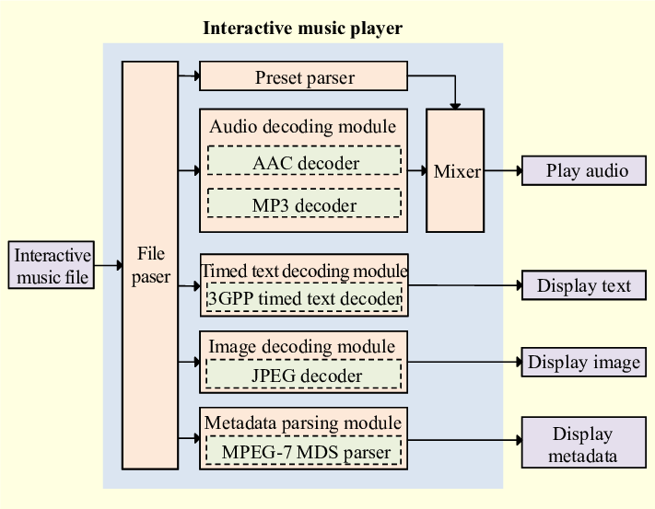

4.**Setup Instructions**

**Prerequisites**

Before setting up the project, ensure you have the following installed:

**Node.js (v16 or later)** – Required to run the React app. [Download Here](https://nodejs.org/)  
 **Git** – To clone the repository. [Download Here](https://git-scm.com/)  
**NPM / Yarn** – For package management (comes with Node.js).  
 **Code Editor (VS Code Recommended)** – For development.

**Installation Steps**

1. Clone the repository from GitHub and navigate into the project directory.
2. Install the required dependencies using npm or yarn.
3. Create a .env file in the root directory and add necessary environment variables.
4. Start the development server to run the application locally.
5. Build the project for production deployment.

5.**Folder Structure Explanation**

**Client (React Application Organization)**

A React project is typically structured into different folders to keep the code clean and organized. Here’s how it is generally organized:

1. **Components Folder (/components)**
   * This folder contains reusable UI components such as buttons, headers, and footers.
   * These components are designed to be used multiple times across different pages.
2. **Pages Folder (/pages)**
   * This folder contains different pages of the application, such as the Home page, About page, and Contact page.
   * Each file in this folder represents a different screen or route in the app.
3. **Assets Folder (/assets)**
   * This folder is used to store static files such as images, stylesheets (CSS or SCSS), and fonts.
   * It helps in keeping media files organized instead of mixing them with components or pages.
4. **Utilities Folder (/utils)**
   * This folder contains helper functions, utility classes, or custom hooks.
   * Utility functions help perform repetitive tasks like formatting dates, making API requests, or managing local storage.
5. **App.js**
   * This is the main component of the React application.
   * It acts as the root component and is responsible for rendering different pages using React Router.
6. **Index.js**
   * This is the entry point of the React application.
   * It mounts the entire React application onto the HTML document.
7. **Public Folder (/public)**
   * This folder contains static files such as index.html and favicon.ico.
   * These files do not change and are served as they are.

**Utilities (Helper Functions, Hooks, etc.)**

The **/utils** folder contains useful functions and custom hooks that help manage the application's logic.

* **Helper Functions**
  + These are functions used across multiple components to perform common tasks like formatting dates, generating random IDs, or making API calls.
* **Custom Hooks**
  + These are reusable React hooks created to handle specific functionalities like fetching data from an API (useFetch.js) or managing form inputs.

6.**Running the React Application Locally**

1. **Navigate to the Project Folder** – Move into the project directory where the React app is located.
2. **Install Dependencies** – Ensure all required packages are installed before running the application.
3. **Start the Development Server** – Launch the frontend server, which will run on http://localhost:3000/ by default.
4. **Using Yarn (Optional)** – If using Yarn instead of npm, run the corresponding commands to install dependencies and start the server.

7.**Component Documentation**

**Key Components**

These are the major components in the application, responsible for core functionalities:

**Header Component**

* + Purpose: Displays the navigation bar and branding of the app.
  + Props: Accepts title (string) to display the app name dynamically.

**Footer Component**

* + Purpose: Provides footer information such as copyright details.
  + Props: None.

**Home Page Component**

* + Purpose: Serves as the main landing page of the application.
  + Props: None.

**About Page Component**

* + Purpose: Displays details about the application or company.
  + Props: None.

**Reusable Components**

These components are designed for reuse across different parts of the app:

**Button Component**

* + Purpose: A customizable button used across multiple pages.
  + Props:
    - text (string) – Button label.
    - onClick (function) – Callback function triggered on click.
    - variant (string) – Defines button style (e.g., primary, secondary).

**Card Component**

* + Purpose: Displays content in a structured card layout.
  + Props:
    - title (string) – Card title.
    - description (string) – Card description.
    - image (string) – URL of the image displayed in the card.

8.**State Management**

**Global State**

Global state management involves sharing data across multiple components in the application. It helps maintain consistent data throughout the app. Common methods include:

* **Context API**: Provides a way to pass data through the component tree without having to pass props manually at every level.
* **Redux**: Manages global state using actions, reducers, and a centralized store.
* **React Query**: Manages asynchronous data fetching and caching.

The global state typically handles user authentication, theme preferences, and data fetched from APIs.

**Local State**

Local state is confined to individual components and manages temporary data or UI interactions. It is commonly handled using the use State hook in functional components.

Example uses:

* Form input values
* Modal visibility
* Toggle buttons
* Error messages

9.**User Interface**

To showcase the user interface, include:

* Screenshots of the home page, login page, and any interactive forms.
* GIFs demonstrating user interactions like form submissions, button clicks, or modal pop-ups.
* Highlight any special UI features like dark mode or responsive design.

10.**Styling**

**CSS Frameworks/Libraries**

The project may use one or more of the following for styling:

* **Tailwind CSS** – A utility-first CSS framework for rapid UI development.
* **Bootstrap** – A popular framework for responsive design and pre-built components.
* **Material UI** – A React component library based on Google’s Material Design.
* **Sass (SCSS)** – A CSS preprocessor for variables, nesting, and mixins.
* **Styled-Components** – A CSS-in-JS library that allows styling within JavaScript files.

Each of these helps in creating clean, maintainable, and scalable styles.

**Theming**

If the application supports theming, it may include:

* **Dark & Light Mode** – Implemented using CSS variables or Context API.
* **Custom Design System** – Defined with consistent colours, typography, and spacing.
* **Dynamic Theming** – Allows users to switch themes dynamically, using local storage or global state.

Theming ensures a consistent and visually appealing user experience across the application.

11.**Testing**

**Testing Strategy**

The testing approach ensures that components and features work correctly across different scenarios. The main testing strategies include:

**Unit Testing**: Tests individual components or functions in isolation.

* + **Tools Used**: Jest, React Testing Library
  + **Example**: Checking if a button renders with the correct text.

**Integration Testing**: Ensures that multiple components work together as expected.

* + **Tools Used**: Jest, React Testing Library
  + **Example**: Testing if a form correctly updates state and submits data.

**End-to-End (E2E) Testing**: Simulates real user interactions across the entire application.

* + **Tools Used**: Cypress, Playwright

**Example**: Testing user login, navigation, and API responses.

**Code Coverage**

To ensure sufficient test coverage, the project may use:

**Jest Coverage Reports**: Generates a summary of tested code using --coverage flag.

**Istanbul (NYC)**: Measures how much of the code is executed during tests.

**SonarQube**: Provides detailed code quality and coverage reports.

High test coverage helps in reducing bugs and maintaining application reliability.

12.**Screenshot or demo:**

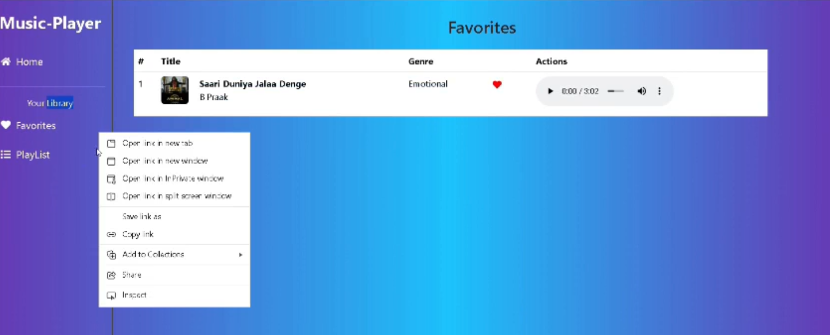

13.**Known Issues**

This section highlights any existing bugs or limitations in the application that users and developers should be aware of.

**Current Issues**

1. **Navigation Delay** – Some users may experience a slight delay when navigating between pages.
   * **Workaround**: Optimize lazy loading and use React Suspense for smoother transitions.
2. **Form Validation Inconsistencies** – Certain edge cases may not be properly handled in form validation.
   * **Workaround**: Improve validation logic and enhance error messages.
3. **Mobile Responsiveness** – Some UI components may not render correctly on smaller screens.
   * **Workaround**: Review and adjust CSS media queries for better mobile support.
4. **API Response Delay** – Slow API responses may cause data fetching issues in some cases.
   * **Workaround**: Implement caching and loading indicators for a better user experience.
5. **Dark Mode Flickering** – Theming may briefly flicker when switching between light and dark mode.
   * **Workaround**: Persist theme state using local storage or context API.

14. **Future Enhancements**

This section outlines potential improvements and features planned for future updates to enhance functionality and user experience.

**Planned Features & Improvements**

1. **New UI Components** – Add reusable UI components such as modals, carousels, and advanced form elements.
2. **Improved Animations** – Enhance user interactions with smooth transitions and animations using Framer Motion.
3. **Dark Mode Enhancements** – Improve dark mode implementation for a seamless theme switch without flickering.
4. **Performance Optimization** – Optimize code splitting, lazy loading, and caching to improve application speed.
5. **Better Form Validation** – Implement more robust client-side validation with better error handling and user feedback.