**CookBook: Your Virtual Kitchen Assistant**

**(React Application Project Documentation)**

**1. Introduction**

**Project Title: CookBook – Your Virtual Kitchen Assistant**

**Team Members:**

**Team ID : SWTID1741146557**

|  |  |  |
| --- | --- | --- |
| **Role** | **Names** | **Email id** |
| Team leader | Harsha Sri.B | sri445787@gmail.com |
| Team Member 1 | Nandhini.P | rekhapalani150386@gmail.com |
| Team Member 2 | Nivedha.G | nivedha1904@gmail.com |
| Team Member 3 | Meghna.BR | meghnaravi04@gmail.com |

**2. Project Overview**

**Purpose:**

CookBook is a feature-rich recipe web application designed to make cooking an engaging and convenient experience. It caters to both novice cooks and professional chefs, offering an intuitive interface, an extensive recipe database, and advanced search and filtering options.

**Features:**

✔️ **Recipe Database** – Access thousands of recipes from TheMealsDB API  
✔️ **Visual Recipe Browsing** – Browse recipes by category with images  
✔️ **Search Functionality** – Find recipes easily using a powerful search bar  
✔️ **Detailed Recipe Pages** – View ingredients, instructions, and tutorial videos  
✔️ **Trending Dishes Section** – See the most popular recipes  
✔️ **Newsletter Subscription** – Get updates on new recipes  
✔️ **User-Friendly Design** – Clean and modern UI for smooth navigation

**3. Architecture**

**Component Structure:**

The React app follows a modular approach:

* **Pages Folder**: Contains major screens such as **Home**, **Recipe Details**, and **Categories**
* **Components Folder**: Includes reusable UI elements such as **Navbar**, **Hero Section**, **Trending Dishes**, etc.
* **Styles Folder**: Contains CSS files for styling

**State Management:**

* Uses **React useState()** for local component state
* Uses **useEffect()** for API calls
* Uses **Axios** for fetching data from TheMealsDB API

**Routing:**

Implemented using **React Router Dom** to navigate between:

* / – Home Page
* /category/:name – Category Page
* /recipe/:id – Recipe Details Page

**4. Setup Instructions**

**Prerequisites:**

* Node.js & npm (Install from [Node.js](https://nodejs.org/en/download/))
* Code editor (VS Code, WebStorm, or Sublime Text)

**Installation Steps:**

1. **Clone the Repository:**
2. git clone [repository-link]
3. cd recipe-app-react
4. **Install Dependencies:**
5. npm install
6. **Start the Development Server:**
7. npm start
8. **Open in Browser:**
   * Navigate to [http://localhost:3000](http://localhost:3000/)

**5. Folder Structure**

recipe-app-react/

│── src/

│ │── components/ # Reusable UI components

│ │── pages/ # Different pages of the app

│ │── styles/ # CSS and styling files

│ │── utils/ # Helper functions and API requests

│── public/

│── package.json

│── README.md

**6. Running the Application**

To start the app locally, use:

npm start

Then open [http://localhost:3000](http://localhost:3000/) in your browser.

**7. Component Documentation**

**Key Components:**

* **Navbar.js** – Navigation bar for switching between pages
* **Hero.js** – Introduction section with a CTA button
* **PopularCategories.js** – Displays different recipe categories
* **TrendingDishes.js** – Highlights trending recipes
* **RecipeCard.js** – A card view for each recipe
* **RecipeDetails.js** – Displays recipe details, including ingredients, instructions, and video

**Reusable Components:**

* **Button.js** – Custom styled button component
* **Loader.js** – Displays loading animation while fetching data

**8. State Management**

**Global State:**

* API calls are handled using **Axios**
* Recipes are stored in state using **useState()**
* Data fetching is managed with **useEffect()**

**Local State:**

* Each component maintains its state for UI-related functionalities (e.g., search bar input, selected category)

**9. User Interface**

* **Homepage**: Features hero section, trending dishes, and popular categories
* **Category Page**: Displays recipes under a specific category
* **Recipe Details Page**: Provides step-by-step cooking instructions, ingredients, and a video tutorial

**Screenshots / Demo Link:**

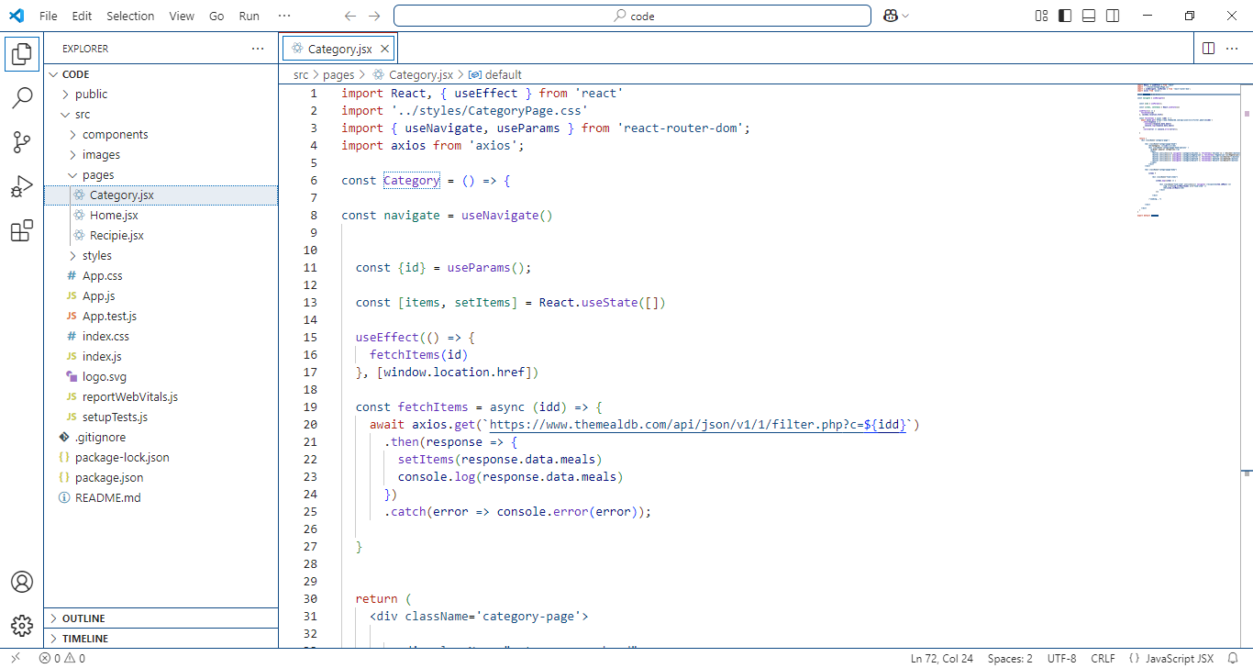

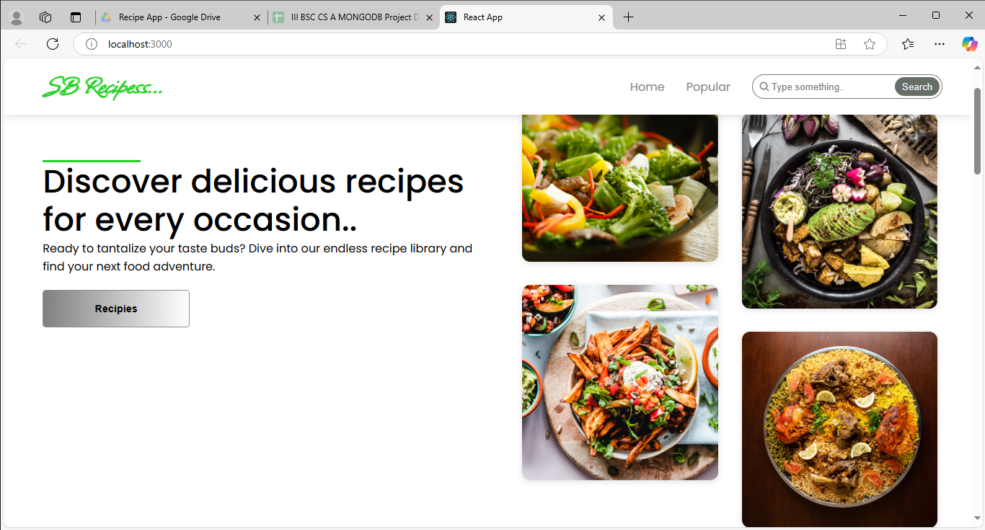

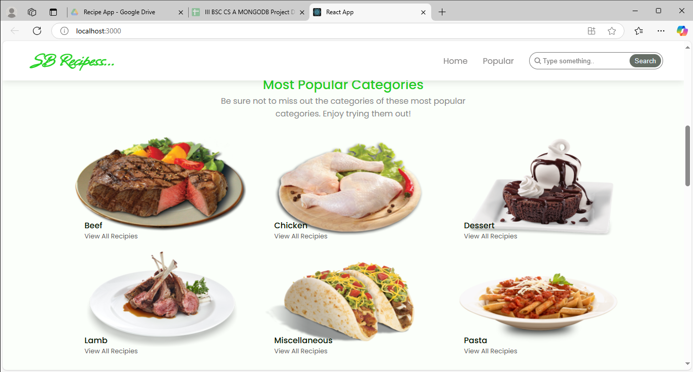

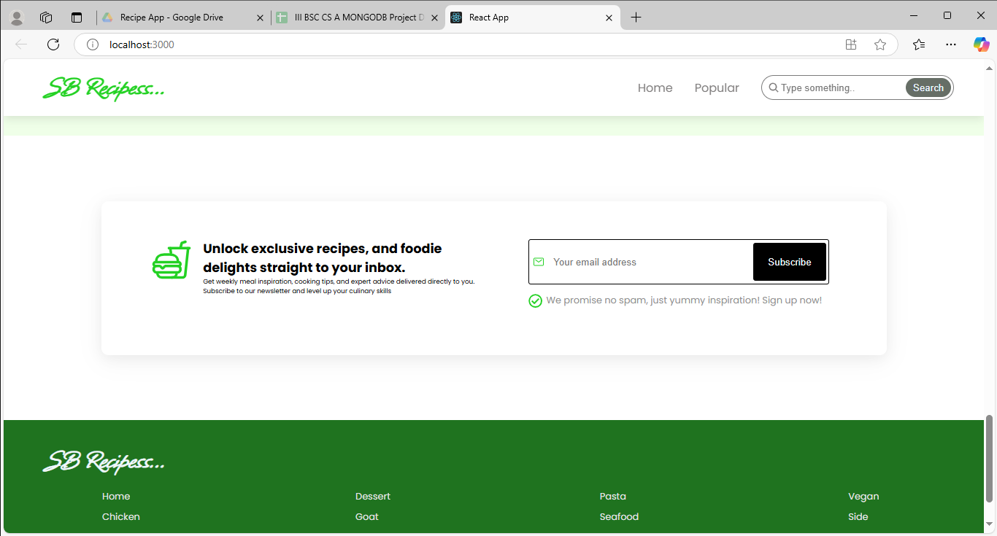

🔗 <https://drive.google.com/file/d/1aBaOQ_rq2hdMP59VnKPKElw_2t0vlFAK/view?usp=drivesdk>

**10. Styling**

**CSS Frameworks/Libraries Used:**

* **Tailwind CSS** or **Bootstrap** for layout and styling
* **CSS Modules** for component-specific styles

**Theming:**

* Light & Dark mode support (optional)
* Uses a consistent color palette for a modern UI

**11. Testing**

**Testing Strategy:**

* **Unit Testing** – Jest for individual component testing
* **Integration Testing** – React Testing Library for component interactions
* **End-to-End Testing** – Cypress for user flows

**Code Coverage:**

* Uses **Jest Coverage Reports** to measure test effectiveness

**12. Screenshots or Demo link**

🔗<https://drive.google.com/file/d/1aBaOQ_rq2hdMP59VnKPKElw_2t0vlFAK/view?usp=drivesdk>

**12. Known Issues**

* **API Limitations** – MealsDB API might have rate limits
* **Mobile Responsiveness** – Needs improvements for smaller screens

**13. Future Enhancements**

✔️ **User Authentication** – Allow users to save their favorite recipes  
✔️ **Recipe Upload Feature** – Users can contribute their own recipes  
✔️ **Shopping List Generator** – Automatically generates a list of ingredients

**Conclusion:**

CookBook is an innovative recipe application that simplifies the cooking experience. With its user-friendly interface, extensive recipe database, and seamless navigation, it provides an engaging platform for culinary enthusiasts. Future updates will introduce more personalized features to enhance the user experience.