**Project Report On**

**InsightStream: Revolutionizing News Consumption**

**Submitten by**

**Kenith paul gnanaraj**

**Reg.No:222212515**

**Hari prasath.P**

**Reg.No:222212506**

**Kamaleshwar.V**

**Reg.No:222212511**

**Lakshmanan.C**

**Reg.No:222212520**

#### ****Table of Contents****

1. **Acknowledgement**
2. **Synopsis**
3. **Introduction**
4. **Analysis of the Problem**
   * Existing System
   * Limitations of Existing Systems
   * Proposed System
5. **Feasibility Study**
6. **Analysis Tools**
   * Functional Diagram
   * Data Flow Diagram
   * Entity Relationship Diagram
7. **Hardware and Software Configuration**
8. **System Design**
   * Input Design
   * Output Design
   * Software Specifications
9. **Testing and Maintenance**
10. **Conclusion**
11. **Appendix**

* Screenshots
* Tables

1. **Bibliography**

**Acknowledgement**

We would like to express our gratitude to everyone who contributed to the development of InsightStream. Special thanks to our mentors, peers, and the open-source community for their support and valuable resources. We also extend our appreciation to news APIs and data providers for offering reliable and up-to-date news sources that are integrated into the application**.**

**Synopsis**

InsightStream is an innovative web application that revolutionizes the way users discover and consume news. It offers a user-friendly interface, dynamic search functionality, and an extensive range of news categories, providing users with access to a diverse range of global news sources. InsightStream allows users to customize their news feed based on personal preferences and explore trending topics in real time. Whether you are looking for the latest headlines or exploring in-depth articles, InsightStream offers a seamless and engaging experience for all users.

**Introduction**

InsightStream aims to redefine how news is consumed by providing an easy-to-use platform with a dynamic and customizable interface. In a world where information overload is common, InsightStream filters and curates news to suit individual user preferences, delivering relevant content based on the user’s interests.

The platform integrates various news sources to ensure a comprehensive and unbiased perspective on current events. InsightStream is designed to be accessible on both desktop and mobile devices, making it a versatile tool for news enthusiasts everywhere.

**Key features of the app include**:

Personalized News Feed: Users can tailor their news experience based on topics, locations, and interests.

Dynamic Search: A powerful search engine to find specific news articles, journalists, or topics.

Trending Topics: A real-time view of the most talked-about topics and breaking news.

**Analysis of the Problem**

**System Analysis**

The current landscape of news consumption is scattered across multiple platforms and applications, which often provide information in fragmented formats. Traditional news apps and websites also struggle with personalization, offering generic feeds that fail to cater to individual interests. Additionally, navigating these platforms can be time-consuming, as users need to go through multiple sources to find the most relevant news.

**Existing System**

There are several news aggregation platforms like Google News, Flipboard, and Feedly. However, these platforms have limitations in terms of:

Personalization: The ability to offer tailored content based on user preferences is limited.

User Interface: Existing apps often provide basic interfaces with limited search functionality or customization.

Speed and Real-Time Data: Most news apps do not provide real-time news, and updates can often be delayed.

**Limitations of Existing System**

Generic Content Feeds: Most platforms give users generic news feeds that are not curated based on specific interests or preferences.

Limited Interaction: Existing systems lack features that allow users to interact with content (e.g., save, share, comment).

Fragmented News Sources: Users need to browse through multiple sources to get a comprehensive view of a story, which is time-consuming.

Cluttered Interface: Many apps offer a cluttered and overwhelming interface, making it difficult to focus on important topics.

**Proposed System**

InsightStream will solve the problems of existing systems by offering:

Customized News Feeds: Personalization features that adapt based on user interests, preferred news categories, and locations.

Advanced Search: A powerful search functionality that allows users to filter articles by keywords, topics, and timeframes.

Trending Topics & Real-Time Updates: Users will be able to access trending topics and breaking news in real time.

Clean User Interface: A user-friendly, clean design with minimal distractions, allowing users to focus on the news that matters to them.

**Feasibility Study**

**Technical Feasibility**

The system is technically feasible using modern web technologies. The frontend will be developed using React.js, with a responsive design that works seamlessly on both mobile and desktop devices. For backend services, Node.js and Express.js will be used to handle API requests and user authentication. Real-time news data will be fetched from trusted news APIs such as NewsAPI, NY Times API, and Guardian API.

**Operational Feasibility**

Operationally, InsightStream will be accessible to anyone with an internet connection and a device capable of running web applications. The app will be designed to scale with increasing user demand, ensuring smooth operations even with a large number of users.

**Economic Feasibility**

The initial cost of developing the platform will be focused on software development, API integrations, and user interface design. The system can be monetized through:

Premium Features: Providing additional features such as access to exclusive news, personalized reports, and an ad-free experience.

Advertising: Displaying unobtrusive ads from trusted partners.

Data Analytics: Offering insights into user trends to third-party organizations (while maintaining user privacy).

**Analysis Tools**

**Functional Diagram**

The Functional Diagram illustrates the main features of the InsightStream application, including the user interface, dynamic search, news feed customization, and real-time updates.

**Dataflow Diagram**

Dataflow Diagrams (DFD) will show how data flows through the system from external news sources, through the backend for processing, and finally displayed on the user interface. It will outline how users interact with the platform and how their preferences are stored and used to customize their experience.

**Entity Relationship Diagram**

The Entity Relationship Diagram (ERD) will illustrate how the data is structured within the system, including entities such as users, preferences, saved articles, and categories.

**Hardware/Software Configuration**

Frontend: React.js, Redux (for state management), Material-UI (for design components)

Backend: Node.js, Express.js

APIs: NewsAPI, NY Times API, Guardian API (for fetching articles and news data)

Database: MongoDB (for storing user data and preferences)

Hosting: AWS or Heroku for hosting the app

**System Design**

**Input Design**

Users will interact with the system by selecting categories of news they are interested in, searching for specific topics or keywords, and customizing their preferences (e.g., location, language). Input forms will be simple and intuitive, ensuring ease of use.

**Output Design**

The Output Design will present news articles in a clean and minimalistic layout, with features like:

Article snippets with images and metadata.

Option to expand articles for more details.

Real-time updates and trending topics section.

A customizable news feed based on user preferences.

**Software Specifications**

Frontend: React.js, Material-UI, Redux

Backend: Node.js, Express.js

API Integration: NewsAPI, NY Times API, Guardian API

Database: MongoDB (to store user preferences and news history)

Authentication: JWT (JSON Web Tokens) for secure login and user session management.

**Testing and Maintenance**

**Testing**

Unit Testing: Testing individual components (e.g., Search Component, News Feed, Authentication).

Integration Testing: Ensuring seamless integration between frontend, backend, and APIs.

User Acceptance Testing (UAT): Validating the app’s usability and ensuring it meets user expectations.

Load Testing: Testing the app’s ability to handle multiple simultaneous users and real-time updates.

**Maintenance**

Bug Fixes: Regular updates to address bugs and performance issues.

Feature Updates: Incorporating user feedback to add new features or refine existing ones.

Security: Ensuring data privacy and protecting against common vulnerabilities.

**Conclusion**

InsightStream is a cutting-edge web application designed to offer users a personalized, intuitive news experience. It provides a clean and organized interface for users to access real-time, tailored news, with powerful search features and customizable preferences. By addressing the limitations of existing news platforms, InsightStream creates a more user-centered approach to news consumption. The app will not only streamline how users consume news but also provide them with insightful analysis of trends and breaking news.

**Appendix**

**Screenshots**

Dashboard: Screenshot of the main dashboard showing personalized news feed, trending topics, and real-time updates.

Search Functionality: Screenshot of the dynamic search bar and results page showing specific topics and articles.

Article View: Screenshot showing the detailed view of a news article with options to save or share.

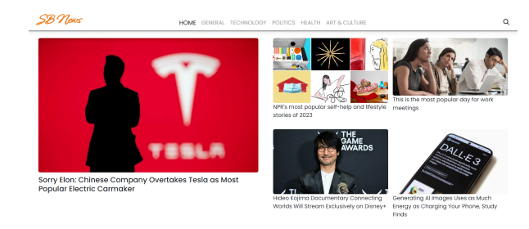

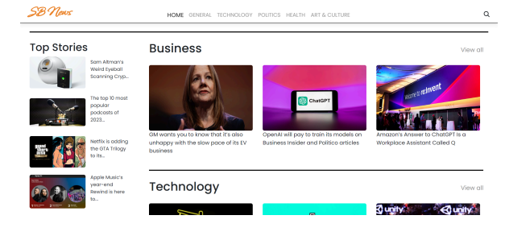

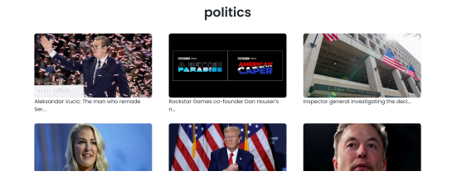

**Tables**

• Users Table: Stores data about users, including ID, profile info, preferences.

• Articles Table: Stores article data such as titles, content, categories, and publication dates.

• Categories Table: Stores available news categories like Politics, Technology, and Sports.

.

**Bibliography**

NewsAPI Documentation: https://newsapi.org/docs/endpoints/everything

React.js Documentation: https://reactjs.org/docs/getting-started.html

Material-UI Documentation: https://mui.com/getting-started/installation/

Node.js Documentation: https://nodejs.org/en/docs/