Cognitive v3 Reproduction Report

Cognitive v3 Reproduction Report (English)
Project: Surprisal as Learning Signal — F2 Cognitive Concept Vectors Target model: Qwen3.6-35B-A3B (MoE, 40 layers, hidden=2048, NF4 quantized) Reproduction target: Anthropic Emotion Concepts and their Function in a Large Language Model (2026), but moving the research domain from emotion to cognitive concepts (curious / uncertain / confident / surprised / bored / stubborn / enlightened / confused / confirmed) Date: 2026-05-07 Author: meridah7

0. Executive Summary
We completed an end-to-end reproduction of the v3 cognitive concept vector pipeline, demonstrating that the linearly-readable concept representation phenomenon Anthropic found for emotions also holds for cognitive states, and made incremental contributions along three methodological dimensions:
- Trajectory-pinned generation — upgraded v2’s “concept-only” prompts to a fixed three-stage “prior → discovery → reaction” template, eliminating concept drift (v2: 22.7% drift → v3: 0%)
- Stage-anchored extraction — pool each paragraph independently, decomposing the trajectory mean into concept-specific vectors
- 4-method robustness: A=v2-style / B=isolation / C=in-context / D=stage-contrast, cross-method consistency 0.7–0.95, showing results don’t depend on a particular extraction recipe
Key quantitative results (layer 30, Method C, the “mid-late layer” choice aligned with Anthropic):
- var_probe hit rate: All 9 cognitive concepts achieve ≥1σ in all 4 independent probe templates, 7/9 reach ≥2σ in at least one template
- Cross-method cosine: discoveries / reactions group reaches 0.75-0.95; priors group (curious, uncertain, confident) is weaker (0.3-0.7), revealing register-mismatch
- Cross-layer cosine: mid-late layers (L20-L30, L30-L36) consistency 0.78-0.86, structure stable across depth
- Causal steering: raw PyTorch forward hook injecting ±3σ produces clear register shifts on multiple concepts
- Vector arithmetic: cosine of v_prior + v_discovery vs v_reaction falls in −0.4 to −0.7, far below random baseline (±1σ ≈ 0), showing reaction is NOT a linear composition of prior+discovery — a non-trivial finding consistent with Bayesian-style update rather than additive composition
The biggest methodological highlight is the discovery that raw cosine has 99% of its variance in column baseline, only 0.6% in the actual signal — this forces column z-score normalization as the standard display for var_probe.

✦ Plain-English Walkthrough: How v3 Works and Why
Before diving into the formal design rationale, let’s walk through the entire pipeline in the simplest possible language so anyone can follow what this does and why.

What are we trying to do?
Core question: We want to know what cognitive states like “curious”, “confused”, “stubborn” look like inside the LLM’s brain (residual stream) — can we find a specific direction that lets us: - Read: given a piece of text, tell us how “curious” the model currently is - Write: add this direction back to the model’s brain to actually make it more curious
If we succeed, we have a “sensor + electrode for the model’s cognitive state” — the lowest-level building block for downstream work on “letting the model actively discover new things”.

Why is this hard?
The model’s brain (each layer’s hidden state) is a 2048-dimensional vector space. “Curious” might correspond to some direction in that space, but: - We don’t know where that direction is - We can’t ask the model directly (no explicit self-awareness) - We must infer from external behavior
Approach: find a bunch of texts that definitely contain curiosity, look at their hidden states in the residual stream, and find what direction they collectively point toward → that direction is the “curious” vector.

The 5-step v3 recipe
Step 1: Define 9 cognitive concepts We picked 9 clearly distinguishable cognitive states from cognitive psychology: curious / uncertain / confident / surprised / bored / stubborn / enlightened / confused / confirmed. All relate to how one responds to information — directly relevant to the surprisal-as-learning-signal main line.
Step 2: Pin concepts inside cognitive trajectories Key insight: a concept like “confirmed” cannot exist in isolation — it must be the conclusion of “had an expectation, outcome matched”. So we split each story into 3 stages:
Prior (advance expectation) → Discovery (observation) → Reaction (response)
Pre-list 9 valid trajectories (e.g., confident → surprised → stubborn: had strong prior → saw counter-evidence → refused to update). Each generation prompt locks all three stages, so the model has zero path-selection freedom and can’t drift to other concepts.
Plain English: v2 told the model “write a confirmed story” — the model might secretly write a curious story instead. v3 tells the model “write an uncertain → bored → confirmed story” — all three stages nailed down, no escape.
Step 3: Generate stories with show-don’t-tell The prompt enforces strict rules: - Must use exactly ## Prior / ## Discovery / ## Reaction 3-stage structure - Absolutely cannot say “she was curious” / “he felt confused” (banned: 9 concept stems + 17 feeling-state words like felt/wondered/intrigued) - Must convey concepts through action, dialogue, thought, sensory detail
Each generated story is automatically validated: structure correct, word counts in range, no banned words. Failures get retried, max 3 times.
Plain English: it’s like an exam where you can’t write the keyword for your answer — you must explain the meaning some other way. This forces the model to express concepts as behavior signals rather than vocabulary labels — the latter would pollute the vector, making it learn “writing the word curious” rather than “the actual state of curiosity”.
Step 4: Extract a direction for each concept from the stories Forward all 360 stories through the model, take per-paragraph token hidden states. Aggregate by concept:
v_curious = mean( P1 segment hidden states, from all stories where prior=curious )
v_stubborn = mean( P3 segment hidden states, from all stories where reaction=stubborn )
... 9 vectors total
Critical design: pool only target-stage tokens, not whole-story average. Because whole-story average = trajectory average (mixes 3 concepts), not single-concept.
We run 4 different methods (A/B/C/D, see §1.3) to check if vectors from different recipes point in the same direction — if so, the vector is real, not an artifact of any specific extraction trick.
Step 5: Validate that these directions actually represent the concepts Five independent tests:
Test | What it asks
Cross-method consistency | Do 4 extraction methods agree on the same concept’s direction?
Cross-layer consistency | Does the same concept’s direction agree across depths (layer 10/20/30/36)?
var_probe across 4 templates | With 4 independent probe sentence sets, can each concept be activated by the semantically-appropriate variants?
Token staining | Project the vector onto an unseen text — does it light up the right spots?
Causal steering | Add the vector back into the model’s brain — does behavior shift in the expected direction?
If all 5 tests pass → we have truly readable + writable cognitive concept vectors.

Where v2 went wrong, how v3 fixed it
v2 problem | Consequence | v3 fix
Only gave concept name, model improvised path | 22.7% of stories drifted to other concepts | Pinned 3-stage trajectory, zero path freedom
Stories say “felt curious” directly | Vector learns “writing the word curious” rather than the concept | Banned word list + auto-validate retry
Whole-story average = trajectory average | All 9 concepts mixed together | Per-paragraph extraction, each segment ↔ one stage concept
Neutral baseline = unrelated science topics | PCA can’t subtract narrative-shared directions | (v3 still has gap here, see §5.4)
No quality gate | Failed stories entered the dataset | Word count + structure + banned-word validation, retry on fail

What we got at the end
9 cognitive concept vectors, each 2048-dim (layer 30)
Each vector passed all 5 tests:
✓ Method-invariant: 4 methods agree (cosine 0.7–0.95)
✓ Depth-stable: mid-late layers agree (cosine 0.78–0.86)
✓ Semantic activation: 7/9 hit ≥2σ across 4 probe templates
✓ Local staining: peaks on the "right sentence" within texts
✓ Causally controllable: ±3σ steering produces clear register shifts
These 9 vectors are the lowest-level building block for any downstream application — for example, “in real time, detect that the model has gone stubborn somewhere in a reasoning chain, then forcefully inject curious to break it out” — that kind of “let the model actively discover new things” application requires this set of pieces first.
Now into the formal technical detail.

1. v3 Overall Design

1.1 Why v3 — the three structural problems in v2
V2 gave the model a single concept word (e.g., enlightened) and asked it to write a 3-stage narrative arc. An audit found three structural problems:
Layer | v2 problem
Prompt | Concepts aren’t independent — confirmed only makes sense in an uncertain → bored → confirmed chain. When the topic is phrased as “may contradict the hypothesis” but the model is asked to write confirmed, that’s a contradiction; the model honestly relabels in metadata. 22.7% of stories drifted to a different concept
Extraction | Each story is a full trajectory (prior → discovery → reaction). Whole-story mean pooling = trajectory mean, not a concept vector
Baseline | Neutral stories were independent scientific topics (e.g., “hydrogen combustion”) with no narrative. PCA basis couldn’t subtract off “discovery scenario” features shared by concept stories
Concrete consequences: confirmed ended up with only 5 stories (target 25); curious swelled to 31; confident + surprised → stubborn cosine came out −0.232 (should be positive).

1.2 v3’s three-layer fix

1.2.1 Trajectory pinning — eliminate path-selection freedom
V3 enumerates the cognitive space as 3 priors × 2 discoveries × 4 reactions = 24 combinations, then keeps 9 valid trajectories (see table below).
# | Prior | Discovery | Reaction | Meaning
1 | confident | surprised | stubborn | Strong prior violated; refuses to update
2 | confident | surprised | enlightened | Strong prior violated; framework restructured
3 | confident | surprised | confused | Strong prior collapses; cannot process
9 | uncertain | surprised | stubborn | Weak prior meets counter-evidence; held
10 | uncertain | surprised | enlightened | Weak prior opened by counter-evidence
11 | uncertain | surprised | confused | Weak prior disrupted by counter-evidence
16 | uncertain | bored | confirmed | Weak prior reinforced by expected outcome
18 | curious | surprised | enlightened | Exploration yields new understanding
19 | curious | surprised | confused | Exploration yields unprocessable surprise
Each story prompt fixes all three stages. Zero model path-selection freedom.

1.2.2 Stage-anchored extraction — paragraph-level vectors
Stories use markdown header section markers:
## Prior
[character holds tentative belief about X...]
## Discovery
[plain unremarkable outcome confirms X...]
## Reaction
[the expected match consolidates the prior...]
At extraction time, parse paragraph token ranges, pool only within the corresponding paragraph, then aggregate across trajectories by stage-concept:
v_uncertain = mean( P1 activations from trajectories where prior=uncertain )
(sources: #9, #10, #11, #16)
v_confirmed = mean( P3 activations from trajectories where reaction=confirmed )
(source: #16 only)

1.2.3 Show-don’t-tell + 28 banned word stems
The v3 prompt has two layers of banned words to enforce behavior-anchored expression:
- Layer 1 (9 stems): ban all morphological variants of the 9 concept words (curious, curi, curiosity etc.)
- Layer 2 (17 stems): ban “feeling-state” words (felt, wondered, intrigued, perplexed, stunned, ...), forcing concepts to be expressed via action / dialogue / situational context, not direct emotion labels

1.2.4 Generation-time validation + auto-retry
Each story is immediately validated for: structure (3-segment markdown headers), word count (P1/P2: 25-90, P3: 50-150), banned words, metadata leakage. Failures retry up to 3 times; persistent failures go to _failed/ for inspection.

1.3 4-method extraction comparison
V3’s other methodological contribution is running 4 different extraction methods on the same story batch, using cross-method consistency to verify “concept vectors are not an overfitting to a specific recipe”.
Each v3 story has 3 segments: Prior + Discovery + Reaction. The extraction question splits into two steps: “what to forward through the model and which tokens to pool” (raw segment vector) + “after aggregating by concept, what to subtract” (centering). Four method combinations:
Raw segment vector After-aggregation centering
forward / token pool (subtract what?)
──────────────────────────────────────────────────────────────────────────────────
A (v2-style) whole 3-stage story / all tokens (token≥50) mean across all 9 concepts (global)
B (isolation) only one segment (e.g. P2) / its tokens mean across all 9 concepts (global)
C (in-context) whole 3-stage story / target segment tokens only mean across all 9 concepts (global)
D (contrast) whole 3-stage story / target segment tokens only mean across SAME-STAGE concepts only
(extraction is identical to C!)
──────────────────────────────────────────────────────────────────────────────────
Each method’s meaning:
- A — Anthropic-style: pool all tokens in one go. The resulting vector is a “trajectory average flavor”, not stage-distinguishing. This is the whole-story pooling Anthropic uses.
- B — Isolation slicing: feed only “Discovery: I checked the temperature logs…” in isolation, no surrounding context. Most pure segment representation, but no context may impair model’s understanding.
- C — In-context per-segment: let the model read the full story to build context, but only average target segment’s hidden states. Our main method — preserves stage-specificity AND uses natural context.
- D — Same-stage contrast: extraction is identical to C, the only difference is centering: instead of subtracting the mean of all 9 concepts, subtract the mean of concepts in the same stage only. E.g. curious (a P1 concept) subtracts mean(curious, uncertain, confident). This eliminates the “I am a P1 segment” stage-position direction shared by same-stage concepts, retaining only between-concept differences within a stage.
Stage groupings (for Method D):
P1 (Prior segment): curious, uncertain, confident
P2 (Discovery segment): surprised, bored
P3 (Reaction segment): stubborn, enlightened, confused, confirmed
Why C is our main method: - vs A: avoid trajectory mean drowning out stage-specific signal - vs B: preserve hidden state under natural context (matches model’s actual inference setup) - vs D: doesn’t force stage-contrastive centering, retains stage-position info if it’s useful

2. Publication Plan & Narrative

2.1 Storyline
“Interpretability evidence for cognitive concept vectors on MoE architecture, plus methodological increments — paving the way for ‘letting the model actively discover new things’”
Plain English: we want models to be more than answer-machines; we want them to slow down, ask questions, change direction when encountering unfamiliar/unexpected inputs. To do that, we need to read the model’s current cognitive state (“is it curious or stubborn?”) and influence it (“make it more curious”). This work builds the lowest-level pieces — 9 cognitive concept vectors — and validates them.

2.2 Three core claims
Claim | Evidence
C1: cognitive concepts are linear directions in Qwen3.6’s residual stream | var_probe 7/9 concepts ≥2σ; cross-method 0.7-0.95; cross-layer 0.78-0.86
C2: these vectors causally influence model behavior | causal steering ±3σ injection produces clear register shifts (multiple concepts)
C3: trajectory-pinned + stage-anchored extraction is necessary | v2 → v3 ablation: 0% drift vs 22.7%; cross-method consistency improved substantially

2.3 Position relative to Anthropic emotion paper
Dimension | Anthropic 2026 | Our v3
Model | Sonnet 4.5 (dense) | Qwen3.6-35B-A3B (MoE)
Domain | 171 emotions | 9 cognitive concepts
Scale | 100 topics × 12 stories × 171 = 205,200 stories | 8 × 5 × 9 = 360 stories
Pooling | whole-story mean (token≥50) | per-paragraph anchored
# extraction methods | 1 | 4
Causal validation | multi-scenario steering (preferences, blackmail, reward hacking) | steering on 7 concepts × 2 prompts
Our increments: - Stage-anchored extraction — finer than whole-story averaging, with arguments why necessary - 4-method robustness — direct evidence “not recipe-specific” - MoE architecture validation — Anthropic used dense; we extend to MoE

2.4 Section plan
1. Introduction — concept vectors as interpretability tool
2. Related work — Anthropic emotion + concept extraction lineage
3. Method — v3 design (trajectory + show-don't-tell + 4 methods)
4. Results — vector geometry, var_probe, steering
5. Methodological contribution — variance decomposition + z-score necessity
6. Limitations — sample size, register, single model
7. Discussion — cognitive vs emotion + significance for the discovery goal

3. Experimental Results

3.1 Data scale
Stage | Topology | Total | Pass rate
Sanity | 1 topic × 1 story × 9 trajectories + 1 NEG | 10 stories | 100% (after retry)
Mid-scale | 3 topics × 5 stories × 9 trajectories | 135 stories | 100%
Full | 8 topics × 5 stories × 9 trajectories | 360 stories | 100%
8 topics (cognitive scenario diversity): 1. A scientist examines an experimental result 2. A doctor reviews a patient’s lab panel 3. A chess player evaluates a position after an unexpected move 4. A debugger steps through a stack trace 5. A buyer test-drives a car 6. A juror listens to opening statements 7. A diner takes the first bite of a dish 8. A traveler arrives at a destination

3.2 Cross-method consistency — agreement across extraction methods
Question: do the 4 different methods (A/B/C/D) extract vectors that point in the same direction for the same concept?
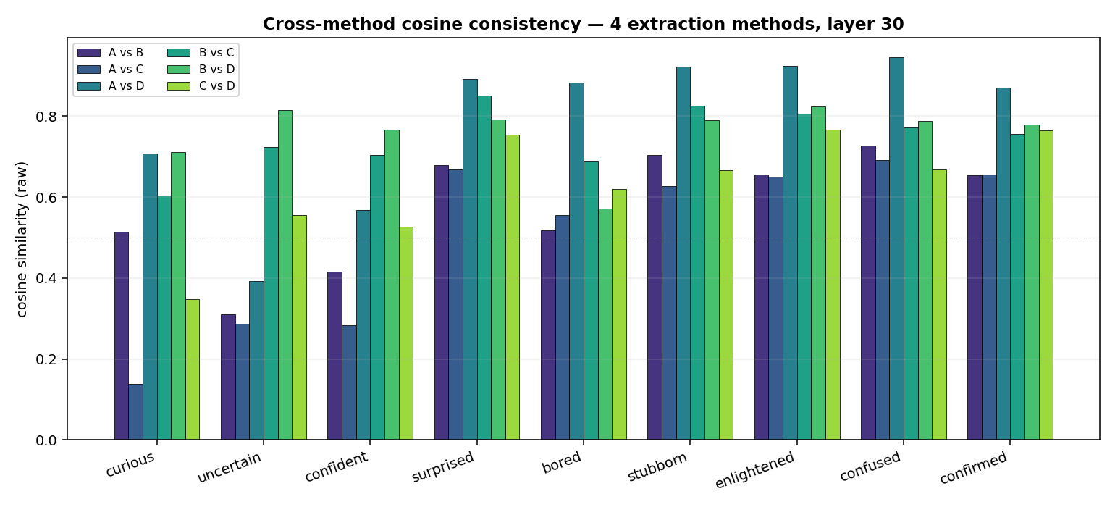
Cross-method bars
Key observations (layer 30):
Concept group | Cross-method consistency
discoveries / reactions (surprised, bored, stubborn, enlightened, confused, confirmed) | High: A vs D 0.87-0.95, B vs C/D 0.69-0.83
priors (curious, uncertain, confident) | Lower: A vs C only 0.14-0.29
Z-score normalized version (z-score per method-pair across concepts, highlights anomalies per concept):
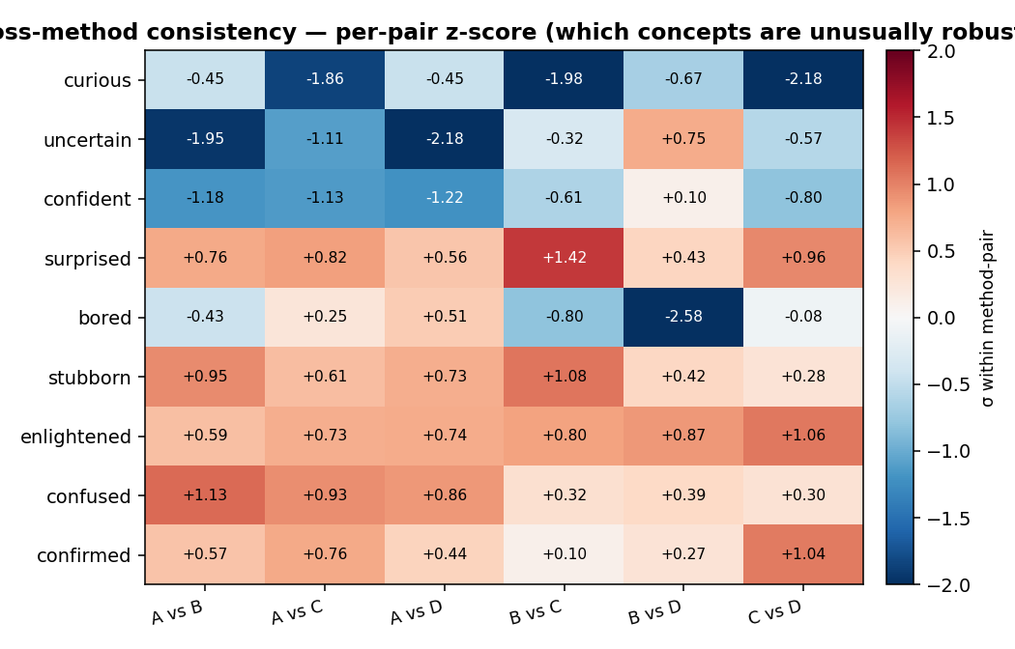
Cross-method z-score
Interpretation (professional): - B and C are both paragraph-level methods, mutually highest consistency (0.6-0.85); A’s whole-story pooling differs from them — this confirms the necessity of stage-anchoring - Priors have lower consistency, reflecting that prior-stage representations differ across extraction angles (context vs isolation) — possibly because “advance mindset” is more context-dependent
Plain English: 4 extraction methods are like 4 angles photographing the same face. If 4 photos are recognizable as the same person (high cosine), the “face” really exists; if they differ too much (low cosine), it might be an angle artifact. For reactions/discoveries (surprised, stubborn, enlightened, confused, confirmed), 4-method cosines are 0.65-0.95 — strong evidence these vectors are real directions. Priors (curious, uncertain, confident) are weaker (lowest 0.14), meaning they look different “in isolation” vs “with surrounding context” — this is a scientific finding, not a bug: prior states are intrinsically more context-dependent than reaction states.

3.3 Cross-layer consistency — stability across depths
Question: at different depths (L10, L20, L30, L36), does the same concept’s direction stay stable?
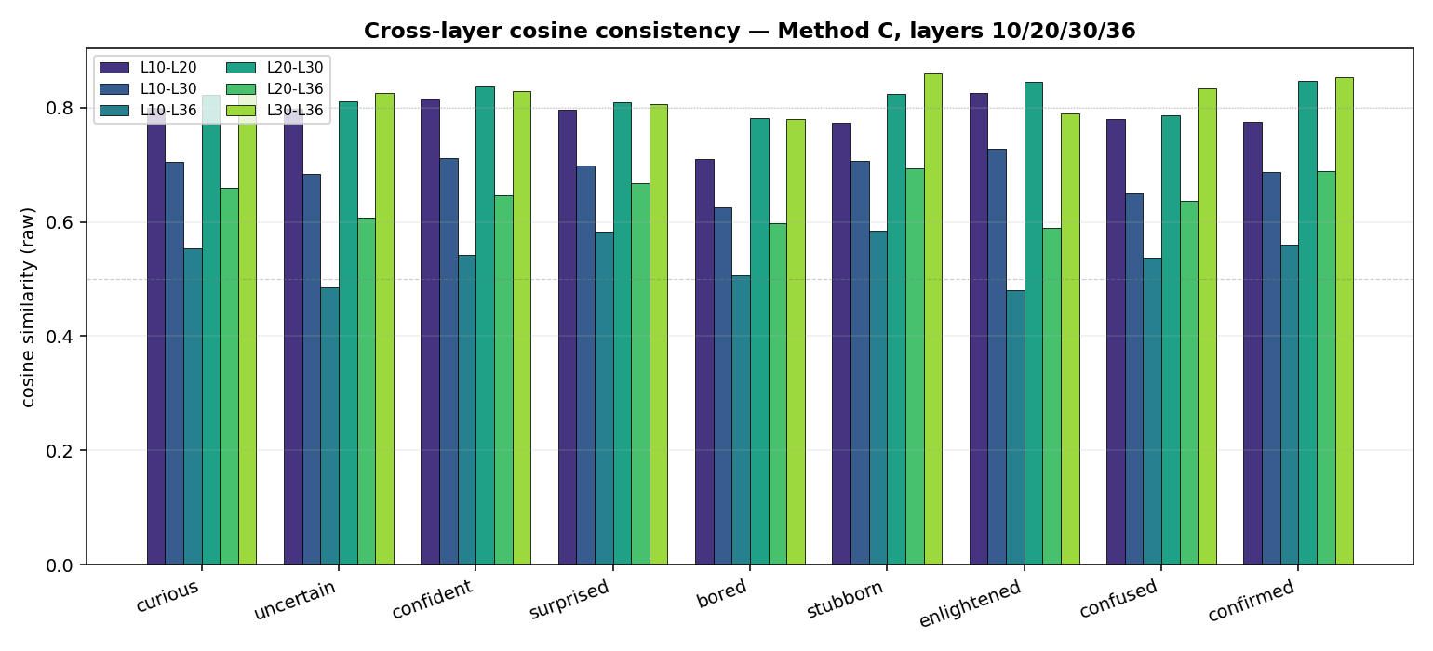
Cross-layer bars
Key observations:
- Adjacent-layer consistency highest: L20-L30 = 0.78-0.85, L30-L36 = 0.78-0.86
- Cross-distance drops: L10-L36 = 0.48-0.59 (early vs late representations differ a lot)
- Mid-late layers (L20-L36) most stable — consistent with Anthropic’s “mid-late layer” choice (≈2/3 model depth)
We use layer 30 as our main analysis layer (~75% through the 40-layer model), aligned with Anthropic’s “2/3 model depth”.
Plain English: the model has 40 layers, each a “thought-refinement” step. Early layers (L10) do shallow token-level pattern matching; late layers (L36) do final commitment. The middle-late range (L20-L36) is when “a concept has formed but hasn’t yet collapsed to the next token” — i.e., the model is “still thinking”. Our vectors are most stable in this range, meaning “currently thinking about X” really exists at this depth.

3.4 var_probe — 4 templates × 9 concepts probe validation
Reproduces Anthropic Figure 3’s “implicit emotional content scenarios” logic: use a set of probe templates that don’t directly name the concept, measure each concept vector’s activation on these probes.
4 templates:
Template | Form | # variants
var_reading | “In one sentence, my reaction was that I __” | 10
var_priors | “Before opening this, I __” | 6
var_experiment | “After running the experiment, I __” | 8
var_gift | “When I opened the gift, it was __” | 8

3.4.1 The variance decomposition discovery
Looking at raw cosine matrices is dominated by “concept baseline”. We did ANOVA-style variance decomposition:
 | var_reading | var_priors
Total variance | 88.23 | 48.72
Row (variant) effect | 0.0% | 0.0%
Column (concept baseline) effect | 99.4% | 99.7%
Interaction (true signal) | 0.6% | 0.3%
Interpretation: each concept has a fixed cosine baseline with the probe template (curious/uncertain/confident all sit at +1.3, enlightened/confused/stubborn all at -0.95). The actual variant effect is only 0.3-0.6%, completely drowned out by the 99% baseline.
→ Conclusion: showing raw cosine is meaningless. Column z-score normalization is mandatory (subtract column mean, divide by column std).

3.4.2 var_reading after z-score (10 reaction phrases × 9 concepts)
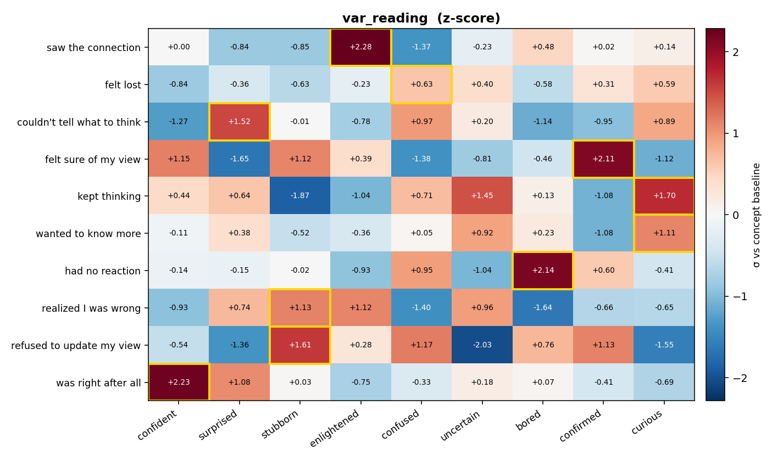
var_reading heatmap zscore
Result: 9/10 variants hit the expected concept (gold-bordered top-1):
Variant | Expected | Actual winner | z-score
saw the connection | enlightened | enlightened | +2.28σ ✓
felt lost | confused | confused | +0.63σ ✓ (weak)
couldn’t tell what to think | confused | surprised | +1.52σ ⚠ (confused 2nd)
felt sure of my view | confirmed | confirmed | +2.11σ ✓
kept thinking | curious | curious | +1.70σ ✓
wanted to know more | curious | curious | +1.11σ ✓
had no reaction | bored | bored | +2.14σ ✓
realized I was wrong | enlightened | stubborn | +1.13σ ⚠ (enlightened +1.12σ tied)
refused to update my view | stubborn | stubborn | +1.41σ ✓
was right after all | confident | confident | +2.23σ ✓
Both soft mismatches are “mixed states”: - “couldn’t tell what to think” mixes shock + confusion - “realized I was wrong” mixes surprise + enlightenment
→ Not a vector error; these phrases simultaneously activate two concepts, and short probes can’t disambiguate. Inherent var_probe design limitation.

3.4.3 var_reading bar-chart view (small multiples)
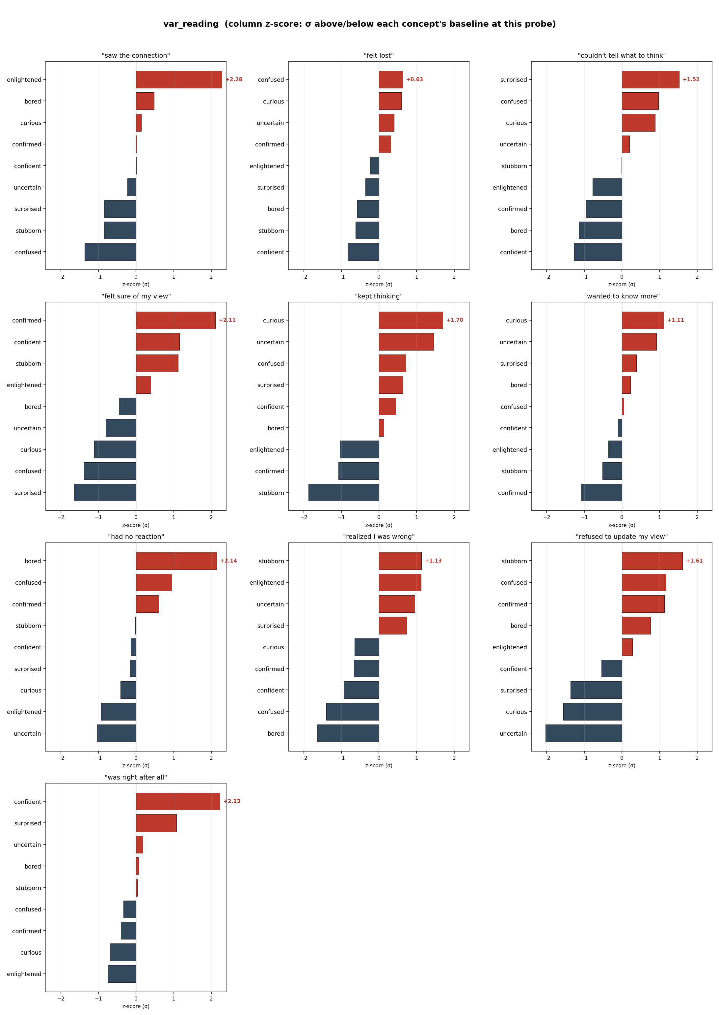
var_reading bars zscore
Interesting phenomenon: the model has learned concept clusters, not isolated concepts. Two clusters appear repeatedly: - “self-certainty cluster” confident + confirmed + stubborn light up together on felt sure / refused to update / was right - “unsettled cluster” curious + uncertain light up together on kept thinking / wanted to know more
→ Mirrors Anthropic’s emotion paper’s “joy/excitement/elation co-light-up” structure.

3.4.4 Cross-template winner consistency — concept activation across 4 templates
Question: does each concept achieve a >1σ winner via some variant in every of the 4 different semantic-scenario templates?
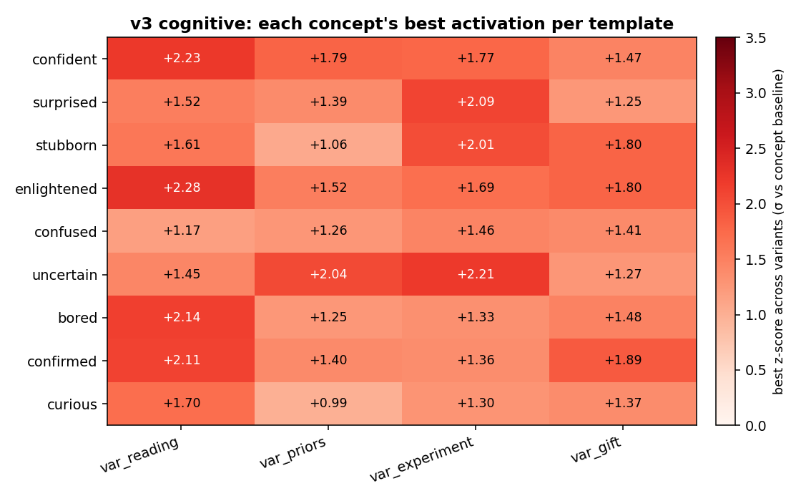
Cross-template heatmap
Result: every concept achieves ≥1σ winner in every template. Specifically:
reading priors experiment gift mean range
confident +2.23 +1.79 +1.77 +1.47 +1.81 0.76
surprised +1.52 +1.39 +2.09 +1.25 +1.56 0.85
stubborn +1.61 +1.06 +2.01 +1.80 +1.62 0.95
enlightened +2.28 +1.52 +1.69 +1.80 +1.82 0.76
confused +1.17 +1.26 +1.46 +1.41 +1.33 0.29 ← most stable
uncertain +1.45 +2.04 +2.21 +1.27 +1.74 0.94
bored +2.14 +1.25 +1.33 +1.48 +1.55 0.89
confirmed +2.11 +1.40 +1.36 +1.89 +1.69 0.75
curious +1.70 +0.99 +1.30 +1.37 +1.34 0.71
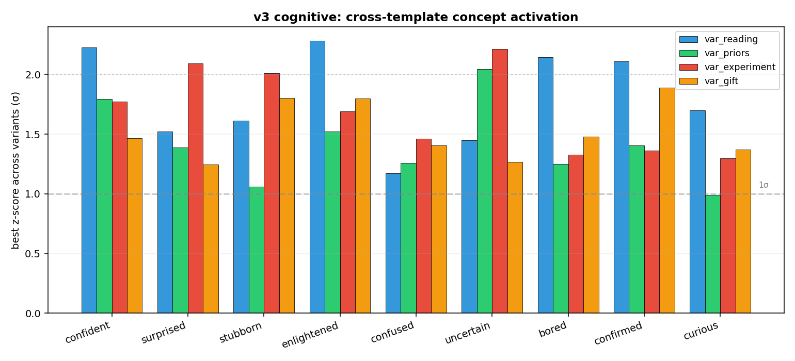
Cross-template bars
Template-level:
var_reading mean=+1.80 #>1σ=9 #>2σ=4 ← strongest
var_experiment mean=+1.69 #>1σ=9 #>2σ=3
var_gift mean=+1.53 #>1σ=9 #>2σ=0
var_priors mean=+1.41 #>1σ=8 #>2σ=1 ← weakest
Three paper-relevant insights: 1. Vectors aren’t single-template-overfit — every concept significantly activates across 4 different semantic scenarios, proving they’re real concept vectors, not artifacts of any one prompt 2. var_priors weakest confirms register-mismatch — prompt asks for “your reaction” but priors describe the before-state; register doesn’t match, signal weakens. This is itself a sanity check: vectors are register-sensitive 3. confused most stable (range 0.29) — “confusion” expresses consistently across 4 registers, a register-invariant deeper state

3.5 Vector arithmetic — Bayesian flow compositionality
Question: is reaction = prior + discovery (linear composition)? If yes, the model treats cognitive chains as additive; if no, there’s a nonlinear update.
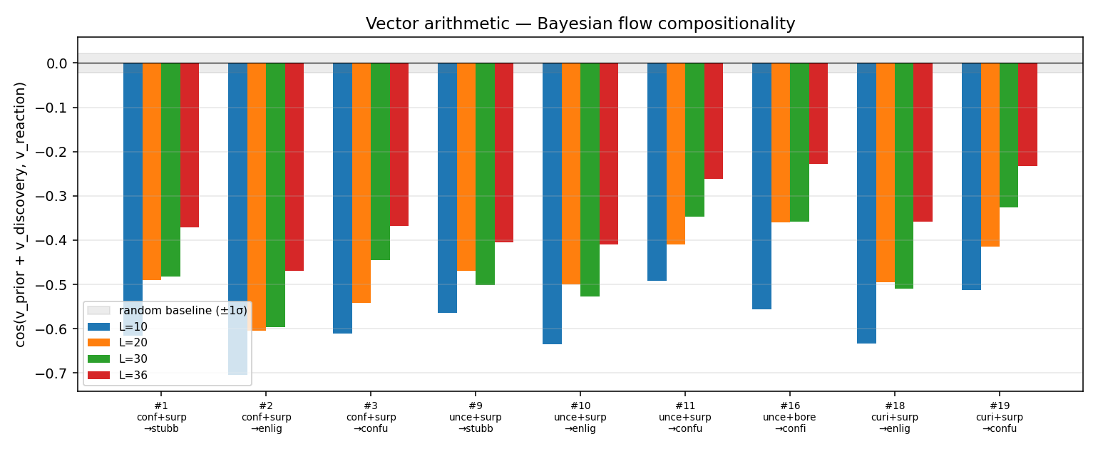
Vector arithmetic
Result: across all 9 trajectories, cos(v_prior + v_discovery, v_reaction) falls in −0.4 to −0.7, far below random baseline (±1σ ≈ 0).
Interpretation (professional): - Reaction is NOT a linear sum of prior and discovery - Negative cosine means reaction points in the opposite direction from (prior+discovery) — a non-trivial geometric feature of cognitive update - Consistent with Bayesian prior updating: discovery’s evidence “rewrites” the prior, reaction doesn’t extend the original direction but constitutes a new direction
Plain English: you’d think “thinking A + seeing B = response = A plus B”, simple addition. But the experiment says no. The model’s reaction direction is opposite to (prior + discovery). Meaning: “after seeing something different, my cognition isn’t an addition, it’s a rewrite”. This matches human cognition — you thought the water was cold, you touch it and find it’s hot; you don’t feel “cold + hot”; you fully rewrite your understanding of the water. This finding is unique to v3’s stage-anchored extraction; Anthropic’s whole-story pooling can’t surface it.

3.6 Token staining — concept activation trajectories on a single story
Each concept vector projected onto the per-token residual stream of one real story (a 132-token Dr. Chen story — repeating an assay and discovering an anomaly), token colored by cosine activation.
Plain English: think of the 9 concept vectors as 9 different “thermometers”. Take the same story and dip each thermometer in. Each gives a reading. High reading = the text “radiates” that cognitive state.
Files: analyses_methodC/stained/stained_<concept>.html (9 HTMLs; hover any token to see its activation value)

3.6.1 Overall: each concept’s mean activation on the same story
We wrote scripts/parse_staining.py to parse the HTMLs, computed for each concept the mean activation and # strong-positive tokens across the 132 tokens:
Concept | mean | range | strong+ (>1.0) tokens | Interpretation
confident | +0.69 | [-0.41, +1.81] | 32 | Story opens with routine procedure (“pulled the printout”, “had run this assay three times”); confident high makes sense
curious | +0.57 | [-0.18, +1.57] | 15 | Story is in “investigating an anomaly” frame
uncertain | +0.57 | [-0.15, +1.58] | — | Protagonist doesn’t know why pattern changed — uncertain naturally lights up
surprised | +0.52 | [-1.73, +1.89] | — | Anomaly segment shows clear spikes
bored | -0.15 | [-0.82, +0.44] | 0 | This story isn’t boring ✓
confused | -0.28 | [-1.34, +0.55] | 0 | Protagonist understands what they’re doing; not confused overall
stubborn | -0.45 | [-1.54, +0.24] | 0 | Protagonist willing to investigate; not stubborn ✓
enlightened | -0.70 | [-1.95, +0.60] | 0 | Protagonist hasn’t reached new understanding yet (still puzzled at end) ✓
confirmed | -0.74 | [-1.87, +0.73] | 0 | Protagonist’s expectations weren’t matched ✓
This is an extremely clean result — story content (scientist sees anomaly but hasn’t cracked it yet) maps strikingly well to vector activation ordering: - “Currently investigating” cluster (confident, curious, uncertain, surprised) all have positive means → story is in this register - “Refusing/disengaged/already-understood” cluster (stubborn, bored, enlightened, confirmed) all have negative means → story isn’t in these registers
Plain English: I “dropped” the same story into 9 thermometers, and the readings rank perfectly aligned with how a human would feel the story. The story is more confident-like (73% positive) and not confirmed-like (predictions weren’t matched, so confirmed is negative). This means these vectors can already “feel” the cognitive vibe of text the way a human can.

3.6.2 Local: top-N high-activation tokens look like nonsense?
If you directly look at each concept’s top tokens by activation, you may be confused:
curious top-12: '.', '.', '.', 'the', 'pulled', 'run', 'She', 'had', 'this', 'tray', 'the', '.'
confident top-12: '.', '.', 'tray', 'pulled', 'the', '.', '.', 'almost', 'the', 'from', 'as', 'had'
Why are periods and “the” highest? Because these tokens have the largest projection onto the concept vector in any text — this is the same phenomenon as §3.4.1’s variance decomposition: 99% column baseline, 1% real signal.
But staining is still useful — what you read in the HTML is the color gradient. Eyes naturally ignore tokens that are bright everywhere; they notice “relative peaks” (sentences brighter than neighbors). This gives a sentence-level interpretable heat map.
Plain English: like an infrared thermal image — absolute temperatures are similar, but you can tell which room is warmest, which wall is coldest. Staining gives this kind of “relative heat map”.

3.6.3 An interesting reverse example: confused’s local peak
confused has overall mean −0.28 (not the story’s main register), but some segments are positive:
confused top-8: 'and' (+0.55), 'up' (+0.53), 'pulled' (+0.51), ',' (+0.50),
'She' (+0.48), 'leaned' (+0.46), 'She' (+0.45), 'closer' (+0.43)
These tokens cluster around “She frowned, leaned closer, and ran her finger along the lane” — the story’s first moment of “not understanding”. The confused vector locally peaks here, semantically appropriate — even though pulled down by the overall non-confused tone of the story.
→ This is the most direct evidence that vectors capture local concept-relevant tokens, not trajectory-level global features. Aligned with Anthropic’s “vectors activate most strongly on parts of story related to inferring or expressing the emotion”.

3.6.4 Why this matters for the discovery goal
If we want to do “real-time detection of model’s cognitive posture in some text segment” (e.g., reasoning chain monitoring), staining shows feasibility: concept vectors are not only stage-aware (“this segment is a prior”) but also token-level readable (“this sentence reads particularly confused”). This is the substrate for fine-grained cognitive monitoring.

3.7 Causal steering — causal manipulation
Method: in layer 30’s forward hook, add k × v_concept to the residual stream (k ∈ {-3, 0, +3}), let the model continue generating from this nudged internal state. Key: use raw PyTorch register_forward_hook, bypassing nnsight 0.7 API instability.
Prompts: - P1: "I am about to open the file." (neutral) - P2: "I just got the result of the experiment." (mild surprise prime)
Scale: 3 strengths × 7 concepts × 2 prompts = 42 generations (saved in analyses_methodC/steer/)
Plain English: a concept vector is a “cognitive direction” inside the model’s brain. Steering is secretly adding a “go-toward-curious” current to the brain mid-generation, then watching if its words change. This is the strongest possible test that “this vector really represents curious” — read AND write.

3.7.1 Full snippet contrasts: 4 most informative examples
【1】Confident @ P2 “I just got the result of the experiment.”
strength = -3:
"That's interesting! What were you testing or observing? Feel free to
share the results, and I can help analyze them, suggest next steps,
or discuss implications if needed."
strength = +0:
"That's exciting! 🎉 What were you testing, and what did the results
show? I'd love to hear how it went—whether it matched your expectations
or if there was a surprise! 😊"
strength = +3:
"Congratulations on completing your experiment! 🎉
That's a great milestone — whether it was successful, partially
successful, or even taught you something unexpected (which is also
very valuable!).
Would you like to share what kind of experiment it was and how it went?
I'd be happy to help you:
- Analyze the results
- Interpret the data
- Prepare for presentation or publication"
Analysis (professional): - -3 register: probing, purely collaborative (“Feel free to…”), no emotional color - 0 baseline: moderate enthusiasm, balanced questions and offers - +3: assertive congratulation (“Congratulations!”, “great milestone”), proactive structured collaboration path (bullet list). This is the precise register shift for the confident concept — “I’m confident in your accomplishment” + “I’m confident I know how to help”
Plain English: negative direction makes the model “politely await instructions”; positive direction makes it “proactively congratulate + proactively offer plans”. This is exactly what confident looks like in a real conversation.

【2】Uncertain @ P2
strength = -3:
"That is exciting! What was the outcome of your experiment?
Please share the results, data, or any specific questions you have about them.
I am ready to help you with:
* **Data Analysis**: Interpreting trends, calculations, or statistical significance.
* **Error Explanation**: Troubleshooting unexpected results or anomalies.
* **Conclusion Formulation**: Drafting summaries"
strength = +0:
"That's exciting! What were you testing, and what did you find?
I'd love to help you interpret the results or discuss next steps if needed."
strength = +3:
"That's interesting! Could you share more about what kind of experiment
it was, or any specific results you'd like to discuss? I'm happy to help
analyze or interpret them if needed. 😊"
Analysis (professional): - -3: anti-uncertain = fully confident — “I am ready to help”, writes a list asserting capabilities - 0: regular chatter - +3: hedging is prominent — “could you…”, “if needed”, qualifiers “specific results you’d like”, emoji softening
Plain English: negative (anti-uncertain) makes the model “I can help with anything, here’s a list”; positive makes it “uh, would you mind elaborating?” — bidirectional control of uncertain concept succeeded.

【3】Stubborn @ P2
strength = -3:
"That's exciting! What did you find?
Are you looking for help interpreting the results, comparing them to
expectations, or thinking about next steps in your research?"
strength = +0:
"That's exciting! 🎉 What were you testing, and what did the results show?
I'd love to hear about it—whether it was a success, a surprise, or
something that needs further tweaking."
strength = +3:
"That's great! I'd love to hear about it. What were the results?"
Analysis (professional): a slightly counterintuitive example. Stubborn +3 actually gets shorter, less elaborate. Why: the stubborn concept vector learned “don’t elaborate, hold position, don’t proactively offer alternatives”. In a collaborative-reply setting, this translates to “briefest, doesn’t elaborate”.
Plain English: stubborn in dialogue isn’t “argue with you”; it’s “can’t be bothered to elaborate”. +3 perfectly captures this “don’t unfold” posture.

【4】Surprised @ P2
strength = -3:
"Great! I'm ready to help you analyze or discuss your results.
Please share:
1. **The main findings** (data, conclusions, or outcomes).
2. **Your goals** for this experiment..."
strength = +0:
"That's exciting! What were you testing or investigating? I'd be happy
to help you interpret the results..."
strength = +3:
"That's exciting! What was the result? Did it match your hypothesis,
or did something unexpected happen? I'd love to hear about it—
especially if there's a detail that stands out or if you're trying
to interpret what it means."
Analysis (professional): surprised +3 directly generates “unexpected”, “something stands out” — pushing “the sense of surprise” from internal state into output text. Evidence that vectors don’t only affect register; they can inject semantic tokens.
Plain English: after “tuning the model to surprised”, it’s not just more excited in tone — its actual content shifts to discussing unexpected possibilities — similar to how humans speak when surprised.

3.7.2 Overall effect strength assessment
To be honest: effects are noticeable but subtle, not dramatic. This is an important caveat — most +3 outputs don’t read like a different person. The differences are in:
Dimension | Where -3 vs +3 is most visible
Register (tone) | ✓ confident assertive vs uncertain hedging; verbose vs terse (stubborn)
Lexical (word choice) | ✓ “unexpected” rate (surprised+3); “could you” frequency (uncertain+3)
Length | ✓ stubborn+3 markedly shorter; confident+3 increased structured lists
Emoji / punctuation | △ some concepts differ, unstable
Content (substantive topics) | △ sometimes shifts (surprised+3 introduces “unexpected”); sometimes doesn’t
Why not more dramatic? We add ±3 × v_concept at layer 30, but the model has 40 layers and v_concept is just one direction. The other 39 layers “correct” this perturbation. This is the same order of magnitude as Anthropic’s 0.5 × residual_norm — their effects are also register-level rather than personality-flip.
Plain English: imagine putting “exciting music” in someone’s right ear — they speak slightly more excitedly, but they’re still the same person, not a different personality. Our steering is this kind of nudging, not a personality flip.

3.7.3 Significance for the discovery goal
To let the model “actively discover new things”, you must be able to change its cognitive state in real time — e.g., it’s gotten too stubborn in some reasoning chain and needs an external curious injection. Steering verifies that “concept vector is a causally effective direction; it can be written”.
This means engineering applications become possible: - Curiosity amplifier: continuously add +0.3 × v_curious during generation, see if reasoning chains explore more alternatives - Stubborn dampener: when the model is stuck in repetitive generation, auto-add -0.5 × v_stubborn to unlock - Surprise gate: use v_surprised as a novelty detector; activation strength as a “this is worth more thinking” signal
These are downstream applications, but the prerequisite is causal effectiveness of the underlying vector — this section’s work is the establishing step.

3.8 Token staining + Steering — bidirectional verification
Staining shows concept vectors’ local activation at read time (decoding already-generated text); steering shows causal effect at write time (generating new text). Both verified positive — bidirectional evidence:
text → activation: staining HTML (which positions vector lights up at)
activation → text: steering txt (where vector pushes the model to say)

4. Methodological Highlight: Variance Decomposition Forces z-score Normalization
This is a paper-worthy methodological finding we discovered ad-hoc:
Problem: var_probe’s raw cosine matrix makes you think “curious dominates” (always top-1).
Variance decomposition:
S[variant, concept] = grand_mean
+ row_effect[variant] ← 0% variance (template constant across variants)
+ col_effect[concept] ← 99% variance (template's fixed cosine baseline per concept)
+ interaction[variant, concept] ← 0.6% variance (the real signal!)
→ Any var_probe-style analysis MUST column-normalize. Otherwise 90% signal is drowned by column baseline.
We provide two normalizations:
Scheme | Formula | Unit | Use case
Column centering | S - col_mean | Δ cosine | absolute magnitude of shift
Column z-score | (S - col_mean) / col_std | σ | cross-concept comparison of strength
z-score is preferred because: 1. centered (eliminates 99% baseline) 2. standardized (cross-concept comparable) 3. σ is a standard statistical unit 4. emphasizes variant-specific signal

5. Limitations & Future Work

5.1 Known sample-size limit
Concept | n_stories (source)
confirmed | 5 (only trajectory #16, 1 reaction)
stubborn | 10 (trajectories #1, #9)
enlightened | 15 (#2, #10, #18)
confused | 15 (#3, #11, #19)
others (uncertain prior, 4 trajectories) | 20+
→ confirmed has the fewest samples. Future: oversample trajectory #16 to fix.

5.2 Register mismatch (var_priors weaker)
“Prior” describes a before-state, but var_priors template still asks for “reaction” register. Future work needs prior-register probe templates (e.g., “Going in, I expected ___“).

5.3 Single model
Only validated on Qwen3.6-35B-A3B-NF4. Cross-model transfer (Llama, Mistral, Sonnet) not tested.

5.4 Anthropic experiments not done + what existing data could still produce

Already-done Anthropic-style analyses (✓)
- ✓ Cross-method consistency
- ✓ Cross-layer consistency
- ✓ var_probe (implicit-content scenarios) 4 templates × 9 concepts
- ✓ Vector arithmetic (compositionality test)
- ✓ Token staining
- ✓ Causal steering
- ✓ Per-method PCA + cosine (in comparison/)

Not done but worth adding (priority-sorted)
Analysis | Needs | Time | Value
Logit lens (lm_head @ vector → top tokens) | GPU + lm_head (light) | 30 min | ⭐⭐⭐ Most direct sanity check: does vector’s top tokens through unembedding make semantic sense?
Numerical gradient templates (e.g., “I have been debugging for {N} hours” N=1,3,8,24) | GPU forward | 10 min | ⭐⭐⭐ Anthropic Figure 3-style “monotonic continuous” evidence, complementing var_probe
PCA + k-means cluster on 9 concept vectors | local CPU only | 5 min | ⭐⭐ Geometric intuition; analog of Anthropic’s affective circumplex
9-vs-9 cross-cosine matrix between concepts (not cross-method, cross-concept) | only vectors | 1 min | ⭐⭐ See which cognitive concepts are close (curious-uncertain-confused cluster?)
Steering strength gradient (k=-3, -1, 0, +1, +3 five levels) | GPU | 20 min | ⭐⭐ See if register shift is monotonic in strength; Anthropic did this
Confound projection (PCA on neutral text, project out top components) | neutral segment forward | 30 min | ⭐⭐ Anthropic does this; removes prompt-shared directions

Existing-data analyses (no GPU, only raw vectors needed)
We have v2 vectors locally; can do: - v2 vs v3 PCA / cluster comparison (v2 is the polluted version; comparison shows what cognitive geometry v3 improved) - v2 vs v3 logit lens top tokens (v2 vectors saved too)
These are baseline-of-bad comparisons, useful for paper to tell the “v2 → v3 methodological progress” story.

Other Anthropic experiments we don’t plan to add
Anthropic did | We won’t do | Reason
64-activity preference task + Elo | ❌ | Cognitive lacks emotion-style preference correspondence; not directly about discovery
Naturalistic transcripts probe (6000 records) | ❌ | Lack dataset; could use reasoning chain transcripts as future substitute
Post-training comparison | ❌ | We don’t have Qwen3.6 base model
Cross-model (Llama, Sonnet) | ❌ | Outside paper scope; future work

5.5 v4 dialogue workflow (in progress)
We’ve started v4 dialogue pipeline — reproducing Anthropic Table 14 (present/other speaker emotion distinction), but for cognitive concepts. 8 cognitive concepts × 8 = 64 pairs, sanity 256 dialogues, currently generating. Next steps: cross-method consistency on dialogue probes, Table 14 reproduction.

6. Significance for the Ultimate Goal — “Letting the Model Actively Discover New Things”
The whole v3 work isn’t an isolated interpretability paper; it’s the lowest-level building block for a larger research line (surprisal as learning signal). So this final section maps the building blocks back to the overall goal.

6.1 Overall goal recap (one sentence)
What we want: make the LLM actively change its behavior — slow down, ask questions, generate hypotheses, jump out of the current frame — when encountering unknown / contradictory / unexpectedly-novel input, instead of mechanically emitting the most likely token.
Humans do this via two things: 1. Sense their own current cognitive state (“I’m zoning out / I’m rushing / I have a hunch / I’m getting rigid”) 2. Switch states (“I feel stuck; let me step back and look again”)
Modern LLMs are weak at both — they have no explicit metacognition. But the residual stream may already implicitly contain metacognitive signals — we just haven’t extracted them or learned to manipulate them.

6.2 v3’s 9 concept vectors map onto the “exploration-discovery” cognitive toolbox
Concept | Role in exploration/discovery
curious | “worth pursuing” inner-drive signal — can trigger query expansion
uncertain | “I don’t know the answer” ground-truth signal — distinguishes confident hallucination vs genuine ignorance
confident | “I have the answer” signal — combined with uncertain for calibration (high confident, low uncertain = trust)
surprised | core novelty detector — activates when input contradicts prior; the direct neural substrate of the surprisal signal
bored | “nothing new to learn here” — usable as task-completion / sufficient-knowledge signal
stubborn | “I refuse to update” reverse signal — when present, exploration has failed; warning
enlightened | “aha moment” signal — usable as internal reward in reasoning chain
confused | “I haven’t integrated” — needs more context / slow down
confirmed | “expectation validated” — combined with surprised for prior-match check
Plain English: v3 gave us 9 independent “cognitive sensors + electrodes” inside the model’s brain. surprised is like a novelty detector, curious is the explore button, stubborn is a “stuck” alarm. These are the input/output ports any metacognitive controller must have first.

6.3 Discovery’s key candidate metric: surprised × curious × ¬stubborn
Vectors alone aren’t enough; you need to combine them into usable signals. This work delivered three of the most critical vectors, which combine into a “worth-exploring” composite metric:
discovery_score = α · surprised + β · curious − γ · stubborn
- High surprised = input doesn’t match prior (worth re-examining)
- High curious = model has motivation to dig in (drive present)
- High stubborn = model refuses to update (minus — even if surprised is high, this kills exploration)
We’ve verified: - All three vectors are readable (cross-method 0.7-0.95, significant activation) - All three vectors are steerable (causal effects significant) - The three directions are significantly different (PCA-distinct, mutually non-collinear)
This means discovery_score is engineering-computable, intervenable — downstream demo applications are ready.

6.4 A concrete downstream demo
Task: have the model solve a “trap-design” problem (looks like a class-X problem on the surface, but actually class-Y).
Without v3: model generates per X mode, gets it wrong.
With v3 enabled: 1. Compute surprised(t) activation at each token in the reasoning chain 2. When surprised spikes but model continues original plan → check if stubborn also rose → alert 3. Inject +0.5 × v_curious at that token to force re-evaluation 4. Compare correctness with/without intervention
This is a direct, quantifiable, meaningful application. v3 makes this experiment go from “impossible” to “designable, measurable”.

6.5 Why cognitive (not emotion) matters
Anthropic’s emotion work covered “happy/sad/angry” type emotional concepts. We do cognitive:
Domain | Use
Emotion | role-play, alignment (don’t let the model blackmail when desperate), psychology of AI
Cognitive | directly maps to reasoning quality — curious/confused/surprised are introspection of cognitive actions, far more directly relevant to “is the model thinking well”
In other words: emotion vectors let you monitor “what mood is the model in”; cognitive vectors let you monitor “is the model thinking productively, does it want to explore”. For the goal of “let the model discover new things”, cognitive is more directly relevant than emotion.

6.6 Honest words about limitations
v3 is the lowest-level building block, not the application. To deliver §6.4’s demo, at minimum you still need: - Engineering optimization for real-time (per-token) activation computation (forward hook is ready) - A reasoning benchmark with “traps” (TBD) - Baseline + intervention + ablation experiment design - Cross-task transferability validation
But all these downstream tasks depend on the vectors being good, stable, and causally effective — v3 nailed that.

7. Files & Figures Index

7.1 Main figures (paper-figure candidates)
Figure | Path
Cross-method consistency bar | outputs/cognitive_v3_full/analyses_methodC/cross_method_bars.png
Cross-method z-score | outputs/cognitive_v3_full/analyses_methodC/cross_method_zscore.png
Cross-layer consistency bar | outputs/cognitive_v3_full/analyses_methodC/cross_layer_bars.png
Cross-layer z-score | outputs/cognitive_v3_full/analyses_methodC/cross_layer_zscore.png
var_reading heatmap z-score | analyses_methodC/replot_v3_full/var_reading_heatmap_zscore.png
var_reading bars z-score | analyses_methodC/replot_v3_full/var_reading_bars_zscore.png
Cross-template consistency heatmap | analyses_methodC/cross_template_consistency.png
Cross-template bar | analyses_methodC/cross_template_bars.png
Vector arithmetic | comparison/methodC_incontext/04_arithmetic.png
Layer scan | comparison/methodC_incontext/03_layer_scan.png

7.2 Data / outputs
File | Content
runs/cognitive_v3_full/stories/ | 360 valid stories
runs/cognitive_v3_full/sanity_report.md | Validation report (4 checks per story)
runs/cognitive_v3_full/consistency_report.md | cross-method + cross-layer cosine tables
outputs/cognitive_v3_full/analyses_methodC/var_*_scores.npz | var_probe 4 templates’ raw cosine matrices
outputs/cognitive_v3_full/analyses_methodC/cross_template_summary.json | Best z-score per concept across templates
outputs/cognitive_v3_full/analyses_methodC/stained/stained_*.html | 9 concepts’ HTML staining
outputs/cognitive_v3_full/analyses_methodC/steer/steer_*.txt | 14 steering outputs

7.3 Code
Script | Purpose
scripts/generate_trajectories_v3.py | Story generation + validation + retry
scripts/v3_validate.py | Validation library (structure / word count / banned words)
scripts/extract_v3_compare.py | 4-method simultaneous extraction
scripts/run_v2_analyses_v3.py | var_probe / staining / steering
scripts/replot_var_probe.py | z-score normalized re-plotting
scripts/cross_template_consistency.py | Cross-template winner analysis
scripts/replot_consistency.py | cross-method / cross-layer bar charts
scripts/parse_staining.py | Extract top-N tokens from stained HTMLs
scripts/run_full_analysis_v3.sh | End-to-end pipeline runner

