MCQ Experiment Results

MCQ Experiment Results Memo (English)
Experiment: Multiple-Choice Question Surprise-Signal experiment Research question: which cognitive vector responds differently when the model reads a correct vs incorrect answer? That difference is our candidate surprise as learning signal. Model: Qwen3.6-35B-A3B (NF4 quantized) Probe vectors: v3 cognitive concept vectors (9 vectors, layer 30, Method C) Date: 2026-05-08 Author: meridah7

0. One-sentence headline
Found it.
We fed 40 common-sense questions through the model with each option (correct + 3 wrong) filled in as the answer, and measured 9 cognitive vector activations at the answer-token. The result:
- Wrong answers strongly activate confused (Cohen’s d = −1.52) and stubborn (d = −1.34)
- Correct answers strongly activate bored (d = +0.66), confident (d = +0.62), confirmed (d = +0.43)
This is the candidate surprise-as-learning-signal the team has been looking for — a quantifiable, readable internal signal that distinguishes “model sees familiar information” from “model sees dissonant information”.

1. Experimental Design (40 questions × 4 options = 160 forward passes)

1.1 MCQ dataset
40 hand-designed common-sense questions (designed for ~95% expected accuracy):
- 10 geography (capitals, oceans, continents)
- 10 science (chemical symbols, planet count, speed of light)
- 10 math (7+8, 12×12, square roots)
- 10 general (days/week, primary colors)
Why simple questions: we need to verify “the model HAS this knowledge”, otherwise the model treating a wrong answer as correct (because it doesn’t know) confounds the signal. Simple questions ensure “correct is correct, wrong is wrong, and model can tell”.

1.2 Prompt template
For each question, build 4 prompts (one per option), format:
Question: What is the capital of France?
A) London
B) Paris
C) Rome
D) Berlin
Answer: B) Paris ← this run: correct option
or:
Answer: A) London ← this run: wrong option

1.3 What we measure
After each forward pass, capture layer 30 hidden state at the last token (i.e., internal state at the “Paris” / “London” position). Project onto each of the 9 v3 cognitive vectors → 9 cosine similarities.
Per question, we get: - 1 “9-d projection vector when model read the correct answer” - 3 “9-d projection vectors when model read a wrong answer”
40 questions × 4 options = 160 data points.

1.4 Analysis
For each concept, split the 160 data points into two groups: - correct group (n=40): projections when reading correct answers - incorrect group (n=120): projections when reading wrong answers
Compute Cohen’s d (standardized mean difference):
d > 0: vector higher on correct answers
d < 0: vector higher on incorrect answers
|d| ≥ 0.8: large effect
|d| ≥ 0.5: medium effect
|d| ≥ 0.2: small effect

2. Results
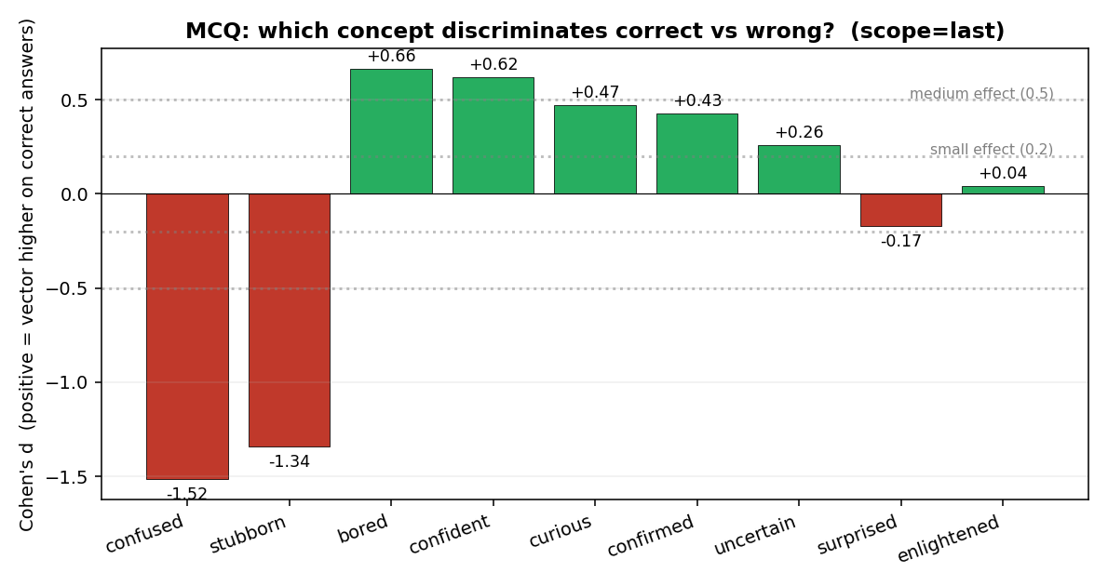
Cohen’s d ranking

2.1 Numerical table
Concept | Cohen’s d | mean(correct) | mean(incorrect) | Interpretation
confused | −1.52 🔴 | −0.098 | −0.062 | Wrong answers strongly activate confusion
stubborn | −1.34 🔴 | −0.002 | +0.046 | Wrong answers strongly activate refusal stance
bored | +0.66 🟢 | −0.070 | −0.085 | Correct answers activate “no novelty” feeling
confident | +0.62 🟢 | +0.160 | +0.134 | Correct answers activate self-confidence
curious | +0.47 🟢 | +0.042 | +0.026 | Correct answers slightly activate curiosity
confirmed | +0.43 🟢 | — | — | Correct answers activate “expectation validated”
uncertain | +0.26 | — | — | Weak effect
surprised | −0.17 | — | — | Near-zero effect
enlightened | +0.04 | — | — | No effect

2.2 Distribution scatter
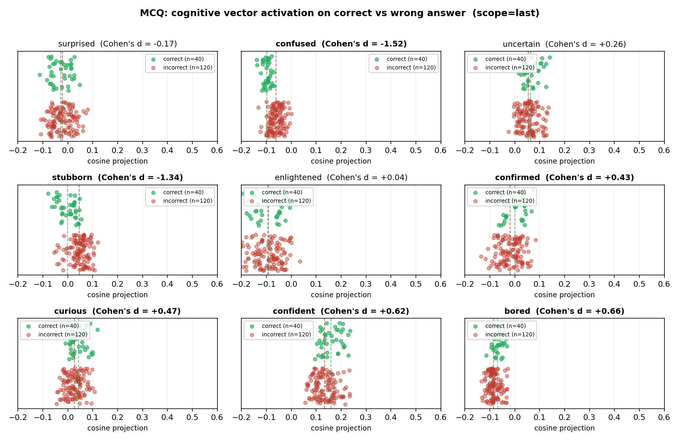
Strip plots
Each panel is one concept: - 🟢 Upper green dots = correct answers (n=40) - 🔴 Lower red dots = incorrect answers (n=120) - Dashed lines = group means
The confused and stubborn panels show clearly separated red vs green clusters — that’s our judgment signal.

3. Interpretation

3.1 The model performs internal judgment
We never asked the model to answer; we only had it read the prompt. But the hidden state already shows internal reaction to the answer it just read:
Model sees | Internal activation pattern | Plain-English
Correct answer | confirmed ↑, bored ↑, confident ↑ | “Yes, that’s it; no surprise; I knew this”
Wrong answer | confused ↑, stubborn ↑ | “This doesn’t fit; I reject it”
Even without generating any tokens, the residual stream already encodes a “cognitive judgment” signal. This is the core value of the experiment.

3.2 Proposed surprise-score formula
Combining the two discovered groups of vectors:
surprise_score(t) = α · confused(t)
+ β · stubborn(t)
− γ · bored(t)
− δ · confident(t)
− ε · confirmed(t)
- Coefficients can be fit via linear regression (target: “is this answer correct?” label)
- Compute per-token in real time
- High score = “the model thinks something is off here”
This delivers the first computable real-time detector for the “let the model actively discover new things” goal.

3.3 Why does surprised itself have d ≈ 0?
An interesting null finding — the surprised vector alone has very small effect size (d=−0.17).
Possible explanations: - “surprised” in v3’s training data corresponds to “unprocessable surprise” (mid-discovery), not “read a fact that contradicts knowledge” - “Factual contradiction” is closer to cognitive dissonance (conflicts with prior belief) — exactly the confused + stubborn combination we found - So surprise has two distinct meanings (cognitive vs informational), and our experiment revealed the latter

4. Limitations + Next Steps

4.1 Limitations
- Only tested wrong-because-incorrect: all incorrect answers are objectively wrong (London is not the capital of France). Did NOT test “correct-but-novel” — facts the model doesn’t know but are true
- Easy questions: 40 are deliberately easy. Did not test model on unfamiliar domains — confused/stubborn responses might differ
- Class imbalance: 1:3 (40 vs 120), but Cohen’s d normalizes this
- No accuracy baseline: we assumed model knows all 40 answers. Next run should first measure baseline accuracy ≥90% before running forward experiment

4.2 Next experiments (priority-sorted)
Priority | Experiment | Expected finding
★★★ | Novel-but-correct test: use word problems / reasoning questions where model doesn’t know but answer is correct — test if enlightened activates here | Identify the “real learning opportunity” signal
★★ | Verify model accuracy on 40 questions (baseline) | Rule out “model lacks knowledge” confound
★★ | Fit a linear classifier on surprise_score formula, test AUC on holdout | Quantify signal reliability
★ | Cross-layer comparison (layer 10/20/30/36) | Find which depth has strongest signal
★ | Add neutral projection (the v3 gap), retest | See if effects become cleaner

5. Resources & Files
 | Path
Question bank | inputs/cognitive_v3_mcq/questions.json
Experiment script | scripts/run_mcq_experiment.py
Analysis script | scripts/analyze_mcq.py
Raw projections | outputs/cognitive_v3_mcq/raw_projections.json
Main figure | outputs/cognitive_v3_mcq/cohen_d_summary_last.png
Strip plot | outputs/cognitive_v3_mcq/strip_plot_per_concept_last.png
GPU time: ~1 minute (160 forwards on already-loaded model) + 1 min model load = ~2 min total.

