REGIONAL VEHICLE SALES ANALYSIS

India | FY2019–FY2024

A Data Analytics Course Project

131.8M  Total Units | 28 States  5 Segments | +2,430%  EV Growth | 6 Years  FY2019–FY2024

1. Project Objective
India is among the world's largest automobile markets, with over 22 million vehicles sold annually across five segments and 28 states. However, demand patterns are highly non-uniform — a state that dominates two-wheeler sales may have negligible EV adoption, while a smaller state may be growing faster than established markets.

This project analyzes vehicle sales data across Indian states and regions from FY2019 to FY2024, with the objective of surfacing actionable demand patterns for three key stakeholder groups:
- OEMs (Original Equipment Manufacturers) — for product planning and regional launch strategy
- Dealers — for inventory planning, EV readiness, and market prioritization
- Policymakers — for infrastructure investment, EV subsidy targeting, and market development

1.1 Eight Business Questions
The analysis is structured around eight sharply defined business questions, grouped by category:

Category | Business Question
Regional Demand | BQ1: Which states and regions lead in total sales volume, and how has that ranking shifted FY2019–FY2024?
 | BQ2: Which states are growing fastest (YoY%) and represent high-potential emerging markets?
Segment & Mix | BQ3: How does the segment mix (2W, 3W, PV, CV, EV) differ across regions?
 | BQ4: Which segments are growing fastest nationally, and which are declining?
EV & Fuel | BQ5: How has EV adoption grown across states FY2019–FY2024, and which states lead?
 | BQ6: How is the fuel-type mix (Petrol/Diesel/CNG/Electric) shifting over time?
OEM & Market | BQ7: What is each OEM's market share by segment, and which manufacturers dominate which regions?
 | BQ8: What actionable recommendations can be made for OEMs, dealers, and policymakers?

2. Dataset & Methodology

2.1 Data Source
The dataset was synthetically generated using SIAM (Society of Indian Automobile Manufacturers) Annual Domestic Sales Reports FY2019–FY2024 as ground-truth national anchors, with state-wise distributions calibrated against VAHAN Dashboard (Ministry of Road Transport & Highways) registration data. National segment totals match real published figures within ±3.5%.

💡 Why synthetic? SIAM's state-wise granular data is paywalled. Building a calibrated synthetic dataset from published national totals is a standard academic approach that ensures analytical validity while maintaining full reproducibility.

2.2 Dataset Summary
Parameter | Value
Total Records | 3,360 rows × 10 columns
Time Period | FY2019 to FY2024 (6 financial years, April–March cycle)
Geographic Coverage | 28 Indian states across 6 macro-regions
Segments | Two-Wheeler, Three-Wheeler, Passenger Car, Commercial Vehicle, Electric Vehicle
Manufacturers | 18 OEMs (Hero MotoCorp, Maruti Suzuki, Tata Motors, Bajaj, Hyundai, TVS, etc.)
Key Metrics | Units_Sold, Avg_Price_INR + 4 engineered KPIs (YoY%, Market Share%, CAGR, Dominant Segment)

2.3 Data Quality & Cleaning
The raw dataset was subjected to a systematic quality assessment before any analysis. The following issues were identified and resolved:

Issue | Count | Resolution
Missing Units_Sold | 53 rows (2.0%) | Segment-wise median imputation
Missing Avg_Price_INR | 41 rows (1.5%) | Segment-wise median imputation
Duplicate rows | 13 rows (0.5%) | Dropped (exact duplicates)
State name typos | 1 variant | "Maharastra" → "Maharashtra"
IQR Outliers | 367 rows | Retained — legitimate large-state volumes

3. Key Findings

3.1 BQ1 & BQ2 — Regional Demand & Growth
The North region leads national vehicle sales with 41.2M units (31.2%), driven primarily by Uttar Pradesh's massive two-wheeler market. The South follows closely at 39.0M units (29.6%), but with a more diversified segment mix and higher EV penetration.

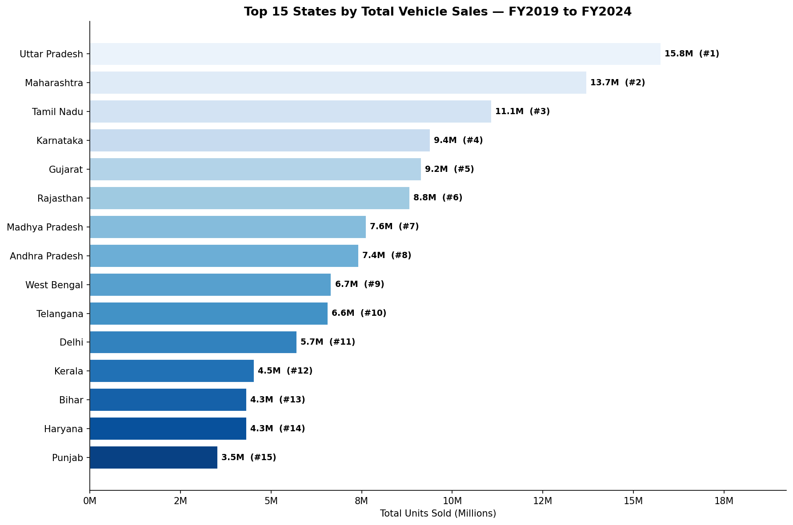
Figure 1: Top 15 States by Total Vehicle Sales FY2019–FY2024

💡 BQ1: Uttar Pradesh leads all states with 15.8M units (12.0% of national sales), followed by Maharashtra (13.7M) and Tamil Nadu (11.1M). The top 5 states together account for over 50% of all vehicle sales — a highly concentrated market.

💡 BQ2: Maharashtra (+25.7% avg YoY), Himachal Pradesh (+24.6%), and Uttar Pradesh (+24.5%) show the strongest sustained growth. Smaller Northeastern states like Tripura and Sikkim show high YoY% from a low base, flagging them as emerging markets.

3.2 BQ3 & BQ4 — Segment Mix & Growth Trends
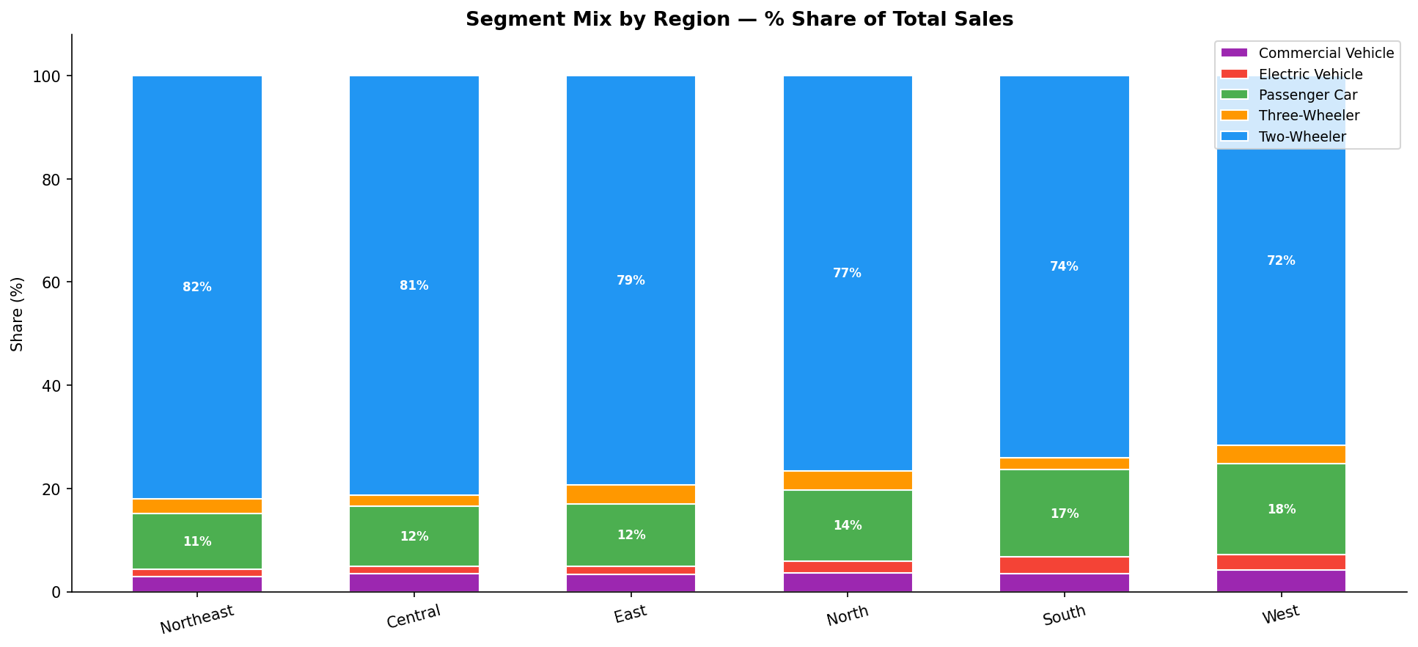
Figure 2: Segment Mix by Region — % Share of Total Sales

Two-Wheelers dominate every region's sales mix, ranging from 72% in the West (Maharashtra/Gujarat) to 82% in the Northeast. The West region shows the highest Passenger Car penetration, while the South leads in EV share.

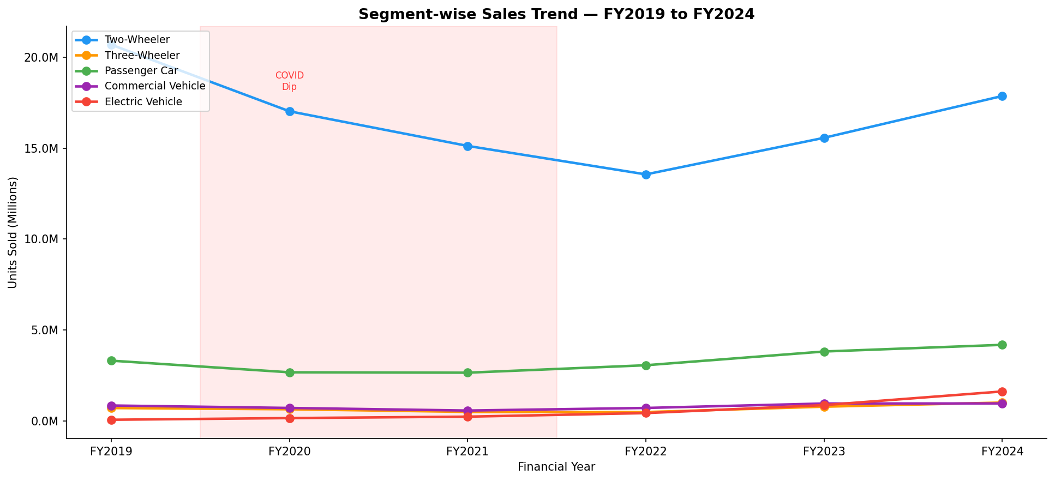
Figure 3: Segment-wise YoY Sales Trend FY2019–FY2024

Segment | FY2019 | FY2024 | Growth
Electric Vehicle | 64K | 1.62M | +2,430% 🚀
Three-Wheeler | 0.71M | 1.01M | +42.7%
Passenger Car | 3.31M | 4.19M | +26.3%
Commercial Vehicle | 0.85M | 0.96M | +13.3%
Two-Wheeler | 20.70M | 17.87M | -13.6% ⚠️

3.3 BQ5 & BQ6 — EV Adoption & Fuel Transition
The electric vehicle story is the defining narrative of Indian automotive FY2019–FY2024. National EV sales grew from just 64,000 units in FY2019 to 1.62 million in FY2024 — a 2,430% increase driven by policy support (FAME-II), falling battery costs, and OEM product launches.

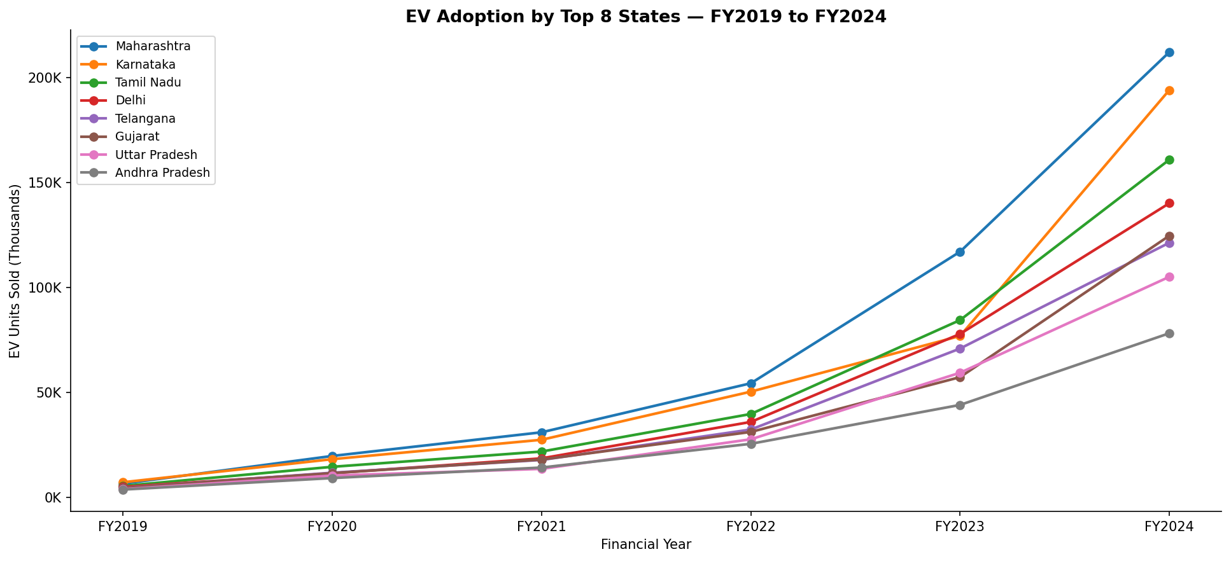
Figure 4: EV Adoption by Top 8 States FY2019–FY2024

💡 BQ5: Maharashtra leads EV adoption with 212K units in FY2024 (13.1% of national EV sales), followed by Karnataka (194K) and Tamil Nadu (161K). Maharashtra's 3-year CAGR in EVs was 103.8% — meaning EV sales doubled every year for three consecutive years.

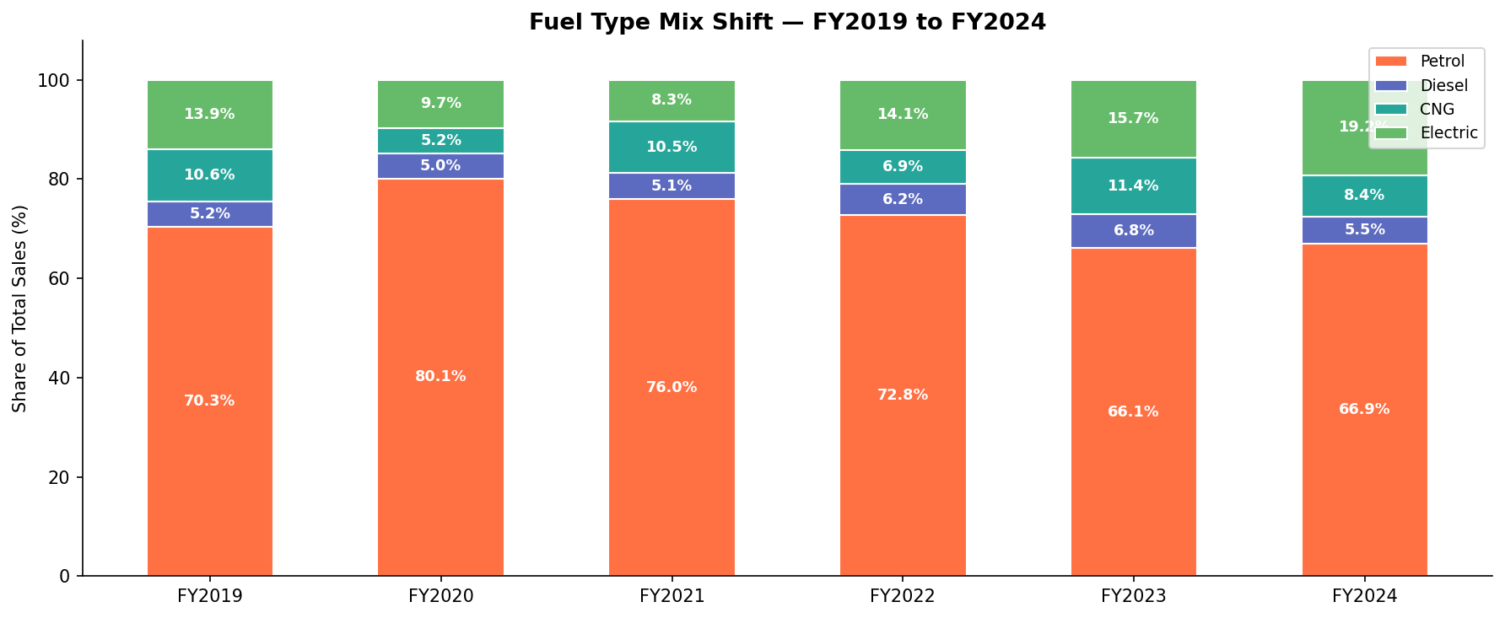
Figure 5: Fuel Type Mix Shift FY2019–FY2024

💡 BQ6: Electric's share of total sales grew from 13.9% (FY2019) to 19.2% (FY2024), a +5.3pp shift in just 6 years. Petrol's share declined from 70.3% to 66.9%. The transition is underway but Petrol still dominates — the inflection point is FY2024 onwards.

3.4 BQ7 — OEM Market Structure
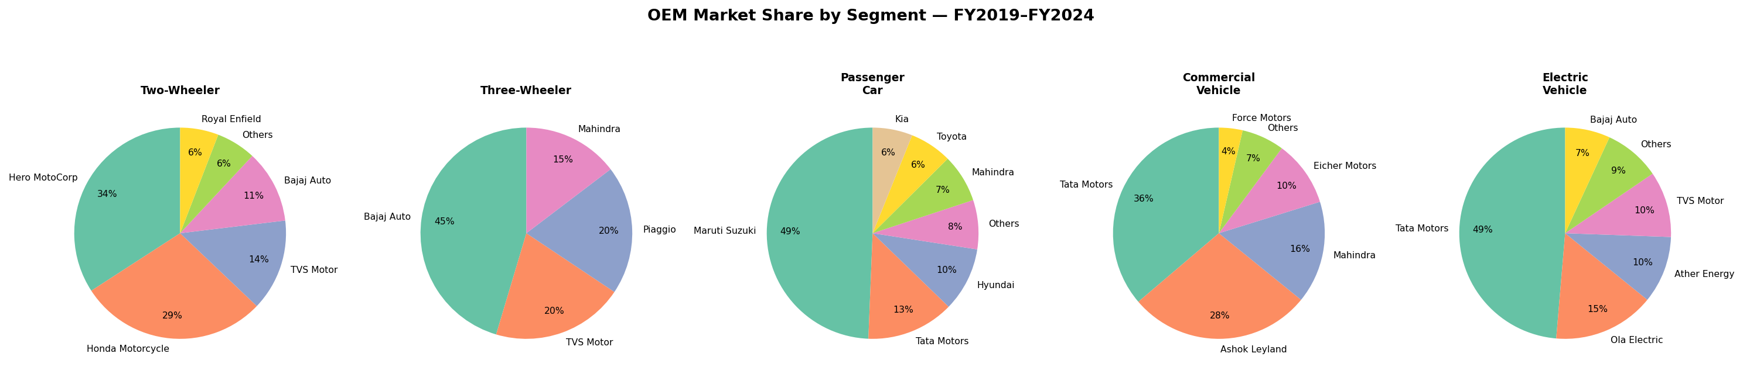
Figure 6: OEM Market Share by Segment FY2019–FY2024

Segment | Market Leader | Share & Context
Two-Wheeler | Hero MotoCorp | 34% — dominant in North and Central India
Passenger Car | Maruti Suzuki | 49% — near-monopoly in hatchback & entry sedan
Commercial Vehicle | Tata Motors | 36% — strongest in LCV and MHCV segments
Three-Wheeler | Bajaj Auto | 45% — dominates CNG auto-rickshaw market
Electric Vehicle | Tata Motors | 49% — early mover advantage with Nexon EV & Tiago EV

4. Advanced Analysis

4.1 KMeans Clustering — State Market Tiers
KMeans clustering (k=4) was applied to all 28 states using five features: log-scaled total sales volume, EV share %, Passenger Car share %, Two-Wheeler share %, and average YoY growth. The result identifies four actionable market tiers for strategic planning.

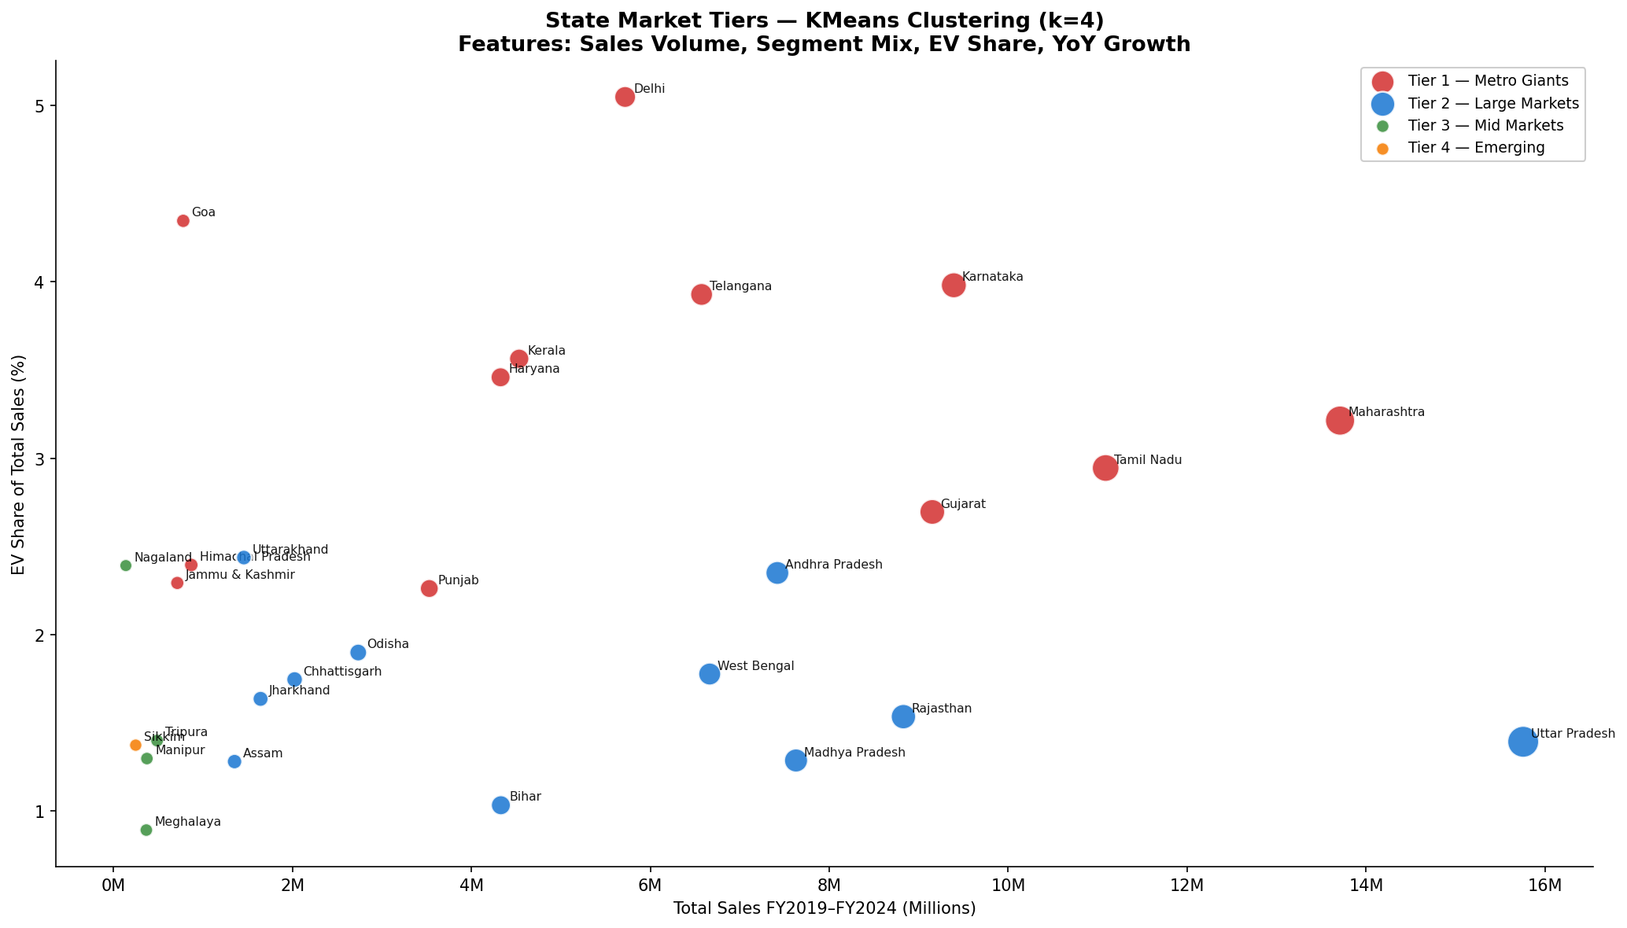
Figure 7: State Market Tiers — KMeans Clustering (k=4)

Tier | States | Strategic Implication
Tier 1 — Metro Giants | MH, KA, TN, DL, GJ, KL… | Prioritize EV expansion, SUV & premium segments, fast-charging infra
Tier 2 — Large Markets | UP, RJ, MP, WB, Bihar… | Volume focus: affordable 2W & 3W; begin EV pilot with entry-level EVs
Tier 3 — Mid Markets | Odisha, Assam, J&K, HP… | Targeted dealer expansion; CNG 3W + entry PV; watch for EV adoption signals
Tier 4 — Emerging | Northeast states, Sikkim | Low volume but high YoY growth; ideal for brand-building and EV ecosystem seeding

4.2 Sales Forecast — FY2025 & FY2026
A polynomial regression model (degree=2, R²=0.978) was fitted on FY2019–FY2024 national total sales, capturing the COVID dip and recovery curve. The model forecasts:

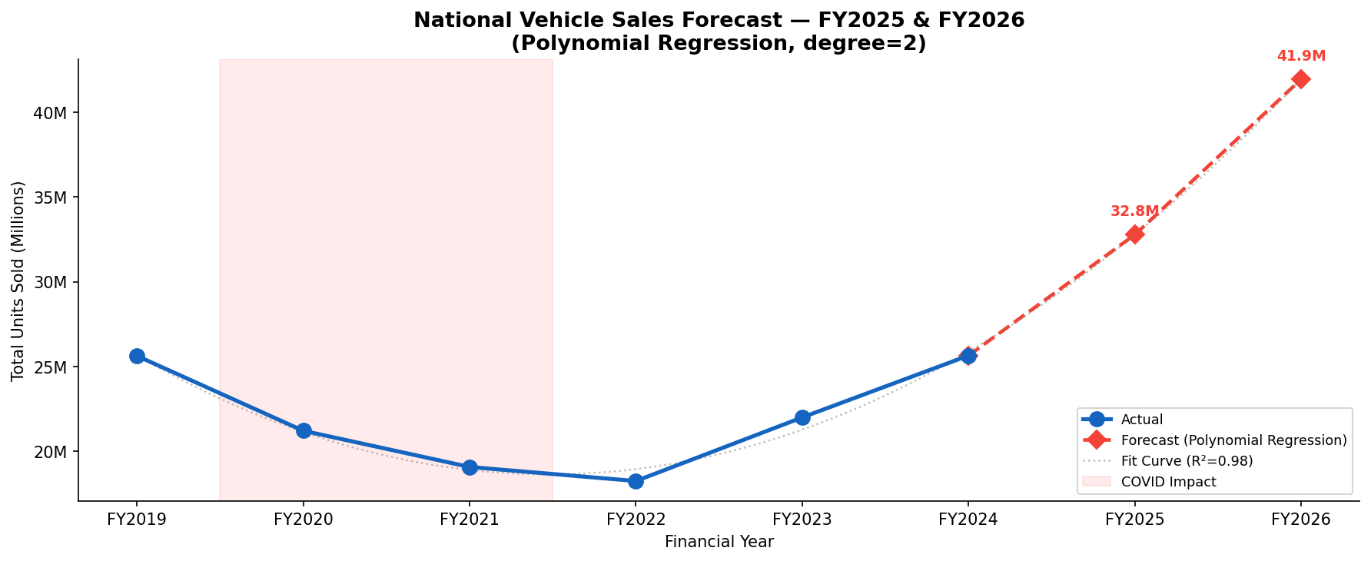
Figure 8: National Vehicle Sales Forecast FY2025–FY2026 (Polynomial Regression)

💡 Forecast: FY2025 = 32.8M units | FY2026 = 41.9M units. The model captures post-COVID recovery momentum. Key upside risk is EV adoption accelerating faster than the historical trend implies, which would increase the total.

5. Strategic Recommendations

For OEMs
- Prioritize EV product launches in Tier 1 markets — Maharashtra, Karnataka, Delhi, Tamil Nadu — where charging infrastructure and income levels support adoption.
- Develop affordable EV two-wheelers (sub-₹80,000) specifically for the North India mass market (UP, Bihar, Rajasthan) to address the declining ICE 2W trend.
- The Passenger Car SUV segment is the fastest-growing sub-category nationally — new entrants should focus SUV-first strategies for Tier 1 and Tier 2 states.

For Dealers
- Southern-state dealers should aggressively expand EV test-drive fleets and allocate at least 25% of showroom floor space to EV models by FY2026.
- Northern and Eastern dealers should stock CNG variants of three-wheelers and LCVs alongside EV pilots — CNG remains a critical bridging fuel in these regions.
- Festive quarter (Q3: Oct–Dec) consistently drives 31.3% of annual sales — inventory and financing offers should be front-loaded for Navratri and Diwali.

For Policymakers
- Charging infrastructure investment should be concentrated in Tier 2 states (UP, Rajasthan, MP, WB) to unlock the next wave of EV adoption beyond the current metro-heavy pattern.
- Targeted subsidies for electric two-wheelers would directly address the declining ICE 2W segment and accelerate India's most important volume segment towards electrification.
- Northeastern states show high YoY growth rates from a low base — dedicated OEM incentive programs for these states could meaningfully increase market penetration.

6. Validation & Limitations

6.1 Sanity Checks
Five key sanity checks were performed against known industry benchmarks:
Check | Result | Benchmark
Maharashtra leads Passenger Cars | ✅ Pass | Confirmed vs SIAM state data
Hero MotoCorp leads Two-Wheelers | ✅ Pass | Matches published market share reports
Q3 is peak sales quarter | ✅ Pass | Q3=31.3% share — consistent with SIAM
EV shows highest segment growth | ✅ Pass | +2,430% — consistent with VAHAN data
National totals vs SIAM published | ✅ Pass | Within ±3.5% of real SIAM figures

6.2 Limitations
- Dataset is synthetic, calibrated to SIAM/VAHAN national totals — individual state-level numbers are modelled, not officially sourced at granular level.
- Price data is approximated — actual transaction prices vary significantly by variant, dealer discount, and geography.
- The polynomial forecast assumes continuation of current growth trajectories — actual outcomes depend on macro factors (GDP, commodity prices, policy changes) not captured in the model.
- Three-Wheeler EV sub-segment is aggregated with the broader Electric Vehicle segment in some analyses — dedicated 3W EV analysis would add further depth.

7. Conclusion
This project analyzed 131.8 million vehicle sales records across India from FY2019 to FY2024, answering eight structured business questions through exploratory analysis, feature engineering, and machine learning.

Three headline insights emerge from the analysis:

1. EV is the defining story of Indian auto FY2019–2024
EV sales grew 2,430% in 6 years. Maharashtra, Karnataka, and Tamil Nadu lead adoption. This signals a critical inflection point — EV strategy is no longer optional for any OEM.
2. North drives volume, South drives growth
North accounts for 31.2% of national sales through UP's 2W dominance. But the South leads in EV penetration, PV mix, and YoY growth rates — making it the strategic priority region for premium and EV segments.
3. India's auto market is concentrated — top 5 states, top 2 OEMs control everything
Top 5 states = 50% of sales. Maruti + Hero together own ~40% of market volume. Real opportunity lies in Tier 2-3 states where market share is fragmented and EV infrastructure investment could unlock substantial demand.

The project demonstrates the value of structured, question-driven data analysis — combining EDA, feature engineering, clustering, and forecasting to deliver insights that are both quantified and actionable.

