

**Name: Vruddhi Tolia Roll No: 115**

Lab Assignment No.: 10

**Date:** 23/04/2021

Aim: **A case study to design and configure any organization network.**

Lab Outcome Attained: LO 6: -To design and configure a network for an organization.

Theory:

Computer network components are the major parts which are needed to install the software*.*

Some important network components are NIC**,** switch**,** cable**,** hub**,** router**,** and modem. Depending on the type of network that we need to install, some

network components can also be removed. For example, the wireless network does not require a cable.

HUB: A Hub is a hardware device that divides the network connection among multiple devices. When computer requests for some information from a network, it first sends the request to the Hub through cable. Hub will broadcast this request to the entire network. All the devices will check whether the request belongs to them or not. If not, the request will be dropped.

Switch: A switch is a hardware device that connects multiple devices on a computer network. A Switch contains more advanced features than Hub. The Switch contains the updated table that decides where the data is transmitted or not. Switch delivers the message to the correct destination based on the physical address present in the incoming message. A Switch does not broadcast the message to the entire network like the Hub. It determines the device to whom the message is to be transmitted. Therefore, we can say that switch provides a direct connection between the source and destination. It increases the speed of the network.

Router: A router is a hardware device which is used to connect a LAN with an internet connection. It is used to receive, analyse and forward the incoming packets to another network. A router works in a *Layer 3 (Network layer) of the*



**Name: Bhavya Sheth Roll No: 97**

*OSI Reference model.* A router forwards the packet based on the information available in the routing table. It determines the best path from the available paths for the transmission of the packet.

Cables: Cable is a transmission media used for transmitting a signal. There are three types of cables used in transmission: Twisted pair cable, Coaxial cable, Fibre-optic cable. *Cabling (wire and wireless) is* to connect the nodes or workstations of your computer network, you need cabling.

Ports: Switch ports are Layer 2-only interfaces associated with a physical port. A switch port can be an access port, a trunk port, or a tunnel port. Switch ports are used for managing the physical interface and associated Layer 2 protocols and do not handle routing or bridging.

Firewall: A Firewall is a necessary part of any security architecture and takes the guesswork out of host level protections and entrusts them to your network security device. Firewalls, and especially Next Generation Firewalls, focus on blocking malware and application-layer attacks, along with an integrated intrusion prevention system (IPS), these Next Generation Firewalls can react quickly and seamlessly to detect and react to outside attacks across the whole network. They can set policies to better defend your network and carry out quick assessments to detect invasive or suspicious activity, like malware, and shut it down.

ISP: An Internet Service Provider (ISP) is the industry term for the company that is able to provide you with access to the Internet, typically from a computer. It provides Internet access to companies, families, and even mobile users. ISP's use fibre-optics, satellite, copper wire, and other forms to provide Internet access to its customers.

Wire/Wireless Network: A wired network uses cables to connect devices, such as laptop or desktop computers, to the Internet or another network. Wired networks, also called Ethernet networks, are the most common type of local area network (LAN) technology. A. wired network is simply a collection of two or more computers, printers, and other devices linked by Ethernet cables.



**Name: Vruddhi Tolia Roll No: 115**

## Diagram: Network Design layout for 9th Floor

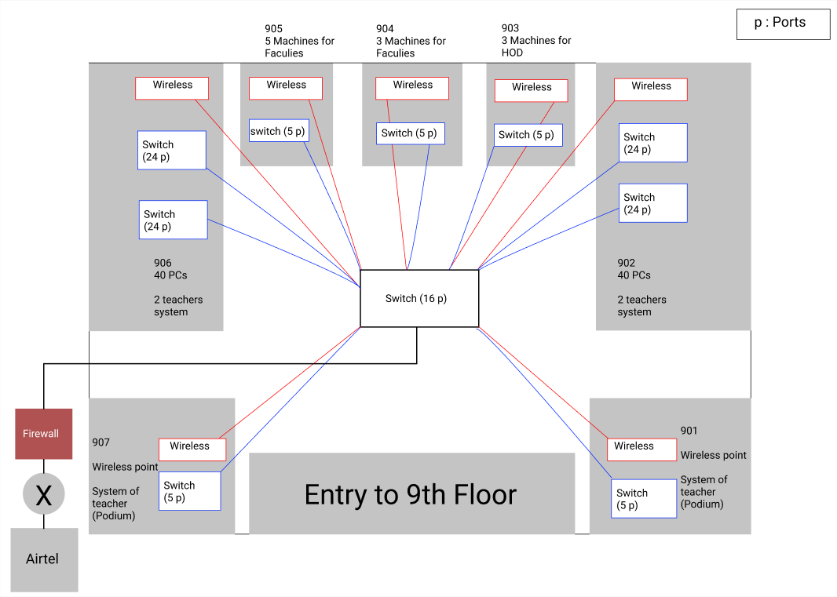

COST OF Networking Components of 9th Floor:

# Wireless Access Points:

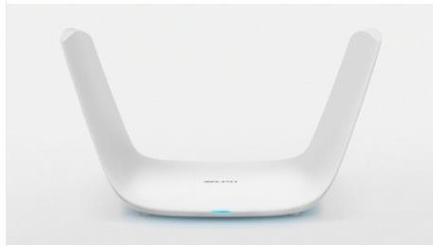



**Name: Vruddhi Tolia Roll No: 115**

* Name: TP Link White Wireless Router, For Office, 100 Mbps * MRP: Rs 2,215

* Quantity: 7

* Total Price: Rs 15,505

* Website: [https://www.indiamart.com/proddetail/wireless-router-](https://www.indiamart.com/proddetail/wireless-router-22905756030.html) [22905756030.html](https://www.indiamart.com/proddetail/wireless-router-22905756030.html)

# Wires:

Straight-Through Cable

A straight-through cable is a type of twisted pair cable that is used in local area networks to connect a computer to a network hub such as a router. This type of cable is also sometimes called a patch cable and is an alternative to wireless connections where one or more computers access a router through a wireless signal. On a straight-through cable, the wired pins match. Straight-through cable use one wiring standard: both ends use T568A wiring standard or both ends use T568B wiring standard. The following figure shows a straight-through cable of which both ends are wired as the T568B standard.

Use straight-through cable for the following cabling:

* + Switch to router
  + Switch to PC or server
  + Hub to PC or server Crossover Cable

An Ethernet crossover cable is a type of Ethernet cable used to connect computing devices together directly. Unlike straight-through cable, crossover cables use two different wiring standards: one end uses the T568A wiring standard, and the other end uses the T568B wiring standard. The internal wiring of Ethernet crossover cables reverses the transmit and receive signals. It is most often used to connect two devices of the same type: e.g., two computers (via network interface controller) or two switches to each other.

Use crossover cables for the following cabling:

* + Switch to switch



**Name: Vruddhi Tolia**

**Roll No: 115**

* + Switch to hub
  + Hub to hub
  + Router to router
  + Router Ethernet port to PC NIC
  + PC to PC

#### Switch to PC:

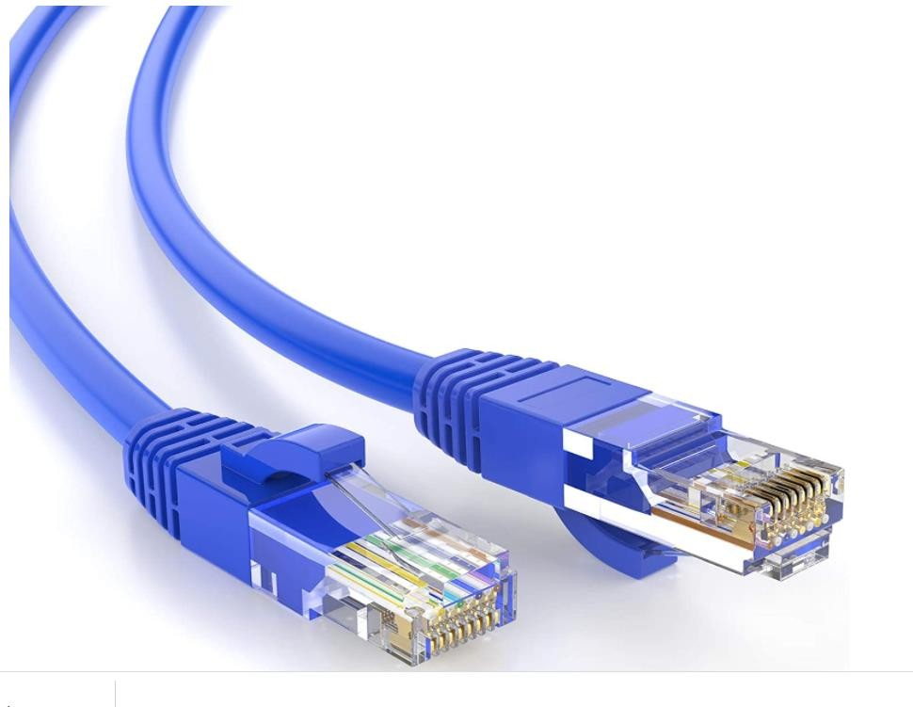

* Name: Cable Creation 35 Feet CAT 5e Ethernet Patch Cable, RJ45 Computer Network Cord, Cat 5e Patch Cord LAN Cable UTP 24AWG+100% Copper Wire, 10.67m, Blue Color

*MRP: Rs 539

* Quantity: 1 wire per PC, so total 93 PCs (93 x 1)

* Total Price: 93 x 539 = Rs 50,127

* Website: [https://www.amazon.in/CableCreation-Ethernet-Computer-](https://www.amazon.in/CableCreation-Ethernet-Computer-NetworkCopper/dp/B01JO3E8F6/ref%3Dasc_df_B01JO3E8F6/?tag=googleshopdes21&linkCode=df0&hvadid=397007741956&hvpos&hvnetw=g&hvrand=18405632912384394080&hvpone&hvptwo&hvqmt&hvdev=c&hvdvcmdl&hvlocint&hvlocphy=9300687&hvtargid=pla-732117666692&psc=1&ext_vrnc=hi) [NetworkCopper/dp/B01JO3E8F6/ref=asc_df_B01JO3E8F6/?tag=googles](https://www.amazon.in/CableCreation-Ethernet-Computer-NetworkCopper/dp/B01JO3E8F6/ref%3Dasc_df_B01JO3E8F6/?tag=googleshopdes21&linkCode=df0&hvadid=397007741956&hvpos&hvnetw=g&hvrand=18405632912384394080&hvpone&hvptwo&hvqmt&hvdev=c&hvdvcmdl&hvlocint&hvlocphy=9300687&hvtargid=pla-732117666692&psc=1&ext_vrnc=hi) [hopdes21&linkCode=df0&hvadid=397007741956&hvpos=&hvnetw=g&h](https://www.amazon.in/CableCreation-Ethernet-Computer-NetworkCopper/dp/B01JO3E8F6/ref%3Dasc_df_B01JO3E8F6/?tag=googleshopdes21&linkCode=df0&hvadid=397007741956&hvpos&hvnetw=g&hvrand=18405632912384394080&hvpone&hvptwo&hvqmt&hvdev=c&hvdvcmdl&hvlocint&hvlocphy=9300687&hvtargid=pla-732117666692&psc=1&ext_vrnc=hi) [vrand=18405632912384394080&hvpone=&hvptwo=&hvqmt=&hvdev=c](https://www.amazon.in/CableCreation-Ethernet-Computer-NetworkCopper/dp/B01JO3E8F6/ref%3Dasc_df_B01JO3E8F6/?tag=googleshopdes21&linkCode=df0&hvadid=397007741956&hvpos&hvnetw=g&hvrand=18405632912384394080&hvpone&hvptwo&hvqmt&hvdev=c&hvdvcmdl&hvlocint&hvlocphy=9300687&hvtargid=pla-732117666692&psc=1&ext_vrnc=hi) [&hvdvcmdl=&hvlocint=&hvlocphy=9300687&hvtargid=pla-](https://www.amazon.in/CableCreation-Ethernet-Computer-NetworkCopper/dp/B01JO3E8F6/ref%3Dasc_df_B01JO3E8F6/?tag=googleshopdes21&linkCode=df0&hvadid=397007741956&hvpos&hvnetw=g&hvrand=18405632912384394080&hvpone&hvptwo&hvqmt&hvdev=c&hvdvcmdl&hvlocint&hvlocphy=9300687&hvtargid=pla-732117666692&psc=1&ext_vrnc=hi) [732117666692&psc=1&ext_vrnc=hi](https://www.amazon.in/CableCreation-Ethernet-Computer-NetworkCopper/dp/B01JO3E8F6/ref%3Dasc_df_B01JO3E8F6/?tag=googleshopdes21&linkCode=df0&hvadid=397007741956&hvpos&hvnetw=g&hvrand=18405632912384394080&hvpone&hvptwo&hvqmt&hvdev=c&hvdvcmdl&hvlocint&hvlocphy=9300687&hvtargid=pla-732117666692&psc=1&ext_vrnc=hi)



**Name: Vruddhi Tolia**

**Roll No: 115**

#### Switch to Switch:

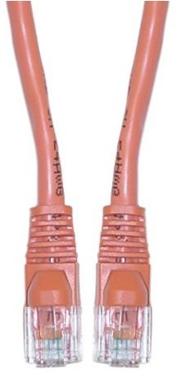

* Name: Offex Cat5e Ethernet Crossover Cable, Snagless / Molded Boot, 10-Foot, Orange (OF-10X6-33310).

* MRP: Rs 1600

* Quantity: 9

* Total Price: Rs 14,400

* Website: [https://www.cart2india.com/modem-cables/offex-cat5e-](https://www.cart2india.com/modem-cables/offex-cat5e-ethernet-crossover-cable-snaglessmolded-boot-10foot-orange-of10x633310/00000000004328292796?gclid=EAIaIQobChMI9Oj64LyU8AIVz8IWBR0NzQTQEAYYASABEgJd4fD_BwE) [ethernet-crossover-cable-snaglessmolded-boot-10foot-orange-](https://www.cart2india.com/modem-cables/offex-cat5e-ethernet-crossover-cable-snaglessmolded-boot-10foot-orange-of10x633310/00000000004328292796?gclid=EAIaIQobChMI9Oj64LyU8AIVz8IWBR0NzQTQEAYYASABEgJd4fD_BwE) [of10x633310/00000000004328292796?gclid=EAIaIQobChMI9Oj64LyU8A](https://www.cart2india.com/modem-cables/offex-cat5e-ethernet-crossover-cable-snaglessmolded-boot-10foot-orange-of10x633310/00000000004328292796?gclid=EAIaIQobChMI9Oj64LyU8AIVz8IWBR0NzQTQEAYYASABEgJd4fD_BwE) [IVz8IWBR0NzQTQEAYYASABEgJd4fD_BwE](https://www.cart2india.com/modem-cables/offex-cat5e-ethernet-crossover-cable-snaglessmolded-boot-10foot-orange-of10x633310/00000000004328292796?gclid=EAIaIQobChMI9Oj64LyU8AIVz8IWBR0NzQTQEAYYASABEgJd4fD_BwE)

#### Switch to Router:



* Name: Cable Creation 35 Feet CAT 5e Ethernet Patch Cable, RJ45 Computer Network Cord, Cat 5e Patch Cord LAN Cable UTP 24AWG+100% Copper Wire, 10.67m, Blue Color

*MRP: Rs 539

* Quantity: 1

* Total Price: Rs 539



**Name: Vruddhi Tolia**

**Roll No: 115**

* Website: [https://www.amazon.in/CableCreation-Ethernet-Computer-](https://www.amazon.in/CableCreation-Ethernet-Computer-Network-Copper/dp/B01JO3E8F6/ref%3Dasc_df_B01JO3E8F6/?tag=googleshopdes-21&linkCode=df0&hvadid=397007741956&hvpos&hvnetw=g&hvrand=18405632912384394080&hvpone&hvptwo&hvqmt&hvdev=c&hvdvcmdl&hvlocint&hvlocphy=9300687&hvtargid=pla-732117666692&psc=1&ext_vrnc=hi) [Network-](https://www.amazon.in/CableCreation-Ethernet-Computer-Network-Copper/dp/B01JO3E8F6/ref%3Dasc_df_B01JO3E8F6/?tag=googleshopdes-21&linkCode=df0&hvadid=397007741956&hvpos&hvnetw=g&hvrand=18405632912384394080&hvpone&hvptwo&hvqmt&hvdev=c&hvdvcmdl&hvlocint&hvlocphy=9300687&hvtargid=pla-732117666692&psc=1&ext_vrnc=hi) [Copper/dp/B01JO3E8F6/ref=asc_df_B01JO3E8F6/?tag=googleshopdes-](https://www.amazon.in/CableCreation-Ethernet-Computer-Network-Copper/dp/B01JO3E8F6/ref%3Dasc_df_B01JO3E8F6/?tag=googleshopdes-21&linkCode=df0&hvadid=397007741956&hvpos&hvnetw=g&hvrand=18405632912384394080&hvpone&hvptwo&hvqmt&hvdev=c&hvdvcmdl&hvlocint&hvlocphy=9300687&hvtargid=pla-732117666692&psc=1&ext_vrnc=hi) [21&linkCode=df0&hvadid=397007741956&hvpos=&hvnetw=g&hvrand=](https://www.amazon.in/CableCreation-Ethernet-Computer-Network-Copper/dp/B01JO3E8F6/ref%3Dasc_df_B01JO3E8F6/?tag=googleshopdes-21&linkCode=df0&hvadid=397007741956&hvpos&hvnetw=g&hvrand=18405632912384394080&hvpone&hvptwo&hvqmt&hvdev=c&hvdvcmdl&hvlocint&hvlocphy=9300687&hvtargid=pla-732117666692&psc=1&ext_vrnc=hi) [18405632912384394080&hvpone=&hvptwo=&hvqmt=&hvdev=c&hvdvc](https://www.amazon.in/CableCreation-Ethernet-Computer-Network-Copper/dp/B01JO3E8F6/ref%3Dasc_df_B01JO3E8F6/?tag=googleshopdes-21&linkCode=df0&hvadid=397007741956&hvpos&hvnetw=g&hvrand=18405632912384394080&hvpone&hvptwo&hvqmt&hvdev=c&hvdvcmdl&hvlocint&hvlocphy=9300687&hvtargid=pla-732117666692&psc=1&ext_vrnc=hi) [mdl=&hvlocint=&hvlocphy=9300687&hvtargid=pla-](https://www.amazon.in/CableCreation-Ethernet-Computer-Network-Copper/dp/B01JO3E8F6/ref%3Dasc_df_B01JO3E8F6/?tag=googleshopdes-21&linkCode=df0&hvadid=397007741956&hvpos&hvnetw=g&hvrand=18405632912384394080&hvpone&hvptwo&hvqmt&hvdev=c&hvdvcmdl&hvlocint&hvlocphy=9300687&hvtargid=pla-732117666692&psc=1&ext_vrnc=hi) [732117666692&psc=1&ext_vrnc=hi](https://www.amazon.in/CableCreation-Ethernet-Computer-Network-Copper/dp/B01JO3E8F6/ref%3Dasc_df_B01JO3E8F6/?tag=googleshopdes-21&linkCode=df0&hvadid=397007741956&hvpos&hvnetw=g&hvrand=18405632912384394080&hvpone&hvptwo&hvqmt&hvdev=c&hvdvcmdl&hvlocint&hvlocphy=9300687&hvtargid=pla-732117666692&psc=1&ext_vrnc=hi)

# Switch:

### 5 port switch

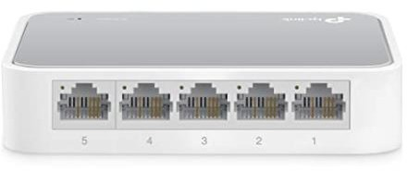

* NAME: TP-Link 5 Port 10/100 Mbps Fast Ethernet Switch | Desktop Ethernet Splitter | Ethernet Hub | Plug & Play | Fanles Quiet | Desktop Design | Green Technology | Unmanaged (TL-SF1005D), White

* MRP: Rs.549

* Quantity: 5

* Total Price: Rs.2,745 * Website:

### 16 port switch

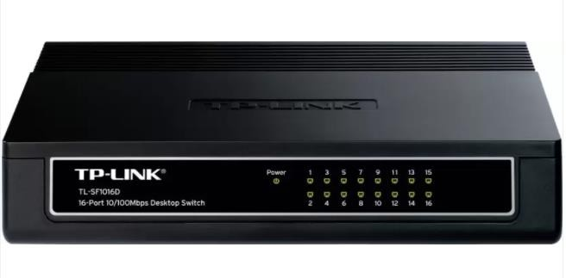



**Name: Vruddhi Tolia Roll No: 115**

* NAME: TP-LINK TL-SF1016D 16-Port 10/100Mbps Desktop Switch (Black) * MRP: Rs. 1499

* Quantity: 1

* Total Price: Rs1,499

* Website: [https://www.flipkart.com/tp-link-tl-sf1016d-16-port-10-](https://www.flipkart.com/tp-link-tl-sf1016d-16-port-10-100mbps-desktop-switch/p/itmezyuzgtxh8rg3) [100mbps-desktop-switch/p/itmezyuzgtxh8rg3](https://www.flipkart.com/tp-link-tl-sf1016d-16-port-10-100mbps-desktop-switch/p/itmezyuzgtxh8rg3)

### 24 port switch

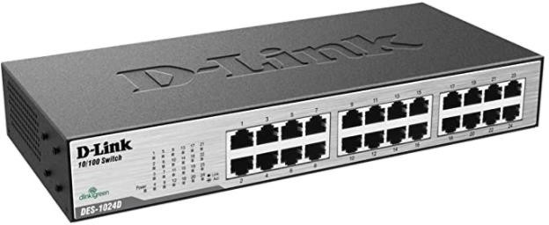

* NAME: D-Link Business DES-1024D Switch 24-Port 10/100MBPS DKTP * MRP: Rs.3,595

* QUANTITY: 4

* Total Price: Rs 14,380

* Website: [https://www.amazon.in/D-Link-Business-1024D-24-Port-](https://www.amazon.in/D-Link-Business-1024D-24-Port-100MBPS/dp/B00GWVAQ8C/ref%3Dsr_1_6?adgrpid=60658562282&dchild=1&ext_vrnc=hi&gclid=Cj0KCQjw9_mDBhCGARIsAN3PaFO_RySqQJLyLxBzSyRkzESznLFOjzekSpLdWEDRTJhU930VuWj0ocaAtGTEALw_wcB&hvadid=294142845995&hvdev=c&hvlocphy=9062207&hvnetw=g&hvqmt=e&hvrand=16299453309558556354&hvtargid=kwd307213815088&hydadcr=27580_1814403&keywords=24%2Bport%2Bnetwork%2Bswitch&qid=1619164090&sr=8-6) [100MBPS/dp/B00GWVAQ8C/ref=sr_1_6?adgrpid=60658562282&dchild](https://www.amazon.in/D-Link-Business-1024D-24-Port-100MBPS/dp/B00GWVAQ8C/ref%3Dsr_1_6?adgrpid=60658562282&dchild=1&ext_vrnc=hi&gclid=Cj0KCQjw9_mDBhCGARIsAN3PaFO_RySqQJLyLxBzSyRkzESznLFOjzekSpLdWEDRTJhU930VuWj0ocaAtGTEALw_wcB&hvadid=294142845995&hvdev=c&hvlocphy=9062207&hvnetw=g&hvqmt=e&hvrand=16299453309558556354&hvtargid=kwd307213815088&hydadcr=27580_1814403&keywords=24%2Bport%2Bnetwork%2Bswitch&qid=1619164090&sr=8-6)

[=1&ext_vrnc=hi&gclid=Cj0KCQjw9_mDBhCGARIsAN3PaFO_RySqQJLyLxB](https://www.amazon.in/D-Link-Business-1024D-24-Port-100MBPS/dp/B00GWVAQ8C/ref%3Dsr_1_6?adgrpid=60658562282&dchild=1&ext_vrnc=hi&gclid=Cj0KCQjw9_mDBhCGARIsAN3PaFO_RySqQJLyLxBzSyRkzESznLFOjzekSpLdWEDRTJhU930VuWj0ocaAtGTEALw_wcB&hvadid=294142845995&hvdev=c&hvlocphy=9062207&hvnetw=g&hvqmt=e&hvrand=16299453309558556354&hvtargid=kwd307213815088&hydadcr=27580_1814403&keywords=24%2Bport%2Bnetwork%2Bswitch&qid=1619164090&sr=8-6) [zSyRkzESznLFOjzekSpLdWEDRTJhU930VuWj0ocaAtGTEALw_wcB&hvadid](https://www.amazon.in/D-Link-Business-1024D-24-Port-100MBPS/dp/B00GWVAQ8C/ref%3Dsr_1_6?adgrpid=60658562282&dchild=1&ext_vrnc=hi&gclid=Cj0KCQjw9_mDBhCGARIsAN3PaFO_RySqQJLyLxBzSyRkzESznLFOjzekSpLdWEDRTJhU930VuWj0ocaAtGTEALw_wcB&hvadid=294142845995&hvdev=c&hvlocphy=9062207&hvnetw=g&hvqmt=e&hvrand=16299453309558556354&hvtargid=kwd307213815088&hydadcr=27580_1814403&keywords=24%2Bport%2Bnetwork%2Bswitch&qid=1619164090&sr=8-6)

[=294142845995&hvdev=c&hvlocphy=9062207&hvnetw=g&hvqmt=e&h](https://www.amazon.in/D-Link-Business-1024D-24-Port-100MBPS/dp/B00GWVAQ8C/ref%3Dsr_1_6?adgrpid=60658562282&dchild=1&ext_vrnc=hi&gclid=Cj0KCQjw9_mDBhCGARIsAN3PaFO_RySqQJLyLxBzSyRkzESznLFOjzekSpLdWEDRTJhU930VuWj0ocaAtGTEALw_wcB&hvadid=294142845995&hvdev=c&hvlocphy=9062207&hvnetw=g&hvqmt=e&hvrand=16299453309558556354&hvtargid=kwd307213815088&hydadcr=27580_1814403&keywords=24%2Bport%2Bnetwork%2Bswitch&qid=1619164090&sr=8-6) [vrand=16299453309558556354&hvtargid=kwd307213815088&hydadcr](https://www.amazon.in/D-Link-Business-1024D-24-Port-100MBPS/dp/B00GWVAQ8C/ref%3Dsr_1_6?adgrpid=60658562282&dchild=1&ext_vrnc=hi&gclid=Cj0KCQjw9_mDBhCGARIsAN3PaFO_RySqQJLyLxBzSyRkzESznLFOjzekSpLdWEDRTJhU930VuWj0ocaAtGTEALw_wcB&hvadid=294142845995&hvdev=c&hvlocphy=9062207&hvnetw=g&hvqmt=e&hvrand=16299453309558556354&hvtargid=kwd307213815088&hydadcr=27580_1814403&keywords=24%2Bport%2Bnetwork%2Bswitch&qid=1619164090&sr=8-6)

[=27580_1814403&keywords=24+port+network+switch&qid=161916409](https://www.amazon.in/D-Link-Business-1024D-24-Port-100MBPS/dp/B00GWVAQ8C/ref%3Dsr_1_6?adgrpid=60658562282&dchild=1&ext_vrnc=hi&gclid=Cj0KCQjw9_mDBhCGARIsAN3PaFO_RySqQJLyLxBzSyRkzESznLFOjzekSpLdWEDRTJhU930VuWj0ocaAtGTEALw_wcB&hvadid=294142845995&hvdev=c&hvlocphy=9062207&hvnetw=g&hvqmt=e&hvrand=16299453309558556354&hvtargid=kwd307213815088&hydadcr=27580_1814403&keywords=24%2Bport%2Bnetwork%2Bswitch&qid=1619164090&sr=8-6) [0&sr=8-6](https://www.amazon.in/D-Link-Business-1024D-24-Port-100MBPS/dp/B00GWVAQ8C/ref%3Dsr_1_6?adgrpid=60658562282&dchild=1&ext_vrnc=hi&gclid=Cj0KCQjw9_mDBhCGARIsAN3PaFO_RySqQJLyLxBzSyRkzESznLFOjzekSpLdWEDRTJhU930VuWj0ocaAtGTEALw_wcB&hvadid=294142845995&hvdev=c&hvlocphy=9062207&hvnetw=g&hvqmt=e&hvrand=16299453309558556354&hvtargid=kwd307213815088&hydadcr=27580_1814403&keywords=24%2Bport%2Bnetwork%2Bswitch&qid=1619164090&sr=8-6)

# Router:

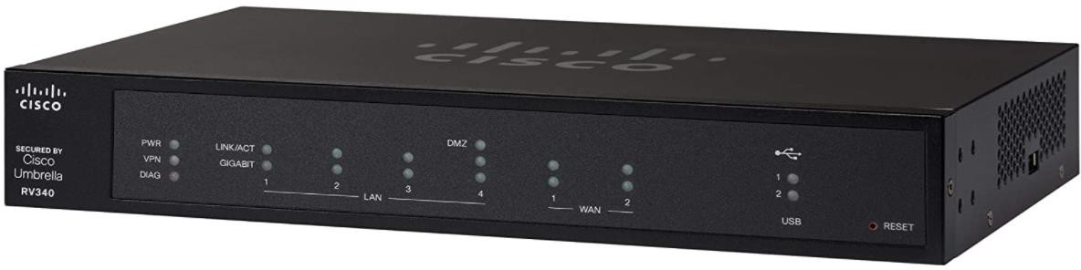



**Name: Vruddhi Tolia Roll No: 115**

* Name: Cisco RV340 VPN Router | 4 Gigabit Ethernet (GbE) Ports | Dual WAN | Limited Lifetime Protection (RV340-K9-IN)

* Quantity: 1

* MRP: Rs 14,239

* Website: [https://www.amazon.in/Cisco-RV340-Dual-Gigabit-](https://www.amazon.in/Cisco-RV340-Dual-Gigabit-Router/dp/B0814V1RZ9/ref%3Dasc_df_B0814V1RZ9/?tag=googleshopdes-21&linkCode=df0&hvadid=396987243813&hvpos&hvnetw=g&hvrand=8217679736822987533&hvpone&hvptwo&hvqmt&hvdev=c&hvdvcmdl&hvlocint&hvlocphy=9062215&hvtargid=pla-854321402612&psc=1&ext_vrnc=hi) [Router/dp/B0814V1RZ9/ref=asc_df_B0814V1RZ9/?tag=googleshopdes-](https://www.amazon.in/Cisco-RV340-Dual-Gigabit-Router/dp/B0814V1RZ9/ref%3Dasc_df_B0814V1RZ9/?tag=googleshopdes-21&linkCode=df0&hvadid=396987243813&hvpos&hvnetw=g&hvrand=8217679736822987533&hvpone&hvptwo&hvqmt&hvdev=c&hvdvcmdl&hvlocint&hvlocphy=9062215&hvtargid=pla-854321402612&psc=1&ext_vrnc=hi) [21&linkCode=df0&hvadid=396987243813&hvpos=&hvnetw=g&hvrand=](https://www.amazon.in/Cisco-RV340-Dual-Gigabit-Router/dp/B0814V1RZ9/ref%3Dasc_df_B0814V1RZ9/?tag=googleshopdes-21&linkCode=df0&hvadid=396987243813&hvpos&hvnetw=g&hvrand=8217679736822987533&hvpone&hvptwo&hvqmt&hvdev=c&hvdvcmdl&hvlocint&hvlocphy=9062215&hvtargid=pla-854321402612&psc=1&ext_vrnc=hi) [8217679736822987533&hvpone=&hvptwo=&hvqmt=&hvdev=c&hvdvc](https://www.amazon.in/Cisco-RV340-Dual-Gigabit-Router/dp/B0814V1RZ9/ref%3Dasc_df_B0814V1RZ9/?tag=googleshopdes-21&linkCode=df0&hvadid=396987243813&hvpos&hvnetw=g&hvrand=8217679736822987533&hvpone&hvptwo&hvqmt&hvdev=c&hvdvcmdl&hvlocint&hvlocphy=9062215&hvtargid=pla-854321402612&psc=1&ext_vrnc=hi) [mdl=&hvlocint=&hvlocphy=9062215&hvtargid=pla-](https://www.amazon.in/Cisco-RV340-Dual-Gigabit-Router/dp/B0814V1RZ9/ref%3Dasc_df_B0814V1RZ9/?tag=googleshopdes-21&linkCode=df0&hvadid=396987243813&hvpos&hvnetw=g&hvrand=8217679736822987533&hvpone&hvptwo&hvqmt&hvdev=c&hvdvcmdl&hvlocint&hvlocphy=9062215&hvtargid=pla-854321402612&psc=1&ext_vrnc=hi) [854321402612&psc=1&ext_vrnc=hi](https://www.amazon.in/Cisco-RV340-Dual-Gigabit-Router/dp/B0814V1RZ9/ref%3Dasc_df_B0814V1RZ9/?tag=googleshopdes-21&linkCode=df0&hvadid=396987243813&hvpos&hvnetw=g&hvrand=8217679736822987533&hvpone&hvptwo&hvqmt&hvdev=c&hvdvcmdl&hvlocint&hvlocphy=9062215&hvtargid=pla-854321402612&psc=1&ext_vrnc=hi)

# Firewall:

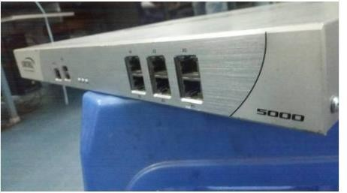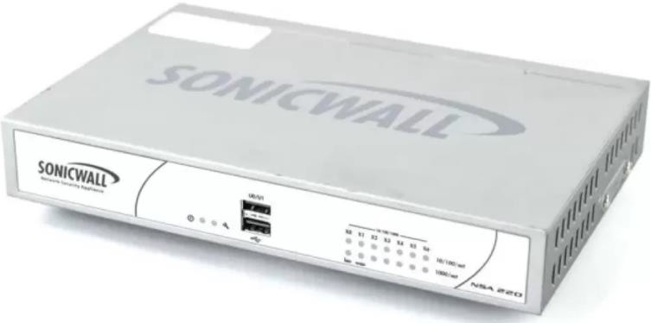

* NAME: Dell SonicWALL NSA 5000 Firewall * MRP: Rs 50,000

* Website: [https://www.indiamart.com/proddetail/dell-sonicwall-nsa-](https://www.indiamart.com/proddetail/dell-sonicwall-nsa-5000-firewall-15308307973.html) [5000-firewall-15308307973.html](https://www.indiamart.com/proddetail/dell-sonicwall-nsa-5000-firewall-15308307973.html)

# Bandwidth:

* This is according to the ISP Provider. (Here, Airtel) * Speed: 100 Mbps



**Name: Vruddhi Tolia Roll No: 115**

# ISP Provider:

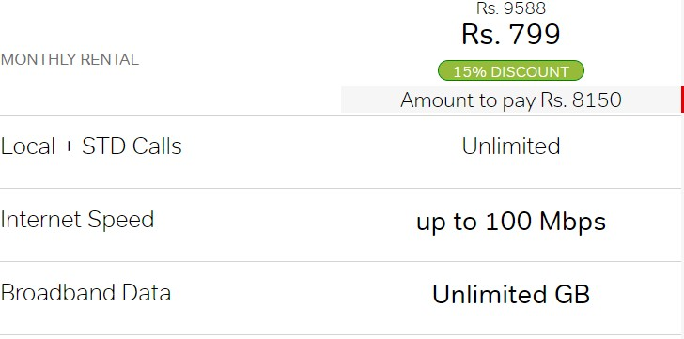

* Name of the ISP Provider: Airtel * Period: 12 months

* Price: Rs 8150/-

* Website: <https://www.airtel.in/internet-provider-near-me/mumbai-isp>

Total Cost To design the Network: **Rs 1,71,584**

## Conclusion: Thus, a case study to design and configure network was done for a particular organisation.