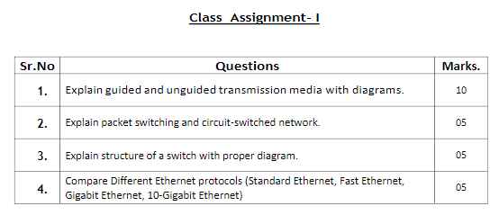

Q1)

**Guided Transmission Media:**

In guided media, transmitted data travels through cabling system that has a fixed path. For example, copper wires, fibre optic wires, etc.

Examples:

* **Twisted Cables:**

Copper wires are the most common wires used for transmitting signals because of good performance at low costs. They are most commonly used in telephone lines. However, if two or more wires are lying together, they can interfere with each other’s signals. To reduce this electromagnetic interference, pair of copper wires are twisted together in helical shape like a DNA molecule. Such twisted copper wires are called **twisted pair**.

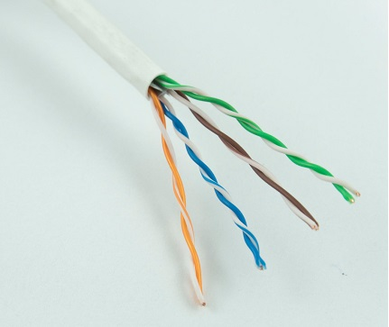

* **Coaxial Cables**

**Coaxial cables** are copper cables with better **shielding** than twisted pair cables, so that transmitted signals may travel longer distances at higher speeds.

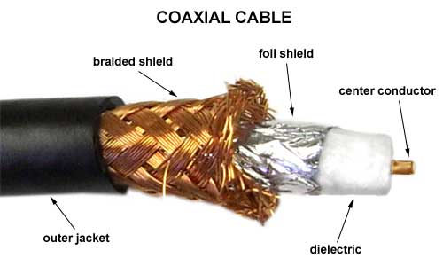

* **Optical Fibre Cables**

Thin glass or plastic threads used to transmit data using light waves are called **optical fibre**. Light Emitting Diodes (LEDs) or Laser Diodes (LDs) emit light waves at the **source**, which is read by a **detector** at the other end. **Optical fibre cable** has a bundle of such threads or fibres bundled together in a protective covering.

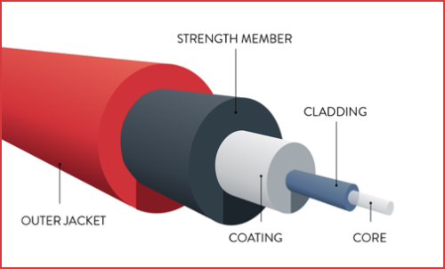

**Unguided Transmission Media:**

In unguided media, transmitted data travels through free space in form of electromagnetic signal. For example, radio waves, lasers, etc.

* **Infrared:**

Low frequency infrared waves are used for very short distance communication like TV remote, wireless speakers, automatic doors, hand held devices etc. Infrared signals can propagate within a room but cannot penetrate walls. However, due to such short range, it is considered to be one of the most secure transmission modes.

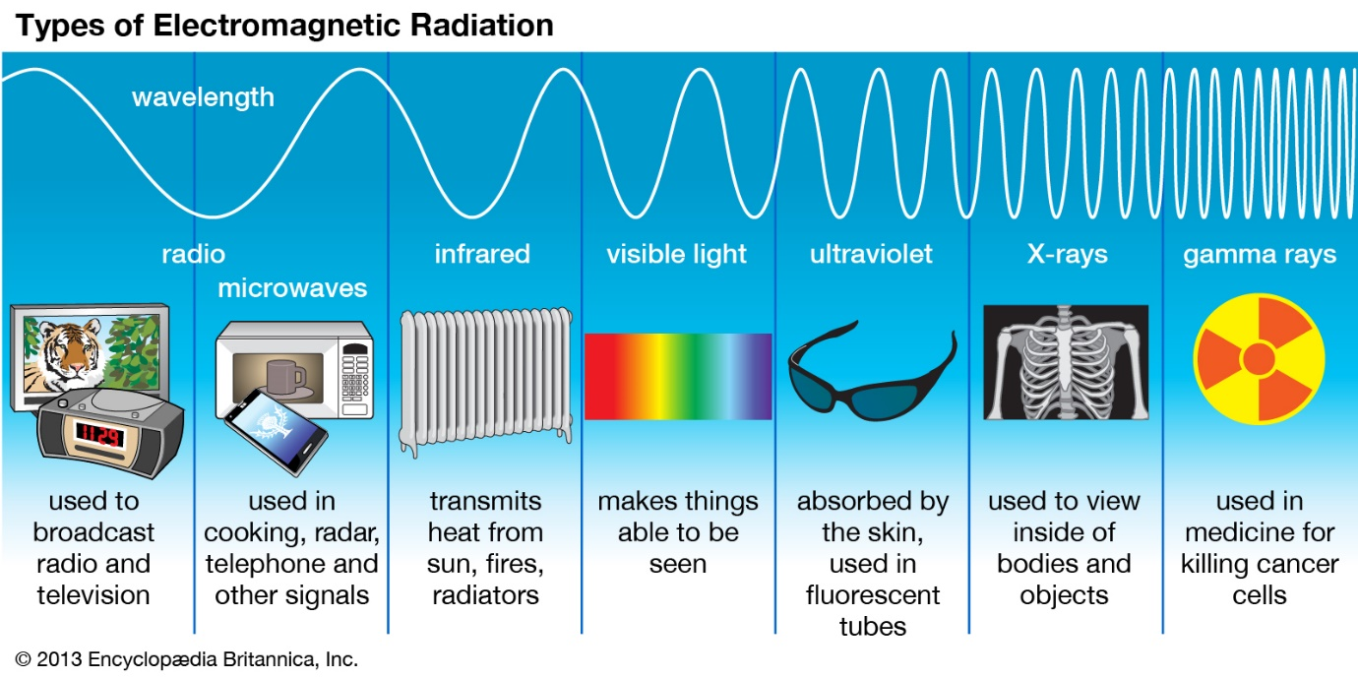

* **Radio wave:**

Transmission of data using radio frequencies is called **radio-wave transmission**. We all are familiar with radio channels that broadcast entertainment programs. Radio stations transmit radio waves using **transmitters**, which are received by the receiver installed in our devices.

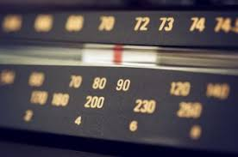

Q2)

**Packet Switching:**

Packet switching is a method of switching in which the data to be sent is transmitted over a digital network in the form of packets.

The packet has two parts: header and data/payload.

The principal is that the data and messages are broken down into packers and each packet with header has a source, destination and node address information.

Diagram:

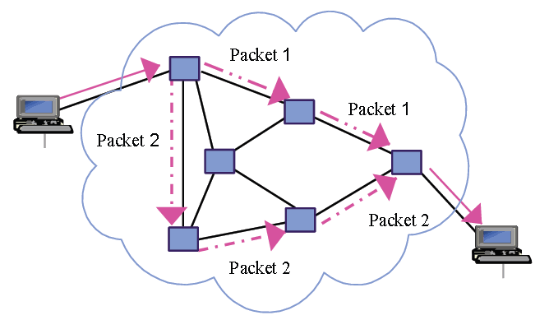

**Circuit Switched Network:**

**Circuit-Switched Network**– a type of [network](https://www.sdxcentral.com/resources/glossary/network/) where the communications between end devices ([nodes](https://www.sdxcentral.com/resources/glossary/node/)) must be set up before they can communicate. Once set up, the “circuit” is dedicated to the two nodes it connects for the duration of that connection. An example of a circuit-switched network is an analogue telephone network.

A virtual circuit-switched network tries to emulate the dedicated connection established by circuit-switching using packet-switching technology.

Diagram:

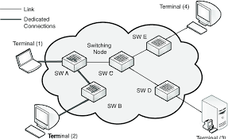

Q3)

A packet switch has 4 different components:

1. Input Ports
2. Outpout Ports
3. Routing Processor
4. Switching Fabric

Diagram below shows the structure of a switch:

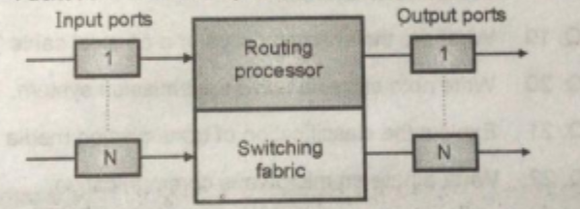

**Input Port:**

This port carries out functions related to physical and datalink layer for packet switching. It constructs bits from received signal, decapsulates packet from and detects errors.

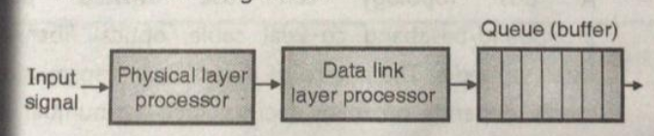

**Output Port:**

This carries same functions as input port but the order is which they are performed is reversed.

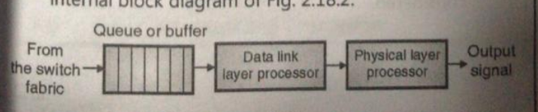

**Routing Processor:**

This is used by the network layer to perform packet switching.

It uses the destination address to find the address of the next hop and the output number from which the packet is to be sent.

**Switching Fabric:**

Switching fabric is the memory of the dedicated computer.

Examples: Crossbar switch, Banyan Switch, and Batcher Banyan Switch.

Q4)

|  |  |  |  |
| --- | --- | --- | --- |
| **Parameter** | **Standard Ethernet** | **Fast Ethernet** | **Gigabit Ethernet** |
| **Max Speed** | 10 Mbps | 100 Mbps | 1 Gbps |
| **MAC technology** | CSMA/CD | CSMA/CD | CSMA/CD |
| **Max segment length** | 500m | - | 25-70m at full speed |
| **Topology** | Bus/Star | - | Point to point or Star |
| **Bandwidth** | Low | High | Very high |
| **Medium** | Copper wires or optical fibre cables | Copper wires or optical fibre cables | Copper wires or optical fibre cables |
| **Minimum frame size** | 64 bytes | 64 bytes | 64 bytes |
| **Mode** | Half or full duplex | Full Duplex | Half or full duplex |