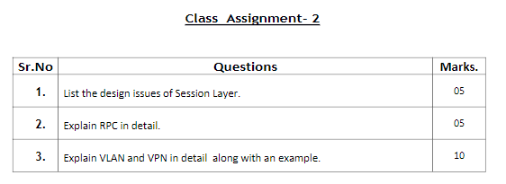

Q1)

The design issues are as follows:

1. If traffic is permitted in only one direction, in this case it must manage the dialog by keeping the track of whose turn is next.
2. Sometimes it may be the case that both the sides do not attempt to carry out the same operation simultaneously.

In such case the responsibility of the session layer is to provide some sort of token management which makes sure this mutual exclusion in communication.

1. In case of long data transmission to a failure-prone line, it can happen that after some portion of data has been transferred, the link may break. In a case like this, data transmission restarts.

If this is faulty the transfer may never complete. In such cases the session layer should have a synchronization mechanism such as checkpoints to make sure that data transmission begins the next time from the point where transmission link went dead.

Q2)

A remote procedure call is an inter process communication technique that is used for client-server-based applications. It is also known as a subroutine call or a function call.

A client has a request message that the RPC translates and sends to the server. This request may be a procedure or a function call to a remote server. When the server receives the request, it sends the required response back to the client. The client is blocked while the server is processing the call and only resumed execution after the server is finished.

The sequence of events in a remote procedure call are given as follows −

* The client stub is called by the client.
* The client stub makes a system call to send the message to the server and puts the parameters in the message.
* The message is sent from the client to the server by the client’s operating system.
* The message is passed to the server stub by the server operating system.
* The parameters are removed from the message by the server stub.
* Then, the server procedure is called by the server stub.

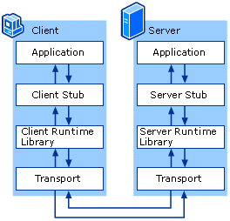Diagram:

Q3)

**VPN:**

The full form for VPN is virtual private network and it’s a private network over public infrastructure.

It boosts online privacy and increases internet security. Its development is to establish secure and cost-effective links between two or more computing networks.

VPN has its own set of software programs, protocols, and security constructs that make secure connectivity possible.

**Example:**

1. Remote client access via VPN
2. Peer to peer VPN
3. Private VPN

**VLAN:**

**VLAN** is a custom network which is created from one or more local area networks. It enables a group of devices available in multiple networks to be combined into one logical network. The result becomes a virtual LAN that is administered like a physical LAN. The full form of VLAN is defined as Virtual Local Area Network.

The below topology depicts a network having all hosts inside the same virtual LAN:

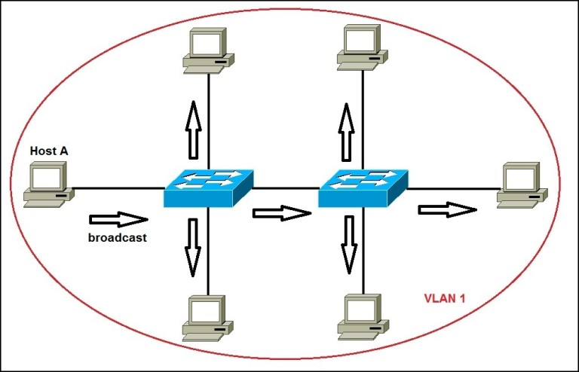

network having all hosts inside the same VLAN

Without VLANs, a broadcast sent from a host can easily reach all network devices. Each and every device will process broadcast received frames. It can increase the CPU overhead on each device and reduce the overall network security.