**Call Data Record**

**CDR** **_DesignDocument-v0.2**

High Level Design & Low Level Design

**Document Control :**

| **Project Revision History** | | | | | | | | |
| --- | --- | --- | --- | --- | --- | --- | --- | --- |
|  |  |  | |  |  |  |  |  |
| **Date** | **Version** | **Author** | **Brief Description of Changes** | | | | **Approver Signature** | |
| 01-10-2022 | v0.1 | Group- 01 |  | | | |  | |
| 10-10-2022 | v0.2 | Group- 01 | Changed Class diagram  and System architecture diagram. | | | |  | |
|  |  |  |  | | | |  | |
|  |  |  |  | | | |  | |
|  |  |  |  | | | |  | |
|  |  |  |  | | | |  | |

**Team Members**

| **Employee ID** | **Employee Name** |
| --- | --- |
| 46264033 | Asutosh Padhi |
| 46252342 | Sumit Sharma |
| 46264342 | Surayya Afsheen |
| 46264337 | Rohit Kumar |
| 46264675 | Nongthombam Deepu Singh |
| 46264631 | Ashish Nitin Shimpi |

**1. Introduction** **6**

1.1. Intended Audience 6

1.2. Acronyms/Abbreviations 6

1.3. Project Purpose 6

1.4. Key Project Objectives 7

1.5. Project Scope and Limitation 7

1.5.1. In Scope 7

1.5.2. Out of scope 7

1.6. Functional Overview 7

1.7. Assumptions, Dependencies & Constraints 8

1.8. Risks 8

**2. Design Overview** **8**

2.1. Design Objectives 8

2.1.1. Recommended Architecture 9

2.2. Architectural Strategies 9

2.2.1. Design Alternative 9

2.2.2. Reuse of Existing Common Services/Utilities 10

2.2.3. Creation of New Common Services/Utilities 10

2.2.4. User Interface Paradigms 10

2.2.5. System Interface Paradigms 10

2.2.6. Error Detection / Exceptional Handling 10

2.2.7. Memory Management 10

2.2.8. Performance 10

2.2.9. Security 10

2.2.10. Concurrency and Synchronization 11

2.2.11. Housekeeping and Maintenance 11

**3. System Architecture** **11**

3.1. System Use-Cases 11

3.2. Subsystem Architecture 12

3.3. System Interfaces 12

3.3.1. Internal Interfaces 13

3.3.2. External Interfaces 13

**4. Detailed System Design** **13**

4.1. Key Entities 13

4.2. Detailed-Level Database Design 14

4.2.1. Data Mapping Information 16

4.2.2. Data Conversion 17

4.3. Archival and retention requirements 17

4.4. Disaster and Failure Recovery 18

4.5. Business Process workflow 19

4.6. Business Process Modeling and Management (as applicable) 20

4.7. Business Logic 20

4.8. Variables 21

4.9. Activity / Class Diagrams (as applicable) 22

4.9.1.Sequence diagram23

4.10. Data Migration 24

4.10.1. Architectural Representation

4.10.2. Architectural Goals and Constraints

4.10.3. Logical View

4.10.4. Architecturally Significant Design Packages

4.10.5. Data model

4.10.6. Deployment View

**5. Environment Description** **24**

5.1. Time Zone Support 24

5.2. Language Support 24

5.3. User Desktop Requirements 24

5.4. Server-Side Requirements 24

5.4.1. Deployment Considerations 24

5.4.2. Application Server Disk Space 24

5.4.3. Database Server Disk Space 24

5.4.4. Integration Requirements 25

5.4.5. Jobs 25

5.4.6. Network 25

5.4.7. Others 25

5.5. Configuration 25

5.5.1. Operating System 25

5.5.2. Database 25

5.5.3. Network 25

5.5.4. Desktop 26

**6. References** **26**

**7. Appendix** **26**

# 

**1. INTRODUCTION**

The introduction of the design document provides an overview of the entire project. The aim of the document is to provide a complete overview of the Call Data Record.

## 

## 1.1 Intended Audience

This document is planned to read by customers, project managers,testers, developers. This project is a prototype that can be used by everyone who wants to search through the file system between server and client user.

**1.2 Acronyms/Abbreviations**

| CDR | Call Details Records |
| --- | --- |
| MSISDN | Mobile Station International PSTN/ISDN Number |
| SMS – MO | Short Message Service – Mobile Originated |
| SMS – MT | Short Message Service – Mobile Terminated |
| MCC | Mobile Country Code |
| MNC | Mobile Network Code |
| MOC | Mobile Originated Call |
| MTC | Mobile Terminating Call |
| GPRS | General Packet Radio Service |
| MB | Mega Byte |
| TCP | Transmission Control Protocol |
| STL | Standard Template Library |

**1.3 Project Purpose**

The project is a prototype for the server and client who provides all the details of call records and descriptions of charging events based on the type of search by the user i.e. search based on MSISDN or search based on the operator name.

**1.4 Key Project Objectives**

* Building connection between client user and the server.
* Provide user access.
  1. **Project Scope and Limitation**

The scope and limitation of the project are listed,

**1.5.1 In Scope**

Each CDR record contains descriptions of charging events such as voice calls and SMS messages with all relevant data. It provides a system which allows clients to choose either to get their bill of calls, sms and data or get the total duration of calls and total amount of data sent and received based on an operator name.

**1.5.2** **Out of scope**

Operating Systems such as Windows are out of scope. Access to the client is only with one port.

* 1. **Functional Overview**

A client and server connection is established, by using TCP protocol, as the data to be processed is in huge amounts.Validate the login credentials of the user with that of the client stored in the server using a container. The client must send a request to the server to retrieve the CDR files stored in the directory and save the processed data to the STL container. A Unique number of up to seven digits called MSISDN (Mobile Station International SD Number) is used to identify the subscription on the mobile network.A customer's MSISDN ID can be used to identify the subscriber's brand name that has a maximum length of 64 characters, the subscriber's mobile country code (MMC) and mobile network code (MNC), with a maximum length of 6 digits.It contains the information about the call duration of outgoing calls, incoming calls,outgoing messages,messages received from others of a particular MSISDN no within the mobile operator and outside mobile operator.Download & upload feature to get data used by using GPRS for some specific MSISDN ID**.**For GPRS the third party MSISDN should be empty. As the customer is not directly connecting to other customers.The third party subscriber is present in case of SMS & call of the other customer who has been connected to.

The Inter Operator settlement contains all the information about total call duration of incoming calls, outgoing calls of a particular brand like Airtel or Jio etc., within the mobile operator and outside mobile operator. Also it contains all the information about the total number of messages received and sent within the mobile operator and outside mobile operator.The Inter Operator settlement contains all the information about the total amount of data used for uploading and downloading files by using GPRS, within the mobile operator and outside mobile operator.For all search fails or other system fails, error handling will be performed by displaying proper Error messages.

* 1. **Assumptions, Dependencies & Constraints**
* Device to receive calls and sms.
* Authentication for the data.
* Linux environment / windows to perform the task and reliable connectivity.
* Data security & privacy.

* 1. **Risks**
* Data is not secure by default so, we need to provide additional authentication to access the data.
* Linux / windows working environment is must.

**2. DESIGN OVERVIEW**

The system consists of a server, and a client user.

**2.1 Design Objectives**

* CDR allows the user to get call details, sms details within or outside service providers.
* CDR enables the user to search for a particular client (subscriber) using client id to get the complete result on to the screen by connecting to the server.
* The Server must be configured to start the service in an initial state.
* The user can start the client program whenever they want.
  + 1. **Recommended Architecture**

The Recommended Architecture is as follows.

Server-side Architecture:

* 1GB RAM
* 500MHz Processor
* 120GB HDD CPU
* Internet connection

Client-side Hardware Interface:

* Internet connection
* Terminal

* 1. **Architectural Strategies**

The project is a Client-Server strategy. The use of Client-Server model based on its request - reply protocol. In this model, the client directly sends his request to the server asking for an appropriate service, and later the server does the work and immediately returns the data as a response back to the client. The server offers various services to the clients based on its client’s request

* + 1. **Design Alternative**

The project uses FTP protocol to read the content of the file. The project uses the TCP protocol to connect between the server and client user . We have used TCP because TCP is a connection-oriented protocol, it is more reliable as it provides error checking support and guarantees delivery of data to the destination router.

* + 1. **Reuse of Existing Common Services/Utilities**

The system requires the existing common services and utilities are:

* Transmission Control Protocol (TCP)
* Other System Calls.
  + 1. **Creation of New Common Services/Utilities**

This project does not create any new common services or utilities.

* + 1. **User Interface Paradigms**
* Desktop
  + 1. **System Interface Paradigms**
* Operating system – Linux/windows.
  + 1. **Error Detection / Exceptional Handling**
* Error detection will be offered during the client and server process.
* Four levels of debug log messages will be included like ERROR, INFO, WARNING & DEBUG.
* TCP provides error checking and recovery mechanisms.
  + 1. **Memory Management**

NA.

* + 1. **Performance**

TCP connection can have a greater impact. Performance of TCP allows the server and client to deliver the best throughput and latency for an individual connection. However, how an application uses each new, or established.

* + 1. **Security**

When an anonymous user tries to access the server, the error message will be displayed.

* + 1. **Concurrency and Synchronization**

Client and server will be in synchronization in receiving and sending the messages.

* + 1. **Housekeeping and Maintenance**
* Clearing the memory buffers from the system.
* When the client exits from the server, the generated file will be moved to the processed data directory.

**3. System Architecture**

* Call Data Record is a client server model where TCP server is used. When a client requests data, the server stores it in text files and returns them immediately.
* The data can be processed according to the need of the user, based on whether the user wants to view the customer side data or the interoperator side data.
* In architecture, all process and data storing is done at server side then send information to client.

**3.1 System Use Cases**

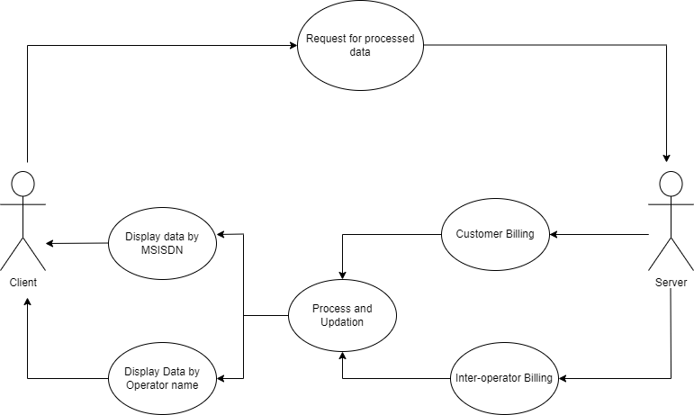

**3.2 Sub-system Architecture**

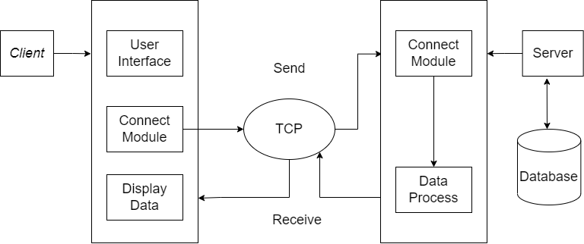

**3.3 System Interfaces**

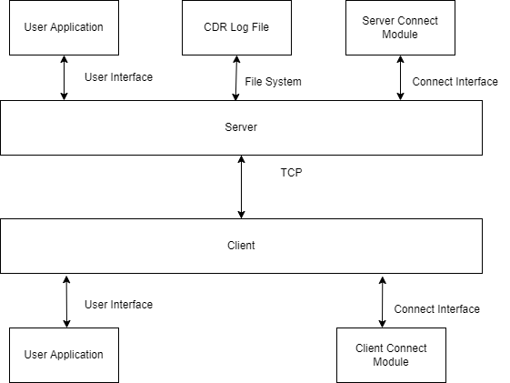

**3.3.1 Internal Interfaces**

The internal interfaces comprise interfaces through which the system interacts with the clients through which it provides them services

**3.3.2 External Interfaces**

The external interface comprises interfaces through which the users interact with the system.

* Windows operating system/ Linux operating system
* Internet

**4. Detailed Design System**

The Call data record (CDR) contains a server & client connection. In this project, we are creating the connection using TCP protocol and we use an STL container to store and retrieve the processed data.   
The client can request the server to process the data according to their need and request for a specific CDR file.

**4.1 Key Entities**

**Server**1. The server stores the files.  
2. Provides data according to client needs.  
3. Provides service on the client request.  
4. Logs are maintained regarding server functions.

**Client**1. The client is an entity run by the user on their system.  
2. It requests to connect with the server.  
3. Client requests the server to search for a particular MSISDN or operator name to get the particular set of information and then disconnects with the server.

**STL Container** STL container used for storing the processed data.

**4.2 Detailed Level Database Designs**

**Level 0 Diagram**

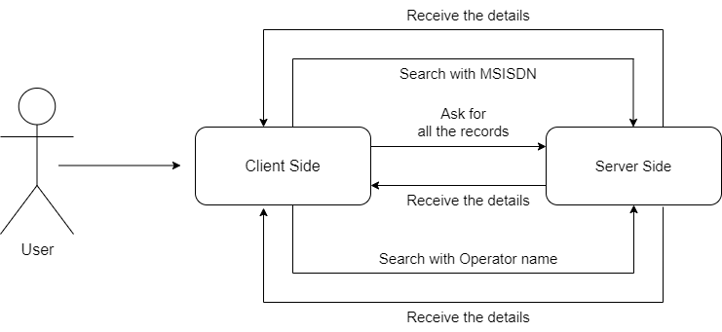

**Level 1 Diagram  
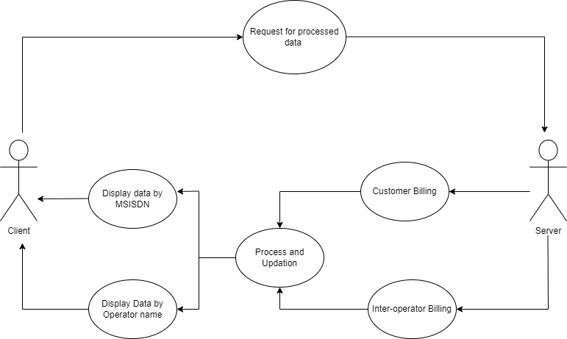**

**Level 2 Diagram**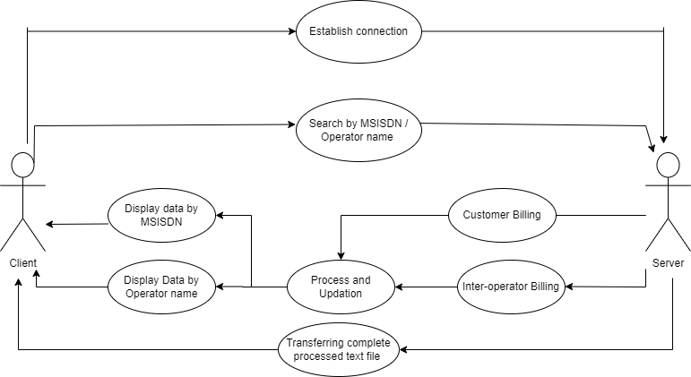

**4.2.1 Data Mapping Information**

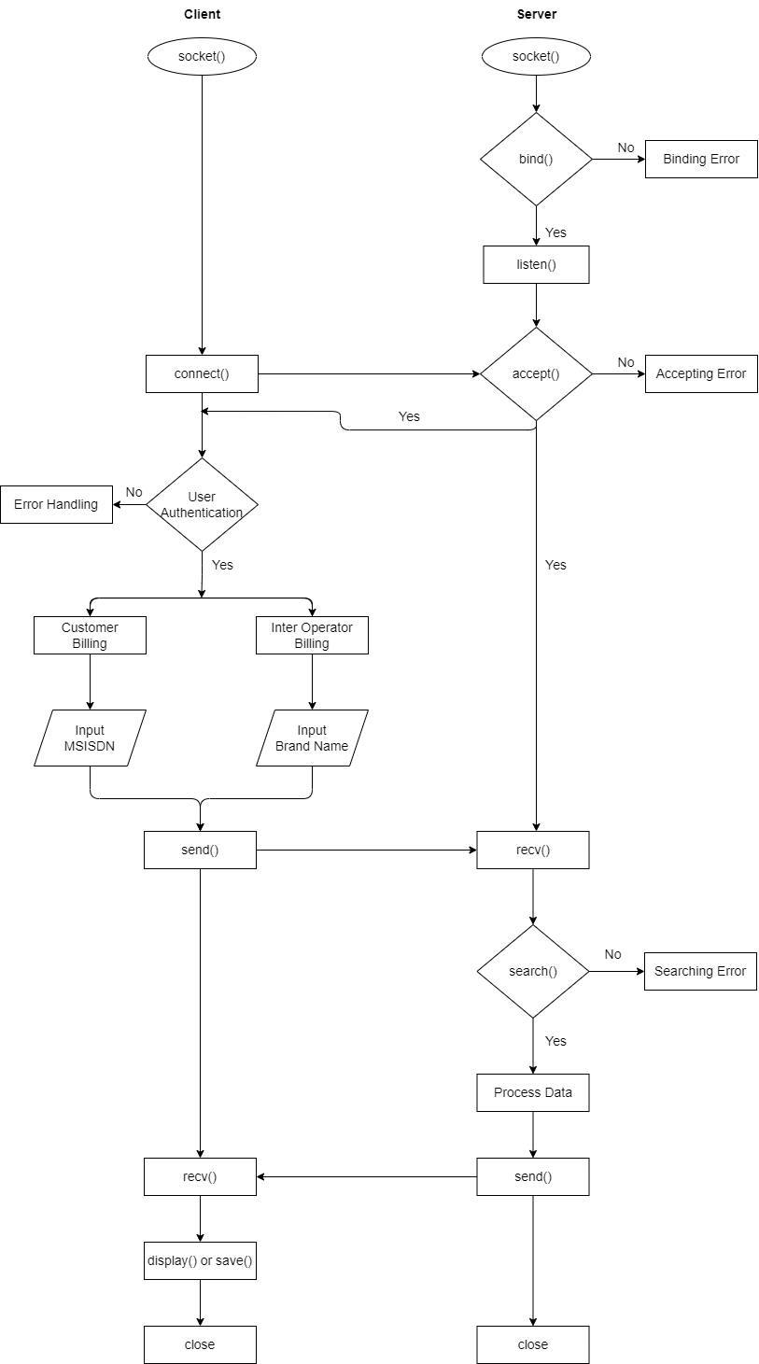

**4.2.2 Data Conversion**

NA

**4.3** **Functional Requirements**

**4.3.1 Create client and server connection**

A client and server connection are established, by using TCP protocol, as the data to be processed is in huge amounts.

**4.3.2 Store the processed data in STL container**

Validate the login credentials of the user with that of the client stored in the server using a container. The client must send a request to the server to retrieve the CDR files stored in the directory and save the processed data to the STL container.

**4.3.3 Feature to provide total incoming calls durations, messages and data used by GPRS based on MSISDN**

The customer billing contains the total duration of incoming calls, outgoing calls, within the mobile operator and outside the mobile operator about particular MSISDN.

Also, it contains all the information about the total number of messages received and sent within the mobile operator and outside mobile operator.

And, it contains dataabout the total amount of data used for uploading and downloading files by using GPRS.

**4.3.4 Feature to provide total incoming calls durations, messages and data used by GPRS based on operator ID**

The Inter Operator settlement contains all the information about total call duration of incoming calls, outgoing calls of a particular brand like Airtel or Jio etc., within the mobile operator and outside mobile operator.

Also, it contains all the information about the total number of messages received and sent within the mobile operator and outside mobile operator.

And, it contains dataabout the total amount of data used for uploading and downloading files by using GPRS.

**4.3.5 Appropriate error handling**

For all search fails or other system fails, error handling will be performed by displaying proper Error messages. This will include Log messages.

**4.3.6 Data Security**

The system shall allow the server on the remote system to set the restrictions on which files users can retrieve, as well as restrictions on storing file

**4.4 Archival and retention requirements**

The safe and efficient long-term storage of data and information associated with it, documents, or materials is called archiving. Archived data, documents, or materials may need to be kept for many years and must be kept permanently protected to prevent unauthorized alterations.We should provide some additional security by adding authentication to access the data.

**4.5 Disaster and Recovery Failure**

A networking disaster recovery plan is a collection of processes intended to prepare an integrated response to a network outage caused by a natural or man-made calamity.

**4.6 Business Process Workflow**

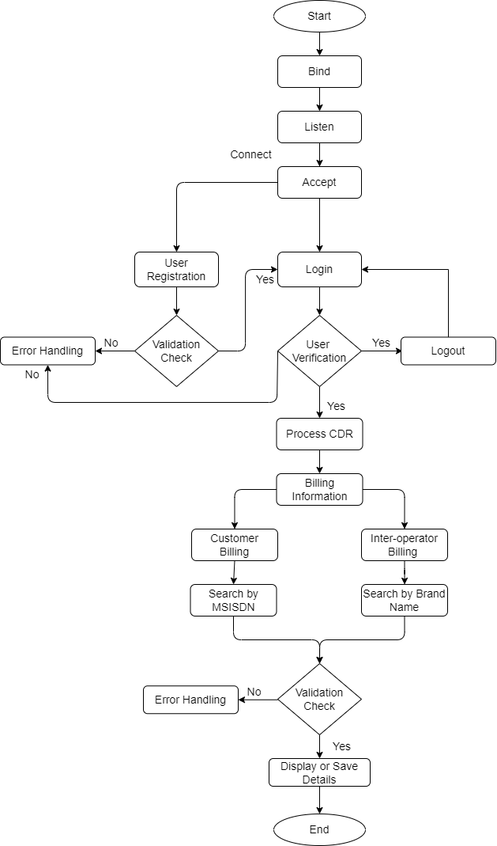

**4.7 Business Process Modeling and Management (AS APPLICABLE)**

**NA**

**4.8 Business Logic**

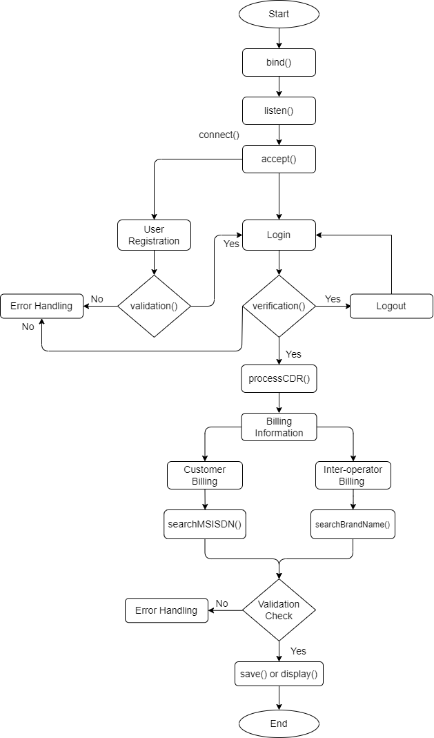

**4.9 Variables**

struct sockaddr_in server_addr

int serverSockfd

int clientSockfd

string ipaddr

socklen_t len

int newfd

int port

string ipAddr

string brandName

longMMC

long inCallDuration

long outCallDuration

long inMsg

long outMsg

long downData

long upData

long MSISDN

long inCallDurationI

long outCallDurationI

long inMsgI

long outMsgI

long inCallDurationO

long outCallDurationO

long inMsgO

long outMsgO

char* username

char* password

**4.10 Class Diagram**

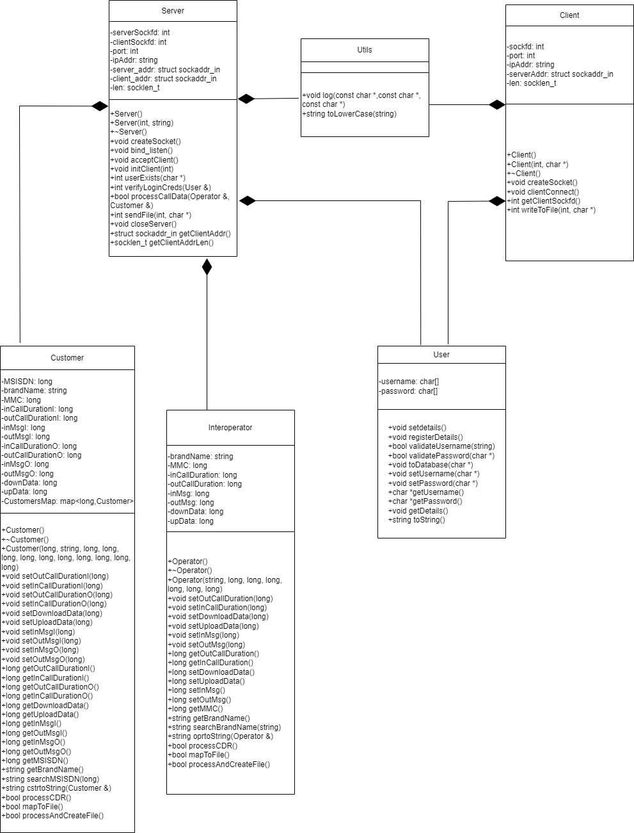

**4.9.1.Sequence diagram**

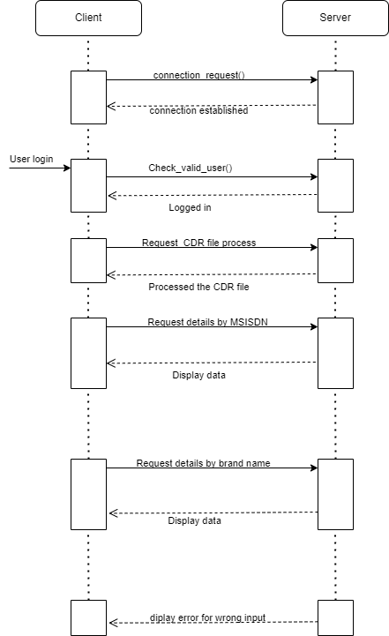

**4.11 Data Migration**

NA

**5. ENVIRONMENT DESCRIPTION**

The Environment description allows the client to connect to the server and requests the server to search for a file on the basis of MSISDN Number and displaying the contents.

## Time Zone Support

* It will support time zones as per Indian standard time(IST) in (GMT +5:30) and UST standard.

## Language Support

* C++ programming language and g++ compilation.

## User Desktop Requirements

* Linux or windows environment

## Server-Side Requirements

In server side,

● Disk space – Minimum 200GB

● connectivity 24x7

### Deployment Considerations

● Network connectivity

### Application Server Disk Space

Disk space – Minimum 200GB

### Database Server Disk Space

NA

### Integration Requirements

### Jobs

NA

### Network

* Require internet connection

### Others

NA

## Configuration

Call details recorder and inter operator settlement both work on client server model. It uses TCP protocol and stores the processed data in STL containers. a client can search for customer billing specifically by mentioning their particular client code to get total SMS sent/received, incoming/outgoing calls within mobile operator/ outside mobile operator and total data downloaded/uploaded.

In Inter operator settlement, Server provides the data for the client, using system calls and TCP protocol for transfer of data. Clients can get details of particular id and get the information of Incoming/Outgoing calls,SMS as well as Data..

### Operating System

* Operating system – Linux.

### Database

* Used .txt file

### Network

* Transmission Control Protocol

### Desktop

* Linux / Windows.

# References

# Appendix

NA