

**CALL DATA RECORD**

**CDR_SRS**

**Software Requirement Specifications**

**CDR v0.1**

**Document Control**

| **Project Revision History** | | | | | | | |
| --- | --- | --- | --- | --- | --- | --- | --- |
|  |  |  |  |  |  |  |  |
| **Date** | **Version** | **Author** | **Brief Description of Changes** | | | **Approver Signature** | |
| 30/09/2022 | 0.1(Draft) | 1. Asutosh Padhi 2. Sumit Sharma 3. Surayya Afsheen 4. Rohit Kumar 5. Nongthombam Deepu Singh 6. Ashish Nitin Shimpi | Software Requirements Documentation | | |  | |

**Team Members**

| **Employee ID** | **Employee Name** |
| --- | --- |
| 46264033 | Asutosh Padhi |
| 46252342 | Sumit Sharma |
| 46264342 | Surayya Afsheen |
| 46264342 | Rohit Kumar |
| 46264675 | Nongthombam Deepu Singh |
| 46264631 | Ashish Nitin Shimpi |

|  | **Table of Contents** | | |  |  |  |
| --- | --- | --- | --- | --- | --- | --- |
| **1.** | **Introduction** | | |  |  | **4** |
|  | 1.1 | Purpose | |  |  | 4 |
|  | 1.2 | Scope | |  |  | 4 |
|  | 1.3 | Definitions, Acronyms, and Abbreviations | |  |  | 4 |
|  | 1.4 | References | |  |  | 4 |
|  | 1.5 | Overview | |  |  | 5 |
| **2.** | **Overall Description** | | |  |  | **5** |
| **3.** | **Specific Requirements** | | |  |  | **6** |
|  | 3.1 | Functionality | |  |  | 6 |
|  |  |  | 3.1.1 – 3.1.14 |  |  |  |
|  | 3.2 | Usability | |  |  | 7 |
|  | 3.3 | Reliability & Availability | |  |  | 7 |
|  | 3.4 | Security | |  |  | 7 |
|  | 3.5 | Supportability | |  |  | 7 |
|  | 3.6 | Design Constraints | |  |  | 8 |
|  | 3.7 | Use Case Diagram | |  |  | 8 |
|  | 3.8 | On-line User Documentation and Help System Requirements | |  |  | 8 |
|  | 3.9 | Purchased Components | |  |  | 8 |
|  | 3.10 | Interfaces | |  |  | 8 |
|  | 3.11 | Licensing Requirements | |  |  | 9 |
|  | 3.12 | Legal, Copyright, and Other Notices | |  |  | 9 |
|  | 3.13 | Applicable Standards | |  |  | 9 |
| **4.** | **Supporting Information** | | |  |  | **9** |

**1. Introduction**

The introduction of the Software Requirements Specification (SRS) provides an overview of the entire SRS with purpose, scope, definitions, acronyms, abbreviations, references, and overview of the SRS. The aim of this document is to gather, analyze and give an in-depth insight into the complete Call Details Record by defining all the requirements in detail. This document is intended to be read by developers, testers, project managers and customers.

**1.1 Purpose**

Purpose of this document is to analyze Call Detail Record in real time and behaviour of the network in real time. But these Call Detail Records have a huge volume, variety of data and different data rate, while current telecom systems are designed without considering these issues in mind.

**1.2 Scope**

This document specifies charging functionality and charging management for cellular service providers. Specifically, this document describes the handling of CDR files that contain CDR records. Each CDR record contains descriptions of charging events such as voice calls and SMS messages with all relevant data.

**1.3 Definitions, Acronyms, and Abbreviations**

| CDR | Call Details Records |
| --- | --- |
| MSISDN | Mobile Station International PSTN/ISDN Number |
| SMS – MO | Short Message Service – Mobile Originated |
| SMS – MT | Short Message Service – Mobile Terminated |
| MCC | Mobile Country Code |
| MNC | Mobile Network Code |
| MOC | Mobile Originated Call |
| MTC | Mobile Terminating Call |
| GPRS | General Packet Radio Service |
| MB | Mega Byte |
| TCP | Transmission Control Protocol |
| STL | Standard Template Library |

**1.4 References**

* <https://www.sciencedirect.com/topics/computer-science/call-data-record>
* <https://www.itu.int/en/ITU-D/Emergency-Telecommunications/Documents/2017/Reports/LB/D012A0000C93301PDFE.pdf>

**1.5 Overview**

The remaining sections of this document provide a general description, including characteristics of the users of this project, functionalities, and other requirements of the proposed system such as functional requirements, supporting information etc.

**2.** **Overall Description**

Call Data Record is a client server model where TCP/ IP protocol is used for the functionalities. The server extracts data from the CDR files and stores it in appropriate STL containers which are shown to the client as per their request. Each session has a unique ID called MSISDN along with operator name and mobile country code.  It also gives each event details that occur in the network. CDR Life cycle generally begins with CDR generation of a call, it is completed according to the events occurring in the call (call end, call join, etc.), then it is collected by different network elements.

Client has to send a request to the server to get the CDR file processed that is stored in a directory and put the required data into appropriate STL containers. While the customer billing file is based on MSISDN, the inter-operator billing is based on the operator through which connection is made.

The customer billing contains information about incoming and outgoing voice calls within and outside the mobile operator, SMS message in both outgoing (MO) and incoming (MT) sent both within and outside the mobile operator and MB of data that is uploaded and downloaded.

Inter Operator Settlement contains information about outgoing calls duration to a subscriber within and outside the mobile operator, incoming voice calls duration to a subscriber within and outside the mobile operator. It contains SMS in both outgoing (MO) and incoming (MT) sent both within and outside the mobile operator along with MB of data that is uploaded and downloaded.

**3.** **Specific Requirements**

 The specific requirements are –

**3.1 Functionality**

**3.1.1 Create client and server connection**

A client and server connection are established, by using TCP protocol, as the data to be processed is in huge amounts.

**3.1.2 Store the processed data in STL container**

Validate the login credentials of the user with that of the client stored in the server using a container. The client must send a request to the server to retrieve the CDR files stored in the directory and save the processed data to the STL container.

**3.1.3 Feature to provide total incoming calls durations, messages and data used by GPRS based on MSISDN**

The customer billing contains the total duration of incoming calls, outgoing calls, within the mobile operator and outside the mobile operator about particular MSISDN.

Also, it contains all the information about the total number of messages received and sent within the mobile operator and outside mobile operator.

And, it contains dataabout the total amount of data used for uploading and downloading files by using GPRS.

**3.1.4 Feature to provide total incoming calls durations, messages and data used by GPRS based on operator ID**

The Inter Operator settlement contains all the information about total call duration of incoming calls, outgoing calls of a particular brand like Airtel or Jio etc., within the mobile operator and outside mobile operator.

Also, it contains all the information about the total number of messages received and sent within the mobile operator and outside mobile operator.

And, it contains dataabout the total amount of data used for uploading and downloading files by using GPRS.

**3.1.5 Appropriate error handling**

For all search fails or other system fails, error handling will be performed by displaying proper Error messages. This will include Log messages.

**3.1.6 Data Security**

The system shall allow the server on the remote system to set the restrictions on which files users can retrieve, as well as restrictions on storing file

**3.2 Usability**

The system is quite efficient and user-friendly by preventing users from having to know the Linux Command for print/search operations.

Based on the menu – driven or console.

**3.3 Reliability & Availability**

This is a free and open-source system.

The system is available in online and offline modes at any time.

The system has a very low failure rate.

**3.4 Security**

The call record data is not secure by default, we need to carry out additional authentication processes by securing the data in the directory.

**3.5 Supportability**

The system is easily accessible on any LINUX system, and it can be managed efficiently.

**3.6 Design Constraints**

The system is built using only C++ language.

**3.7 Use Case Diagram**

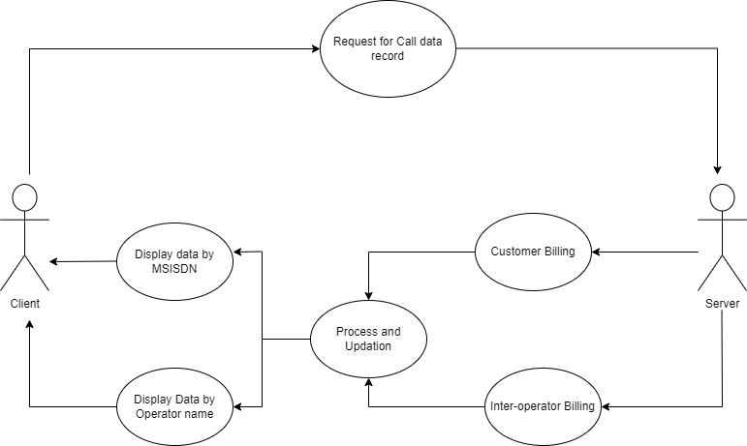

**3.8 Online user Documentation and Help System Requirements**

Stable Network Connection,

System with Linux Terminal.

**3.9 Purchased Components**

Not Applicable.

**3.10 Interface**

The internal interface properties and methods that can be accessed are:

* CDR File
* STL containers
* Threads
* Socket Connection

The external interface compromises interfaces through which the users interact with the system

* Windows operating system/Linux operating system.
* Network Connectivity.

**3.11 Licensing Requirements**

Not Applicable

**3.12 Legal, Copyright, and Other Notices**

All rights reserved.

**3.13 Applicable Standards**

Industry standard.

**4. Supporting Information**

Use case Diagram