1. Create and AmI
2. Create an load balancer

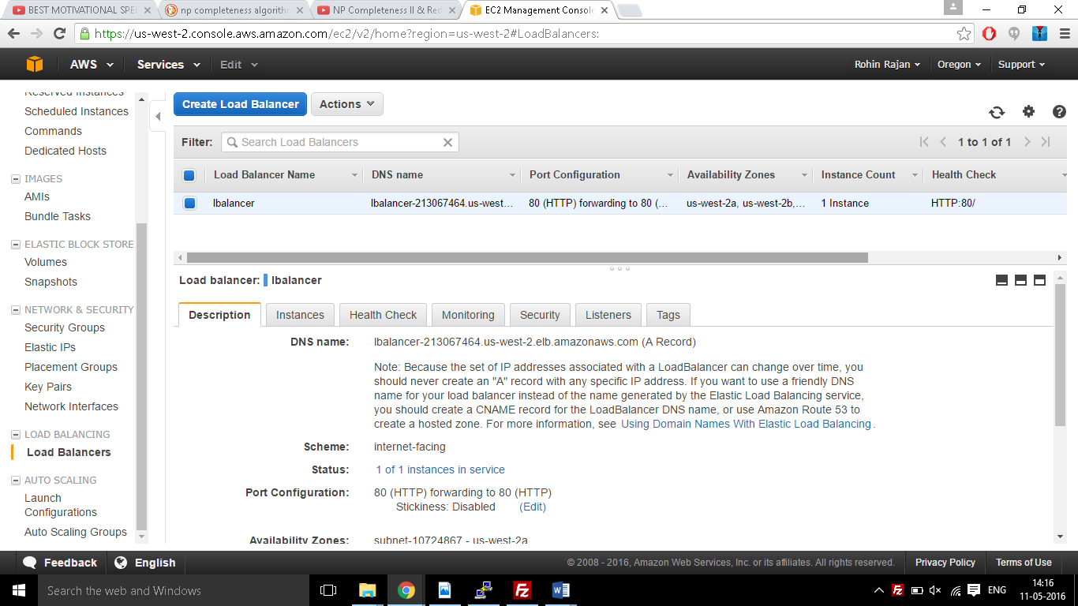

1. Create an auto scalling group
2. Add the instances to it
3. Now create new scaling policies and append them to it.

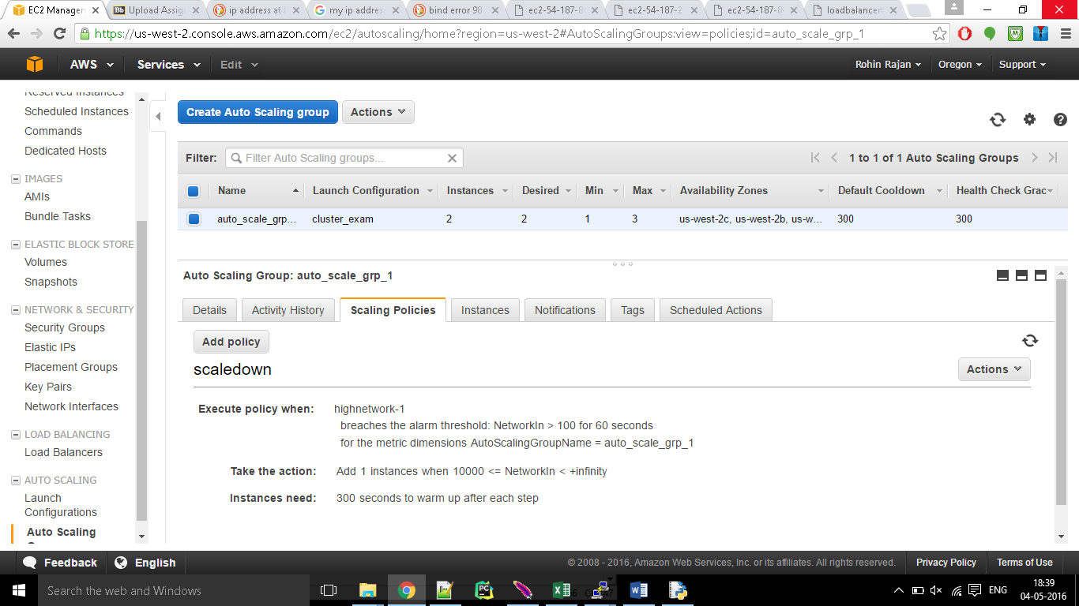

1. Using Jmeter we can trigger the new instances and you would be able to see that new instance gets spanned based on the scaling policy that has been created.
2. We can also scale down by setting the policy accordingly.