Commerce 3ke3 assignment 1 report

Part 1.1 A

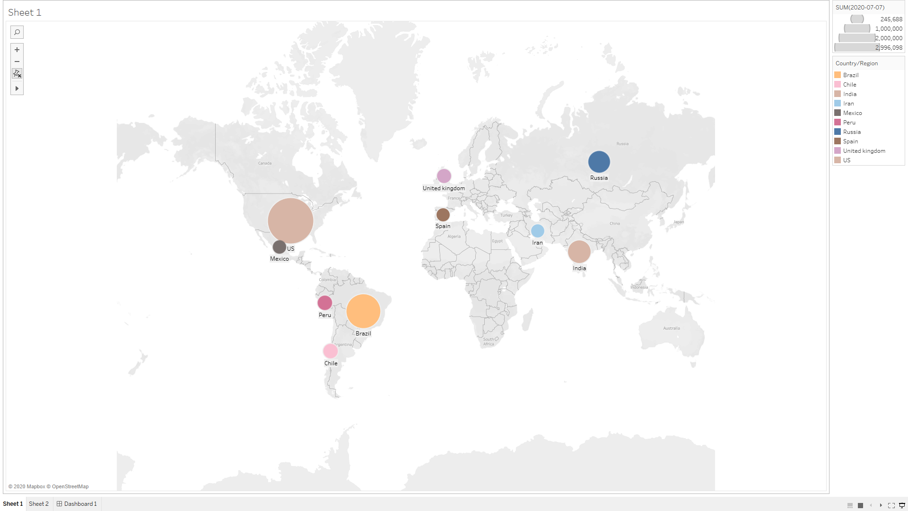

Part B

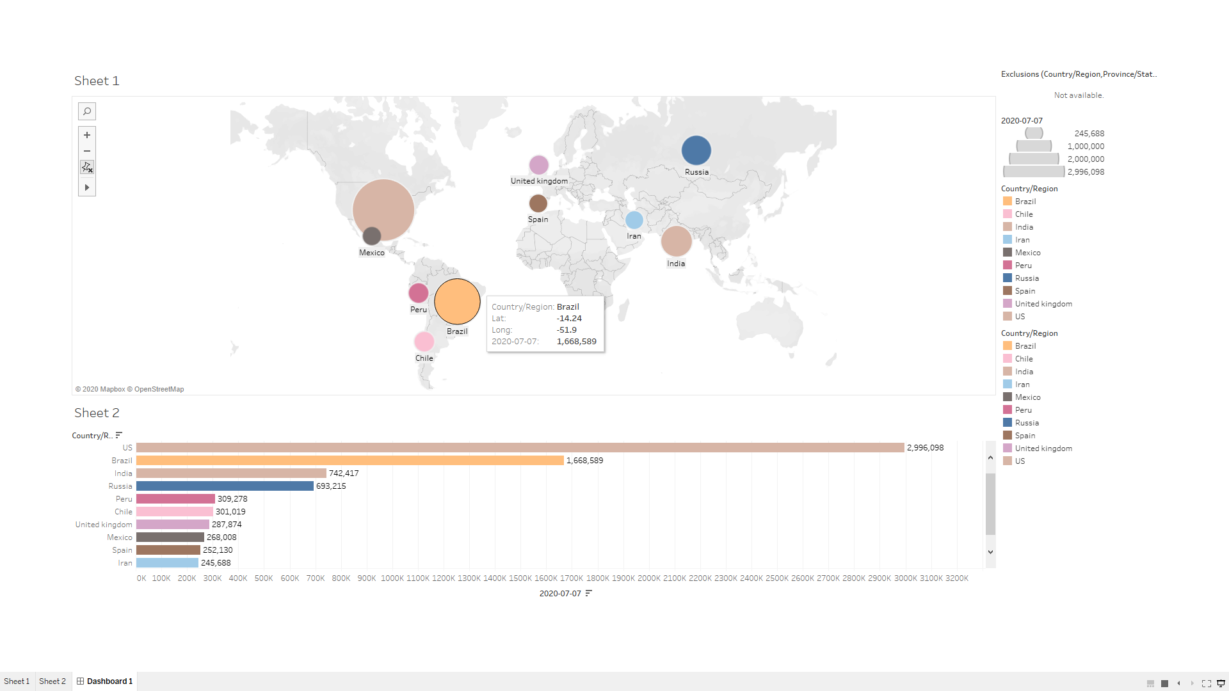

Part C

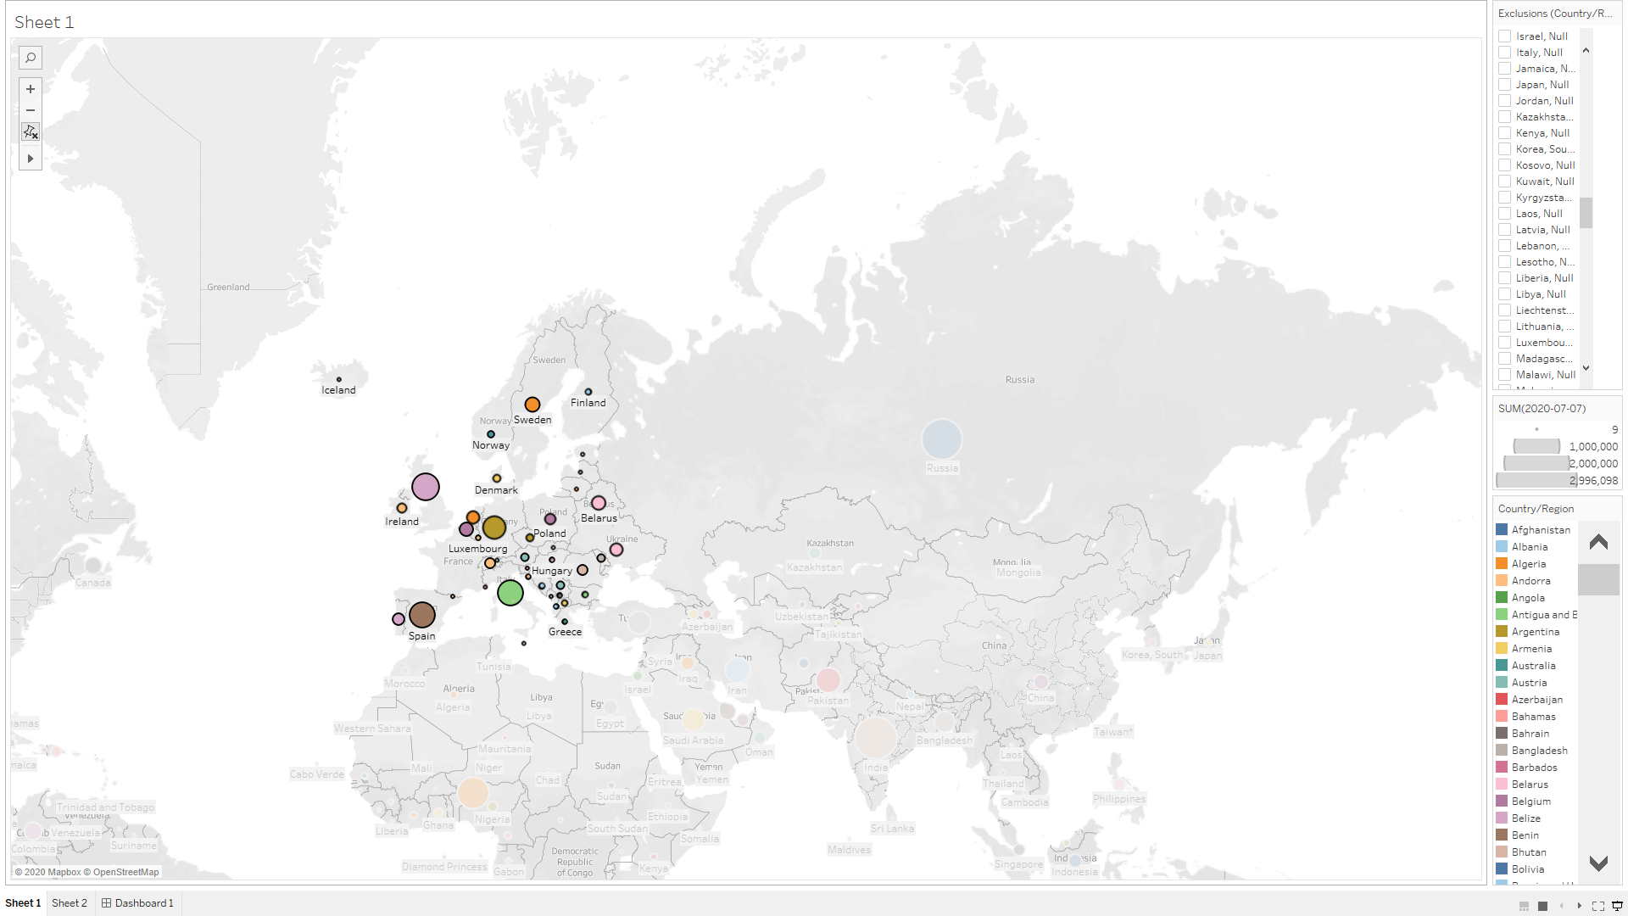 

Least amount: 1st holy See ,2nd Liechtenstein and 3rd Monaco.

Part D

**Compare and contrast the number of confirmed cases for the 7 countries with the largest population, including China, India, the United States, Indonesia, Brazil, Russia, and Mexico. Do you think the country’s population is a significant factor affecting the number of cases? You are required to write two or three sentences in which you first specify if these 7countries with the highest population are among the 10 countries with the highest number of confirmed cases. Then you can discuss the rankings of these countries in terms of the number of confirmed cases (1 point for each country).**

Higher population could be a part of the factor, this is evident because India, Russia, Mexico, Brazil and the united states are the countries that has the highest population and is among top 10 countries having the highest number of confirmed cases but China and Indonesia aren’t among them. This is still important because of the majority. US ranks no. 1 in confirmed cases, 2nd is Brazil, 3rd is India, 4th is Russia, 5th is Peru, 6th is Chile, 7th is United Kingdom, 8th is Mexico, 9th Spain and 10th is Iran.

Part 2.1  
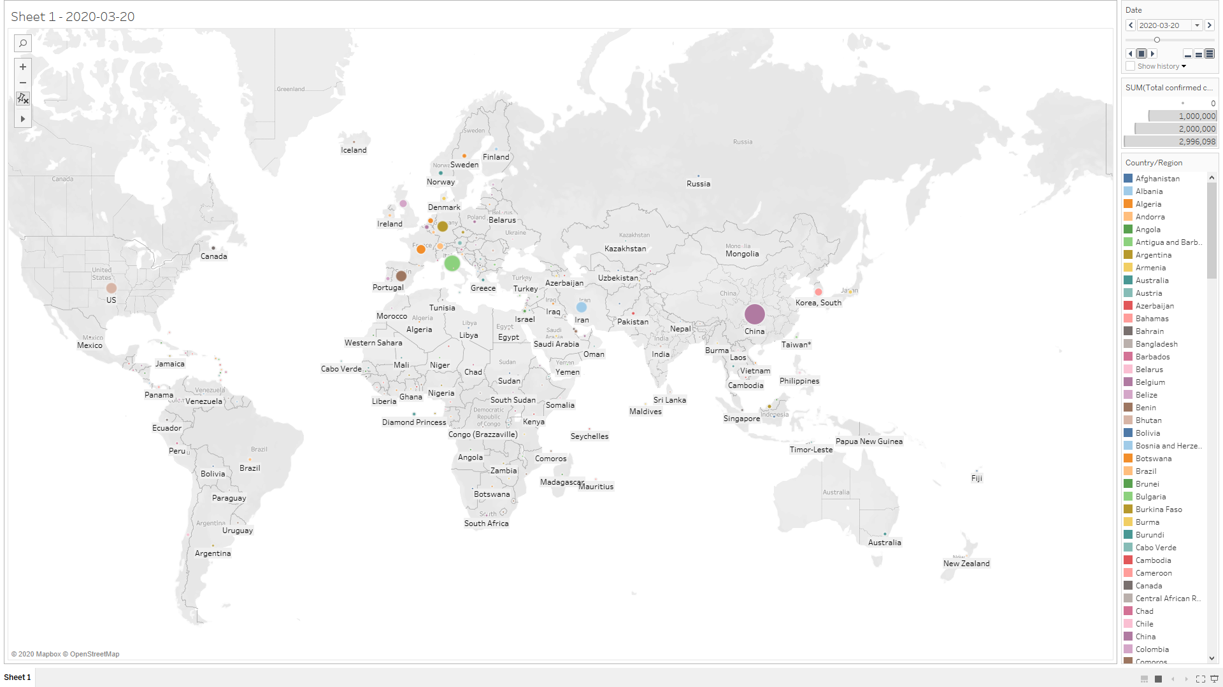

Part 2.2

Fastest to reach 100,000 confirmed cases- 1st U.S, 2nd Italy and 3rd Spain

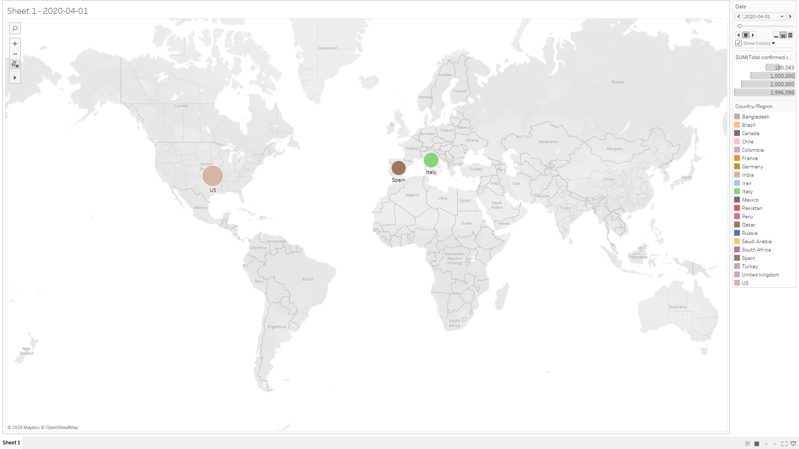

Slowest to reach 100,000 confirmed cases- 1st Qatar, 2nd Colombia and 3rd south Africa

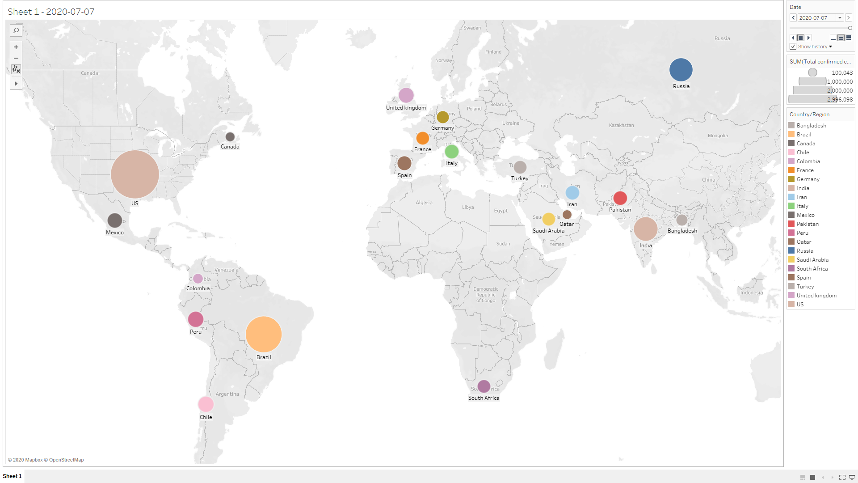

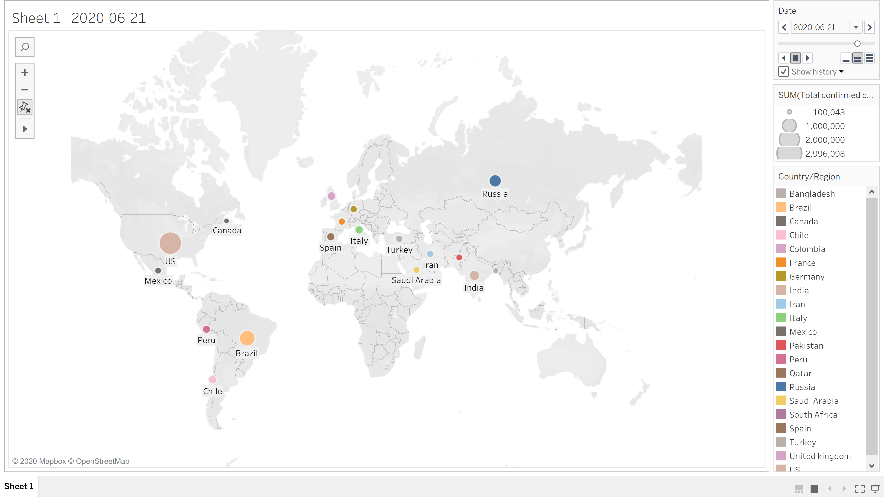

(map without the top 3 slowest countries)

Part 2.3

**Follow the spread rate (by monitoring countries bubbles) of the 7 largest countries, including Russia, Canada, the United States, China, Brazil, Australia, and India in the first and last two months of the period in the map and explain if there are any differences among these countries in terms of the spread of the pandemic during these two time slots?(1point for each country discussion**

**China**-During the first month china was leading in terms of faster spread rate in confirmed cases but began slowing down the spread rate in terms of confirmed cases compared to other countries and the numbers were stabilizing

**Russia**- during the first month, the spread of Covid 19 in Russia was significantly lower because there were no confirmed cases compared to china. In the last two months of the period, in May and June the spread rate increased a lot faster than china.

**United States**- during the end of the first month there were only a few confirmed cases compared to china but within the last two months, United States confirmed cases surpassed the spread rate of china. Other than china The US was leading in terms of confirmed cases among the larger countries (aprox.15 cases)

**Brazil**- during the end of the first month there were no confirmed cases compared to china and the spread rate was slower but within the last two months, the speed of the spread rate started increasing rapidly compared to china

**India**- during the end of the first month there were a few confirmed cases compared to china and the spread rate was slower but within the last two months, the speed of the spread rate started increasing rapidly compared to china

**Canada**-during the end of the first month there were a few confirmed cases compared to china and the spread rate was slower but within the last two months, the speed of the spread rate started increasing rapidly compared to china

**Australia**- During the end of the first month there were a few confirmed cases similar to the US (aprox.15 cases) compared to china and the spread rate was slower but within the last two months, the speed of the spread rate started increasing but not as fast as other larger countries. This was the slowest spread rate other than china in terms of confirmed cases within the last 2 months.

Part 3

3.1

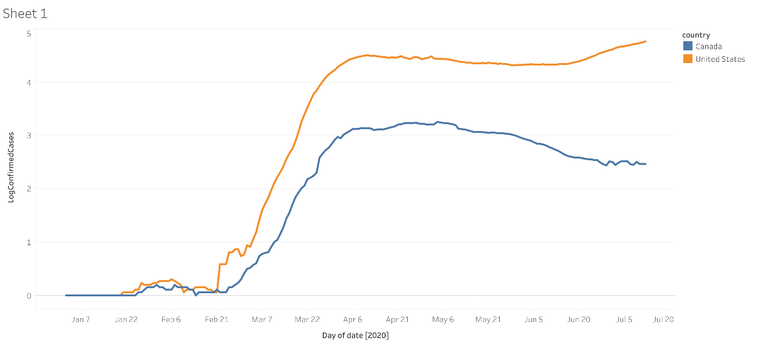 Canada vs USA (north America continent)

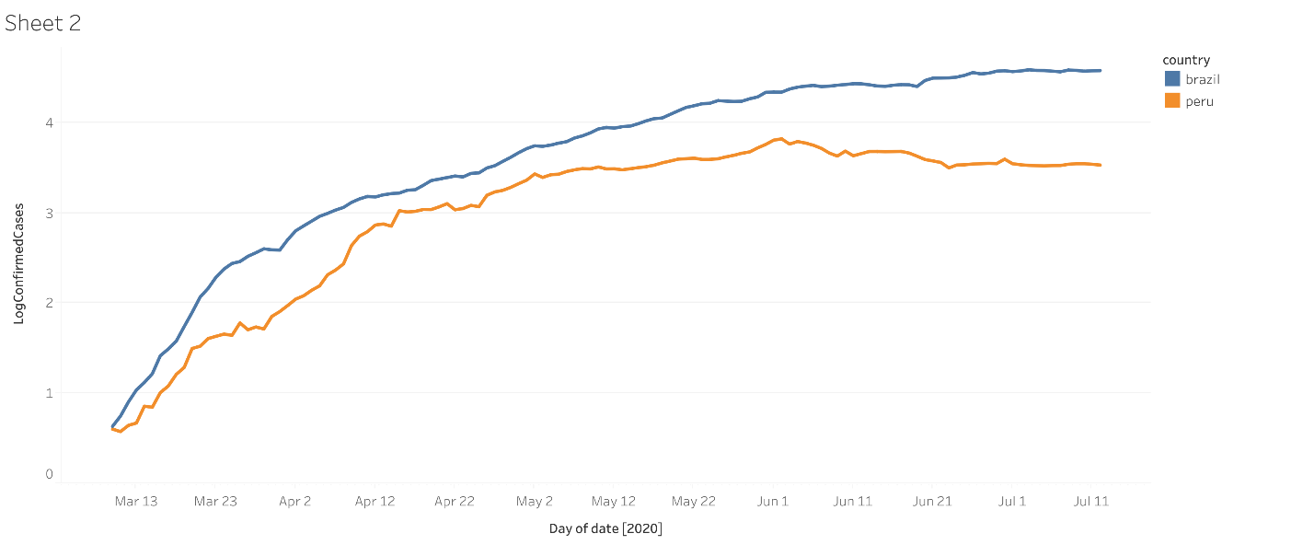  
Brazil vs Peru (south America continent)

Egypt vs south Africa (Africa continent)

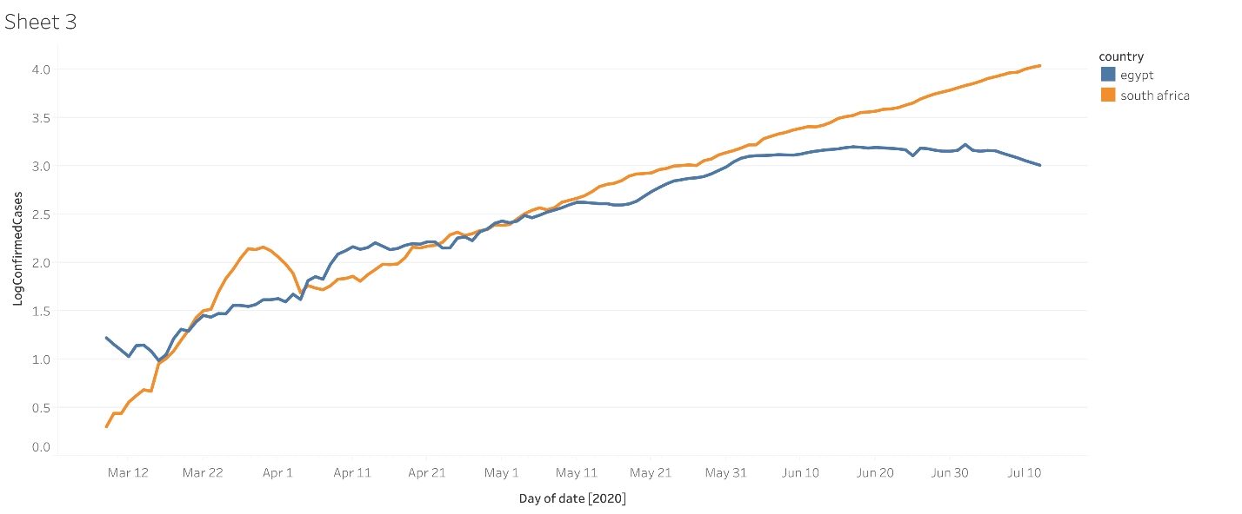

Croatia vs Italy (European continent)

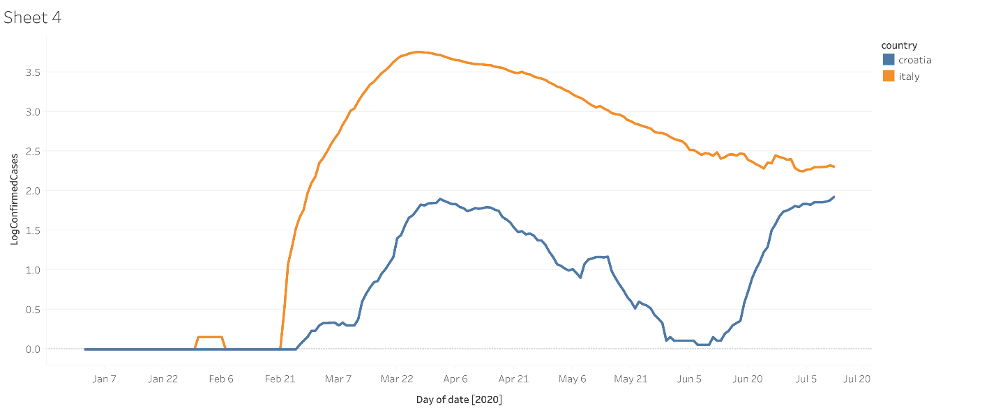

India vs south Korea (Asian continent)

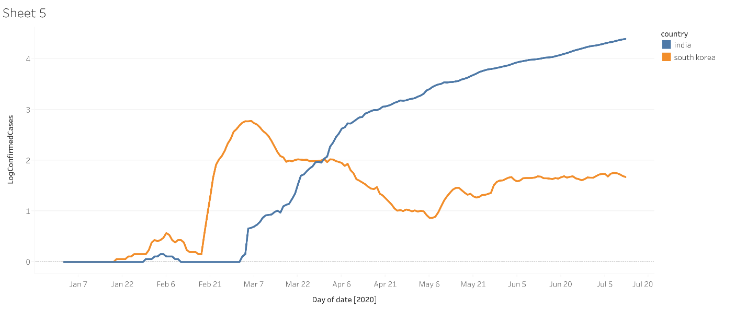

Australia vs new Zealand (Australian continent)

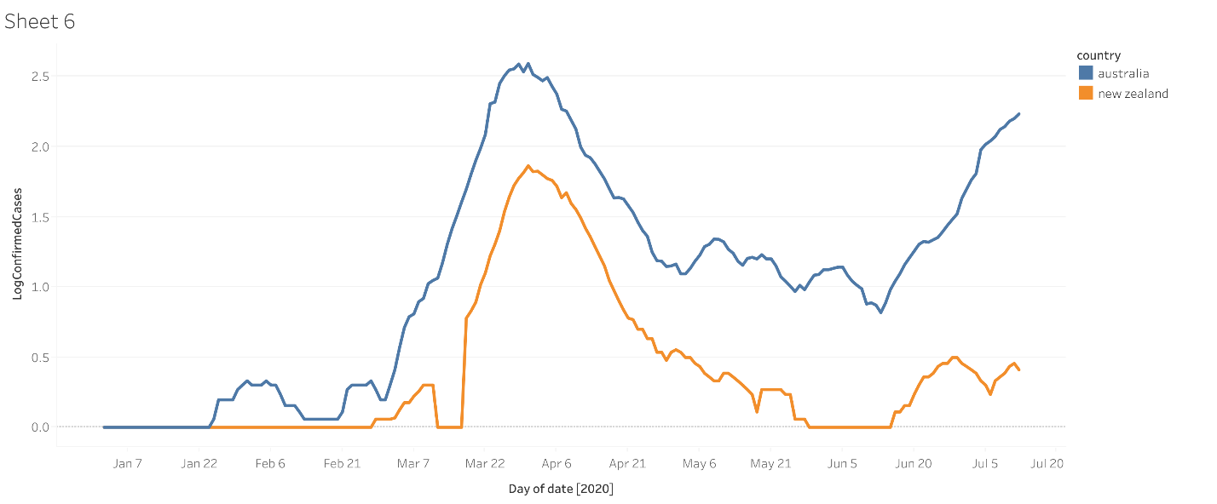

Question 3.2

1. In each continent, which country(ies) could have flattened the curve(Flattening the curve involves reducing the number of new cases from one day to the next.)?In the countries with flattened curves, specify when (roughly) the curve started to flatten. The time may have been close to their lockdown since most countries went into lockdown to stop the spread of the virus (2 points: 1 for the country name and 1 for the time).

**Ans.** I

In the North American continent, the united states could have flattened the curve. Canada had a flatten curve, the curve started to flatten on June 30th

In the south American continent, brazil could have flattened the curve. Peru had flattened curve, the curve started to flatten on June 24th

In the African continent, south Africa could have flattened the curve. Egypt had flattened curve, the curve started to flatten on June 24th h, 2020

In the European continent, Croatia could have flattened the curve. Italy had a flattened curve, the curve started to flatten on June 12th, 2020

In the Asian continent, India could have flattened the curve. South Korea had flattened curve, the curve started to flatten on June 12th, 2020

In the Australian continent, Australia could have flattened the curve. New Zealand had flattened curve, the curve started to flatten on June 28th, 2020

1. For the countries with the flattened curve, do you think they were able to control the spread of the virus after reopening? For each continent compare the countries with each other. Hence, in total, there should be 6 comparisons in your report (2 points for each comparison).

**Ans**

In the North American continent, the united states hit the highest confirmed case but for short period of time but failed maintain that level at June 17th reaching new highs whereas Canada reached new highs back in may 4th and began slowed down the number of cases after that and began flattening at June 30th

In the south American continent, brazil seems to keep increasing the number confirmed cases while Peru seems to have pattern but has flattened its curve on June 24th and slowed its rate of new cases.

In the African continent, south Africa seems to be following a linear line and has continually increased its rate of new cases while Egypt flatten and slowed down its rate of new cases on June 24th and began decreasing on July 7th

In the European continent, Croatia had higher rate of cases on March 29th compared to Italy. They both seem following a parabolic shape. Italy flatten its curve near June 12 after slowing down its rate of new cases, but Croatia went back to its new highs after slowing down its rate around May 31st

In the Asian continent, India continuously increase the rate of new case and hasn’t slowed down unlike south Korea March 7th and flattened its curve on June 12th. Both countries have different patterns.

In the Australian continent, Australia has the highest number of cases compared to New Zealand. Both have parabolic patterns. Australia kept increasing back to its new highs July 11th after slowing down on June 13th.

1. For each continent, do you think the curves of the two countries show the same behavior? If yes, what is your prediction about the spread of COVID-19 in that continent for the near future (next month)? Otherwise, provide your prediction for each country separately (1 point for each continent discussion).

**Ans.**

Brazil and Peru seem to follow the same behavior similar to log where the practice is that in the near future spread of new cases In the south American continent will eventually stabilize and flatten its curve in the next few months

Australia and New Zealand follow the same behavior up until a major jump after June 13th, my prediction would be Australia will eventually reach its previous highs of new cases while New Zealand stabilize or slows down its rate.

For north America, my prediction for next would continuously increase in rate of new cases while Canada stabilize its rate of cases neither increasing nor decreasing

For the African continent, in the next month Africa will continuously increase its rate of new cases while Egypt decrease its rate of new cases

For the European continent, my predication for next month, Italy will stabiles at rate of new cases flattening the curve while Croatia will increase its rate of new cases

For the Asian continent, next moth India will continuously increase its rate of new cases while south Korea will stabilize and flatten its rate of new cases